BAN502_Project

Phase1_VariableSelection

Load libraries
library(tidyverse)
## ── Attaching core tidyverse packages ──────────────────────── tidyverse 2.0.0 ──
## ✔ dplyr 1.2.1 ✔ readr 2.2.0
## ✔ forcats 1.0.1 ✔ stringr 1.6.0
## ✔ ggplot2 4.0.3 ✔ tibble 3.3.1
## ✔ lubridate 1.9.5 ✔ tidyr 1.3.2
## ✔ purrr 1.2.2
## ── Conflicts ────────────────────────────────────────── tidyverse_conflicts() ──
## ✖ dplyr::filter() masks stats::filter()
## ✖ dplyr::lag() masks stats::lag()
## ℹ Use the conflicted package (<http://conflicted.r-lib.org/>) to force all conflicts to become errors
library(tidymodels)
## ── Attaching packages ────────────────────────────────────── tidymodels 1.5.0 ──
## ✔ broom 1.0.12 ✔ rsample 1.3.2
## ✔ dials 1.4.3 ✔ tailor 0.1.0
## ✔ infer 1.1.0 ✔ tune 2.1.0
## ✔ modeldata 1.5.1 ✔ workflows 1.3.0
## ✔ parsnip 1.6.0 ✔ workflowsets 1.1.1
## ✔ recipes 1.3.2 ✔ yardstick 1.4.0
## ── Conflicts ───────────────────────────────────────── tidymodels_conflicts() ──
## ✖ scales::discard() masks purrr::discard()
## ✖ dplyr::filter() masks stats::filter()
## ✖ recipes::fixed() masks stringr::fixed()
## ✖ dplyr::lag() masks stats::lag()
## ✖ yardstick::spec() masks readr::spec()
## ✖ recipes::step() masks stats::step()
library(GGally)
library(ggcorrplot)
library(gridExtra)
##
## Attaching package: 'gridExtra'
##
## The following object is masked from 'package:dplyr':
##
## combine
library(lmtest)
## Loading required package: zoo
##
## Attaching package: 'zoo'
##
## The following objects are masked from 'package:base':
##
## as.Date, as.Date.numeric
library(glmnet)
## Loading required package: Matrix
##
## Attaching package: 'Matrix'
##
## The following objects are masked from 'package:tidyr':
##
## expand, pack, unpack
##
## Loaded glmnet 5.0
library(MASS)
##
## Attaching package: 'MASS'
##
## The following object is masked from 'package:dplyr':
##
## select
library(leaps)
library(splines)
library(car)
## Loading required package: carData
##
## Attaching package: 'car'
##
## The following object is masked from 'package:dplyr':
##
## recode
##
## The following object is masked from 'package:purrr':
##
## some
library(e1071)
##
## Attaching package: 'e1071'
##
## The following object is masked from 'package:tune':
##
## tune
##
## The following object is masked from 'package:rsample':
##
## permutations
##
## The following object is masked from 'package:parsnip':
##
## tune
##
## The following object is masked from 'package:ggplot2':
##
## element
library(ROCR)
library(usemodels)
library(mice)
## Registered S3 method overwritten by 'lme4':
## method from
## na.action.merMod car
##
## Attaching package: 'mice'
##
## The following object is masked from 'package:stats':
##
## filter
##
## The following objects are masked from 'package:base':
##
## cbind, rbind
library(VIM)
## Loading required package: colorspace
## Loading required package: grid
## VIM is ready to use.
##
## Suggestions and bug-reports can be submitted at: https://github.com/statistikat/VIM/issues
##
## Attaching package: 'VIM'
##
## The following object is masked from 'package:recipes':
##
## prepare
##
## The following object is masked from 'package:datasets':
##
## sleep
library(skimr)
library(UpSetR)
library(rpart)
##
## Attaching package: 'rpart'
##
## The following object is masked from 'package:dials':
##
## prune
library(rpart.plot)
library(RColorBrewer)
library(rattle)
## Loading required package: bitops
##
## Attaching package: 'bitops'
##
## The following object is masked from 'package:Matrix':
##
## %&%
##
## Rattle: A free graphical interface for data science with R.
## Version 5.6.2 Copyright (c) 2006-2023 Togaware Pty Ltd.
## Type 'rattle()' to shake, rattle, and roll your data.
##
## Attaching package: 'rattle'
##
## The following object is masked from 'package:VIM':
##
## wine
library(caret)
## Loading required package: lattice
##
## Attaching package: 'lattice'
##
## The following object is masked from 'package:UpSetR':
##
## histogram
##
##
## Attaching package: 'caret'
##
## The following objects are masked from 'package:yardstick':
##
## precision, recall, sensitivity, specificity
##
## The following object is masked from 'package:rsample':
##
## calibration
##
## The following object is masked from 'package:purrr':
##
## lift
library(ranger)
##
## Attaching package: 'ranger'
##
## The following object is masked from 'package:rattle':
##
## importance
library(randomForest)
## randomForest 4.7-1.2
## Type rfNews() to see new features/changes/bug fixes.
##
## Attaching package: 'randomForest'
##
## The following object is masked from 'package:ranger':
##
## importance
##
## The following object is masked from 'package:rattle':
##
## importance
##
## The following object is masked from 'package:gridExtra':
##
## combine
##
## The following object is masked from 'package:dplyr':
##
## combine
##
## The following object is masked from 'package:ggplot2':
##
## margin
library(vip)
##
## Attaching package: 'vip'
##
## The following object is masked from 'package:utils':
##
## vi
library(titanic)
library(naniar)
##
## Attaching package: 'naniar'
##
## The following object is masked from 'package:skimr':
##
## n_complete

Import dataset
train <- read_csv("C:/Users/miche/OneDrive/Desktop/BAN 502 Predictive Analytics/Course Project/train.csv")
## Rows: 26570 Columns: 26
## ── Column specification ────────────────────────────────────────────────────────
## Delimiter: ","
## chr (4): product_code, attribute_0, attribute_1, failure
## dbl (22): id, loading, attribute_2, attribute_3, measurement_0, measurement_...
##
## ℹ Use `spec()` to retrieve the full column specification for this data.
## ℹ Specify the column types or set `show_col_types = FALSE` to quiet this message.

Dataset train, structure and summary
str(train)
## spc_tbl_ [26,570 × 26] (S3: spec_tbl_df/tbl_df/tbl/data.frame)
## $ id : num [1:26570] 0 1 2 3 4 5 6 7 8 9 ...
## $ product_code : chr [1:26570] "A" "A" "A" "A" ...
## $ loading : num [1:26570] 80.1 84.9 82.4 101.1 188.1 ...
## $ attribute_0 : chr [1:26570] "material_7" "material_7" "material_7" "material_7" ...
## $ attribute_1 : chr [1:26570] "material_8" "material_8" "material_8" "material_8" ...
## $ attribute_2 : num [1:26570] 9 9 9 9 9 9 9 9 9 9 ...
## $ attribute_3 : num [1:26570] 5 5 5 5 5 5 5 5 5 5 ...
## $ measurement_0 : num [1:26570] 7 14 12 13 9 11 12 4 9 10 ...
## $ measurement_1 : num [1:26570] 8 3 1 2 2 4 2 8 6 4 ...
## $ measurement_2 : num [1:26570] 4 3 5 6 8 0 4 8 5 7 ...
## $ measurement_3 : num [1:26570] 18 18.2 18.1 17.3 19.3 ...
## $ measurement_4 : num [1:26570] 12.5 11.5 11.7 11.2 12.9 ...
## $ measurement_5 : num [1:26570] 15.7 17.7 16.7 18.6 17 ...
## $ measurement_6 : num [1:26570] 19.3 17.9 18.2 18.3 15.7 ...
## $ measurement_7 : num [1:26570] 11.7 12.7 12.7 12.6 11.3 ...
## $ measurement_8 : num [1:26570] 20.2 17.9 18.3 19.1 18.1 ...
## $ measurement_9 : num [1:26570] 10.7 12.4 12.7 12.5 10.3 ...
## $ measurement_10: num [1:26570] 15.9 17.9 15.6 16.3 17.1 ...
## $ measurement_11: num [1:26570] 17.6 17.9 NA 18.4 19.9 ...
## $ measurement_12: num [1:26570] 15.2 11.8 13.8 10 12.4 ...
## $ measurement_13: num [1:26570] 15 14.7 16.7 15.2 16.2 ...
## $ measurement_14: num [1:26570] NA 15.4 18.6 15.6 12.8 ...
## $ measurement_15: num [1:26570] 13 14.4 14.1 16.2 13.2 ...
## $ measurement_16: num [1:26570] 14.7 15.6 17.9 17.2 16.4 ...
## $ measurement_17: num [1:26570] 764 682 663 826 580 ...
## $ failure : chr [1:26570] "No" "No" "No" "No" ...
## - attr(*, "spec")=
## .. cols(
## .. id = col_double(),
## .. product_code = col_character(),
## .. loading = col_double(),
## .. attribute_0 = col_character(),
## .. attribute_1 = col_character(),
## .. attribute_2 = col_double(),
## .. attribute_3 = col_double(),
## .. measurement_0 = col_double(),
## .. measurement_1 = col_double(),
## .. measurement_2 = col_double(),
## .. measurement_3 = col_double(),
## .. measurement_4 = col_double(),
## .. measurement_5 = col_double(),
## .. measurement_6 = col_double(),
## .. measurement_7 = col_double(),
## .. measurement_8 = col_double(),
## .. measurement_9 = col_double(),
## .. measurement_10 = col_double(),
## .. measurement_11 = col_double(),
## .. measurement_12 = col_double(),
## .. measurement_13 = col_double(),
## .. measurement_14 = col_double(),
## .. measurement_15 = col_double(),
## .. measurement_16 = col_double(),
## .. measurement_17 = col_double(),
## .. failure = col_character()
## .. )
## - attr(*, "problems")=<pointer: 0x00000257d8be74b0>
summary(train)
## id product_code loading attribute_0
## Min. : 0 Length :26570 Min. : 33.16 Length :26570
## 1st Qu.: 6642 N.unique : 5 1st Qu.: 99.99 N.unique : 2
## Median :13284 N.blank : 0 Median :122.39 N.blank : 0
## Mean :13284 Min.nchar: 1 Mean :127.83 Min.nchar: 10
## 3rd Qu.:19927 Max.nchar: 1 3rd Qu.:149.15 Max.nchar: 10
## Max. :26569 Max. :385.86
## NAs :250
## attribute_1 attribute_2 attribute_3 measurement_0
## Length :26570 Min. :5.000 Min. :5.00 Min. : 0.000
## N.unique : 3 1st Qu.:6.000 1st Qu.:6.00 1st Qu.: 4.000
## N.blank : 0 Median :6.000 Median :8.00 Median : 7.000
## Min.nchar: 10 Mean :6.754 Mean :7.24 Mean : 7.416
## Max.nchar: 10 3rd Qu.:8.000 3rd Qu.:8.00 3rd Qu.:10.000
## Max. :9.000 Max. :9.00 Max. :29.000
##
## measurement_1 measurement_2 measurement_3 measurement_4
## Min. : 0.000 Min. : 0.000 Min. :13.97 Min. : 8.008
## 1st Qu.: 5.000 1st Qu.: 4.000 1st Qu.:17.12 1st Qu.:11.051
## Median : 8.000 Median : 6.000 Median :17.79 Median :11.733
## Mean : 8.233 Mean : 6.257 Mean :17.79 Mean :11.732
## 3rd Qu.:11.000 3rd Qu.: 8.000 3rd Qu.:18.47 3rd Qu.:12.410
## Max. :29.000 Max. :24.000 Max. :21.50 Max. :16.484
## NAs :381 NAs :538
## measurement_5 measurement_6 measurement_7 measurement_8
## Min. :12.07 Min. :12.71 Min. : 7.968 Min. :15.22
## 1st Qu.:16.44 1st Qu.:16.84 1st Qu.:11.045 1st Qu.:18.34
## Median :17.13 Median :17.52 Median :11.712 Median :19.02
## Mean :17.13 Mean :17.51 Mean :11.717 Mean :19.02
## 3rd Qu.:17.80 3rd Qu.:18.18 3rd Qu.:12.391 3rd Qu.:19.71
## Max. :21.43 Max. :21.54 Max. :15.419 Max. :23.81
## NAs :676 NAs :796 NAs :937 NAs :1048
## measurement_9 measurement_10 measurement_11 measurement_12
## Min. : 7.537 Min. : 9.323 Min. :12.46 Min. : 5.167
## 1st Qu.:10.757 1st Qu.:15.209 1st Qu.:18.17 1st Qu.:10.703
## Median :11.430 Median :16.127 Median :19.21 Median :11.717
## Mean :11.431 Mean :16.118 Mean :19.17 Mean :11.702
## 3rd Qu.:12.102 3rd Qu.:17.025 3rd Qu.:20.21 3rd Qu.:12.709
## Max. :15.412 Max. :22.479 Max. :25.64 Max. :17.663
## NAs :1227 NAs :1300 NAs :1468 NAs :1601
## measurement_13 measurement_14 measurement_15 measurement_16
## Min. :10.89 Min. : 9.14 Min. : 9.104 Min. : 9.701
## 1st Qu.:14.89 1st Qu.:15.06 1st Qu.:13.957 1st Qu.:15.268
## Median :15.63 Median :16.04 Median :14.969 Median :16.436
## Mean :15.65 Mean :16.05 Mean :14.996 Mean :16.461
## 3rd Qu.:16.37 3rd Qu.:17.08 3rd Qu.:16.018 3rd Qu.:17.628
## Max. :22.71 Max. :22.30 Max. :21.626 Max. :24.094
## NAs :1774 NAs :1874 NAs :2009 NAs :2110
## measurement_17 failure
## Min. : 196.8 Length :26570
## 1st Qu.: 619.0 N.unique : 2
## Median : 701.0 N.blank : 0
## Mean : 701.3 Min.nchar: 2
## 3rd Qu.: 784.1 Max.nchar: 3
## Max. :1312.8
## NAs :2284

Dataset train, factor conversion
train = train %>% mutate(product_code = as_factor(product_code)) %>%
mutate(attribute_0 = as_factor(attribute_0)) %>%
mutate(attribute_1 = as_factor(attribute_1)) %>%
mutate(failure = as_factor(failure))

Dataset train, structure and summary
str(train)
## tibble [26,570 × 26] (S3: tbl_df/tbl/data.frame)
## $ id : num [1:26570] 0 1 2 3 4 5 6 7 8 9 ...
## $ product_code : Factor w/ 5 levels "A","B","C","D",..: 1 1 1 1 1 1 1 1 1 1 ...
## $ loading : num [1:26570] 80.1 84.9 82.4 101.1 188.1 ...
## $ attribute_0 : Factor w/ 2 levels "material_7","material_5": 1 1 1 1 1 1 1 1 1 1 ...
## $ attribute_1 : Factor w/ 3 levels "material_8","material_5",..: 1 1 1 1 1 1 1 1 1 1 ...
## $ attribute_2 : num [1:26570] 9 9 9 9 9 9 9 9 9 9 ...
## $ attribute_3 : num [1:26570] 5 5 5 5 5 5 5 5 5 5 ...
## $ measurement_0 : num [1:26570] 7 14 12 13 9 11 12 4 9 10 ...
## $ measurement_1 : num [1:26570] 8 3 1 2 2 4 2 8 6 4 ...
## $ measurement_2 : num [1:26570] 4 3 5 6 8 0 4 8 5 7 ...
## $ measurement_3 : num [1:26570] 18 18.2 18.1 17.3 19.3 ...
## $ measurement_4 : num [1:26570] 12.5 11.5 11.7 11.2 12.9 ...
## $ measurement_5 : num [1:26570] 15.7 17.7 16.7 18.6 17 ...
## $ measurement_6 : num [1:26570] 19.3 17.9 18.2 18.3 15.7 ...
## $ measurement_7 : num [1:26570] 11.7 12.7 12.7 12.6 11.3 ...
## $ measurement_8 : num [1:26570] 20.2 17.9 18.3 19.1 18.1 ...
## $ measurement_9 : num [1:26570] 10.7 12.4 12.7 12.5 10.3 ...
## $ measurement_10: num [1:26570] 15.9 17.9 15.6 16.3 17.1 ...
## $ measurement_11: num [1:26570] 17.6 17.9 NA 18.4 19.9 ...
## $ measurement_12: num [1:26570] 15.2 11.8 13.8 10 12.4 ...
## $ measurement_13: num [1:26570] 15 14.7 16.7 15.2 16.2 ...
## $ measurement_14: num [1:26570] NA 15.4 18.6 15.6 12.8 ...
## $ measurement_15: num [1:26570] 13 14.4 14.1 16.2 13.2 ...
## $ measurement_16: num [1:26570] 14.7 15.6 17.9 17.2 16.4 ...
## $ measurement_17: num [1:26570] 764 682 663 826 580 ...
## $ failure : Factor w/ 2 levels "No","Yes": 1 1 1 1 1 1 2 2 1 1 ...
summary(train)
## id product_code loading attribute_0
## Min. : 0 A:5100 Min. : 33.16 material_7:21320
## 1st Qu.: 6642 B:5250 1st Qu.: 99.99 material_5: 5250
## Median :13284 C:5765 Median :122.39
## Mean :13284 D:5112 Mean :127.83
## 3rd Qu.:19927 E:5343 3rd Qu.:149.15
## Max. :26569 Max. :385.86
## NAs :250
## attribute_1 attribute_2 attribute_3 measurement_0
## material_8:10865 Min. :5.000 Min. :5.00 Min. : 0.000
## material_5:10362 1st Qu.:6.000 1st Qu.:6.00 1st Qu.: 4.000
## material_6: 5343 Median :6.000 Median :8.00 Median : 7.000
## Mean :6.754 Mean :7.24 Mean : 7.416
## 3rd Qu.:8.000 3rd Qu.:8.00 3rd Qu.:10.000
## Max. :9.000 Max. :9.00 Max. :29.000
##
## measurement_1 measurement_2 measurement_3 measurement_4
## Min. : 0.000 Min. : 0.000 Min. :13.97 Min. : 8.008
## 1st Qu.: 5.000 1st Qu.: 4.000 1st Qu.:17.12 1st Qu.:11.051
## Median : 8.000 Median : 6.000 Median :17.79 Median :11.733
## Mean : 8.233 Mean : 6.257 Mean :17.79 Mean :11.732
## 3rd Qu.:11.000 3rd Qu.: 8.000 3rd Qu.:18.47 3rd Qu.:12.410
## Max. :29.000 Max. :24.000 Max. :21.50 Max. :16.484
## NAs :381 NAs :538
## measurement_5 measurement_6 measurement_7 measurement_8
## Min. :12.07 Min. :12.71 Min. : 7.968 Min. :15.22
## 1st Qu.:16.44 1st Qu.:16.84 1st Qu.:11.045 1st Qu.:18.34
## Median :17.13 Median :17.52 Median :11.712 Median :19.02
## Mean :17.13 Mean :17.51 Mean :11.717 Mean :19.02
## 3rd Qu.:17.80 3rd Qu.:18.18 3rd Qu.:12.391 3rd Qu.:19.71
## Max. :21.43 Max. :21.54 Max. :15.419 Max. :23.81
## NAs :676 NAs :796 NAs :937 NAs :1048
## measurement_9 measurement_10 measurement_11 measurement_12
## Min. : 7.537 Min. : 9.323 Min. :12.46 Min. : 5.167
## 1st Qu.:10.757 1st Qu.:15.209 1st Qu.:18.17 1st Qu.:10.703
## Median :11.430 Median :16.127 Median :19.21 Median :11.717
## Mean :11.431 Mean :16.118 Mean :19.17 Mean :11.702
## 3rd Qu.:12.102 3rd Qu.:17.025 3rd Qu.:20.21 3rd Qu.:12.709
## Max. :15.412 Max. :22.479 Max. :25.64 Max. :17.663
## NAs :1227 NAs :1300 NAs :1468 NAs :1601
## measurement_13 measurement_14 measurement_15 measurement_16
## Min. :10.89 Min. : 9.14 Min. : 9.104 Min. : 9.701
## 1st Qu.:14.89 1st Qu.:15.06 1st Qu.:13.957 1st Qu.:15.268
## Median :15.63 Median :16.04 Median :14.969 Median :16.436
## Mean :15.65 Mean :16.05 Mean :14.996 Mean :16.461
## 3rd Qu.:16.37 3rd Qu.:17.08 3rd Qu.:16.018 3rd Qu.:17.628
## Max. :22.71 Max. :22.30 Max. :21.626 Max. :24.094
## NAs :1774 NAs :1874 NAs :2009 NAs :2110
## measurement_17 failure
## Min. : 196.8 No :20921
## 1st Qu.: 619.0 Yes: 5649
## Median : 701.0
## Mean : 701.3
## 3rd Qu.: 784.1
## Max. :1312.8
## NAs :2284
skim(train)
Data summary
Name | train
Number of rows | 26570
Number of columns | 26
_______________________
Column type frequency:
factor | 4
numeric | 22
________________________
Group variables | None
Variable type: factor
skim_variable | n_missing | complete_rate | ordered | n_unique | top_counts
product_code | 0 | 1 | FALSE | 5 | C: 5765, E: 5343, B: 5250, D: 5112
attribute_0 | 0 | 1 | FALSE | 2 | mat: 21320, mat: 5250
attribute_1 | 0 | 1 | FALSE | 3 | mat: 10865, mat: 10362, mat: 5343
failure | 0 | 1 | FALSE | 2 | No: 20921, Yes: 5649
Variable type: numeric
skim_variable | n_missing | complete_rate | mean | sd | p0 | p25 | p50 | p75 | p100 | hist
id | 0 | 1.00 | 13284.50 | 7670.24 | 0.00 | 6642.25 | 13284.50 | 19926.75 | 26569.00 | ▇▇▇▇▇
loading | 250 | 0.99 | 127.83 | 39.03 | 33.16 | 99.99 | 122.39 | 149.15 | 385.86 | ▃▇▂▁▁
attribute_2 | 0 | 1.00 | 6.75 | 1.47 | 5.00 | 6.00 | 6.00 | 8.00 | 9.00 | ▅▇▁▅▃
attribute_3 | 0 | 1.00 | 7.24 | 1.46 | 5.00 | 6.00 | 8.00 | 8.00 | 9.00 | ▃▃▁▇▃
measurement_0 | 0 | 1.00 | 7.42 | 4.12 | 0.00 | 4.00 | 7.00 | 10.00 | 29.00 | ▆▇▂▁▁
measurement_1 | 0 | 1.00 | 8.23 | 4.20 | 0.00 | 5.00 | 8.00 | 11.00 | 29.00 | ▅▇▃▁▁
measurement_2 | 0 | 1.00 | 6.26 | 3.31 | 0.00 | 4.00 | 6.00 | 8.00 | 24.00 | ▅▇▂▁▁
measurement_3 | 381 | 0.99 | 17.79 | 1.00 | 13.97 | 17.12 | 17.79 | 18.47 | 21.50 | ▁▃▇▃▁
measurement_4 | 538 | 0.98 | 11.73 | 1.00 | 8.01 | 11.05 | 11.73 | 12.41 | 16.48 | ▁▅▇▁▁
measurement_5 | 676 | 0.97 | 17.13 | 1.00 | 12.07 | 16.44 | 17.13 | 17.80 | 21.42 | ▁▁▇▃▁
measurement_6 | 796 | 0.97 | 17.51 | 1.00 | 12.71 | 16.84 | 17.52 | 18.18 | 21.54 | ▁▂▇▅▁
measurement_7 | 937 | 0.96 | 11.72 | 1.00 | 7.97 | 11.04 | 11.71 | 12.39 | 15.42 | ▁▃▇▃▁
measurement_8 | 1048 | 0.96 | 19.02 | 1.01 | 15.22 | 18.34 | 19.02 | 19.71 | 23.81 | ▁▅▇▂▁
measurement_9 | 1227 | 0.95 | 11.43 | 1.00 | 7.54 | 10.76 | 11.43 | 12.10 | 15.41 | ▁▃▇▃▁
measurement_10 | 1300 | 0.95 | 16.12 | 1.41 | 9.32 | 15.21 | 16.13 | 17.02 | 22.48 | ▁▂▇▂▁
measurement_11 | 1468 | 0.94 | 19.17 | 1.52 | 12.46 | 18.17 | 19.21 | 20.21 | 25.64 | ▁▂▇▃▁
measurement_12 | 1601 | 0.94 | 11.70 | 1.49 | 5.17 | 10.70 | 11.72 | 12.71 | 17.66 | ▁▂▇▃▁
measurement_13 | 1774 | 0.93 | 15.65 | 1.16 | 10.89 | 14.89 | 15.63 | 16.37 | 22.71 | ▁▇▇▁▁
measurement_14 | 1874 | 0.93 | 16.05 | 1.49 | 9.14 | 15.06 | 16.04 | 17.08 | 22.30 | ▁▂▇▃▁
measurement_15 | 2009 | 0.92 | 15.00 | 1.55 | 9.10 | 13.96 | 14.97 | 16.02 | 21.63 | ▁▃▇▂▁
measurement_16 | 2110 | 0.92 | 16.46 | 1.71 | 9.70 | 15.27 | 16.44 | 17.63 | 24.09 | ▁▃▇▂▁
measurement_17 | 2284 | 0.91 | 701.27 | 123.30 | 196.79 | 618.96 | 701.02 | 784.09 | 1312.79 | ▁▅▇▁▁

Explore visual of missingness
gg_miss_var(train)
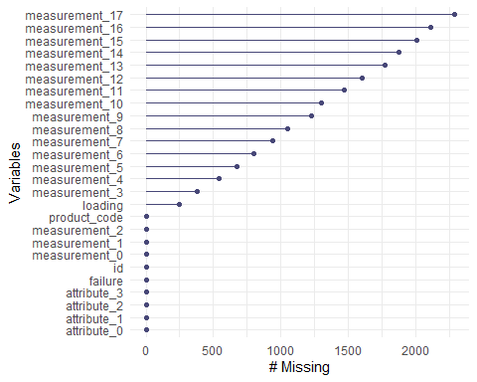

Explore/ visual 1 for patterns of missingness
gg_miss_upset(train, nsets = 16)
## Warning: `aes_string()` was deprecated in ggplot2 3.0.0.
## ℹ Please use tidy evaluation idioms with `aes()`.
## ℹ See also `vignette("ggplot2-in-packages")` for more information.
## ℹ The deprecated feature was likely used in the UpSetR package.
## Please report the issue at <https://github.com/hms-dbmi/UpSetR/issues>.
## This warning is displayed once per session.
## Call `lifecycle::last_lifecycle_warnings()` to see where this warning was
## generated.
## Warning: Using `size` aesthetic for lines was deprecated in ggplot2 3.4.0.
## ℹ Please use `linewidth` instead.
## ℹ The deprecated feature was likely used in the UpSetR package.
## Please report the issue at <https://github.com/hms-dbmi/UpSetR/issues>.
## This warning is displayed once per session.
## Call `lifecycle::last_lifecycle_warnings()` to see where this warning was
## generated.
## Warning: The `size` argument of `element_line()` is deprecated as of ggplot2 3.4.0.
## ℹ Please use the `linewidth` argument instead.
## ℹ The deprecated feature was likely used in the UpSetR package.
## Please report the issue at <https://github.com/hms-dbmi/UpSetR/issues>.
## This warning is displayed once per session.
## Call `lifecycle::last_lifecycle_warnings()` to see where this warning was
## generated.
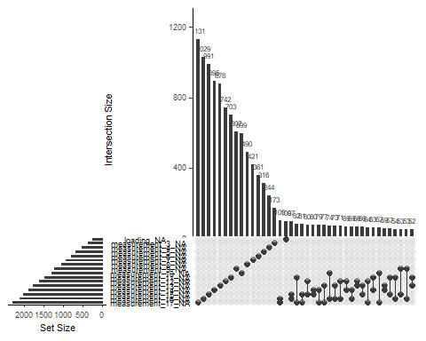

Explore/ visual 2 for patterns of missingness
vis_miss(train)
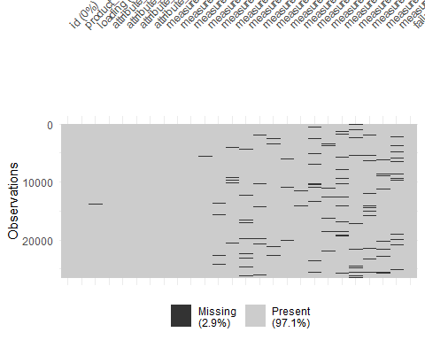

Data Exploration

Categorical variables

Bar charts
ggplot(train, aes(x=attribute_0, fill=failure)) + geom_bar(position="fill") + theme_bw()
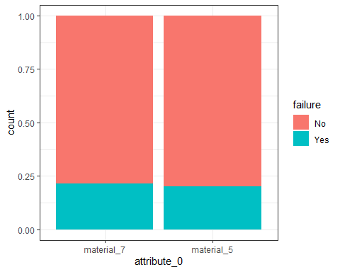
ggplot(train, aes(x=attribute_1, fill=failure)) + geom_bar(position = "fill") + theme_bw()
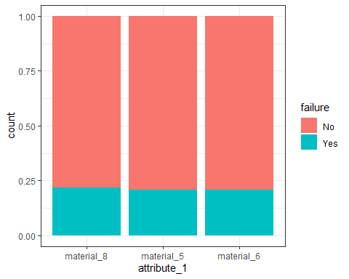
ggplot(train, aes(x=product_code, fill=failure)) + geom_bar(position = "fill") + theme_bw()
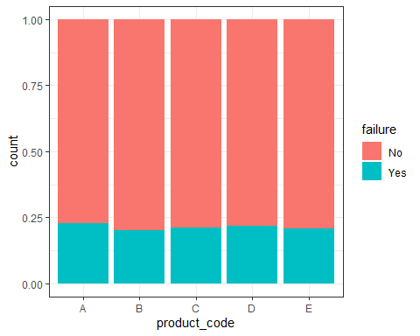
ggplot(train, aes(x=failure, fill=failure)) + geom_bar() + theme_bw()
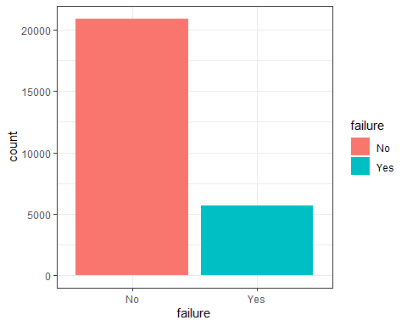

Proportions table, categorical variables
train %>%
group_by(attribute_0) %>%
summarise(
n = n(),
failures = sum(failure == "Yes"),
failure_rate = failures / n
)
## # A tibble: 2 × 4
## attribute_0 n failures failure_rate
## <fct> <int> <int> <dbl>
## 1 material_7 21320 4597 0.216
## 2 material_5 5250 1052 0.200
train %>%
group_by(attribute_1) %>%
summarise(
n = n(),
failures = sum(failure == "Yes"),
failure_rate = failures / n
)
## # A tibble: 3 × 4
## attribute_1 n failures failure_rate
## <fct> <int> <int> <dbl>
## 1 material_8 10865 2379 0.219
## 2 material_5 10362 2164 0.209
## 3 material_6 5343 1106 0.207
train %>%
group_by(product_code) %>%
summarise(
n = n(),
failures = sum(failure == "Yes"),
failure_rate = failures / n
)
## # A tibble: 5 × 4
## product_code n failures failure_rate
## <fct> <int> <int> <dbl>
## 1 A 5100 1159 0.227
## 2 B 5250 1052 0.200
## 3 C 5765 1220 0.212
## 4 D 5112 1112 0.218
## 5 E 5343 1106 0.207

Numerical variables

Distributions
ggplot(train, aes(x=loading)) + geom_histogram()
## `stat_bin()` using `bins = 30`. Pick better value `binwidth`.
## Warning: Removed 250 rows containing non-finite outside the scale range
## (`stat_bin()`).
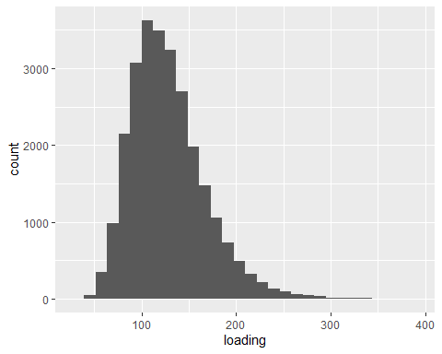
ggplot(train, aes(x=attribute_2)) + geom_histogram()
## `stat_bin()` using `bins = 30`. Pick better value `binwidth`.
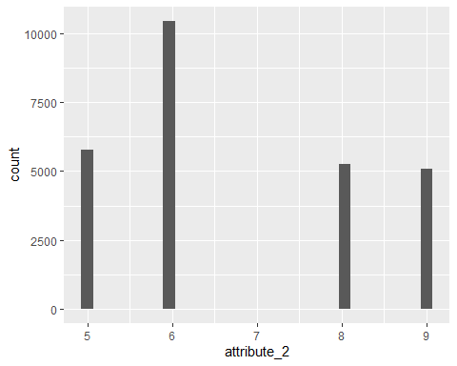
ggplot(train, aes(x=attribute_3)) + geom_histogram()
## `stat_bin()` using `bins = 30`. Pick better value `binwidth`.
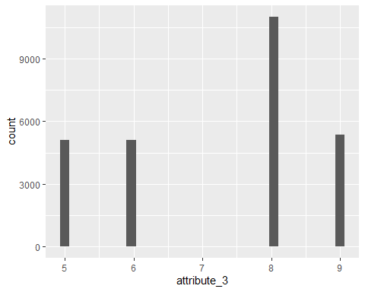
ggplot(train, aes(x=attribute_3)) + geom_histogram()
## `stat_bin()` using `bins = 30`. Pick better value `binwidth`.
ggplot(train, aes(x=measurement_0)) + geom_histogram()
## `stat_bin()` using `bins = 30`. Pick better value `binwidth`.
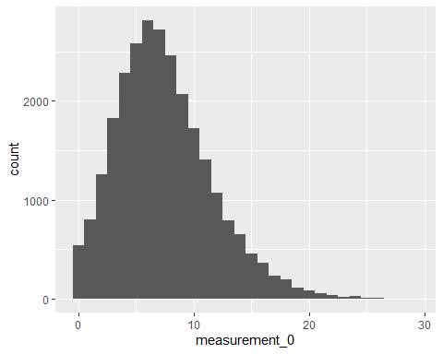
ggplot(train, aes(x=measurement_1)) + geom_histogram()
## `stat_bin()` using `bins = 30`. Pick better value `binwidth`.
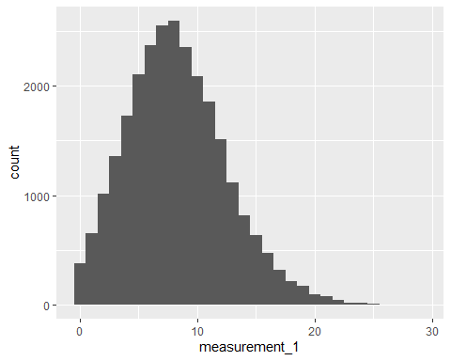
ggplot(train, aes(x=measurement_2)) + geom_histogram()
## `stat_bin()` using `bins = 30`. Pick better value `binwidth`.
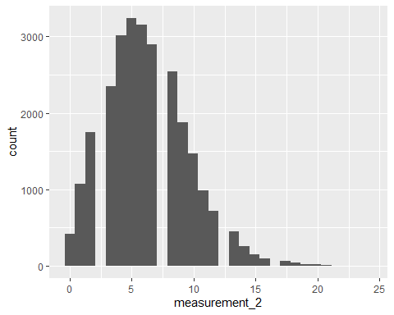 Remove outliers
train = train %>% filter(measurement_2 < 22)
ggplot(train, aes(x=measurement_3)) + geom_histogram()
## `stat_bin()` using `bins = 30`. Pick better value `binwidth`.
## Warning: Removed 381 rows containing non-finite outside the scale range
## (`stat_bin()`).
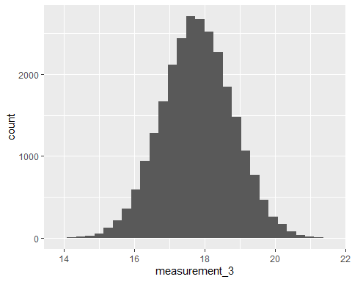
ggplot(train, aes(x=measurement_4)) + geom_histogram()
## `stat_bin()` using `bins = 30`. Pick better value `binwidth`.
## Warning: Removed 538 rows containing non-finite outside the scale range
## (`stat_bin()`).
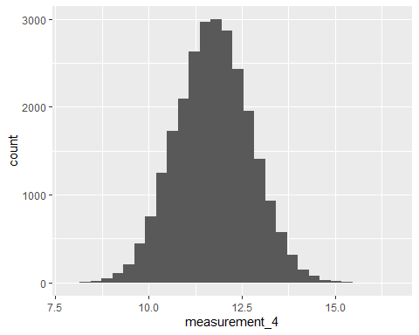
ggplot(train, aes(x=measurement_5)) + geom_histogram()
## `stat_bin()` using `bins = 30`. Pick better value `binwidth`.
## Warning: Removed 676 rows containing non-finite outside the scale range
## (`stat_bin()`).
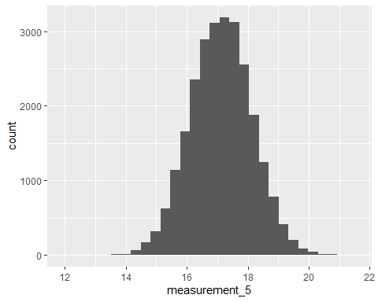
ggplot(train, aes(x=measurement_6)) + geom_histogram()
## `stat_bin()` using `bins = 30`. Pick better value `binwidth`.
## Warning: Removed 796 rows containing non-finite outside the scale range
## (`stat_bin()`).
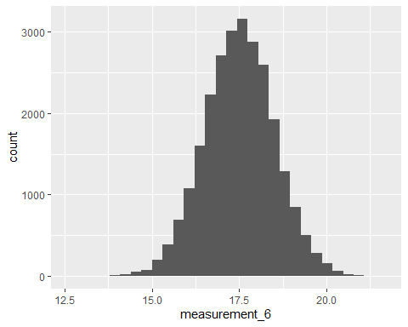
ggplot(train, aes(x=measurement_7)) + geom_histogram()
## `stat_bin()` using `bins = 30`. Pick better value `binwidth`.
## Warning: Removed 937 rows containing non-finite outside the scale range
## (`stat_bin()`).
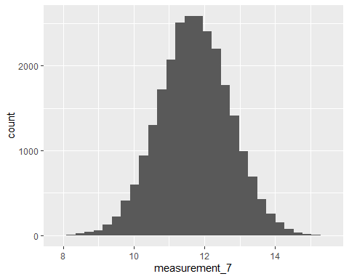
ggplot(train, aes(x=measurement_8)) + geom_histogram()
## `stat_bin()` using `bins = 30`. Pick better value `binwidth`.
## Warning: Removed 1047 rows containing non-finite outside the scale range
## (`stat_bin()`).
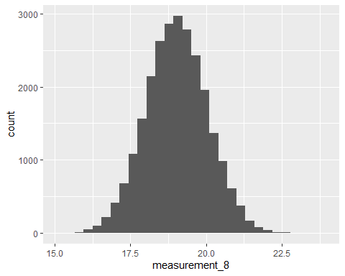 Remove outliers
train = train %>% filter (measurement_8 < 23.5)
ggplot(train, aes(x=measurement_9)) + geom_histogram()
## `stat_bin()` using `bins = 30`. Pick better value `binwidth`.
## Warning: Removed 1171 rows containing non-finite outside the scale range
## (`stat_bin()`).
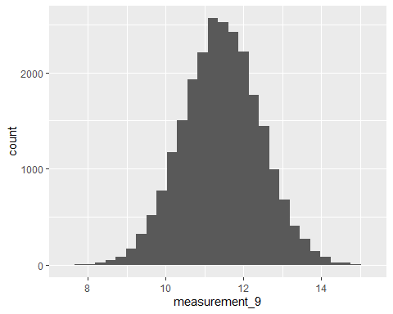
ggplot(train, aes(x=measurement_10)) + geom_histogram()
## `stat_bin()` using `bins = 30`. Pick better value `binwidth`.
## Warning: Removed 1245 rows containing non-finite outside the scale range
## (`stat_bin()`).
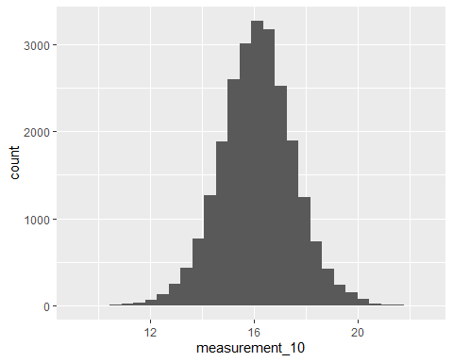
ggplot(train, aes(x=measurement_11)) + geom_histogram()
## `stat_bin()` using `bins = 30`. Pick better value `binwidth`.
## Warning: Removed 1409 rows containing non-finite outside the scale range
## (`stat_bin()`).
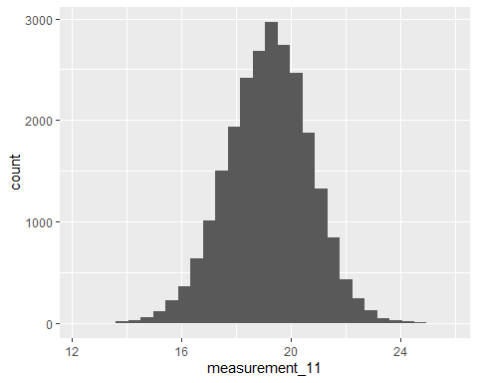
ggplot(train, aes(x=measurement_12)) + geom_histogram()
## `stat_bin()` using `bins = 30`. Pick better value `binwidth`.
## Warning: Removed 1544 rows containing non-finite outside the scale range
## (`stat_bin()`).
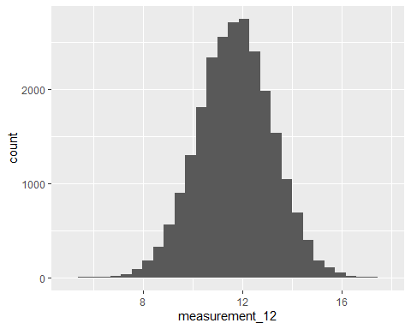
ggplot(train, aes(x=measurement_13)) + geom_histogram()
## `stat_bin()` using `bins = 30`. Pick better value `binwidth`.
## Warning: Removed 1718 rows containing non-finite outside the scale range
## (`stat_bin()`).
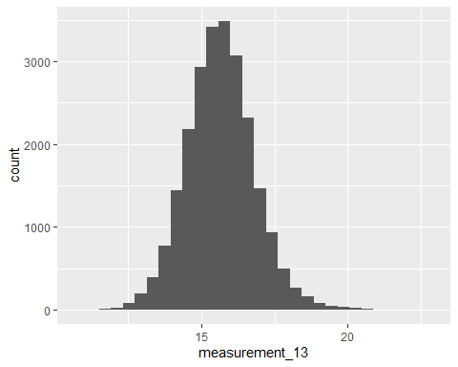
ggplot(train, aes(x=measurement_14)) + geom_histogram()
## `stat_bin()` using `bins = 30`. Pick better value `binwidth`.
## Warning: Removed 1802 rows containing non-finite outside the scale range
## (`stat_bin()`).
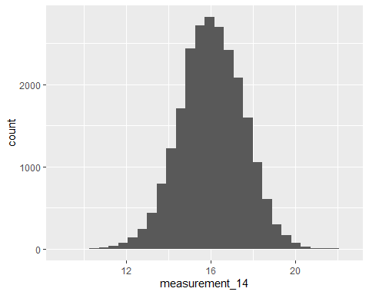
Remove outliers
train = train %>% filter(measurement_14 > 8)
ggplot(train, aes(x=measurement_15)) + geom_histogram()
## `stat_bin()` using `bins = 30`. Pick better value `binwidth`.
## Warning: Removed 1781 rows containing non-finite outside the scale range
## (`stat_bin()`).
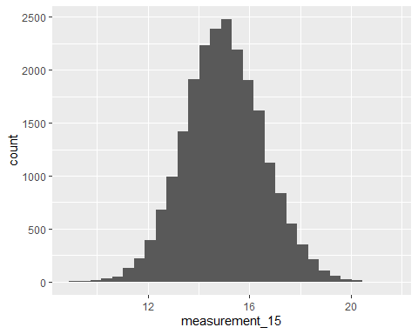 Remove outliers
train = train %>% filter(measurement_15 < 23)
ggplot(train, aes(x=measurement_16)) + geom_histogram()
## `stat_bin()` using `bins = 30`. Pick better value `binwidth`.
## Warning: Removed 1734 rows containing non-finite outside the scale range
## (`stat_bin()`).
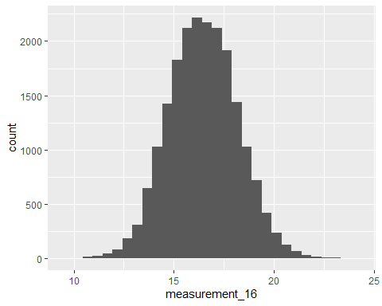
ggplot(train, aes(x=measurement_17)) + geom_histogram()
## `stat_bin()` using `bins = 30`. Pick better value `binwidth`.
## Warning: Removed 1891 rows containing non-finite outside the scale range
## (`stat_bin()`).
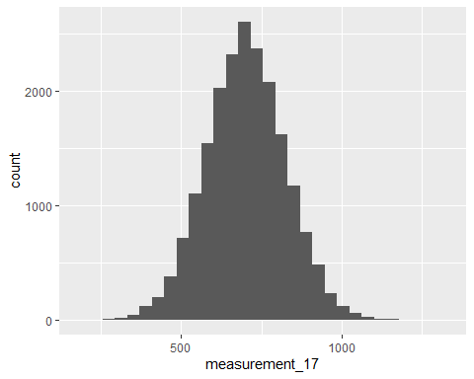
Remove outliers
train = train %>% filter(measurement_17 < 1500)

Impute data into new dataframe
imp = mice(train, m=5, method = "pmm")
##
## iter imp variable
## 1 1 loading measurement_3* measurement_4* measurement_5* measurement_6* measurement_7* measurement_9* measurement_10* measurement_11* measurement_12* measurement_13* measurement_16*
## 1 2 loading* measurement_3* measurement_4* measurement_5* measurement_6* measurement_7* measurement_9* measurement_10* measurement_11* measurement_12* measurement_13* measurement_16*
## 1 3 loading* measurement_3* measurement_4* measurement_5* measurement_6* measurement_7* measurement_9* measurement_10* measurement_11* measurement_12* measurement_13* measurement_16*
## 1 4 loading* measurement_3 measurement_4* measurement_5* measurement_6* measurement_7* measurement_9* measurement_10* measurement_11 measurement_12* measurement_13* measurement_16*
## 1 5 loading* measurement_3* measurement_4* measurement_5* measurement_6* measurement_7* measurement_9* measurement_10* measurement_11* measurement_12* measurement_13* measurement_16*
## 2 1 loading* measurement_3* measurement_4* measurement_5* measurement_6* measurement_7* measurement_9* measurement_10 measurement_11* measurement_12* measurement_13 measurement_16*
## 2 2 loading* measurement_3* measurement_4* measurement_5* measurement_6* measurement_7* measurement_9* measurement_10* measurement_11* measurement_12* measurement_13* measurement_16
## 2 3 loading* measurement_3* measurement_4* measurement_5* measurement_6* measurement_7* measurement_9* measurement_10* measurement_11* measurement_12* measurement_13* measurement_16
## 2 4 loading* measurement_3* measurement_4* measurement_5* measurement_6* measurement_7* measurement_9* measurement_10* measurement_11* measurement_12* measurement_13* measurement_16*
## 2 5 loading measurement_3* measurement_4* measurement_5* measurement_6* measurement_7 measurement_9* measurement_10* measurement_11* measurement_12* measurement_13* measurement_16*
## 3 1 loading* measurement_3* measurement_4* measurement_5* measurement_6* measurement_7* measurement_9* measurement_10* measurement_11* measurement_12* measurement_13* measurement_16*
## 3 2 loading* measurement_3* measurement_4* measurement_5 measurement_6* measurement_7* measurement_9* measurement_10* measurement_11* measurement_12* measurement_13* measurement_16
## 3 3 loading* measurement_3 measurement_4* measurement_5* measurement_6 measurement_7* measurement_9* measurement_10* measurement_11* measurement_12* measurement_13* measurement_16*
## 3 4 loading* measurement_3* measurement_4* measurement_5* measurement_6* measurement_7 measurement_9* measurement_10* measurement_11* measurement_12* measurement_13* measurement_16*
## 3 5 loading* measurement_3* measurement_4* measurement_5* measurement_6* measurement_7* measurement_9* measurement_10* measurement_11 measurement_12* measurement_13* measurement_16
## 4 1 loading* measurement_3* measurement_4* measurement_5 measurement_6* measurement_7 measurement_9* measurement_10* measurement_11 measurement_12* measurement_13* measurement_16*
## 4 2 loading* measurement_3 measurement_4* measurement_5* measurement_6* measurement_7* measurement_9* measurement_10* measurement_11* measurement_12 measurement_13* measurement_16*
## 4 3 loading* measurement_3* measurement_4* measurement_5* measurement_6* measurement_7* measurement_9* measurement_10* measurement_11* measurement_12* measurement_13* measurement_16*
## 4 4 loading* measurement_3* measurement_4* measurement_5* measurement_6* measurement_7* measurement_9* measurement_10* measurement_11 measurement_12* measurement_13* measurement_16*
## 4 5 loading measurement_3* measurement_4* measurement_5* measurement_6* measurement_7* measurement_9* measurement_10* measurement_11* measurement_12* measurement_13 measurement_16
## 5 1 loading* measurement_3* measurement_4* measurement_5* measurement_6* measurement_7* measurement_9* measurement_10* measurement_11 measurement_12* measurement_13* measurement_16*
## 5 2 loading measurement_3* measurement_4* measurement_5* measurement_6* measurement_7* measurement_9* measurement_10* measurement_11* measurement_12* measurement_13* measurement_16*
## 5 3 loading* measurement_3* measurement_4* measurement_5* measurement_6* measurement_7* measurement_9* measurement_10* measurement_11* measurement_12* measurement_13* measurement_16*
## 5 4 loading* measurement_3* measurement_4* measurement_5* measurement_6* measurement_7* measurement_9* measurement_10* measurement_11* measurement_12* measurement_13 measurement_16*
## 5 5 loading* measurement_3* measurement_4* measurement_5* measurement_6* measurement_7* measurement_9* measurement_10* measurement_11* measurement_12* measurement_13* measurement_16
## Warning: Number of logged events: 571
imp_train = complete(imp)

Univariate logistic regressions
summary(glm(failure ~ attribute_2, data = imp_train, family = binomial))
##
## Call:
## glm(formula = failure ~ attribute_2, family = binomial, data = imp_train)
##
## Coefficients:
## Estimate Std. Error z value Pr(>|z|)
## (Intercept) -1.40266 0.08112 -17.292 <2e-16 ***
## attribute_2 0.01285 0.01169 1.099 0.272
## ---
## Signif. codes: 0 '***' 0.001 '**' 0.01 '*' 0.05 '.' 0.1 ' ' 1
##
## (Dispersion parameter for binomial family taken to be 1)
##
## Null deviance: 20684 on 20042 degrees of freedom
## Residual deviance: 20683 on 20041 degrees of freedom
## AIC: 20687
##
## Number of Fisher Scoring iterations: 4
summary(glm(failure ~ attribute_3, data = imp_train, family = binomial))
##
## Call:
## glm(formula = failure ~ attribute_3, family = binomial, data = imp_train)
##
## Coefficients:
## Estimate Std. Error z value Pr(>|z|)
## (Intercept) -1.10362 0.08675 -12.721 <2e-16 ***
## attribute_3 -0.02938 0.01181 -2.488 0.0129 *
## ---
## Signif. codes: 0 '***' 0.001 '**' 0.01 '*' 0.05 '.' 0.1 ' ' 1
##
## (Dispersion parameter for binomial family taken to be 1)
##
## Null deviance: 20684 on 20042 degrees of freedom
## Residual deviance: 20678 on 20041 degrees of freedom
## AIC: 20682
##
## Number of Fisher Scoring iterations: 4
summary(glm(failure ~ measurement_0, data = imp_train, family = binomial))
##
## Call:
## glm(formula = failure ~ measurement_0, family = binomial, data = imp_train)
##
## Coefficients:
## Estimate Std. Error z value Pr(>|z|)
## (Intercept) -1.352099 0.035518 -38.067 <2e-16 ***
## measurement_0 0.004894 0.004150 1.179 0.238
## ---
## Signif. codes: 0 '***' 0.001 '**' 0.01 '*' 0.05 '.' 0.1 ' ' 1
##
## (Dispersion parameter for binomial family taken to be 1)
##
## Null deviance: 20684 on 20042 degrees of freedom
## Residual deviance: 20683 on 20041 degrees of freedom
## AIC: 20687
##
## Number of Fisher Scoring iterations: 4
summary(glm(failure ~ measurement_1, data = imp_train, family = binomial))
##
## Call:
## glm(formula = failure ~ measurement_1, family = binomial, data = imp_train)
##
## Coefficients:
## Estimate Std. Error z value Pr(>|z|)
## (Intercept) -1.265725 0.037831 -33.457 <2e-16 ***
## measurement_1 -0.006104 0.004130 -1.478 0.139
## ---
## Signif. codes: 0 '***' 0.001 '**' 0.01 '*' 0.05 '.' 0.1 ' ' 1
##
## (Dispersion parameter for binomial family taken to be 1)
##
## Null deviance: 20684 on 20042 degrees of freedom
## Residual deviance: 20682 on 20041 degrees of freedom
## AIC: 20686
##
## Number of Fisher Scoring iterations: 4
summary(glm(failure ~ measurement_2, data = imp_train, family = binomial))
##
## Call:
## glm(formula = failure ~ measurement_2, family = binomial, data = imp_train)
##
## Coefficients:
## Estimate Std. Error z value Pr(>|z|)
## (Intercept) -1.368864 0.037128 -36.869 <2e-16 ***
## measurement_2 0.008479 0.005212 1.627 0.104
## ---
## Signif. codes: 0 '***' 0.001 '**' 0.01 '*' 0.05 '.' 0.1 ' ' 1
##
## (Dispersion parameter for binomial family taken to be 1)
##
## Null deviance: 20684 on 20042 degrees of freedom
## Residual deviance: 20682 on 20041 degrees of freedom
## AIC: 20686
##
## Number of Fisher Scoring iterations: 4
summary(glm(failure ~ measurement_3, data = imp_train, family = binomial))
##
## Call:
## glm(formula = failure ~ measurement_3, family = binomial, data = imp_train)
##
## Coefficients:
## Estimate Std. Error z value Pr(>|z|)
## (Intercept) -1.445639 0.307680 -4.699 2.62e-06 ***
## measurement_3 0.007303 0.017254 0.423 0.672
## ---
## Signif. codes: 0 '***' 0.001 '**' 0.01 '*' 0.05 '.' 0.1 ' ' 1
##
## (Dispersion parameter for binomial family taken to be 1)
##
## Null deviance: 20684 on 20042 degrees of freedom
## Residual deviance: 20684 on 20041 degrees of freedom
## AIC: 20688
##
## Number of Fisher Scoring iterations: 4
summary(glm(failure ~ measurement_4, data = imp_train, family = binomial))
##
## Call:
## glm(formula = failure ~ measurement_4, family = binomial, data = imp_train)
##
## Coefficients:
## Estimate Std. Error z value Pr(>|z|)
## (Intercept) -1.19445 0.20255 -5.897 3.7e-09 ***
## measurement_4 -0.01032 0.01718 -0.600 0.548
## ---
## Signif. codes: 0 '***' 0.001 '**' 0.01 '*' 0.05 '.' 0.1 ' ' 1
##
## (Dispersion parameter for binomial family taken to be 1)
##
## Null deviance: 20684 on 20042 degrees of freedom
## Residual deviance: 20684 on 20041 degrees of freedom
## AIC: 20688
##
## Number of Fisher Scoring iterations: 4
summary(glm(failure ~ measurement_5, data = imp_train, family = binomial))
##
## Call:
## glm(formula = failure ~ measurement_5, family = binomial, data = imp_train)
##
## Coefficients:
## Estimate Std. Error z value Pr(>|z|)
## (Intercept) -1.63119 0.27965 -5.833 5.45e-09 ***
## measurement_5 0.01848 0.01634 1.131 0.258
## ---
## Signif. codes: 0 '***' 0.001 '**' 0.01 '*' 0.05 '.' 0.1 ' ' 1
##
## (Dispersion parameter for binomial family taken to be 1)
##
## Null deviance: 20684 on 20042 degrees of freedom
## Residual deviance: 20683 on 20041 degrees of freedom
## AIC: 20687
##
## Number of Fisher Scoring iterations: 4
summary(glm(failure ~ measurement_6, data = imp_train, family = binomial))
##
## Call:
## glm(formula = failure ~ measurement_6, family = binomial, data = imp_train)
##
## Coefficients:
## Estimate Std. Error z value Pr(>|z|)
## (Intercept) -1.77732 0.26498 -6.707 1.98e-11 ***
## measurement_6 0.02651 0.01517 1.747 0.0806 .
## ---
## Signif. codes: 0 '***' 0.001 '**' 0.01 '*' 0.05 '.' 0.1 ' ' 1
##
## (Dispersion parameter for binomial family taken to be 1)
##
## Null deviance: 20684 on 20042 degrees of freedom
## Residual deviance: 20681 on 20041 degrees of freedom
## AIC: 20685
##
## Number of Fisher Scoring iterations: 4
summary(glm(failure ~ measurement_7, data = imp_train, family = binomial))
##
## Call:
## glm(formula = failure ~ measurement_7, family = binomial, data = imp_train)
##
## Coefficients:
## Estimate Std. Error z value Pr(>|z|)
## (Intercept) -1.46672 0.18861 -7.777 7.45e-15 ***
## measurement_7 0.01281 0.01592 0.805 0.421
## ---
## Signif. codes: 0 '***' 0.001 '**' 0.01 '*' 0.05 '.' 0.1 ' ' 1
##
## (Dispersion parameter for binomial family taken to be 1)
##
## Null deviance: 20684 on 20042 degrees of freedom
## Residual deviance: 20684 on 20041 degrees of freedom
## AIC: 20688
##
## Number of Fisher Scoring iterations: 4
summary(glm(failure ~ measurement_8, data = imp_train, family = binomial))
##
## Call:
## glm(formula = failure ~ measurement_8, family = binomial, data = imp_train)
##
## Coefficients:
## Estimate Std. Error z value Pr(>|z|)
## (Intercept) -2.08700 0.32800 -6.363 1.98e-10 ***
## measurement_8 0.04052 0.01720 2.356 0.0184 *
## ---
## Signif. codes: 0 '***' 0.001 '**' 0.01 '*' 0.05 '.' 0.1 ' ' 1
##
## (Dispersion parameter for binomial family taken to be 1)
##
## Null deviance: 20684 on 20042 degrees of freedom
## Residual deviance: 20679 on 20041 degrees of freedom
## AIC: 20683
##
## Number of Fisher Scoring iterations: 4
summary(glm(failure ~ measurement_9, data = imp_train, family = binomial))
##
## Call:
## glm(formula = failure ~ measurement_9, family = binomial, data = imp_train)
##
## Coefficients:
## Estimate Std. Error z value Pr(>|z|)
## (Intercept) -1.214184 0.197542 -6.146 7.92e-10 ***
## measurement_9 -0.008875 0.017219 -0.515 0.606
## ---
## Signif. codes: 0 '***' 0.001 '**' 0.01 '*' 0.05 '.' 0.1 ' ' 1
##
## (Dispersion parameter for binomial family taken to be 1)
##
## Null deviance: 20684 on 20042 degrees of freedom
## Residual deviance: 20684 on 20041 degrees of freedom
## AIC: 20688
##
## Number of Fisher Scoring iterations: 4
summary(glm(failure ~ measurement_10, data = imp_train, family = binomial))
##
## Call:
## glm(formula = failure ~ measurement_10, family = binomial, data = imp_train)
##
## Coefficients:
## Estimate Std. Error z value Pr(>|z|)
## (Intercept) -1.264252 0.182292 -6.935 4.05e-12 ***
## measurement_10 -0.003158 0.011153 -0.283 0.777
## ---
## Signif. codes: 0 '***' 0.001 '**' 0.01 '*' 0.05 '.' 0.1 ' ' 1
##
## (Dispersion parameter for binomial family taken to be 1)
##
## Null deviance: 20684 on 20042 degrees of freedom
## Residual deviance: 20684 on 20041 degrees of freedom
## AIC: 20688
##
## Number of Fisher Scoring iterations: 4
summary(glm(failure ~ measurement_11, data = imp_train, family = binomial))
##
## Call:
## glm(formula = failure ~ measurement_11, family = binomial, data = imp_train)
##
## Coefficients:
## Estimate Std. Error z value Pr(>|z|)
## (Intercept) -1.148486 0.218767 -5.250 1.52e-07 ***
## measurement_11 -0.008717 0.011377 -0.766 0.444
## ---
## Signif. codes: 0 '***' 0.001 '**' 0.01 '*' 0.05 '.' 0.1 ' ' 1
##
## (Dispersion parameter for binomial family taken to be 1)
##
## Null deviance: 20684 on 20042 degrees of freedom
## Residual deviance: 20684 on 20041 degrees of freedom
## AIC: 20688
##
## Number of Fisher Scoring iterations: 4
summary(glm(failure ~ measurement_12, data = imp_train, family = binomial))
##
## Call:
## glm(formula = failure ~ measurement_12, family = binomial, data = imp_train)
##
## Coefficients:
## Estimate Std. Error z value Pr(>|z|)
## (Intercept) -1.302677 0.122864 -10.603 <2e-16 ***
## measurement_12 -0.001119 0.010507 -0.107 0.915
## ---
## Signif. codes: 0 '***' 0.001 '**' 0.01 '*' 0.05 '.' 0.1 ' ' 1
##
## (Dispersion parameter for binomial family taken to be 1)
##
## Null deviance: 20684 on 20042 degrees of freedom
## Residual deviance: 20684 on 20041 degrees of freedom
## AIC: 20688
##
## Number of Fisher Scoring iterations: 4
summary(glm(failure ~ measurement_13, data = imp_train, family = binomial))
##
## Call:
## glm(formula = failure ~ measurement_13, family = binomial, data = imp_train)
##
## Coefficients:
## Estimate Std. Error z value Pr(>|z|)
## (Intercept) -1.07053 0.19139 -5.594 2.22e-08 ***
## measurement_13 -0.01543 0.01201 -1.285 0.199
## ---
## Signif. codes: 0 '***' 0.001 '**' 0.01 '*' 0.05 '.' 0.1 ' ' 1
##
## (Dispersion parameter for binomial family taken to be 1)
##
## Null deviance: 20684 on 20042 degrees of freedom
## Residual deviance: 20683 on 20041 degrees of freedom
## AIC: 20687
##
## Number of Fisher Scoring iterations: 4
summary(glm(failure ~ measurement_14, data = imp_train, family = binomial))
##
## Call:
## glm(formula = failure ~ measurement_14, family = binomial, data = imp_train)
##
## Coefficients:
## Estimate Std. Error z value Pr(>|z|)
## (Intercept) -1.461007 0.188026 -7.770 7.83e-15 ***
## measurement_14 0.009052 0.011654 0.777 0.437
## ---
## Signif. codes: 0 '***' 0.001 '**' 0.01 '*' 0.05 '.' 0.1 ' ' 1
##
## (Dispersion parameter for binomial family taken to be 1)
##
## Null deviance: 20684 on 20042 degrees of freedom
## Residual deviance: 20684 on 20041 degrees of freedom
## AIC: 20688
##
## Number of Fisher Scoring iterations: 4
summary(glm(failure ~ measurement_15, data = imp_train, family = binomial))
##
## Call:
## glm(formula = failure ~ measurement_15, family = binomial, data = imp_train)
##
## Coefficients:
## Estimate Std. Error z value Pr(>|z|)
## (Intercept) -1.15583 0.16785 -6.886 5.73e-12 ***
## measurement_15 -0.01066 0.01114 -0.957 0.339
## ---
## Signif. codes: 0 '***' 0.001 '**' 0.01 '*' 0.05 '.' 0.1 ' ' 1
##
## (Dispersion parameter for binomial family taken to be 1)
##
## Null deviance: 20684 on 20042 degrees of freedom
## Residual deviance: 20683 on 20041 degrees of freedom
## AIC: 20687
##
## Number of Fisher Scoring iterations: 4
summary(glm(failure ~ measurement_16, data = imp_train, family = binomial))
##
## Call:
## glm(formula = failure ~ measurement_16, family = binomial, data = imp_train)
##
## Coefficients:
## Estimate Std. Error z value Pr(>|z|)
## (Intercept) -0.238645 0.149064 -1.601 0.109
## measurement_16 -0.065214 0.009005 -7.242 4.42e-13 ***
## ---
## Signif. codes: 0 '***' 0.001 '**' 0.01 '*' 0.05 '.' 0.1 ' ' 1
##
## (Dispersion parameter for binomial family taken to be 1)
##
## Null deviance: 20684 on 20042 degrees of freedom
## Residual deviance: 20631 on 20041 degrees of freedom
## AIC: 20635
##
## Number of Fisher Scoring iterations: 4
summary(glm(failure ~ measurement_17, data = imp_train, family = binomial))
##
## Call:
## glm(formula = failure ~ measurement_17, family = binomial, data = imp_train)
##
## Coefficients:
## Estimate Std. Error z value Pr(>|z|)
## (Intercept) -1.7219037 0.1008591 -17.072 < 2e-16 ***
## measurement_17 0.0005773 0.0001407 4.103 4.07e-05 ***
## ---
## Signif. codes: 0 '***' 0.001 '**' 0.01 '*' 0.05 '.' 0.1 ' ' 1
##
## (Dispersion parameter for binomial family taken to be 1)
##
## Null deviance: 20684 on 20042 degrees of freedom
## Residual deviance: 20667 on 20041 degrees of freedom
## AIC: 20671
##
## Number of Fisher Scoring iterations: 4

Full logistic regression table
model <- glm(failure ~ ., data = imp_train, family = binomial)
summary(model)
##
## Call:
## glm(formula = failure ~ ., family = binomial, data = imp_train)
##
## Coefficients: (5 not defined because of singularities)
## Estimate Std. Error z value Pr(>|z|)
## (Intercept) -5.482e-01 1.075e+00 -0.510 0.61000
## id 5.408e-06 1.137e-05 0.476 0.63435
## product_codeB -1.921e-01 8.674e-02 -2.215 0.02675 *
## product_codeC -1.561e-01 1.359e-01 -1.149 0.25071
## product_codeD -1.820e-01 1.944e-01 -0.936 0.34911
## product_codeE -2.436e-01 2.511e-01 -0.970 0.33192
## loading 7.047e-03 4.228e-04 16.668 < 2e-16 ***
## attribute_0material_5 NA NA NA NA
## attribute_1material_5 NA NA NA NA
## attribute_1material_6 NA NA NA NA
## attribute_2 NA NA NA NA
## attribute_3 NA NA NA NA
## measurement_0 8.831e-04 4.631e-03 0.191 0.84876
## measurement_1 -6.815e-04 4.808e-03 -0.142 0.88728
## measurement_2 1.298e-02 5.541e-03 2.343 0.01915 *
## measurement_3 2.563e-03 1.758e-02 0.146 0.88407
## measurement_4 -2.237e-02 1.811e-02 -1.235 0.21666
## measurement_5 -1.890e-02 1.992e-02 -0.949 0.34275
## measurement_6 2.708e-03 1.674e-02 0.162 0.87152
## measurement_7 -8.684e-03 1.799e-02 -0.483 0.62922
## measurement_8 -2.057e-03 2.257e-02 -0.091 0.92739
## measurement_9 -1.869e-02 1.779e-02 -1.051 0.29347
## measurement_10 -4.225e-03 1.139e-02 -0.371 0.71067
## measurement_11 -5.533e-03 1.177e-02 -0.470 0.63820
## measurement_12 2.820e-03 1.091e-02 0.258 0.79603
## measurement_13 -7.510e-03 1.226e-02 -0.613 0.54007
## measurement_14 -6.466e-04 1.188e-02 -0.054 0.95659
## measurement_15 -7.553e-04 1.164e-02 -0.065 0.94826
## measurement_16 -6.421e-02 9.256e-03 -6.937 4.01e-12 ***
## measurement_17 7.139e-04 2.358e-04 3.028 0.00246 **
## ---
## Signif. codes: 0 '***' 0.001 '**' 0.01 '*' 0.05 '.' 0.1 ' ' 1
##
## (Dispersion parameter for binomial family taken to be 1)
##
## Null deviance: 20684 on 20042 degrees of freedom
## Residual deviance: 20319 on 20018 degrees of freedom
## AIC: 20369
##
## Number of Fisher Scoring iterations: 4
tidy(model) %>%
arrange(p.value)
## # A tibble: 30 × 5
## term estimate std.error statistic p.value
## <chr> <dbl> <dbl> <dbl> <dbl>
## 1 loading 0.00705 0.000423 16.7 2.24e-62
## 2 measurement_16 -0.0642 0.00926 -6.94 4.01e-12
## 3 measurement_17 0.000714 0.000236 3.03 2.46e- 3
## 4 measurement_2 0.0130 0.00554 2.34 1.92e- 2
## 5 product_codeB -0.192 0.0867 -2.22 2.67e- 2
## 6 measurement_4 -0.0224 0.0181 -1.24 2.17e- 1
## 7 product_codeC -0.156 0.136 -1.15 2.51e- 1
## 8 measurement_9 -0.0187 0.0178 -1.05 2.93e- 1
## 9 product_codeE -0.244 0.251 -0.970 3.32e- 1
## 10 measurement_5 -0.0189 0.0199 -0.949 3.43e- 1
## # ℹ 20 more rows

