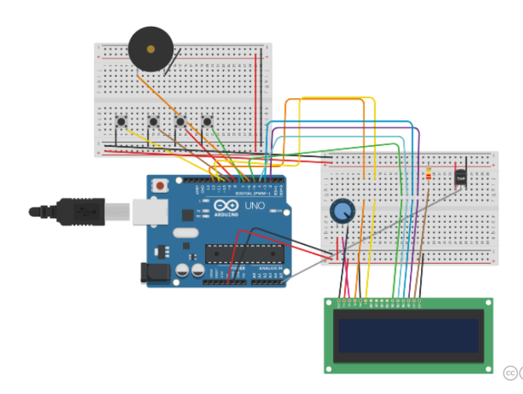**Digital Clock**

**Deniz Bulmuş 1613528**

Liquid crystal lcd is the code that initialize the library with the numbers of the interface pins.

showTime(); , showTemp(); , showAlarm(); , changeTime(); , initialTime = millis(); is the display function.

handleButtons(); to handling the buttons. And in this function with if else statement we also test if the buttons work or not and it takes 3 seconds. We test every single button.

Button 1 sets the time. Button 2 Sets alarm. Button 3 shows the temperature and the button 4 stops the timer and alarm.

In Void Showtime function we set the format for the clock and in this function we set hours and minutes and we also set cursor and display the time.

In float temperature function we have float voltage for converting that temperature to voltage, float temperatureC for calculating the temperature and then float temperatureF for converting it to fahrenheit.

void showAlarm() in this function we set the alarm we have variables for setting alarm active abd if alarm is not set it will say no al. void playAlarm() is for alarm to ring in the exact time.

void changeTime() it counts the seconds minutes and hours.

void setTime() this is the first set time function.