Level Design Document

Snowfreaks : Office version

Level Name: Office

PS: I couldnt put the lights so you can see the Project in unlit state.

**Overview**

* **Introduction**

Office is the main level of this game, where characters are trapped in the Office and trying to get out of the Office.The spirit of old Office member dies in an snowball fight by breaking his neck and back for revenge. Trying to get out of the Office building and its surroundings before spirit kills you is the main task of the game.

* **Level** **Overview**

In the Office level players will experience dark and supressed atmosphere with a bit dark humour. This level will be introduced for Windows 10 and ps4, where players can buy it from steam or epic games .There will be one boss and some jumpscares.Office will be exactly like modern offices we usually see and it will be haunted by a former office member spirit. Players will experience horror in the best way possible.

* **Concept**

The main concept of the Office level is being alone at night where player usually stays but slowly being aware of the strange entity and paranormal encounters also it attacks the player.Being in somewhere players usually stay even if it is dark can probably give them some secure feeling and what they wont expect is when they will get attacked by the spirit with snowballs that containts that something destroys the player in the moment.  Level will have 3D and also 2D models. Office will challenge players to discover and survive.

* **Narrative**

A former Office member named Felix Kjelberg has been brutally murdered in Office building in 20 December 2018. They found his body in a bizarre condition in entrance corridor. The autopsy report said that he was burnt with acid which is mixed with water in several places on his body and the fatal impact on his body was an ice pick to his forehead which pierced him and it pinned him to the wall it was so horrifying that the janitor who found his body is still in threapy because of this bizaree incident felix haunts the building at night and attacks people who works on night shift with acidic snowballs and ice pick if you survive you must not talk about the inciden tor felix will choke you to death while you sleep. Because of this rule of the haunting no body knew what was happening but now you will surely be aware since you are on night shift today survive till morning and be careful he will attack you when you dont expect him to do so…

* **Gameplay**
* Wake up on 3rd floor on your desk, phone rings and pick up the phone
* Narrative will warn you with small cinematic of the death day of Felix
* Players can go into other rooms as an optional path
* This level is medium size and medium difficulty
* Enemies have similar AI

Enemies are classed into 2 different one which goes boss and medium ones

* After surviving till morning 6:00 AM, players are rewarded with cinematics
* 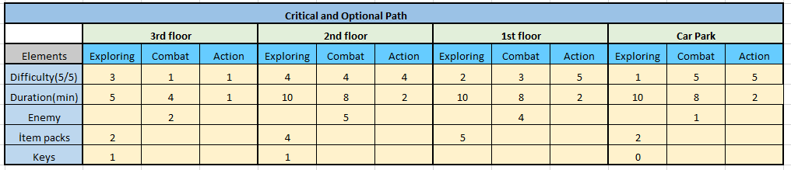**Critical** **&** **Optional** **Path** **Beat** **Chart**
* 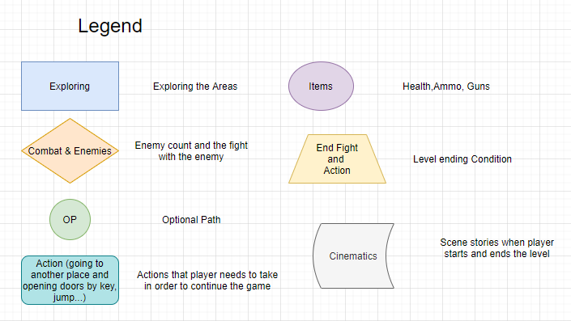**Flow Chart**

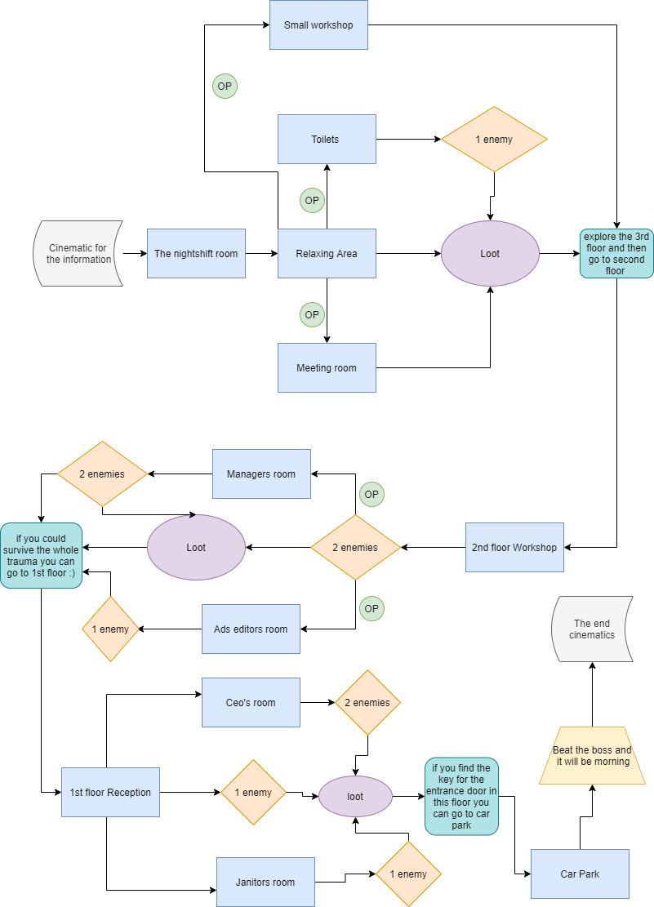

* 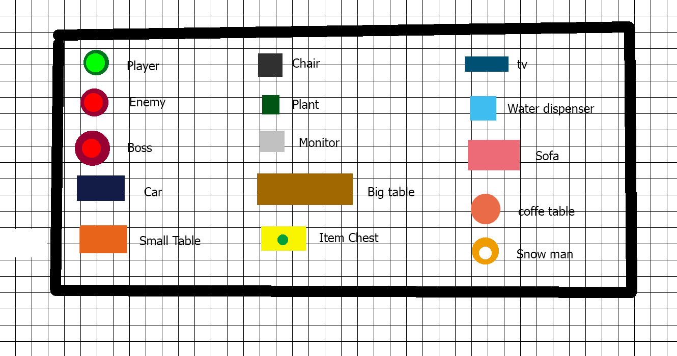**Layout plan**

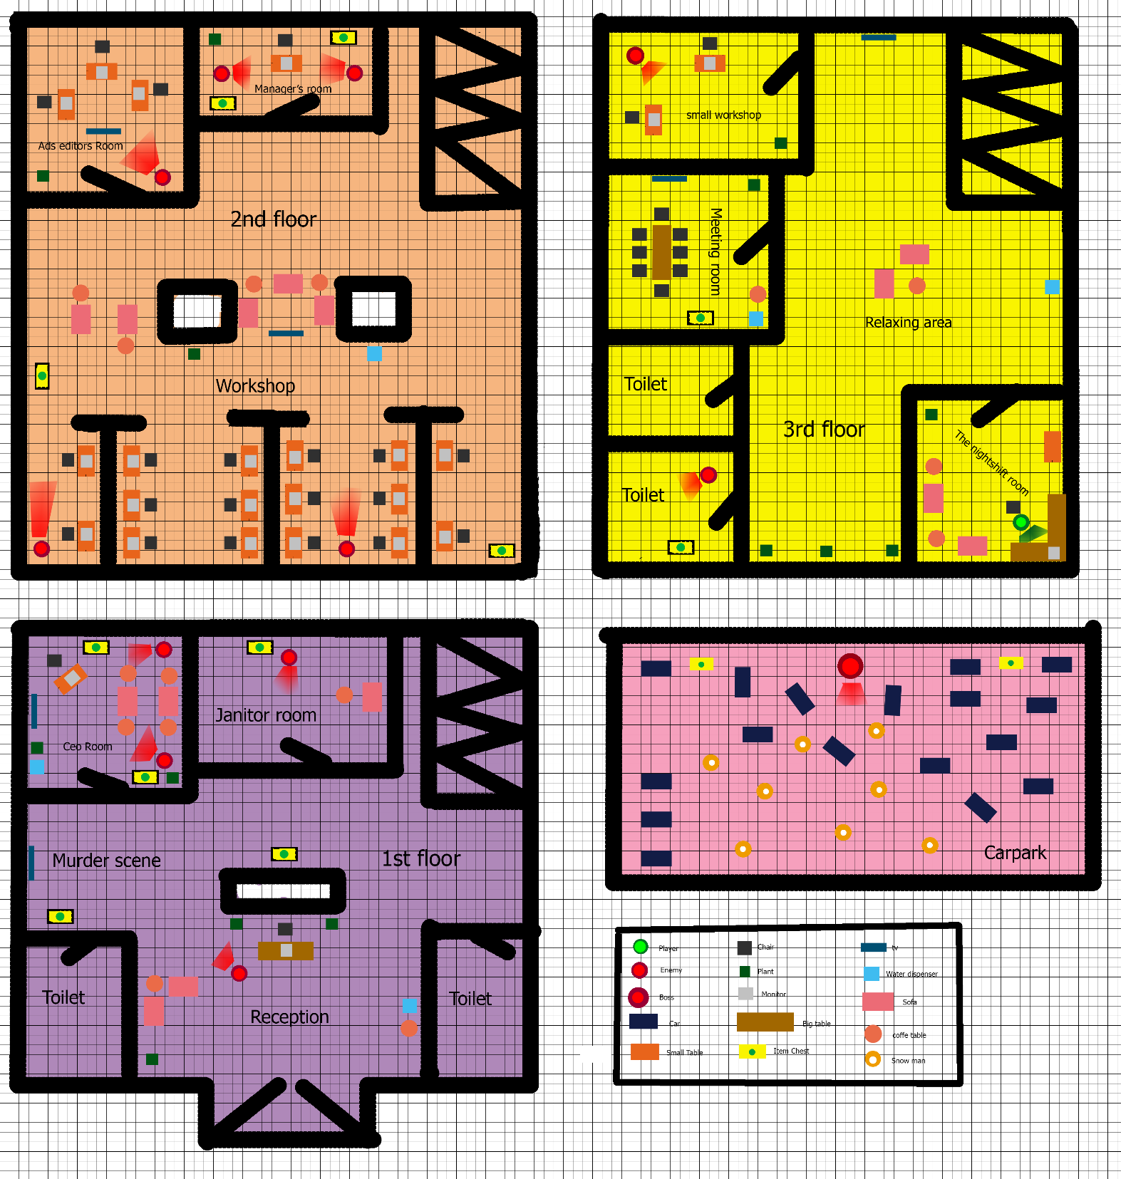

* **Objectives and Challenges**
* **Nightshift room and Relaxing area**

First of all players will get a brief info about the task in Nightshift room. After that they will take the Relaxing area route to decide which room they want to start searching some weapons and keys for the 2nd floor and while looking for those loots they will experience some jump scares. Players can use furnitures and doors for their strategies in the game. For the begining except small workshop and toilet players wont face the enemy. By this it is aimed to make the player feel more comfortable and adapted as well expect the unexpected. Relaxing area is decision route for making the players find out the right path which would help them.

**-Small Workshop**

Small Workshop is an optional path that have 1 jumpscare in it. It is guarded with 1 enemy. It has no loot. Just a trap room.

**-Meeting Room**

Meeting room has no enemies and It has loot in one of them with snowball gun ,flashlight and snow crystal in it.

**-Toilets**

This room has one enemy and there is a loot with 2nd floor key in it that players have to obtain before going to second floor. If players dont obtain these they will die and will have to restart the game so obtaining this loot is compulsory.

**Critical Path**

* Enter the relaxing area
* Explore and find the right room with weapons in it
* Proceed to eliminate enemies
* Collect items and key
* Find a way to go to second floor

**Optional path**

* Enter the relaxing area
* Enter Meeting room
* Obtain the gun loot
* Eliminate enemies that are in small workshop
* Enter the toilet
* Eliminate enemies
* Get the key
* Go to 2nd floor
* **2nd Floor and Workshop**

2nd floor workshop is the widest hall of the game, where workers spend their time mostly. Players won’t be able to see the enemy in the hall, because they will be waiting and facing their back to the wall and as soon as player go close to them enemies will attack them suddenly. This part of the game is hard and players have to be careful about their room choices.2nd floor also have ads editors room as trap room if player goes there with no weapons he will end up dying and restarting. 2nd floor has 5 enemies in it 4 loots and 1 key to 1st floor. This part has more items for crafting your snowball gun and snow crystal. This will challenge players against the enemies. Because if you dont make your gun stronger in this level enemies can kill you.

**-Ads editors room**

Ads editors room is an optional path. Players have plenty objects to hide behind from the enemy(jumpscare) and dodge the attacks. This room has only 1 enemy.

**-Manager’s room**

Managers room is critical path because it has key to the 1st floor in one of the loots in the room. This room contains 2 loots and 2 enemies. The enemies are both facing to the players and when they attemp to leave the room with the key they will start attacking to the player and there will be an exciting chase.

**Critical Path**

* Get to the second floor workshop.
* Eliminate enemies that are in sight..
* Explore the workshop for loots .
* Enter the managers room .
* Improve your weapons and get the 1st floor key.
* Eliminate enemies that are in sight.
* Go to the 1st floor.

**Optional Path**

* Get to the second floor workshop.
* Eliminate enemies that are in sight..
* Explore the workshop for loots .
* Enter the Ads editors room.
* Eliminate the enemy on sight.
* Enter the managers room.
* Get the key and loots
* Eliminate enemies that in sight.
* Go to the 1st floor.
* **1st floor, Reception and murder scene**

1st floor, reception and murder scene is the part that you can get more information of the murder and the boss enemy’s story which will make player think about some strategy for the boss fight. Players can enjoy this brief cinematics about the murder and after that they can start searching for the building key which will led them to carpark for the boss fight. There is 4 enemies and 5 loots in total which will make the player ready for the boss fight and exit the building. If player didnt clear the first enemy in the reception and obtain the loots entering the other rooms will ending up players death.

**-Janitors room**

There will be only one jumpscare and a loot with the building key. Classical Janitor room with cleaning materials in it with small resting area for the janitor.

**-Ceo room**

This room probably the most classy room in the game. This room has two enemies looking like snowman and unless player go closer to them they will not move. There will be 2 loots with stronger weapon and some items to make the final weapon ready for the boss.

**-Toilets**

These rooms are for hiding from the enemies till they calm down and then player can attack them back with new strategies. Player can save the game in the empty toilets.

**Critical Path**

* Explore the 1st floor.
* Get the closest loot.
* Go to the murder scene.
* Cinematics.
* Get the loot.
* Eliminate the enemy in sight.
* Go to the Janitor room.
* Obtain the building key.
* Go to the CEO room.
* Eliminate the Enemies.(Player can hide in toilets while attack).
* Go to carpark.
* **CARPARK (BOSS LEVEL)**

There are many places to hide and run at this point. It is the final fight so enemy has much power and health if the player didnt get all the loots the fight will be harder for them. There will be a lot of snowman and cars and if they get the loots there can upgrade their gun and they can improve their health. If the players beat the boss they will reach the morning and win the game. There will be cinematics to show to player that they won the game.