Examining a Quarter Century of Publishing Trends in Social Work Research: A Data Science Perspective

### Data Revolution

It is estimated that 90% of all the data in human history has been generated in the past two years, and the amount of data continues to grow by roughly 2.5 quintillion bytes every day [(IBM, nd-a)](http://www-01.ibm.com/software/data/bigdata/what-is-big-data.html). We have unprecedented opportunities for deriving actionable insights from these data to advance the human condition. The significance continues to gain the attention of national and international organizations. For example, the Independent Expert Advisory Group (IEAG) of the United Nations prepared a report entitled, *A World That Counts: Mobilising the Data Revolution for Sustainable Development* [(IEAG, 2014)](http://www.undatarevolution.org/report/). The IEAG (2014) argues that "Data are the lifeblood of decision-making and the raw material for accountability. Without high-quality data providing the right information on the right things at the right time; designing, monitoring and evaluating effective policies becomes almost impossible" (p. 2). The United States federal government established an open data initiative, motivated by the awareness that data can have the greatest impact when it is "accessible, discoverable, and usable" [(www.data.gov)](www.data.gov). Data from all levels of government that is made completely open can lead to "cost savings, efficiency, fuel for business, improved civic services, informed policy, performance planning, research and scientific discoveries, transparency and accountability, and increased public participation in the democratic dialogue" (www.data.gov). At the time of preparing this article, over 124,000 data sets were freely available through www.data.gov among a diverse set of topic areas: agriculture, business, climate, consumers, ecosystems, education, energy, finance, health, local government, manufacturing, ocean studies, public safety, and science and research.

In 2012, the NIH established the Big Data to Knowledge (BD2K) initiative, recognizing the potential of data to advance our understanding of human health and disease. This initiative was designed to support four broad goals: 1) to facilitate use of biomedical digital assets by making them discoverable, accessible, and citable; 2) to conduct research and develop methods, software and tools to analyze biomedical big data; 3) to enhance training in the development of use and tools necessary for biomedical big data science; and 4) to support a data ecosystem that accelerates discovery as part of the digital enterprise (NIH). At roughly the same time, the National Science Foundation (NSF) created new initiatives to harness the potential of the data revolution, arguing that "data are motivating a profound transformation in the culture and conduct of scientific research in every field of science and engineering ... American scientists must rise to the challenges and seize the opportunities afforded by this new, data-driven revolution" (Suresh, XXX). The programs of the NSF are organized around capacity building and innovative applications. Capacity building activities focus on developing fundamental theories, techniques, methodologies and technologies that are broadly applicable to big data problems. Innovative applications relate to specific domains advancing innovative ideas that provide solutions “with potential for a broader impact on data science and its applications.”

### Data Science and Social Work

We are indeed living in a data revolution. The relevance to social work research is clear — we have the opportunity to study human behavior and other social phenomena in real time, with vastly improved reliability in our measurements, and at scale. Data comes from a wide range of sources, including (but not limited to) social media interactions, electronic medical records, audio and video recordings, click stream data, transaction data, web logs, embedded sensors, and GPS. New tools allow blending of data sets, unique ways to analyze data, and methods of visualizations that can produce insights limited only by one's imagination. As stated by the NIH, "lack of appropriate tools, poor data accessibility, and insufficient training, are major impediments to rapid translational impact" in this new era of data. It is essential that the field of social work fully embraces the data revolution and considers the extent to which the existing research infrastructure and training is preparing both social work researchers and providers to be effective and efficient in a data rich world. The potential of the data revolution is reflected in the current *Grand Challenge* entitled, “Harness technology for social good.” However, we believe that the data revolution goes beyond this single *Grand Challenge* as it provides the opportunity to be informative in all areas of social work research.

Data science serves as a useful framework for broadening the existing research infrastructure and training opportunities within social work. Data science is similar to traditional academic research, as it includes the key roles of substantive expertise and traditional research methodologies. Much of the theoretical basis comes from the field of statistics (Zumel & Mount, 2014), but the famous statistician William Cleveland argued that it is an interdisciplinary field that is much larger than statistics (Cleveland, XXX). A major difference is that data science draws heavily from knowledge in the areas of computer science, software engineering, and information technology. Unlike traditional academic research, data science is particularly well suited for tackling the *3 V’s* of big data: *volume*, *variety*, and *velocity*. More specifically, in data-rich environments, researchers encounter an amount or volume of data that often exceeds the capacity of traditional database systems. Data also come in a variety of formats, ranging from highly structured data contained in relational databases to massive stores of unstructured text-data culled from social media. Many data opportunities go beyond the traditional approach of downloading a dataset and analyzing it with an off-the-shelf statistical package like SPSS, Stata, or SAS. Now, data can be accessed in real time through application program interfaces (API), which brings along the challenge of *velocity* — that is, data can be transmitted at a rate that grossly exceeds the computing power of desktop computers. These are practical challenges that need to be addressed in order to maximize the potential of these new data.

Another feature that distinguishes data science from traditional academic research is the focus on generating *actionable insights* from data rather than theory building and hypothesis testing. In fact, data science is more interested in deriving useful insights from correlational patterns as opposed to uncovering causal mechanisms. The focus is on the development of data products (Davenport, XXX), as opposed to reporting analysis. Data products are tools or services that generate actionable insights from the data itself, including (but not limited to) automated reports or dashboards, recommendation systems, prediction algorithms, decision tools, and interactive visualizations that help people with non-technical background make sense of complex data. Data science also values the philosophy of *openness* or open science. Thus, much effort is devoted to creating sustainable systems that make data as widely and freely accessible as possible, and developing and promoting the use of open source tools for managing and analyzing data. The concept of reproducible research is a *rule* rather than the *exception*. This involves making both data and statistical code available alongside research reports. This helps ensure the quality of the research, in addition to allowing researchers to make advances without having duplicate work that has already been done. Data science is by no means incompatible with traditional academic research. We believe that the tools, research strategies, and principles of data science are complementary to traditional ways of knowledge building in social work, offering many unique opportunities to improve the quality, efficiency, and impact of this area of research.

### Overview of Current Study

In the current study, we seek to utilize the opportunities of the data revolution and data science by applying a range of tools and strategies to construct an historical base of social work research. In doing so we take on two of the 3 Vs of big data: volume due the amount of data collected and variety in terms of the multiple sources of that data. The data are article records harvested from existing bibliographic databases hosted on ProQuest and EbscoHost. Article records are already widely used in various bibliometric studies, particularly those that are intended to reveal publication networks within scientific communities. It does so by creating links between co-authors, and then visually representing the edges and vertices of the network. This is also done with article citation histories, to show influence over time. In this study, we were interested in the various article meta-data that are common to many scientific article records. For example, a single article record in psycINFO can have as many as XX pieces of meta-data including: dates, journal titles, article titles, author names, author affiliations, full text abstracts, keywords, subject classification, methodology, location, populations, page numbers, and source of funding. This is a rather large amount of information about a single paper, at least compared to the amount of information contained in article records before the availability of electronic storage and access. Large collections of article records may contain potentially interesting trends in the research, assuming the selection of the article records were conducted in a way that allowed meaningful inferences to be derived.

In the current study, we sought to capture every journal article record published in every social work journals over the in past quarter century (1989-2013) and to explore the various meta-data to uncover potentially interesting trends in the social work scholarship. For example, we can reasonably infer estimates of the *size* of social work scholarship by counting the number of unique article records. And, growth of the field can be inferred by examining the number of article records over time. Similarly, we examine the extent to which *team science* has become part of the research practice, as this has implications for training of social work researchers. We also use location meta-data to understand the extent to which different areas of the world have and have not been the focus of social work research. Finally, we used topic modeling to extract topic areas that define the focus of social work research. The execution of this research was grounded in the tools and values of data science. Thus, all data were managed and analyzed using the open source software, R. We also used an open source authoring system that integrates the statistical analysis with the text of the manuscript. Along with this manuscript, the authors will also release the actual data and statistical code, thereby meeting the requirements of *reproducible research*, as defined by King (). To our knowledge, this is the first time fully reproducible research (as defined by King, XXXX), has been published in a social work journal.

Davenport: <http://blogs.wsj.com/cio/2014/06/25/so-you-want-to-build-a-data-product/>

<http://www.nsf.gov/pubs/2015/nsf15544/nsf15544.htm>

<http://www.nsf.gov/news/news_summ.jsp?cntn_id=123607&org=NSF&from=news>

# Methods

### Extraction of article records

Our list of social work journals was guided by the work of Hodge and Lacasse (2011). More specifically, Hodge and Lacasse (2011) identified 84 disciplinary social work journals based on a variety of sources, including *An Author’s Guide to Social Work Journals* (NASW Press, 1997), Thyer’s (2005) more recent listing of social work periodicals, and Genamics JournalSeek (<http://journalseek.net/>). Hodge and Lacasse (2011) examined the mission and aims of each journal, and eliminated journals that were specific to another field or had an had an inter-disciplinary focus. For the current study, our primary search query included all journal titles in this list.

To help ensure comprehensive coverage of all possible core social work journals, we created a supplemental search query that extracted journal titles with any of the following terms:

* "social work"
* "social welfare"
* "social casework"
* "social service"
* "human service"
* "social development"
* "social environment"

Using this search queries, we extract journal article recrods from three major databases on the EbscoHost platform: PsycINFO, Social Service Abstracts, and Social Work Abstracts. Because of known gaps in indexing in databases (Holden, Barker, Kuppens, Rosenberg & LeBreton, 2014; Holden, Barker, Covert-Vail, Rosenberg, & Cohen, 2009), we also searched ProQuest, which linked to an additional 46 minor databases, including (but not limited to): ERIC, Sociological Abstracts and Worldwide Political Science Abstracts. In every search, we used a filter in attempt to extract only article records that were classified as *journal articles*, thereby excluding other forms of scholarly communication that was not relevant to the current study (e.g., book reviews, editorials, obituaries, etc.). We limited the timeframe to a 25 year period, from 1989 to 2013 (inclusive). Articles published in years 2014 and 2015 were excluded because of delays in indexing. Search results were exported in batches of article records based on the restrictions of the platform. Article records were text files in a *generic bibliographic format*. The article records contained various meta-data based on the database from which the article record was extracted. Meta-data include (but are not limited to): article title, journal title, publication year, author name(s), author affiliation(s), abstract, keywords, methodological classification, funding source, location of study, subject groups, digital object identifier (DOI), number of references, number of pages, etc. These files were post-processed into a structured database using a set of scripts written in the R statistical programming language. The initial search resulted in 38,251 article records from 123.

The search queries were purposefully specified to be overly inclusive to ensure full coverage of all possible social work journals contained in the major and minor databases. Additionally, a visual inspection of the article records revealed problems in the original indexing of articles that requires subsequent data cleaning. Thus, our data cleaning procedures focused separately on journal titles and article records.

### Data cleaning: Journal titles

The first step of data cleaning involved fixing journal title names due to discrepant errors in indexing. For example, *Journal of Gay and Lesbian Social Services* was indexed as a journal separate from *Journal of Gay & Lesbian Social Services* (use of "and" vs. "&"). Other examples involved journals indexed with and without subtitles, or journals with and without the word "The" at the beginning of the title. Additionally, some journals changed titles over their history. For example, *Journal of Technnology in Human Services* is formerly known as *Computers in Human Services*. In these situations, the former titles were merged with the current titles.

Many journals from allied health disciplines used one of the supplemental search terms in special editions, which were also included in the journal title. Thus, many non-social work journals were captured in the extraction process. To resolve this issue, we created a list of all journal titles that were not part of the core list defined by Hodge and Lacasse (2011). Study authors reviewed these journal titles and discussed whether each candidate title should be retained or excluded. When disagreements occurred, the study authors reviewed the mission and aims of the journals, names of editorial board members, and focus of the articles. A consensus was reached on all journal titles to be excluded and retained. After these procedures, the number of article records and journal titles was reduced to 37,046 and 82.

### Data cleaning: Article records

Our search procedures involved the use of three major databased and 46 minor databases, which resulted in some duplication of article records. Thus, a matching algorithm was constructed to identify and remove all duplicate article records. As previously noted, the filtering of only journal articles was not successful due to errors in the original indexing. Thus, other scholarly communications were captured in the extractio process. These other scholarly communications were readily identified due to specific patterns in the titles, such as the terms "Book Review," "From the Editor," and "Obituary." Given the number of article records in the database, it was not feasbile to manually extract these recrods. Instead, we created a separate database with representative examples of article records that we wanted to extract. We also added representative examples of article records to be retained. We then wrote a series of *regular expressions* to extract the problematic article records. Regular expressions are a sequence of characters that form search patterns, allowing extraction of records that match the specified pattern. In other words, it is a more sophisticated implementation of the search function common to all major word processors. We tested our regular expressions on the test database, achieving > 95% accuracy with regard to retaining and extracting article records. These regular expressions were then applied to the full database. We then excluded article records if they were missing essential meta-data, including author name(s), journal title, article title, and publication field. As an additional requirement, we required all articles to be $≥3$ pages in length. Finally, we eliminated all social work journals with total article counts of < 10 for the entire 25 year window (*Issues in Social Work Education*, *Maatskaplike Werk/Social Work*, *Pediatric Social Work*, and *Critical Social Work*). These cleaning procedures resulted in a final database of 32,105 articles and 78 journals.

### Data quality checks

We performed a variety of checks on the final database. Because the size of the database, it was not feasible to manually inspect all records. Thus, we randomly sampled article records from the database and cross-checked the data we procured with the information listed with the journal's homepage. We also inspected a scatter plot of the number of article records for each journal by the number of years the journal appeared within the 25 window timeframe. Journals that exhibited significant deviation from the regression line were inspected to ensure that our cleaning procedures did not systematically exclude article records or retain other scholarly communications. All observed discrepancies were verified as differences in journals actual publication output. Finally, we also made checks of number of journal article records for various journals indexed in the *Web of Science*. Although the counts were close -- i.e., within 10% -- similar indexing problems observed from our record extraction were also observed in the *Web of Science* database, such as misclassification of book reviews as journal articles. Thus, we are unable to quantify the actual amount of error in our database is due to problems in indexing. At the same time, we are relying on the same source of data that social work researchers use to inform their work. Too much cleaning and post-processing of the search results can give rise to validity issues because social work researchers are using an information source that contain the errors we have attempted to eliminate. The issue of reliability and validity are given further attention in the discussion section of this study.

### Analyses

# Results

### Journal summary

The study was restricted to a 25-year timeframe, 1989 (inclusive) to 2013 (inclusive). Table 1 provides a summary of all the journals contained in the database, the years of inclusion, number of articles present, and whether the journal was included on the list of disciplinary journals defined by Hodge and Lacasse (2011). Appendix A provides a summary of journals on the list of Hodge and Lacasse that were not included in this historical database (N = 14). A total of 4 journals were excluded because they had only 1 or 2 article records (see Appendix A). Otherwise, all other journals met the minimum requirement of at least 20 article records. It is important to note that the years of inclusion in the database may not be fully consistent with the actual output of the journal for the given timeframe. The possible discrepancies are accounted due to delays and errors of indexing, which is a known and longstanding problem in social work research (see Holden; Holden). The problems associated with indexing are reviewed in further detail in the discussion section of this article.

25 journals were represented across all 25 years. The mean number of years of inclusion is 16.14 7.95. Figure 1a provides a graphical summary of the number of journal titles for each year over the 25 year study period. The first year of the study period contained XX journals, and the maximum number of articles was observed for the years XX. The decline in years 2012 to 2013 may be an artifact due to indexing, given that some journals were still in existence but article records could not be obtained (e.g., XXXX).

### Article summary

The historical database includes 32,107 overr the 25 year period (see Table 1). The average number of articles per journal was 1,284 (median = 1,243, sd = 437). The ratio of journals to articles (see figure 1a) was relatively consistent across time.

The length of the articles showed some change over time, going from approximately 12 pages in 1989. The length of the articles increased to about 15 pages and has remain at approximately this length since the early 2000's. The standard deviation has remained fairly stable over the time period, ranging from 5.46 to 6.47.

### Author summary

The mean number of authors showed a rising trajectory over the study time period, with an average of 1.65 authors () in 1989 to 2.28 authors (sd = 1.58) in 2013. The median number of authors was XX. Between years XX and XX, the number fluctuated between 1 and 2, and has remained stable at 2 authors per year since 2009. The standard deviation of the number of authors per paper has continued on a steady upward trajectory since the beginning of the study period.

For further contextual information, the number of PhD degrees was plotted using data available from the NSF for years 2002 to 2012. The ratio of the number of PhD degress to the number of articles published that year was XXXX.

title first last n H  
 Families in Society 1989 2013 1650 Y  
 Social Work 1989 2013 1456 Y  
 British Journal of Social Work 1989 2013 1348 Y  
 Journal of Gerontological Social Work 1989 2013 1216 Y  
 Research on Social Work Practice 1991 2013 1086 Y  
 Social Work in Health Care 1989 2013 1035 Y  
 International Social Work 1989 2013 985 Y  
 Health & Social Work 1989 2013 940 Y  
 Journal of Social Work Education 1990 2013 888 Y  
 Social Work Education 1999 2013 826 Y  
 Journal of Sociology & Social Welfare 1989 2013 813 Y  
 Journal of Human Behavior in the Social Environment 1997 2013 787 Y  
 Clinical Social Work Journal 1989 2013 761 Y  
 Social Service Review 1989 2013 739 Y  
 Indian Journal of Social Work 1989 2012 729 Y  
 Affilia 1989 2013 718 Y  
 Child & Adolescent Social Work Journal 1989 2013 702 Y  
 Reflections: Narratives of Professional Helping 1995 2013 654 Y  
 Social Work With Groups 1989 2013 638 Y  
 Journal of Social Service Research 1989 2013 621 Y  
 Journal of Psychosocial Oncology 1989 2013 599 Y  
 Social Work Research 1989 2013 583 Y  
 Administration in Social Work 1989 2013 574 Y  
 Child & Family Social Work 1997 2013 570 Y  
 Journal of Social Work Practice 1989 2013 560 Y  
 Journal of Gay & Lesbian Social Services 1994 2013 510 Y  
 Smith College Studies in Social Work 1989 2013 478 Y  
 Journal of Community Practice 1994 2013 467 N  
 Journal of Technology in Human Services 1989 2013 442 Y  
 International Journal of Social Welfare 1999 2013 411 Y  
 Journal of Teaching in Social Work 1989 2013 403 Y  
 Canadian Social Work Review 1989 2013 394 Y  
 European Journal of Social Work 2000 2013 382 Y  
 Journal of Social Work Practice in the Addictions 2001 2013 351 Y  
 Arete 1989 2013 349 Y  
 Social Work & Christianity 1999 2013 320 Y  
 Social Work in Mental Health 2002 2013 293 Y  
 Qualitative Social Work 2002 2013 282 Y  
 Journal of Baccalaureate Social Work 1995 2013 281 Y  
 Journal of Ethnic & Cultural Diversity in Social Work 2000 2013 259 Y  
 Journal of HIV/AIDS & Social Services 2002 2013 259 Y  
 Psychoanalytic Social Work 1989 2013 257 Y  
 Journal of Social Work 2001 2013 255 Y  
 Australian Social Work 2006 2013 244 Y  
 Social Development Issues 1992 2013 241 Y  
 Children & Schools 2003 2013 236 Y  
 Advances in Social Work 2000 2012 235 Y  
 Social Work in Public Health 2007 2013 226 Y  
 Social Work & Social Sciences Review 1989 2013 212 Y  
 Social Work & Society 2003 2012 211 Y  
 Professional Development 1998 2012 210 Y  
 Journal of Family Social Work 1995 2013 201 Y  
 Social Work Review 2010 2013 184 Y  
 Practice: Social Work in Action 2005 2013 176 Y  
 Journal of Religion & Spirituality in Social Work 2004 2013 168 Y  
 The Hong Kong Journal of Social Work 1993 2012 155 Y  
 Journal of Social Work in End-of-Life & Palliative Care 2005 2013 148 Y  
 School Social Work Journal 1991 2013 143 Y  
 Journal of Evidence-Based Social Work 2004 2013 121 Y  
 Ethics & Social Welfare 2009 2013 114 N  
 Journal of Social Work in Disability & Rehabilitation 2002 2013 103 Y  
 Journal of Social Work Research & Evaluation 2000 2005 98 Y  
 China Journal of Social Work 2009 2013 97 Y  
 Journal of Progressive Human Services 2000 2013 96 Y  
 Journal of School Social Work 1989 2004 67 N  
 Journal of Practice Teaching in Social Work & Health 1998 2005 66 Y  
 Journal of the Society for Social Work & Research 2010 2013 63 N  
 Rural Social Work 2000 2004 58 Y  
 Journal of Social Work & Human Sexuality 1989 1993 52 N  
 Canadian Social Work 1999 2005 47 Y  
 Journal of Applied Social Sciences 1994 1999 47 Y  
 Journal of Comparative Social Welfare 2008 2012 42 Y  
 Rural Social Work & Community Practice 2005 2009 39 N  
 Asia Pacific Journal of Social Work & Development 1997 2003 36 Y  
 Journal of Social Work Values & Ethics 2009 2012 33 Y  
 Social Work Forum 2004 2009 27 Y  
 Contemporary Rural Social Work 2010 2013 23 N  
 Journal of Multicultural Social Work 1999 2000 21 N

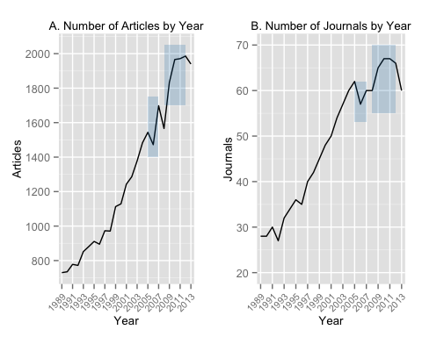

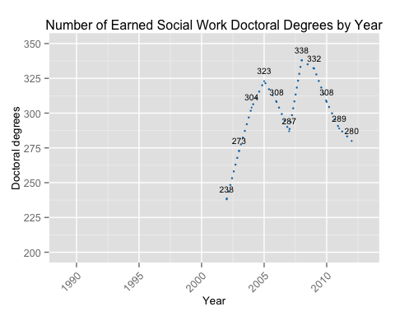 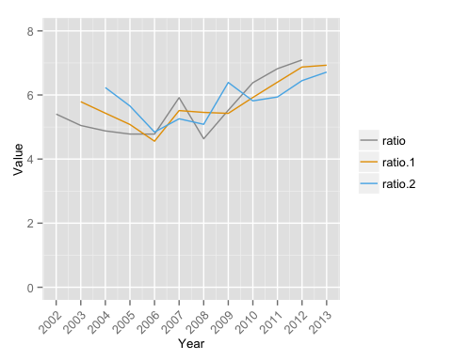

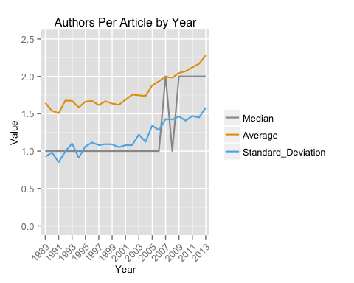

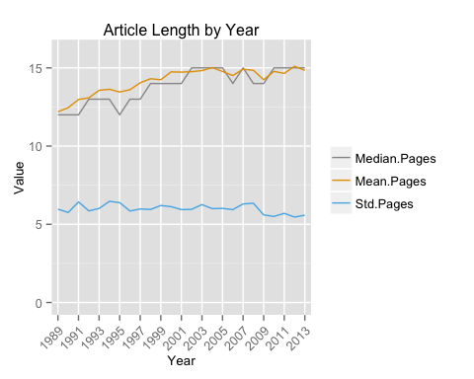

# Appendix A

Articles on Hodge and Lacasse (2011) but not in the current study.

[1] "Annual of Social Work"   
 [2] "Black Caucus"   
 [3] "Caribbean Journal of Social Work"   
 [4] "Critical Social Work"   
 [5] "Electronic Journal of Social Work"   
 [6] "IUC Journal of Social Work Theory & Practice"   
 [7] "Japanese Journal of Social Services"   
 [8] "Journal of Changsha Social Work"   
 [9] "Journal of Forensic Social Work"   
[10] "Journal of Rural Social Work & Social Development"  
[11] "Journal of Social Work in Long-Term Care"   
[12] "The New Social Worker"   
[13] "The Social Worker/Le Travaileur Social"   
[14] "The Spirituality & Social Work Forum"

Source: local data frame [4 x 2]  
  
 record N  
1 Critical Social Work 1  
2 Issues in Social Work Education 1  
3 Maatskaplike Werk/Social Work 1  
4 Iowa Journal of School Social Work 2