I used mongoDB as my databases. The databases is white-list so with the -env you can gain access to the databases. The service have 5 different function from sign up, update, find, delete, and find all.

Signup used a form to gain all the necessary information to make a new user. The ID is continuing to generate using an external module in mongoose and it will continue to increase by 1.

Update used the same form and used the ID form-control to find the user to be able to update.

Find is simply input the ID to receive respond from the databases to get the json file of the user.

Delete function quiet similar but delete it after finding it.

findAll get all the json file of the user and construct a table html in the front end.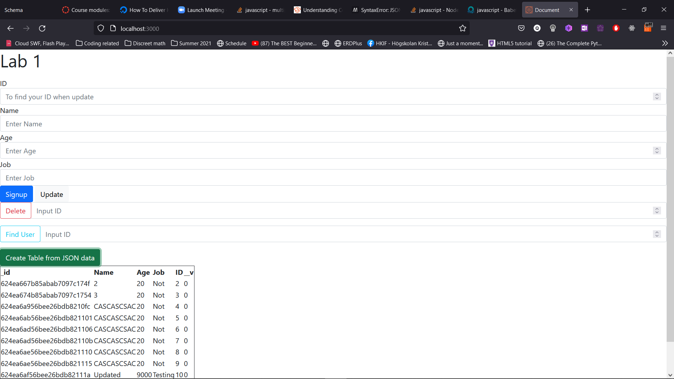

Some of the challenge that I got caught on is learning the fetch function and reading the data after getting it. Making the html table was also quiet a difficult issue that I have. I was trying to make the table editable, but it was quiet tricky so I decide to make a function that create a new table every time you press the button. This allow the data to be updated and see without the need to refresh the page. The reason is the function is fetching the new data set every time and construct a html table new as well. The other issues that I have was trying to reused the form for signup and update as well. The reason for this is because I think it will make it more streamline. The way I decide to do this is by get the same form but put it into 2 const and each of them have there own eventListerner that look at the button when press. This will then allow two functions to be run independently but still using the same form. The issues is when signup you don’t need to put in ID as it is not read when press signUp.