Quinoa Trial Berkane, Morocco
Objective: Comparison of different irrigation management methods for quinoa on water use efficiency in the semiarid northeastern oriental region of Morocco.
Location: Slimania Research Station, Berkane (34.960811, -2.359585 decimal degree)
Sowing date: 17.12.24
Start irrigation management methods: 22.02.25
End irrigation: 28.04.25
Harvest: 13.05.25
Climate:
Table 1: Climate data Slimania Station from 1998 - 2024
Month | Min Temp | Max Temp | Humidity | Wind | Sun | Precipitation
 | [°C] | [°C] | [%] | [km/day] | [h] | [mm]
Jan | 4.4 | 17.7 | 70.5 | 105 | 6.6 | 46.8
Feb | 5.6 | 18.6 | 69.0 | 114 | 6.9 | 31.5
Mar | 7.1 | 20.2 | 67.9 | 122 | 6.8 | 41.3
Apr | 9.3 | 22.0 | 68.2 | 122 | 7.4 | 34.6
May | 12.0 | 24.7 | 65.0 | 124 | 8.9 | 23.1
Jun | 15.6 | 28.1 | 62.7 | 154 | 9.3 | 2.0
Jul | 18.6 | 31.8 | 57.0 | 145 | 9.3 | 0.9
Aug | 19.3 | 32.7 | 59.2 | 142 | 8.6 | 3.8
Sep | 16.1 | 28.0 | 63.2 | 121 | 7.5 | 15.0
Oct | 13.4 | 25.7 | 68.3 | 109 | 7.1 | 31.5
Nov | 8.7 | 21.5 | 70.8 | 107 | 6.4 | 51.9
Dec | 5.8 | 18.5 | 71.6 | 114 | 5.8 | 31.9
 |  |  |  |  | total | 314.2

Soil:
Depth | clay % | silt % | sand % | Texture
15-30 cm | 10 | 15.2 | 74.8 | Sandy loam

- Field capacity (FC): 179 mm Dragino Sensor value: 28%
- Permanent Wilting Point (PWP): 87 mm Dragino Sensor value: 18.8%
- Total Available Water (TAW): 92 mm

Irrigation Management Methods:
- CROPWAT
- Sensor
- Farmers’ Practice
Design: 3x2
- Irrigation management (three levels)
  - CROPWAT
  - Sensor
  - Farmers’ Practice
- Variety (two levels)
  - Titicaca
  - ICBA Q5

Irrigation Management
 | CROPWAT | Sensor | Farmers Practice
Titicaca | T1 | T2 | T3
ICBA Q5 | T4 | T5 | T6
Variety

Plot
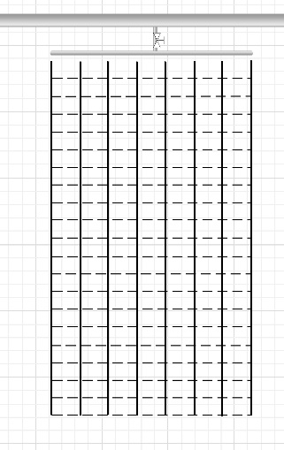

  - 5 m x 3 m
  - 8 drip lines
  - 15 cm between plants within the row
  - Two Dragino LSE01 Soil moisture sensors in 20 cm depth
  - One within the row ( )
  - One between the rows ( )
  - Measuring soil moisture (Vol%), EC, and temperature every 20
minutes

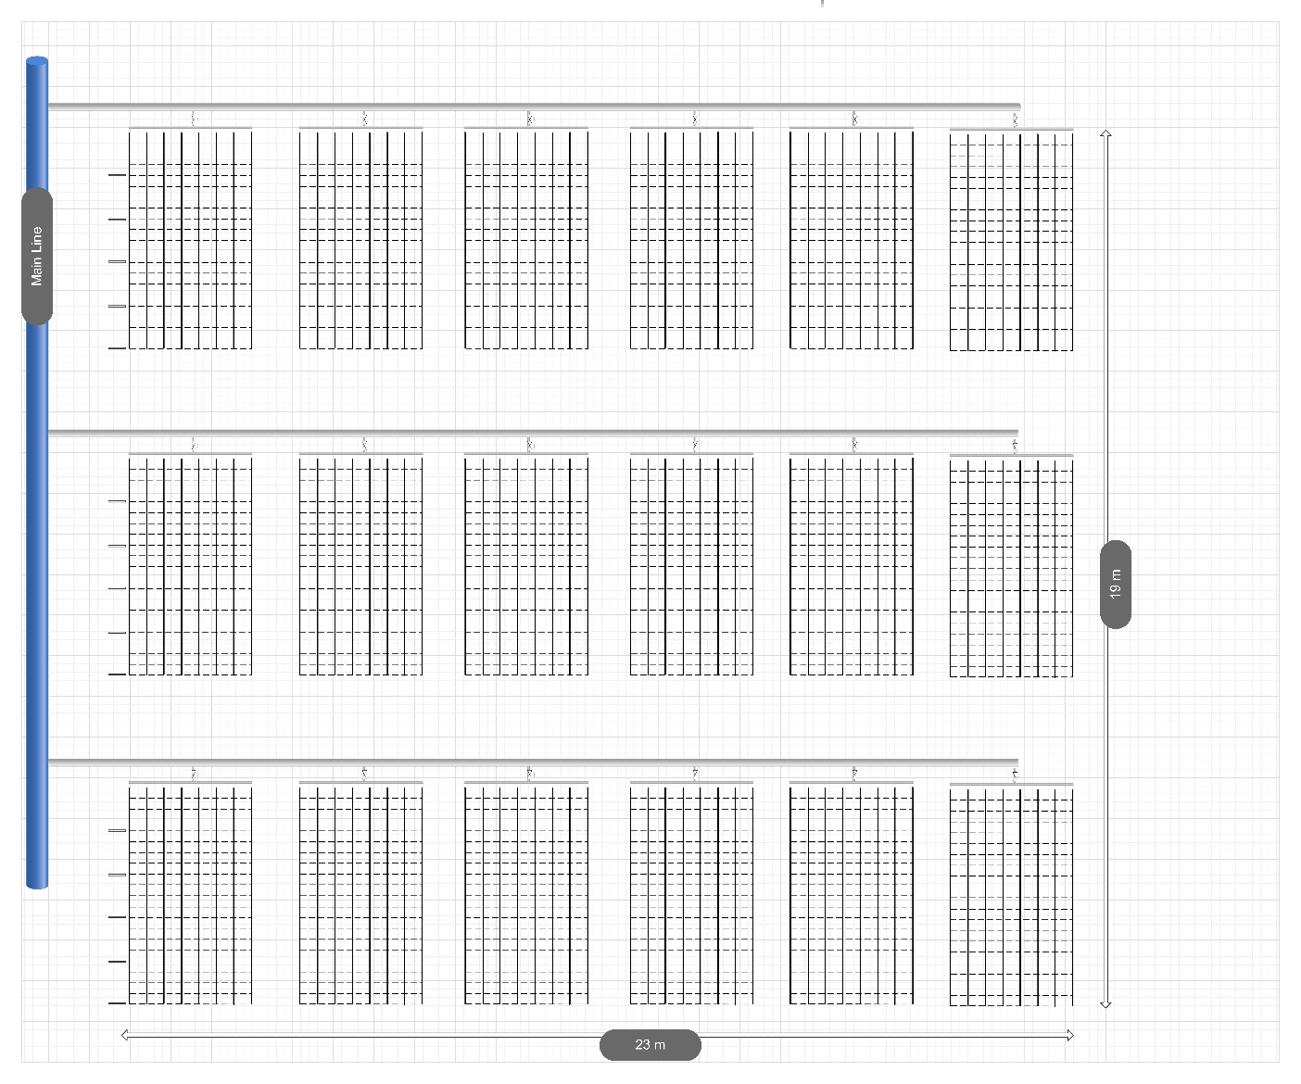
T4
T4
T4
T2
T2
T2
T1
T1
T1
T5
T5
T3
T3
T3
T6
T6
T6
T5
1
2
3
4
5
6
13
14
15
16
17
18
7
8
9
10
11
12

Treatment |  | Plot No. | Sensor No. Within | Sensor No. Between
4 | CW | 1 | 1 | 2
2 | Sensor | 2 | 3 | 4
1 | CW | 3 | 5 | 6
5 | Sensor | 4 | 7 | 8
3 | Farmer | 5 | 9 | 10
6 | Farmer | 6 | 11 | 12
3 | Farmer | 7 | 13 | 14
4 | CW | 8 | 15 | 16
6 | Farmer | 9 | 17 | 18
2 | Sensor | 10 | 19 | 20
5 | Sensor | 11 | 21 | 22
1 | CW | 12 | 23 | 24
5 | Sensor | 13 | 25 | 26
6 | Farmer | 14 | 27 | 28
3 | Farmer | 15 | 29 | 30
1 | CW | 16 | 31 | 32
4 | CW | 17 | 33 | 34
2 | Sensor | 18 | 35 | 36

Irrigation Management 1: CROPWAT

The irrigation management model from the FAO uses climate data for evapotranspiration calculation. Crop data including crop coefficient (kc), rain, and soil data are used to determine crop water requirements and generate an irrigation plan.
- Irrigation if 65% of the plant available water is used up (critical depletion)
Depletion assumed on historical weather data (1998 – 2024)
- Irrigation to 85% of field capacity
- Potential additional irrigation for lack of rain (06.03., 15.03., 24.03., 01.04., 10.04., 20.04.)
Table 2: Irrigation table CROPWAT
Date |  | Experimental Day | Irrigation Volume | Irrigation Duration
 |  |  | [mm] | [min]
22.02.2025 | Sat | 68 | 18.5 | 29
02.03.2025 | Sun/Mon | 76 | 20 | 32
10.03.2025 | Mon | 84 | 19.1 | 30
20.03.2025 | Thurs | 94 | 21.2 | 34
29.03.2025 | Sat | 103 | 18.7 | 30
05.04.2025 | Sat | 110 | 18.4 | 29
15.04.2025 | Tue | 120 | 20.8 | 33
25.04.2025 | Fri | 130 | 19.1 | 30
30.04.2025 | Wed | 135/End

Treatments: T1 & T4

Irrigation Management 2: Sensor

Irrigation based on the soil moisture value of the “within row sensors” of the respective plots.
- Irrigation at a depletion of 65% of the total available water (TAW)
Dragino Value: 22%
- Irrigation to 85% of the field capacity
Dragino Value: 26.6%
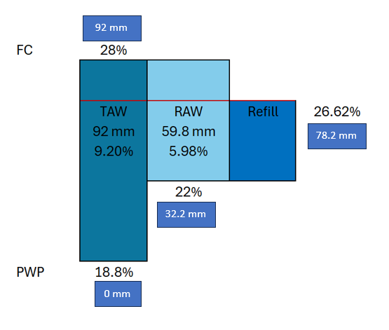
Figure 1: Chart sensor irrigation. Field capacity (FC): 179 mm, Permanent Wilting Point (PWP): 87 mm.
Plant available water

Treatments: T2 & T5

Irrigation Management 3: Farmers’ Practice

Irrigation based on experience and knowledge of the local farmers (Station technician)
- Irrigation time and date are noted.
Treatments: T3 & T6

