Task

1. Uztelecom predicts which customers will cancel their contract next month.
Scenario # | Learning Type | Justification | Input | Output
 | Supervised Learning  (Class) | Labels exist: the model learns from historical data where churn (yes/no) is already known | Customer data: age, usage, contract type | Customers likely to cancel their contract next month

2. A self driving car learns to navigate Tashkent traffic by repeatedly trying routes and receiving penalties for unsafe moves
Scenario # | Learning Type | Justification | Input | Output
 | Reinforestment | self driving car learns through trial and error. It gets rewards for correct picks and penalties for mistakes. No labeled examples — it learns from | Sensor data: visual input, traffic signals, road conditions | Safe and optimal driving policy

3. Uzum marketplace recommends products to users based on their browsing and purchase history
Scenario # | Learning Type | Justification | Input | Output
 | UnSupervised Learning | Labels exist: the model learns from historical data where churn (yes/no) is already known | User clicks, views, purchase history | Recommended products

4. A system groups Tashkent neighborhoods by internet usage patterns without any predefined categories
Scenario # | Learning Type | Justification | Input | Output
 | Unsupervised (Clustering) | No labels — nobody told the system what groups to find. It discovers patterns on its own. | Internet usage data per neighborhood: speed, hours online, data consumed | Groups of neighborhoods with similar usage patterns

5. An email provider classifies incoming messages as spam or not spam.
Scenario # | Learning Type | Justification | Input | Output
 | Supervised Learning  (Classification) | Learns from labeled emails (spam / not spam). | Email text, metadata | spam or not spam.

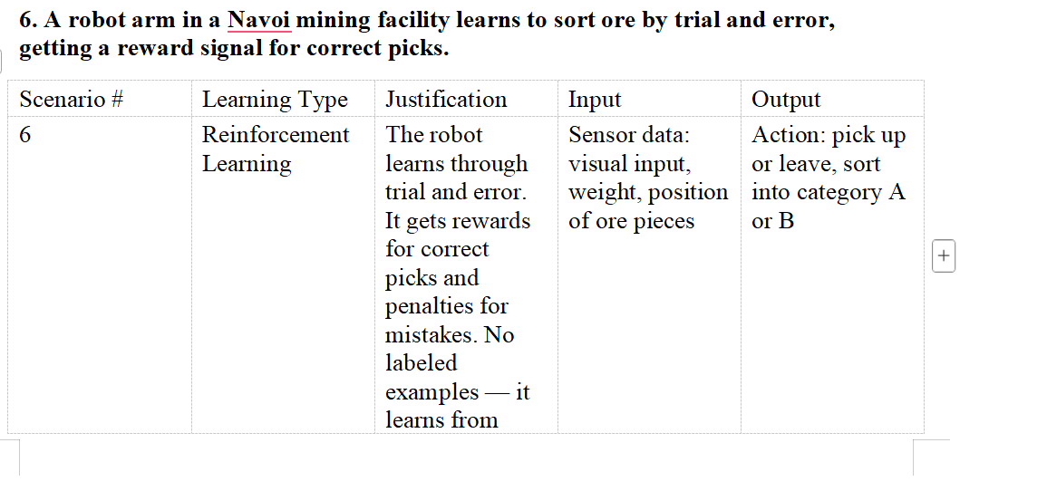

7. Dynamic pricing for Uztelecom mobile data plans — adjusting prices in real time based on demand signals and user response
Scenario # | Learning Type | Justification | Input | Output
 | Supervised Learning  (Dynamic Pricing) | Adjusts prices based on reward signals like demand and user response. | Demand data, user behavior, sales history | Optimal dynamic price

- A hospital in Samarkand uses patient Records to predict diabetes risk.

Scenario # | Learning Type | Justification | Input | Output
 | Supervised Learning  (Classification) | Uses labeled patient records to predict disease risk | Patient health records | Diabetes risk prediction

9. An algorithm segments Uztelecom’s 10 million subscribers into
marketing groups based on usage behavior — no one told it how many groups to make.
Scenario # | Learning Type | Justification | Input | Output
 | UnSupervised Learning  (Clustering) | No predefined groups; discovers patterns in user behavior. | Subscriber usage data | Customer segments

10. A chess engine improves its play by competing against itself over millions of games.

Scenario # | Learning Type | Justification | Input | Output
 | Reinforcement Learning (Self-play) | Learns by playing against itself and improving through rewards | Game states from self-play | Strong chess-playing policy

11. Detecting SIM card 1fraud at Uztelecom by flagging transactions that look different from a user’s normal pattern
Scenario # | Learning Type | Justification | Input | Output
 | UnSupervised Learning  (Clustering) | Detects deviations from normal behavior without explicit fraud labels. | Transaction history, usage patterns | Fraud alerts

12. A news aggregator clusters articles into topics automatically

Scenario # | Learning Type | Justification | Input | Output
 | UnSupervised Learning  (Clustering) | Groups similar news articles automatically. | Article text data | Topic clusters

13. Predicting house prices in Tashkent from square footage, district, and floor number.

Scenario # | Learning Type | Justification | Input | Output
 | Supervised Learning (Regression) | Learns relationship between features and house prices. | House features (size, district, floor) | Predicted house price

- A warehouse robot learns the fastest route between shelves by exploring and receiving time-based penalties

Scenario # | Learning Type | Justification | Input | Output
 | Reinforcement  Learning | Learns optimal path via trial, error, and time penalties. | Robot sensors, map of warehouse | Fastest navigation policy

15. A model translates Uzbek text to English using a dataset of sentence pairs.

Scenario # | Learning Type | Justification | Input | Output
 | Supervised  Learning | Learns from paired examples of input and output sentences. | Uzbek–English sentence pairs | Translated Text

16. Spotify creates a “Discover Weekly” playlist by finding users with similar listening habits and cross-recommending.

Scenario # | Learning Type | Justification | Input | Output
 | Unsupervised | Finds similar users and recommends content based on shared preferences. | User listening history | Personalized playlists

17. An algorithm detects unusual spikes in Uztelecom’s network traffic without labeled examples of “normal” vs “anomaly.”

Scenario # | Learning Type | Justification | Input | Output
 |  | Detects unusual spikes without labeled “normal” or “abnormal” data. | Network traffic data | Anomaly alerts

