Regions
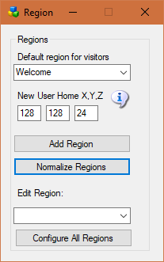
Default region for visitors: This is your “Welcome” region. Hypergrid visitors and people who log in for the first time get sent to this region. The region must be online.
New User Home X,Y,Z: Users that create accounts on the web page will land at this spot on your Welcome region. Their home is set here.
Default: 128,128,24
Add a Region: will bring up a dialog form for adding a new region.
Normalize Regions: The web maps require that the lower left corner be started at 1000,1000. This will move all regions so that the chosen region is at 1000,1000. All regions maintain their relative positions.
Edit Region: will bring up a dialog form to edit the selected region.
Configure All Regions: will open all regions for editing.

