Backup - AutoBackup

if enabled, and Opensim Autobackup module periodically saves all regions as OAR files.

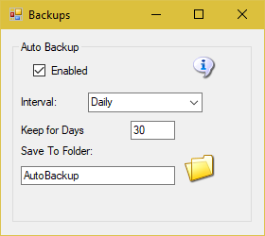

If this is enabled, Opensim will make an OAR backup of each region after Opensim has run for Interval time. The files will appear in the Outworldzfiles\Autobackup folder.

Keep for Days will delete any OAR older than this period of time.

Save To Folder: You can click on “Autobackup” folder name, or the folder Icon, and set a different location.

Links:

http://opensimulator.org/wiki/Load_Oar_0.9.0%2B

