Apache Web Server
You may optionally set up an Apache Web server with PHP7, WordPress, Joomla/jOpensim, or other Content Management (CMS) system. The default purpose of Apache/PHP is to serve a detailed map, object search and other useful functions. It is optional and may be disabled. If you do not need local search or the additional maps, then you can leave Apache & PHP disabled.
If your system tells you the msvcr100.dll is missing, click the [Install C++ Runtime] button. This will install all necessary runtimes.
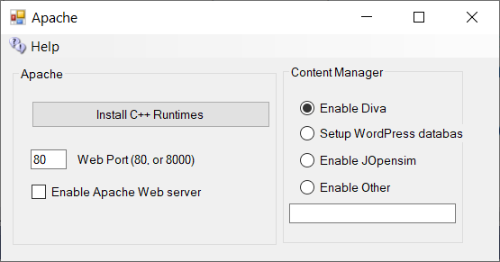
The checkbox for [Enable Apache Web Server] must be set for the web server and PHP to work. When enabled a map will appear at your URL on port 80. You can hover on any square and see its size, location, name, and other details.
The system will install “Apache HTTP Server” as a running service when you first click [Start] to bring up your regions in your grid. Apache will then start when your PC is booted, or if the service crashes. No DOS boxes will appear. The advantage is less clutter and 24-hour operation of the web server. But if you run from another folder, the server will still attempt to from the original folder. You must stop the Apache Service and remove Apache before starting any copy in another folder.
Web Port defaults to 80. If your ISP blocks port 80, try another port greater than 1024 and less then 40,000.

