License Agreement:

Dreamgrid is Copyright 2011 by Outworldz, LLC under the GNU Affero General Public License (AGPL 3.0). The GNU Affero General Public License is a free, copyleft license for software and other kinds of works, specifically designed to ensure cooperation with the community in the case of network server software. All rights are irrevocable provided the stated conditions are met. This License explicitly affirms your unlimited permission to run the unmodified Program. https://www.gnu.org/licenses/agpl-3.0.txt

Source code: https://github.com/Outworldz/DreamWorld

Other open source licenses apply to Opensimulator and the libraries and other functions included herein. A list is provided in several folders:

- \Licenses_to_Content
- \Opensim\ThirdPartyLicenses
- \Opensim\NOTES

Data Collection Policy

Outworldz, LLC does not collect personally identifiable information. No personal details of your site, such as passwords or usernames are other details are sent to Outworldz.

Publicity:

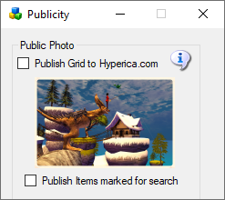

If you check the Publish Grid button, the system will send public information about your grid, such as the web address, to Outworldz, LLC for use in the Hyperica.com directory. This information is removed automatically if you turn your grid off or uncheck the box.

DNS

The DYN DNS system stores public IP addresses and your domain name as is necessary to run the DNS system.

Anonymous data

The unique random identifier of your machine is stored at Outworldz along with a small amount of anonymous data. This includes whether your software passes diagnostics, the revision level, and whether it is on the Hypergrid. This is used for quality control purposes.

The Outworldz web server may also automatically collect and store routine information in server logs. This may include details of how you used our service, such as your search queries or Internet protocol address, browser type, browser language, the date and time of your request and referral URL.

