Maps
Opensim has many different maps settings. Dreamgrid has multiple easy-to-use combinations. Opensimulator has several Map tile makers which vary in quality, and speed. It can take an exceedingly long time to boot when using the Better and Best maps. These maps which use the Warp3D engine must load all prims, mesh, and textures, so it takes a long time to generate new maps. Also, any bad textures may cause harmless errors from corrupted assets to appear on your console.
I recommend you run all maps at Best setting once, then set Maps to None. You can remake maps when enough changes have been made.

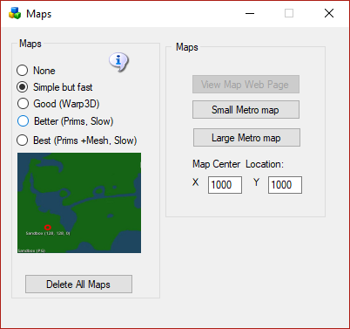
- None: No maps will be made. This is a good setting as the regions will boot very quickly. Any existing maps are not deleted.
- Simple but Fast: MapImageModule is used with just Land showing
- Good: Uses Warp3D module with just Land showing
- Better: Uses Warp3D module with Land, Prims, and land Textures showing
- Best: Uses Warp3D module with Land, Prims, Mesh, Sculpts, and all Textures including prims showing.
- Delete All Maps: If you delete a region, the map will remain. Click this to clear out all maps. You will need to regenerate all maps again by choosing a setting and restarting all regions.
- View Map Web page: Enabled if your system is booted. Opens a web browser to http://localhost:8002/wifi/map.htm.
- Small Metro Map and Large Metro Maps Available only if your Apache/PHP is enabled in Settings Web Pages. These maps are generated by PHP and Apache web server.
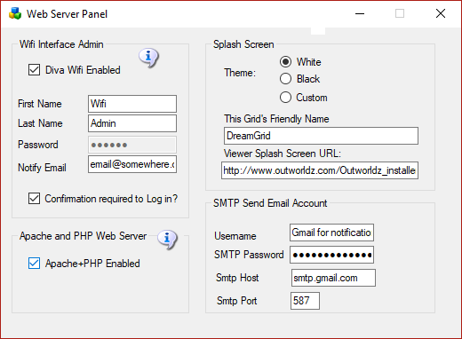

Manual regeneration
Normally, one would generate map tiles at startup. You can also manually force map tile regeneration with the console command 'generate map<enter>'.

