Rearrange Regions

It is difficult to get your regions close to each other without touching. DreamGrid has a simple function to rearrange your grid into a grid of regions:
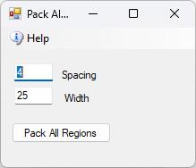

Spacing:
Spacing is the gap between regions:
Spacing of 0: 
Spacing of 1: 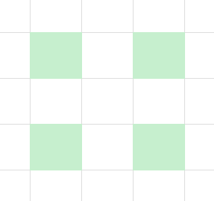
Width is the largest right-hand border distance from the start.
Spacing = 0, Width of 2: 

