Publish Grid
Publish Grid sends shows your grid in the list at Hyperica.com.
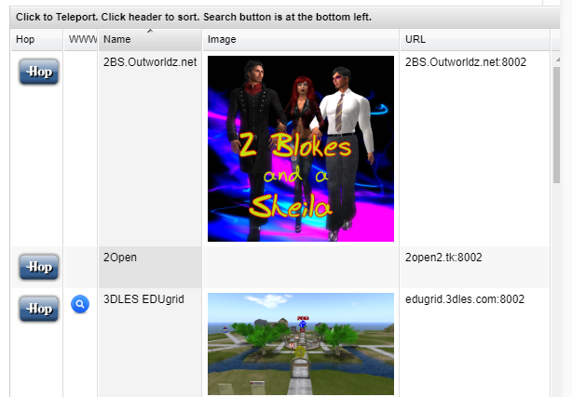

Photos:

Click the Green box to load PNG image and it will appear in your listing.

