Script Settings
Default Engine for scripts is XEngine.
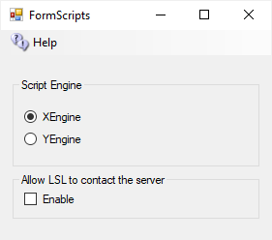
YEngine is a new engine that has better support for the llSleep() command. YEngine offers some features that improve performance and prevent timeouts.
The problem with using llSleep function in Opensim scripts is that it may cause a script to freeze, requiring a reset. This is due to the way XEngine deals with running multiple scripts at once.
The parse in Yengine is also like Second Life as it uses the same order when evaluating a series of expressions. XEngine parsed the order in the opposite direction from Second Life.

Allow LSL to contact the server:
By default, OpenSimulator does not allow scripts to make HTTP calls to addresses on the simulator's LAN. This stop LSL from scanning your ports inside your firewall. If you need to allow scripts to make some LAN calls, enable this checkbox. We recommend that you do not enable this unless you are very sure about what you are doing. When disabled, it will allow access to no ports on the server. You can see more in Opensim.proto - search for OutboundDisallowForUserScripts.
Default: Unchecked

