Robust and Server Type
This menu item “Server Type” lets you choose from either a Grid Server with Robust, or from different Region Server choices to connect to another grid.
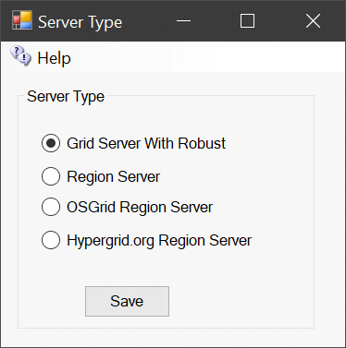

Grid Server with Robust
A grid server is modeled after the World Wide Web, with independent domains. Content is spread across small, independent and on large domains, independently, yet interlinks. Robust is the service that lets HyperGrid users enter each world. A Grid Server can also support regions locally. A grid server can host as many Region servers as its memory and CPU capacity allows.

Region Server
A Region server uses a separate Dreamgrid Robust Grid Server for all assets and login services. Only regions and their content are stored locally. The grid server may be located on the same LAN, or on another WAN. A Region Server always uses the same Domain Name and port as the Hosting server.
In cases where the Grid server is on a different WAN IP address, you must also enter the Region Servers IP address or domain name in the Region Ports setting:
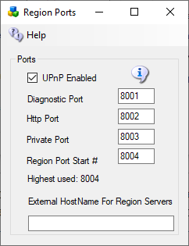

OsGrid Region Server
The OsGrid region server is a preconfigured region server already set up to connect to OsGrid.

Hypergrid.org Region Server
The Hypergrid.org region server is a preconfigured region server already set up to connect to Hypergrid.org.

