Terms of Service
The TOS form lets you change the HTML for your TOS. A SAMPLE TOS is included here.
Feel free to delete it or change it as you see fit.
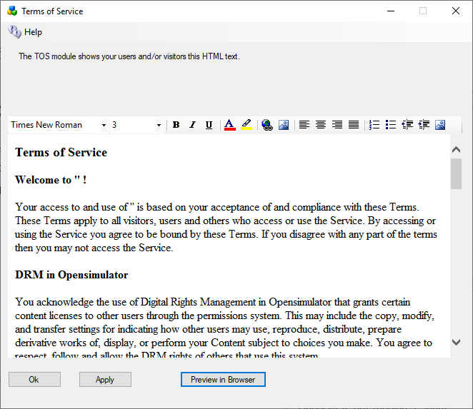
#includes There are several include directives that bring in the rest of the web site. Diva uses a series of <!--#include file=header.html --> statements to bring in files from the other folder set in Opensim\WifiPages. Includes in those files then bring in increasingly of the web pages from Opensim\Bin\Wifipages.
#get There are several statements that are replaced by server data:
Users in World: <!-- #get var=UsersInworld -->
Regions: <!-- #get var=RegionsTotal -->
Total Users: <!-- #get var=UsersTotal -->
Active Users last <!-- #get var=UsersActivePeriod --> days
Active Users: <!-- #get var=UsersActive -->

