Region Panel
Give your region a name and click [Save]. You can immediately start it up by clicking the name in the Regions panel.
If you click Delete, the region INI file will still be there, but the file name will change to .bak from .ini.
Regions are stored in the folder Outworldzfile\opensim\bin\Regions in folders by each DOS box name. The DOS box folder has a Region folder in it that holds the Region.ini file. See Rules for INI files at the bottom of this Help file for more details.
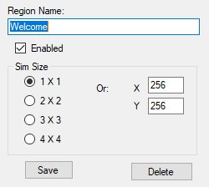

Rules:
- Always use a square sim size.
- Use multiples of 256 such as 256X256, 512X512, and so on.
- Each region size can be anything from 256 X 256 to 1024 X 1024, or higher. Huge region sizes such as 4096 X 4096 can be used for flying or car racing. If you go over 8192 X 8192, you can expect it to be slow as the land size gets very, very large and laggy, as it grows exponentially.
- You can replace 4 single regions with a single 2X2 region and there will be no lag when crossing the (nonexistent) border. Vehicles can move smoothly anywhere. Also, NPCs can move about freely. Look in any region settings panel and you will see a "size" box. Check the 2X2 box, save it, and restart the region. It will grow North and East and will be 4 times larger overall. You will also need to move it in X and/or Y or delete the other regions as regions cannot overlap. You can shrink them, too, but objects that fall off the right and top edge will be lost.
- You can only set regions of the same size next to each other.

Options
The next section contains optional items you may choose to change.
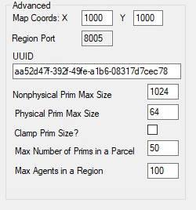
Map Coords: The (x, y) location of the region on the grid. You can set regions next to each other by changing the X and Y coordinates and restarting the region. The X and Y is the lower left point on the global map.
If you get messages saying that regions overlap, change the coordinates to some large number and retry the region boot. If your region still will not start due to it overlapping, type this into the Robust console:
deregister region id <UUID Goes Here>
Copy and paste the region UUID where it says <UUID Goes Here>. This can be done on Windows with Ctrl-V, or by right clicking the Robust title bar and selecting Edit->Paste.
UUID: Never change the UUID unless you want to start with a blank region again. Altering the UUID will force the system to create a new, blank region the next time it is started, and you will be forced to move your region to another spot.
MaxAgents: The maximum number of agents that can be in the in the region at any given time. The default is 100.
MaxPrims: The maximum number of prims that the region will be listed as supporting. However, this limit is not currently enforced by OpenSimulator. Due to LL protocol constraints, the maximum limit that can be shown is 45000.
PhysicalPrimMax: The maximum dimensions of a physical prim. This is a single number which applies to X, Y and Z co-ordinates. This will affect resizing of existing prims. Default is 10.
NonphysicalPrimMax: The maximum dimensions for a non-physical prim. This is a single number which applies to X, Y and Z co-ordinates. This will affect resizing of existing prims. Default is 256.
ClampPrimSize: If true then if a viewer attempts to create a prim which has any dimension larger than the NonphysicalPrimMax, then that dimension is reduced to NonphysicalPrimMax. Default is false;
MaptileStaticUUID: UUID of texture to use as a maptile for this region. Only set if you have disabled dynamic generation of the map tile from the region contents.

Overrides
The next section are overrides for global settings made elsewhere.
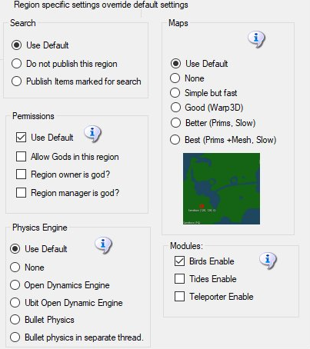
Each of these settings is specific to this ONE region. As an example, if you want maps to made Best quality for just one region, you can set it here. It will override the glob al maps setting for this region.
At lower right are settings to enable Bird, Tides, and Teleporter. These settings extend the Global settings to enable these modules on a per-region basis.

Rules for INI files

Dreamgrid has several simple rules for *.INI files that differ slightly from stock Opensim.

Example of how regions are organized is found in the file system:
Opensim\bin\Regions\SOME DOS BOX NAME\Region\Fred.ini
Opensim\bin\Regions\SOME DOS BOX NAME\Region\Rak.ini
These two regions Fred and Rak will be in a single Dos box named "SOME DOS BOX NAME".
If you rename the folder "SOME DOS BOX NAME" to "Internet", they will be in a DOS box named "Internet".
If you create a new folder named "HEY", like this:
Opensim\bin\Regions\HEY\
And then MOVE Region\Rak.ini into it:
Opensim\bin\Regions\HEY\Region\Rak.ini
You will end up with a DOS box named "Hey" with the Region named "Rak" in it.
The other Dos box will have just Fred in it:
Opensimulator\bin\Regions\SOME DOS BOX NAME\Region\Fred.ini

Rules:
- No Duplicates: Do not leave a Region.ini in one folder and the same Region.ini in another. All files such as Region.bak are ignored.
- The only thing you need to put in the SOME DOS BOX NAME\Region\ is one or more Region.INI files.
- All other files, such as Opensim.ini are automatically re-created when you start the region.
- The INI file name must match the [Region Name] inside it. This example region [Welcome] must be saved as “Welcome.ini”.
- Only one [Region Name] is allowed in an INI file.
- All contents of a Region file are made by Dreamgrid and will be overwritten. See the Region Control Panel to change the settings.

