FSAssets Settings
FSAssets is intended for larger grids where the size of the database is expected to exceed 50GB. This option will save the assets to the file system as opposed to the default service which stores assets as blobs in the database. This option also provides deduplication abilities. Each asset is hashed when it is received for storage. If the asset already exists, the asset service will link to the existing file rather than store two copies.

IMPORTANT: This is a major change in database structure. If you already have a MySQL database running with a lot of assets, this will help speed it up, but it will cost a lot of disk space. If you start out with this setting, it will use the least space. Once you switch to FSAssets, you cannot go back to just MySQL without losing data entered since the switch.

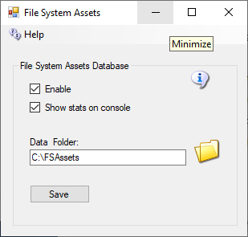

Data Folder
This is the folder in which the asset data will be saved. Default = ./fsassets/data
SpoolDirectory Folder
The spool directory is a folder used for temporary storage while the asset is hashed and compressed before it gets moved to the BaseDirectory. This must be on the same file system as the base directory. Default = ./fsassets/tmp

Migration

FSAssets will use the MySQL database to collect the original data. This will not automatically convert all the old assets to the new service. To convert all assets from the default service there is a Robust console command provided:
import <conn> <table> [<start> <count>]

The import command expects a database connection string and the name of the legacy asset table to be passed as parameters. The following example shows how to start the import process for a MySQL database. Change the connection details to match your database schema, username and password, or use the DreamGrid default shown here, and copy and paste this into your Robust console:

import "Data Source=localhost;Port=3306;Database=robust;User ID=robustuser;Password=robustpassword;Old Guids=true;" assets

Depending on the size of your existing assets table, the import process will take some time to complete. The optional parameters, start and count allow you to specify the position and number of rows to convert.

A default, blank database will look like this:

R.O.B.U.S.T.# import "Data Source=localhost;Port=3306;Database=robust;User ID=robustuser;Password=robustpassword;Old Guids=true;" assets
Reading data
0 assets imported so far
100 assets imported so far
200 assets imported so far
Import done, 274 assets imported
R.O.B.U.S.T.#

