Ban Lists
Bans can be set for IP addresses, Viewers, and MAC addresses. MAC addresses are a serial number found in Ethernet cards. These bans shut off all incoming traffic by editing robust.HG.ini and by adding entries to the Windows Firewall. They are not a total solution but can work in many cases.
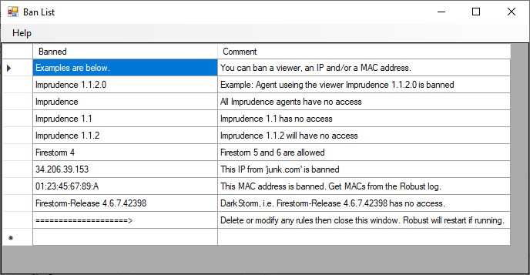
Bans for IP addresses go into effect at once. The others go into effect when Robust restarts. The system will restart Robust for you if necessary.
You can get the IP address and MAC address of people when they log in from the Robust log. Look in the menu system at Help ->View Logs->Robust. A typical entry would be as follows:
INFO (104) - OpenSim.Services.HypergridService.GatekeeperService [GATEKEEPER SERVICE]: Login request for Jo.Inlander@ www.xyz.com:8002 @ http://www.xyz.com:8002/ (3be47575-06dd-46b0-8637-87a8967c432c) at ab8d7770-3782-21e4-8c41-1813211c9b88 using viewer Firestorm-Releasex64 5.3.9.58205, channel Firestorm-Releasex64, IP 109.44.15.201, Mac d5af8bee7e6a265c41e729416d570f57, Id0 dac5b5d03d9bbe2225d2c91c3238d59f, Teleport Flags: ViaLogin. From region Her Place (2c53df18-143f-4340-ae73-f2885d9694d8) @ http://grid.fred.com:8002/
To ban the grid that the avatar Jo.Inlander lives on, look up the grid IP address with the DOS command ‘ping’.
To ban Jo’s IP address, add her IP 109.44.15.201.
To ban her viewer, add Firestorm-Releasex64 5.3.9.58205.
To Ban her PC by its Ethernet card MAC address, add d5af8bee7e6a265c41e729416d570f57

