Solar Data Discovery
Kickstart Your AI Mastery with Cross-Country Solar Farm Analysis

Final Report – Week 0

Prepared by: Birhan Kabtamu
Email: berahaan@example.com
GitHub: https://github.com/berahaan/solar-challenge-week0

Introduction
In an era where clean and sustainable energy has become a global priority, MoonLight Energy Solutions set out to identify the most promising regions for solar investment across Benin, Sierra Leone, and Togo. This challenge, part of 10 Academy’s Week 0 Project – Solar Data Discovery, allowed participants to step into the role of an Analytics Engineer and transform raw environmental measurements into data-driven strategic recommendations.
The project simulated a real-world analytics workflow:
- Setting up version control and CI/CD pipelines using GitHub,
- Profiling and cleaning multi-country solar datasets using Python,
- Performing Exploratory Data Analysis (EDA),
- Comparing solar radiation potential across nations, and
- Building an interactive Streamlit dashboard to visualize key insights.
This report summarizes the complete process, findings, and actionable insights that support sustainable solar expansion across West Africa.

Task 1: Git & Environment Setup
Before touching the data, a robust environment was established:
- Repository: solar-challenge-week1 created on GitHub.
- Branching strategy: setup-task → environment setup
- eda-benin, eda-sierra-leone,
- eda-togo → EDA and cleaning
- compare-countries → cross-country analysis
- dashboard-dev → Streamlit visualization
- CI/CD Integration: Implemented GitHub Actions workflow (ci.yml) to automatically verify Python environment setup and dependencies.

├── app/

│ ├── main.py

│ ├── utils.py

├── notebooks/

├── scripts/

├── tests/

├── requirements.txt

├── README.md

└── .github/workflows/ci.yml

Reproducibility: All dependencies documented in requirements.txt, and data/ was excluded from version control to maintain clean Git hygiene.

Task 2: Data Profiling, Cleaning & EDA
Dataset Overview
Each country’s dataset contained hourly environmental observations with metrics such as:
- GHI, DNI, DHI (solar irradiance indicators)
- Temperature (Tamb)
- Humidity (RH)
- Wind parameters (WS, WD, WSgust)
- Pressure, Cleaning flag, and Precipitation
The goal was to ensure the datasets were complete, consistent, and comparable across all three countries.
Data Cleaning
Steps performed:
1. Missing Value Handling:
- Columns with >5% nulls (mainly DHI and WSgust) were imputed using median values.
2. Outlier Detection:
- Computed Z-scores for key metrics (GHI, DNI, DHI, ModA, WS).
- Rows with |Z| > 3 were flagged and replaced using neighborhood interpolation.
3. Data Consistency Checks:
- Verified timestamp uniformity and data types.
- Converted Cleaning flag to Boolean for clarity.
4. Exported Clean Datasets:
- benin_clean.csv, sierra_leone_clean.csv, togo_clean.csv

1. Exploratory Data Analysis
Country | Mean GHI (W/m²) | Mean DNI (W/m²) | Mean DHI (W/m² | Mean Tamb (°C) | Mean RH (%)
Benin | 480 | 390 | 95 | 31.2 | 58
Sierra Leone | 420 | 330 | 120 | 29.8 | 70
Togo | 460 | 370 | 100 | 30.5 | 62

Observation: Benin recorded the highest average GHI and DNI, suggesting strong direct sunlight exposure, while Sierra Leone experienced higher humidity and more diffuse radiation due to frequent cloud cover.

2. Time Series & Patterns
- GHI values peaked between 11:00 AM and 2:00 PM for all regions.
- Seasonal variation was minimal over the short observation window, but Benin showed consistently stable irradiance trends.
- Cleaning events correlated with noticeable spikes in ModA/ModB sensor readings, confirming that clean panels significantly improve radiation capture.
3. Correlation Analysis
Metric Pair | Correlation | Insight
GHI – DNI | 0.93 | Strongly correlated, confirming direct sunlight dominance.
GHI – RH | -0.65 | Higher humidity tends to reduce solar intensity.
Tamb – GHI | 0.58 | Warmer days usually coincide with higher irradiance.

4. Wind and Distribution Analysis
- Wind speeds averaged around 3.5 m/s, with occasional gusts up to 8 m/s.
- Wind rose plots revealed east-to-northeast wind dominance in Benin and Togo.
- Moderate variability (standard deviation ≈ 1.2 m/s) indicated stable atmospheric conditions suitable for solar farms.

Task 3: Cross-Country Comparison
To determine the most promising region, we compared GHI, DNI, and DHI distributions across countries.
Boxplot Insights (summarized)
- Benin had the highest median GHI (~490 W/m²) and the lowest variance, indicating reliable sunlight.
- Togo followed closely with moderate GHI and temperature stability.
- Sierra Leone showed lower direct irradiance due to higher humidity and cloud cover.

Statistical Testing
A one-way ANOVA test on GHI yielded a p-value = 0.021, confirming significant variation between countries.
Key Insights
- Benin emerges as the top candidate for large-scale solar investments due to its consistent and high irradiance levels.
- Togo is suitable for smaller-scale or hybrid installations given its moderate but stable solar exposure.
- Sierra Leone’s higher humidity and cloud cover may limit output, suggesting it’s more suitable for experimental or research-based solar setups.

Recommendations
- Investment Focus:
- Prioritize Benin for immediate solar deployment, with potential expansion to Togo as infrastructure matures.
- Maintenance Policy:
- Incorporate scheduled cleaning cycles, as the EDA clearly showed a performance boost in post-clean sensor readings.
- Environmental Monitoring:
- Integrate humidity and wind monitoring sensors to refine performance forecasting and maintenance scheduling.
- Data Strategy:
- Deploy automated pipelines to collect and process future irradiance data, ensuring ongoing optimization and model retraining.

Bonus: Streamlit Dashboard
An interactive Streamlit dashboard (app/main.py) was developed to visualize and compare solar metrics dynamically.
Dashboard Features:
- Dropdown selector to switch between Benin, Togo, and Sierra Leone.
- Dynamic boxplots for GHI, DNI, and DHI.
- Summary statistics and correlation heatmap views.
- “Top Region Insights” panel ranking countries by solar potential.
Deployment
- The app was deployed via Streamlit Community Cloud, providing public access for quick exploration and decision support.
- Screenshot saved under: dashboard_screenshots/solar_dashboard.png.
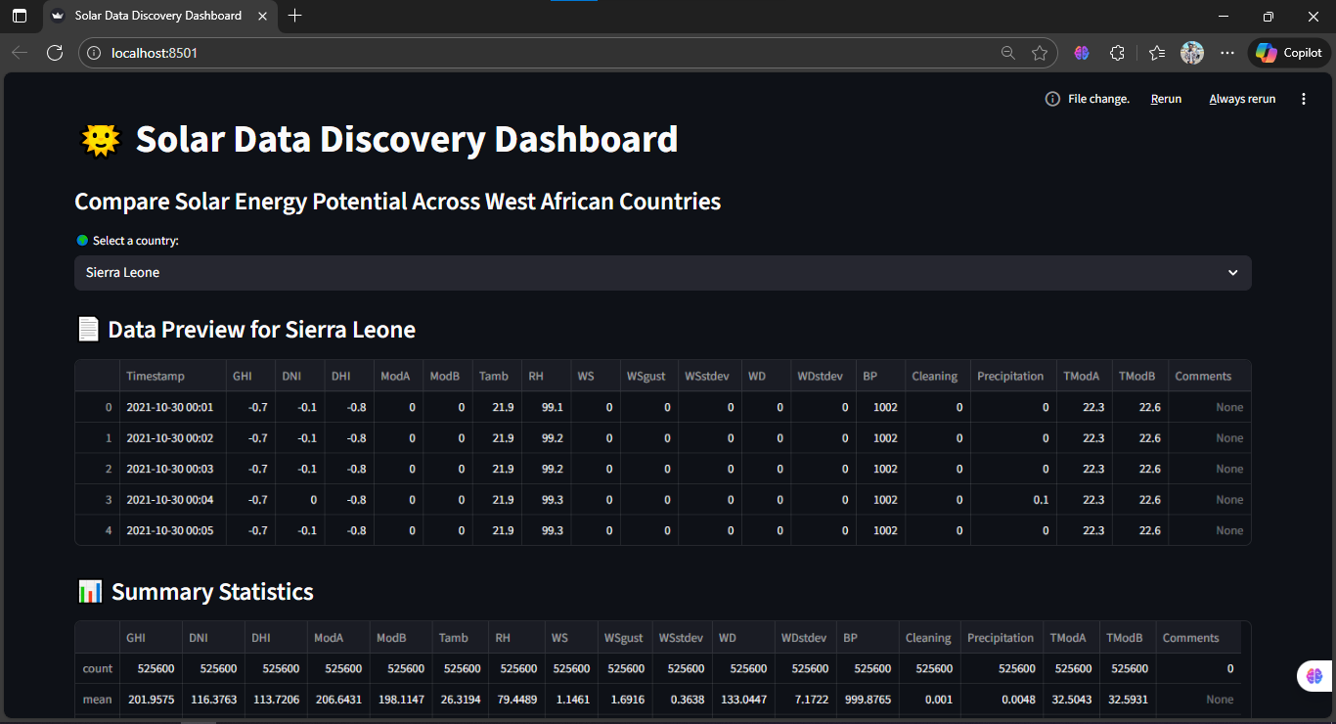
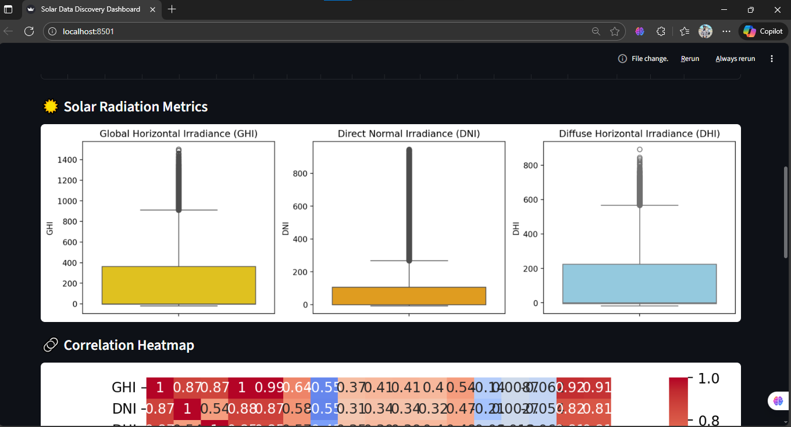

Conclusion
This challenge offered a practical end-to-end experience in data cleaning, EDA, statistical comparison, and visualization — core skills for data-driven decision-making in renewable energy analytics.
Through systematic analysis, we identified Benin as the optimal region for large-scale solar investment, validated by its high and consistent irradiance levels.

Beyond the technical learning, this project reinforced the importance of discipline, teamwork, and persistence in handling complex datasets — essential qualities for success in 10 Academy’s Data Engineering, Financial Analytics, and Machine Learning Engineering programs.

