# Subsystem Descriptions

## Temperature Management = Temperature Monitoring + Heating Control

The new tuberculosis vaccine can only work if it is stored under its optimal temperature conditions. A continuous, consistent and high-yielding process is needed for the production of the vaccine, and temperature control holds a significant role in ensuring these. Therefore, this subsystem focused on devising a mechanism by which temperature could be: constantly monitored, adjusted by the user at the vaccine storage facility, measured in real time and recorded within a temperature log. This subsystem comprises of two smaller subsystems, the combination of which completes the entire Temperature Management System. These two smaller systems include: Temperature Monitoring and Heating Control.

This subsystem was stipulated to maintain the temperature of the vaccine at a set point within a range of $25℃-35℃$ and within a margin of $±0.5℃$ of the set point. Moreover, the material provided to achieve this task included: a resistive heater element, a negative temperature coefficient (NTC) thermistor, one 12v lead acid battery, an MSP430 microcontroller with Energia software and one plastic cup which would contain the potential vaccine.

This diagram shows the combined temperature management system design with monitoring and heating:

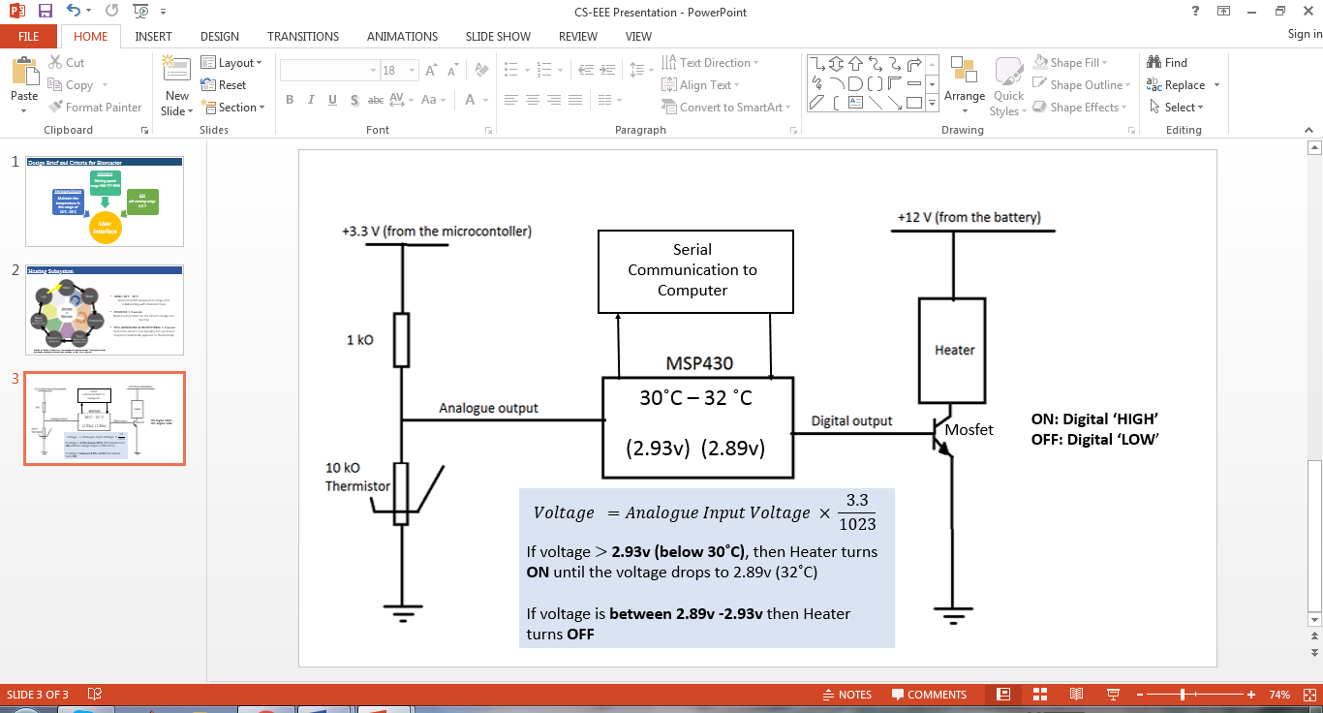

*Figure 1: The complete Temperature Management Final Circuit Design*

### Temperature Monitoring Subsystem

*Author: Kimberlee Laloo, Chingis Latifov*

This subsystem made use of the voltage divider concept. The microcontroller only allows a maximum voltage of approximately 3.3v, therefore, to regulate the voltage going to it, the team decided to power a voltage divider from the MSP430 itself so that its maximum voltage would never be exceeded. A 1kΩ resistor was used in the divider circuit with the thermistor to ensure that the fraction of the output voltage never exceeds this maximum microcontroller voltage. The thermistor has a negative temperature coefficient which implies that as temperature increases, the resistance decreases and so if used on its own, it can cause too large a voltage at the output. Voltage coming out of the voltage divider is an analogue signal which is the input to the MSP430. The MSP430 has an in-built analogue to digital converter (ADC) which reads 10 bits. Therefore, using the Energia software, this analogue voltage was converted to digital by multiplying it by $\frac{3.3}{2^{10}-1}$ through a code shown in Figure 2 of Appendix 1.

Initially, the temperature range that we were using to achieve optimum temperature within the bioreactor was $25°C – 35°C$. However, through further discussion with the BE/ChemE/BME team, this range was reduced to $30°C – 32°C$ improve the yield of vaccine from the reaction.

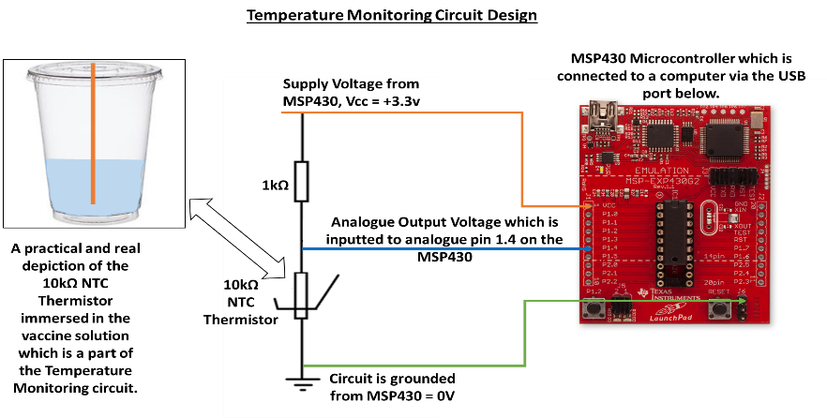

*Figure 3: Circuit Diagram showing how Temperature can be monitored*

|  |  |
| --- | --- |
| ***Temperature Monitoring Subsystem Results*** | |
| **Voltage, V/volts** | **Temperature ℃** |
| 2.93 | 30 |
| 2.91 | 31 |
| 2.89 | 32 |

### *Figure 4: Results obtained from Temperature Subsystem*

### Heating Control Subsystem

*Author: Shanice Ong Sheue Nie, Berat Cevik*

In this part of the project, we had to write a program on the Energia software that monitors the temperature of the mixture in the bioreactor and controls the heating system accordingly, in order to keep the temperature of the mixture within a specified range. If the voltage goes higher than 2.93V (which means the temperature is lower than 30°C), the computer sends a digital signal of “HIGH” (3.3V) through the output PIN to the heater to turn it on by closing the MOSFET switch. If the voltage is lower than 2.93V (which means the temperature is higher than 30°C), the computer sends a digital signal of “LOW” (0V) through the output PIN to the heater to turn it off by opening the MOSFET switch. Alternatively, to turn the heater on and off manually the integers “1” and “0” can be entered into the serial communication window to send a digital signal of “HIGH” and “LOW” respectively to the heater. The temperature readings can be observed and the operations can be done through a common Graphic User Interface, shared with the other two subsystems. When the temperature is > 32°C, an LED lights on the microcontroller.

Since the average maximum temperature in Uganda does not exceed $28°C$, we decided to include only a heating system, without a cooling system. This decision meant that the ME/CEGE specialist team had to source less power for the system.

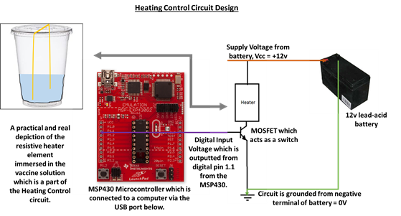

*Figure 5: Circuit Diagram showing how heating can be controlled*

**Heating Control Subsystem Results**

The results from the Heating Control Subsystem can be seen in Figure 6 of Appendix 1.

**Temperature Management Subsystem Results and Validation**

This graph proves that the overall subsystem works since it read the initial value of $29℃$ and sent the signal to the microcontroller which then activated the heating system. The vaccine was heated to its maximum optimal temperature of $32℃$.

**Appendix 1**

Macintosh HD:Users:ongheanboon:Desktop:Screen Shot 2015-12-20 at 10.07.43 am.png

*Figure 2: Conversion from analog input to voltage in Energia code*

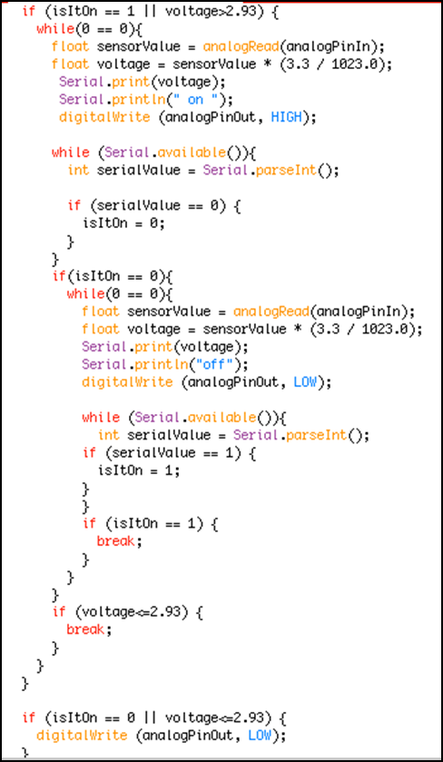

*Figure 6: Part of the Energia program showing the if-statements for turning the heater on and off*