CS529 HW1

Q1 – Software Installation and Readiness
I chose Gephi since my work environment is Ubuntu.

For installation, go to https://gephi.org/users/download/ and download the file required for your OS. For Ubuntu, this downloads an archive that contains necessary files and the binary to execute Gephi. No additional installation is required.

Q2-1 – VOSviewer Map & Network Generation
For this part, I chose the scientific network of Jeffrey Cohn, who is a prominent figure in affective computing. The data downloaded from webofscience includes ~140 authors. This data is filtered to eliminate duplicate authors and the resulting map & network files (vos-jeffrey_cohn-map.csv and vos-jeffrey_cohn-network.csv respectively) are attached to the submission. The network looks like the following image after cleanup and postprocessing. This image, as well as the raw data (named webofscience-jeffrey_cohn-raw.csv) are also attached to the submission.
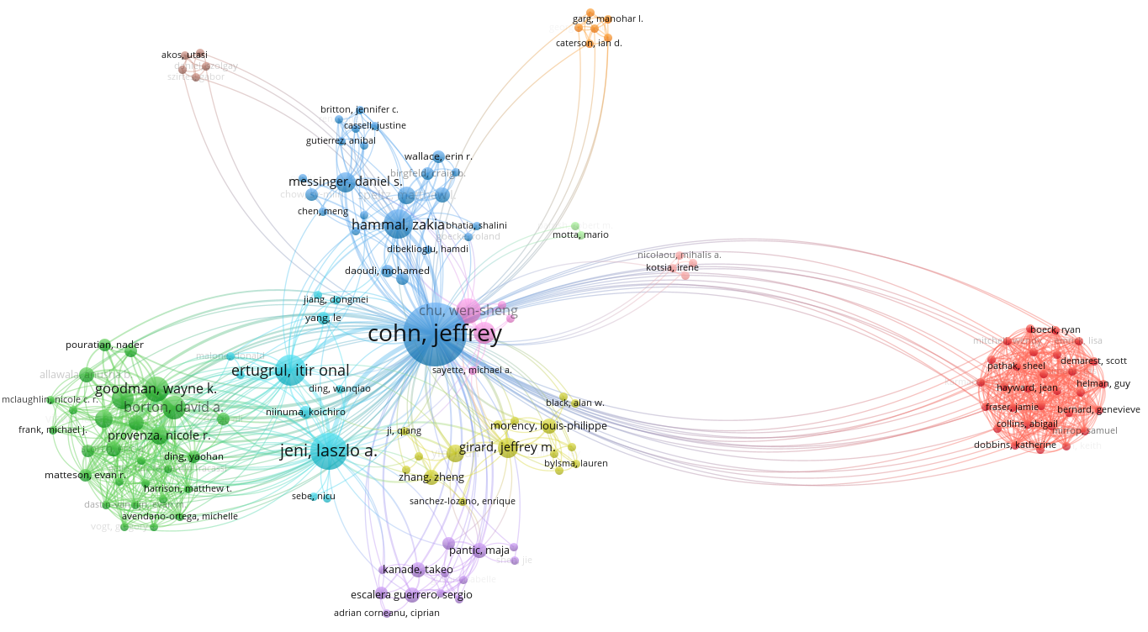
To obtain the same view, make sure maximum number of authors per document is set to 1000, minimum number of documents of an author is set to 1, and minimum number of citations of an author is set to 0, number of authors to be selected is set to 143.

Q2-2 Importing to Gephi & Analysis
In this part, I imported the previous map and network files to Gephi and modifed the resulting graph to look visually pleasing. Note that network file is modified before importing to Gephi such that the first line in the file now contains a “Souırce, Target, Strength” line to ensure Gephi-compatibility.
After importing, I ran ForceAtlas with repulsion strength=10000 and attraction strength=10. Then, I computed the degree of each node and filtered the node size such that the largest node size=100 and smallest node size=25. Afterwards, nodes are partitioned based on cluster ids imported from VOSviewer. The resulting graph is shown below. The graph generated by Gephi is also attached to the submission (named gephi-jeffrey_cohn.gexf.gephi).
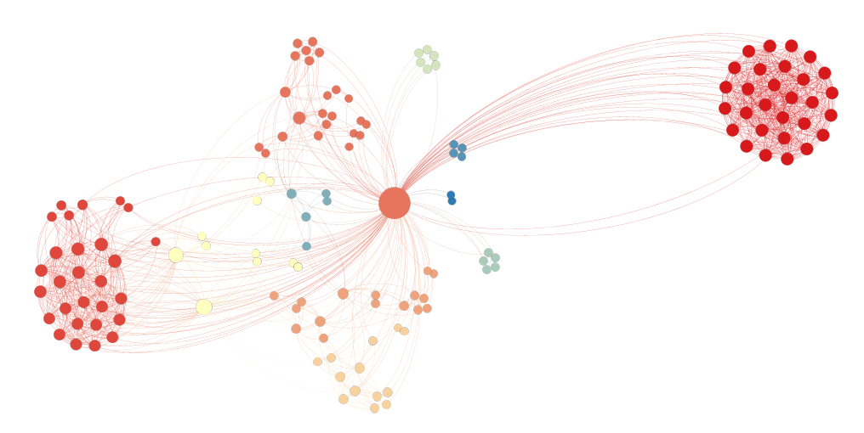
According to VOSviewer, this graph contains 11 unique clusters. Some are obvious and quite large, such as the two dark-red clusters on the opposite sides of the image, some are smaller in size which are weakly connected to the rest of the graph based on their connections to the center. This likely implies that there are certain groups of authors that study specific topics under the broad umbrella of affective computing which tend to cite other authors that study their topics, which results in densely-connected clusters. There are also authors that lie in between the left-most red cluster and the center which are connected to and cite prominent figures in many different clusters, indicating that these authors do not specialize in a specific area but rather prefer to study multiple distinct yet related fields.
Based on my observations, one interesting conclusion is that the center node, which is Jeffrey Cohn, seems to contribute, directly or indirectly, to many fields under affective computing and may be a leading figure in each as well. It’s also interesting to see so densely-connected clusters which could indicate that published work in these specific fields may be incremental or repetitive.
Apart from the center node, the next two most important nodes based on average degree (and node size by extension) are labeled “jeni, laszlo a.” and “ertugrul, itir onal”. Both of these authors lie in the yellow cluster that is between the dense, left-most cluster and the center ndoe. They are cited by most authors in this dense-cluster on the left, and are connected to the cluster on the top and the bottom (which are shown with orange-like colors). This means a large portion of the graph is connected to these nodes, which unsurprisingly increases their significance.

