CS529 HW2

Q1 – One-Mode Projections

1A - Person X Person Network
In the image, I share the Person x Person projection of the original graph. The nodes represent people attending to the events and the edges are weighted according to their values: The larger weight of an edge is, the thicker that edge is displayed.

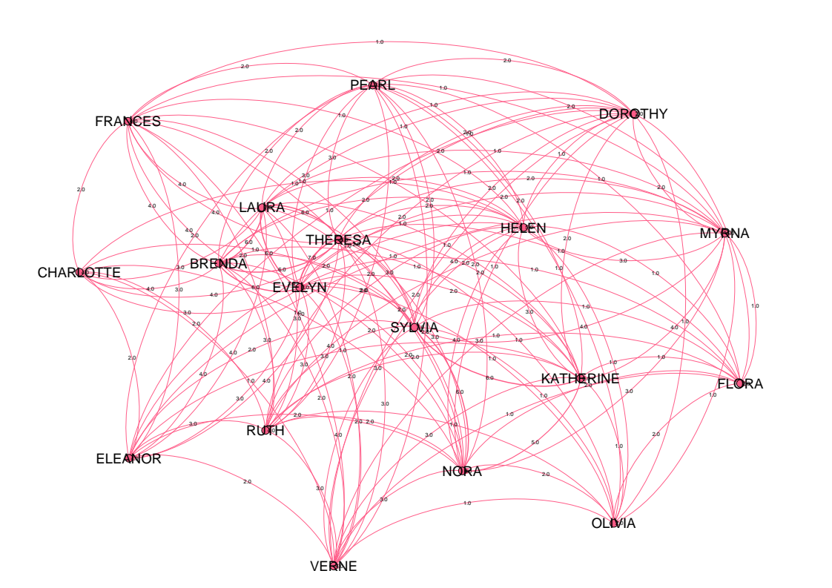
In my submission, ‘people_people.gexf.gephi’ contains the Gephi project containing the graph shown above. ‘people_people.pdf’ contains this image, and ‘people_people-graph.csv’ contains the adjacency matrix that this graph is based on. However, note that while importing the adjacency graph, since there are duplicate entries, make sure you select the ‘last’ as your merge option.

1B - Event X Event Network
The image below shows the Event X Event projection of the original graph. The nodes represent organized events and edges are weighted similar to the People x People projection: The larger weight of an edge is, the thicker that edge is displayed.

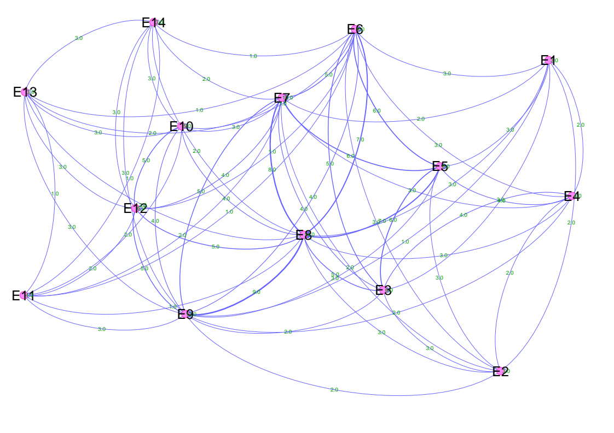
In my submission, ‘event_event.gexf.gephi’ contains the Gephi project containing the graph shown below. ‘event_event.pdf’ contains the image, and ‘event_event-graph.csv’ contains the adjacency matrix (plus the node directionality) that the graph is based on. However, note that while importing the adjacency graph, since there are duplicate entries, make sure you select the ‘last’ as your merge option.

Remarks Regarding Q1
Note that Gephi’s projection tool (Multimode Networks) did not provide self-loops, which required manual intervention. Hence, both of these graphs are constructed by manually processing the provided csv files in Python. The relevant script is also attached to the submission (named ‘script.py’).

Q2 – Interpreting People X People Network
People X People contains information regarding co-attendance of participants. For example, ‘Helen’ and ‘Verne’ attended three events simultaneously, specifically ‘E7, E8, E12’. Thus, the edge weight connecting these two nodes is 3, which means these two persons attended 3 events simultaneously. Since co-participation is a mutual relationship, the graph contains undirected edges only. Lastly, the self loops, which are referred to as ‘loops’ in the assignment correspond to the number of events each person attends. For example, ‘LAURA’ attends 7 unique events, thus the self loop over this node has a weight of 7.

Q3 – Interpreting Event X Event Network
Event X Event contains information regarding participants attending both events given an event pair. For example, persons ‘EVELYN, LAURA’ jointed both events ‘E1, E2’. Thus, the weight of edge connecting ‘E1’ and ‘E2’ is 2. Since the number of common participants between a pair of events is a mutual relationship, the graph contains undirected edges only. Lastly, the self loops which are referred to as ‘loops’ in the assignment correspond to the number of attendants for each event. For example, ‘E8’ has 14 total participants, thus the self loop over this node has a weight of 14.

