TED UNIVERSITY
Department of Computer Engineering
CMPE 491
Capstone Design Project I

PerDrobe
  - Technical Annex
Personalized Clothing and Outfit Recommendations
Team members
Yiğit Özmut — 10039204492
Atay Aktürk — 192232261
Seyid Berat Ergün — 10012213640
Supervisor
Ayşenur Birtürk
Jury members
Jury Member 1: To be determined by the supervisor
Jury Member 2: To be determined by the supervisor
Academic Year 2026–2027
16 October 2026

1 Project Overview
PerDrobe is a proposed mobile platform for personalized wardrobe, outfit and clothing recommendations. It will combine a private digital wardrobe with explicit style and fit preferences and signals from likes, saves and follows. Users will be able to request outfits from clothes they own or find catalogue items that complement those clothes. Product-level size guidance will be provided only where the available measurements and product size information support it.
Our recommendation pipeline will represent garments, construct candidate outfits and products, and rank them for a particular user. Outfit Remix will adapt a discovered outfit through compatible substitutions from the user’s wardrobe. We will compare a clothing-attribute baseline with configurations that add preference signals and wardrobe context. The work spans CMPE 491 and CMPE 492. This proposal describes the planned system and evaluation; no experimental results are available at this stage.
Project website: https://beratergun.github.io/perdrobe/
The academic project page hosts the proposal and will be updated throughout CMPE 491 and CMPE 492.

Problem and motivation
A clothing recommendation can reflect a person’s taste while remaining difficult to use with the clothes that person owns. Size selection introduces a separate uncertainty: a familiar size label does not by itself establish how a particular product will fit. PerDrobe brings wardrobe context, style preferences and supported fit information into the same recommendation workflow.
The intended users are people who want help assembling outfits from their own garments and assessing possible additions to their wardrobe. Social discovery will supply outfit references and preference signals through a limited set of sharing, following and saving functions.

Objectives and engineering contribution
We will build an integrated prototype for wardrobe management, outfit ranking, reference-outfit adaptation and catalogue recommendation. A separate size module will offer guidance for supported products. The prototype must preserve ownership boundaries, identify missing information and allow users to correct their preferences.
The engineering contribution is a controlled comparison of recommendation configurations that use different sources of personal context. We will examine whether interaction-derived preferences and wardrobe information change recommendation relevance, diversity and practical usefulness, and identify cases in which the additional context provides little benefit.

Research question
To what extent do style preferences derived from user interactions and personal wardrobe context improve clothing and outfit recommendation relevance over a clothing-attribute baseline?

2 Scope and Related Work
The core deliverable is a mobile prototype supported by a backend recommendation service and a bounded product catalogue. The following functions define the implementation scope across the two semesters.
Smart Wardrobe. Users will add and edit garments manually, attach images and record category, color, season and style attributes. Wardrobes will be private by default.
Personalized Outfit Recommendation. Style What I Own mode will rank compatible combinations of owned garments using stated preferences and available interaction history.
Size and Fit Recommendation. The system will estimate a suitable size for supported products using optional measurements, usual sizes, fit preferences and available charts. It will abstain when evidence is insufficient.
Outfit Remix. A reference outfit will be adapted to the user’s wardrobe through compatible substitutions, with reused items and unfilled roles identified.
Wardrobe-Aware Shopping. Complete My Wardrobe mode will rank catalogue items by personal relevance and the useful combinations they enable with owned garments.
Social Style Discovery. Users will share selected outfits, follow profiles or collections, like outfits and save collections. These actions will provide preference signals. Comments and messaging are outside the core scope.

Conditional extensions and exclusions
Duo Match is a conditional multi-user recommendation extension. It would seek two individually relevant outfits with compatible color, style or formality, using only information both users authorize. It may serve friends, siblings, partners or people attending the same event. It will be attempted only after the individual recommendation pipeline, core integration and evaluation preparation are complete.
Automatic clothing recognition, visual similarity search and automatic trend collection are optional investigations. Full virtual try-on, cloth simulation, advanced 3D avatar fitting, checkout, payment, comments and private messaging are outside the core scope. Manual garment attributes will remain sufficient for all core workflows.

Related work and positioning
Han et al. [1] model outfit compatibility and item completion using visual-semantic representations and a bidirectional recurrent model. Their work informs our treatment of compatibility between garments. He and McAuley [2] incorporate visual information into personalized ranking from implicit feedback, providing a reference for combining item representations with user signals. PerDrobe will examine these ideas in the context of an individual wardrobe.
Bayesian Personalized Ranking [3] provides an optimization objective for learning rankings from implicit feedback. We will consider this approach if sufficient interactions are available. Development will begin with an interpretable attribute-based baseline; model complexity will be guided by data suitability and validation. The cited methods and datasets have not been selected for adoption.

3 Recommendation Methodology

Representation and candidate generation
Each garment will have a stable identifier and structured category, color, season and style attributes. Brand, size, fit and an image will be optional. Missing attributes will be recorded explicitly. User profiles will distinguish stated preferences from estimates derived from interaction history. Before enough behavioral evidence is available, recommendations will rely on onboarding choices and garment attributes.
In Style What I Own mode, candidate generation will combine owned garments into outfits with compatible category roles. Request constraints and category filters will bound the search before combinations are scored. Catalogue discovery will retrieve items in relevant categories and retain their source and availability metadata. If no suitable candidate is available, the system will report the limitation.

Compatibility and personalized ranking
The first implementation will use interpretable attribute similarity and compatibility rules. Configuration B will add agreement with stated preferences and signals from likes, saves, follows and remix actions. Interaction weights and any time decay will be selected on validation data. An absent interaction will not automatically be treated as dislike, and repeated actions will not be allowed to dominate the profile without normalization.
Configuration C will add features describing a candidate’s relationship to owned garments. Catalogue ranking may account for the combinations a new item enables and its overlap with existing items. Outfit ranking may consider garment reuse and diversity across recommendations. We will start with a weighted score and investigate learned ranking or embeddings when the available data supports comparison. Candidate generation and ranking will operate on recorded garment and user data.

Outfit Remix and wardrobe completion
Outfit Remix will represent a reference outfit as garment roles with attributes, retrieve possible substitutions for each role and rank the resulting combinations jointly. Independent nearest-item matches can produce an incoherent outfit, so the final score must also account for compatibility between substituted pieces. The output will identify reused items, substitutions and missing roles. In wardrobe-only mode a missing role will remain unfilled; catalogue suggestions will be offered separately in Complete My Wardrobe mode.
For example, an outfit containing a white T-shirt, black jeans, white sneakers and an overshirt could be adapted using an owned white T-shirt, dark blue jeans and white sneakers. The jeans are a possible substitution; the overshirt remains an unfilled role. This example illustrates the intended workflow.

Size and fit estimation
The size module will normalize chart units and compare product-specific size ranges with voluntarily supplied measurements, usual sizes and fit preference. It will preserve distinctions between body measurements and garment dimensions. Where labels exist, a learned estimator can be compared with this chart-based baseline. Missing charts, ambiguous units or unsupported product categories will produce an insufficient-data response. A numerical confidence value will be used only if it can be calibrated against validation outcomes.

4 System Architecture and Data
The client will send authenticated requests to the backend. The backend will enforce permissions, obtain the permitted data and invoke the recommendation service. Models will be replaceable behind a stable service interface so experiments can compare ranking methods without redesigning the application.
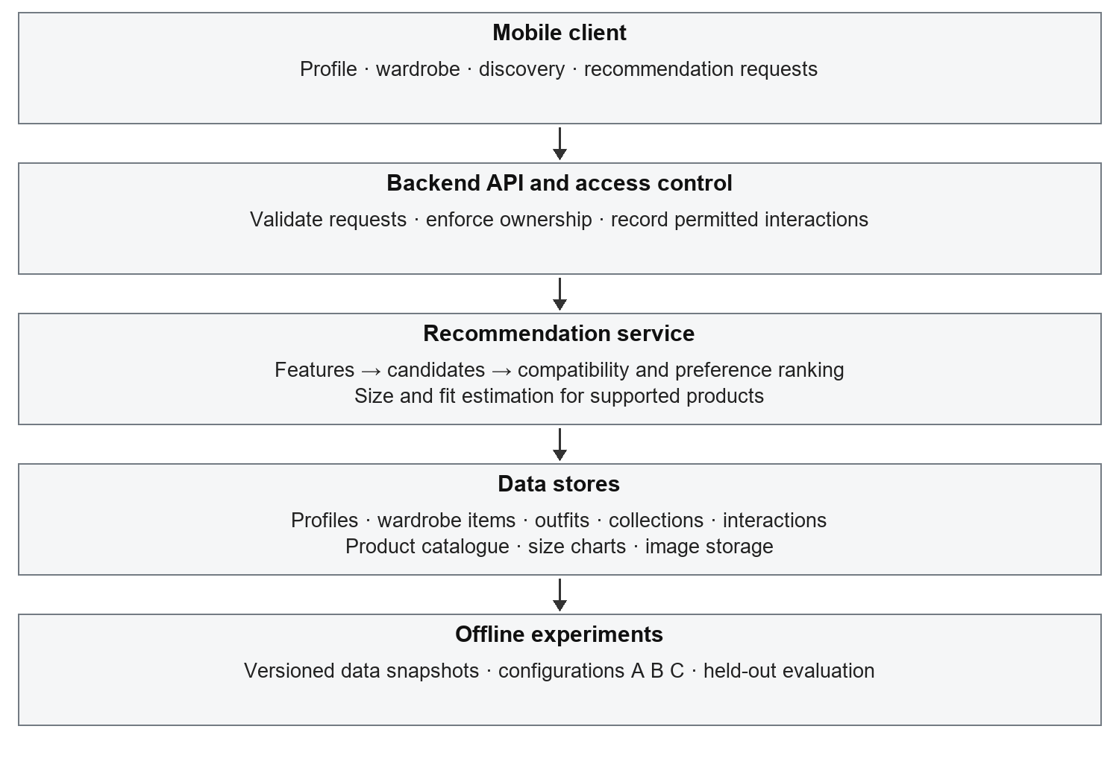
Figure 1. Proposed architecture. Arrows show the main processing sequence; the API mediates authorized reads and writes, and experiments use controlled data snapshots.

Data strategy and service boundaries
The relational data model will distinguish users, wardrobe items, catalogue products, outfits and their constituent items, collections, follows and timestamped interaction events. Ownership and visibility will be explicit. Product size charts will retain their source, unit and category. Image storage will be separate from structured records, with access governed by the associated item’s visibility.
Initial development will use a manually prepared sample catalogue or a dataset whose license permits the intended use. No retailer API, partnership, dataset size or live stock feed is assumed. Data preparation will record provenance, permitted use, missing fields and transformations. Sample data will test software behavior; it will not be presented as evidence of real-user recommendation quality.

Proposed implementation direction
The initial direction is Android with Kotlin and Jetpack Compose, a Python FastAPI backend, PostgreSQL and separate object storage. Supabase services are one option for authentication and storage. Recommendation experiments may use scikit-learn or PyTorch; vector indexing will be added only if needed. Technology choices remain subject to prototyping. The academic website will use static HTML and CSS on GitHub Pages.

5 Experimental Design and Evaluation
To what extent do style preferences derived from user interactions and personal wardrobe context improve clothing and outfit recommendation relevance over a clothing-attribute baseline?
Model | Inputs | Purpose
A | Clothing attributes only | Reference ranking based on garment compatibility and content similarity.
B | A + explicit preferences and interaction signals | Estimate the incremental value of personalization.
C | B + personal wardrobe context | Estimate the incremental value of wardrobe compatibility and reuse.

A, B and C will use the same representation, request constraints and eligible candidate pool within each task. Wardrobe-only candidates come from owned items in every configuration; C adds wardrobe features to ranking. Catalogue comparisons will use the same snapshot, avoiding gains caused by different candidate eligibility.

Protocol and relevance judgments
Outfit ranking, catalogue recommendation and remix adaptation will be evaluated separately. With sufficient timestamped interactions, we will use earlier events for training, a later interval for tuning and a final interval for held-out testing. Features will use only information available before each cutoff. Duplicate outfits and related item variants will be checked across splits to reduce leakage.
A consent-based user evaluation is planned, subject to supervisor agreement and applicable university processes. Recruitment and participant count remain open. Participants will assess shuffled recommendations without configuration labels. A pilot will establish relevance criteria and a graded rating scale, fixed before final testing. Explicit judgments will be distinguished from implicit signals; missing feedback will not be treated as dislike.
Area | Planned measures and interpretation
Ranking relevance | Precision@K for binary relevance and normalized discounted cumulative gain (NDCG@K) for graded ranking relevance. K and the rating rubric will be fixed before final testing.
Practical usefulness | User ratings of outfit wearability, faithfulness to a reference outfit and usefulness of catalogue additions, reported separately.
Diversity and coverage | Attribute-based intra-list diversity and the fraction of eligible catalogue items recommended across evaluated requests.
Size and fit | Exact-size or fit-category agreement on labeled, supported cases, alongside the supported-case and abstention rates. Charts alone are not ground-truth fit labels.
System performance | Median and 95th-percentile API latency under a documented workload, separating inference from network and storage time.

Analysis and limits
We will compare configurations per user, report uncertainty where justified and analyze cold-start cases separately. Conclusions will remain limited to the available judgments and fit labels.

6 Development Plan and Privacy
We will work in short implementation iterations using a shared issue backlog, version control and code review. Work packages will cover the mobile client, backend and data services, and recommendation experiments. Cross-review and regular integration will help the team identify interface problems early. Each iteration will produce a working increment and record design decisions and unresolved risks.
Course | Phase | Planned work | Completion evidence
CMPE 491 | Early phase | Refine requirements and related work; select permitted data; define schemas and evaluation protocol. | Reviewed scope, data inventory and testable requirements.
CMPE 491 | Middle phase | Build profile, wardrobe, catalogue and interaction services; integrate the mobile foundation. | Integrated vertical slice with access controls.
CMPE 491 | Final phase | Implement configuration A and initial size-chart logic; verify logging and initial recommendation flow. | Baseline prototype, design documentation and evaluation plan.
CMPE 492 | Early phase | Implement B and C; integrate Outfit Remix and wardrobe-aware shopping. | Comparable ranking configurations and core workflows.
CMPE 492 | Middle phase | Refine supported size guidance; run pilot evaluation; consider Duo Match only after core integration. | Frozen experiment protocol and tested core prototype.
CMPE 492 | Final phase | Run comparisons and user evaluation; test performance and privacy; stabilize the demonstration. | Final report, presentation, reproducibility materials and updated website.

These phases are indicative, not official course deadlines. Detailed dates will follow the course calendar and supervisor feedback. The CMPE 491 baseline, reliable data pipeline and access controls are prerequisites for the CMPE 492 comparison. Optional extensions will not displace final evaluation or core integration.

Privacy and security design
Wardrobes will be private by default. Sharing an outfit will require an explicit user action and will not publish body measurements or the rest of the wardrobe. The prototype will minimize collected information and let users edit or delete their profile, measurements, garments and images. Duo Match, if implemented, will use only mutually authorized items and preferences.
The backend will validate authentication and resource ownership on every protected operation. Planned controls include encrypted transport, protected image access, file-type and upload-size validation, and exclusion of measurements and credentials from application logs. Tests will include attempts to read or modify another user’s records. Experiment logs will use pseudonymous identifiers and a defined retention period agreed before participant data collection.
Fit guidance will describe garment suitability without judging a user’s body. Users will be able to correct inferred preferences. Evaluation will examine whether ranking repeatedly favors a narrow set of styles or popular items. Permissions and university requirements will be reviewed before participant data is collected.

7 Risks and Expected Deliverables
Risk | Mitigation
Data access and licensing | Use a bounded, manually prepared or permitted catalogue; record provenance and reuse conditions. Retailer integration is not a dependency.
Sparse preference history | Use onboarding and content similarity for new users; report cold-start and returning-user results separately.
Incomplete size information | Normalize units, retain product/category context and abstain when charts or labels are inadequate.
Scope and integration | Protect the recommendation comparison and core workflows; defer Duo Match and visual extensions. Integrate early through versioned API contracts.
Biased or weak evaluation | Use matched candidate pools, held-out judgments and per-user summaries; report limitations and negative findings.
Private data exposure | Test ownership checks, image access, deletion and consent boundaries before participant use.

Deliverables and completion criteria
By the end of CMPE 491, we aim to deliver the requirements and design documentation, data inventory, integrated wardrobe/profile foundation, initial interaction storage, content baseline and evaluation protocol. CMPE 492 will deliver the integrated core prototype, recommendation comparisons, supported size module, final report and demonstration. The project website will retain the proposal and add later reports and presentations at the same address.
Core acceptance will require a user to add and manage garments, obtain an owned-item outfit, remix a reference outfit with explicit substitutions, and inspect a catalogue addition in wardrobe context. Supported size requests must show their basis; unsupported requests must abstain. Experiment materials will record the data version, split, configuration, random seed where applicable and metric definitions. Privacy tests and reproducible evaluation scripts will accompany the final implementation.
The project will produce an integrated prototype and evidence about the benefits and limitations of preference signals and wardrobe context. The final report will relate the observed results to the available data and evaluation conditions. It will document unsuccessful approaches, incomplete core tasks and deferred extensions as well as any measured improvements.

References
[1] X. Han, Z. Wu, Y.-G. Jiang and L. S. Davis. Learning Fashion Compatibility with Bidirectional LSTMs. ACM Multimedia, 2017.
https://arxiv.org/abs/1707.05691
[2] R. He and J. McAuley. VBPR: Visual Bayesian Personalized Ranking from Implicit Feedback. AAAI, 2016.
https://arxiv.org/abs/1510.01784
[3] S. Rendle, C. Freudenthaler, Z. Gantner and L. Schmidt-Thieme. BPR: Bayesian Personalized Ranking from Implicit Feedback. UAI, 2009.
https://arxiv.org/abs/1205.2618

