Evolution Map Builder

# Step 1 – Read image as grayscale

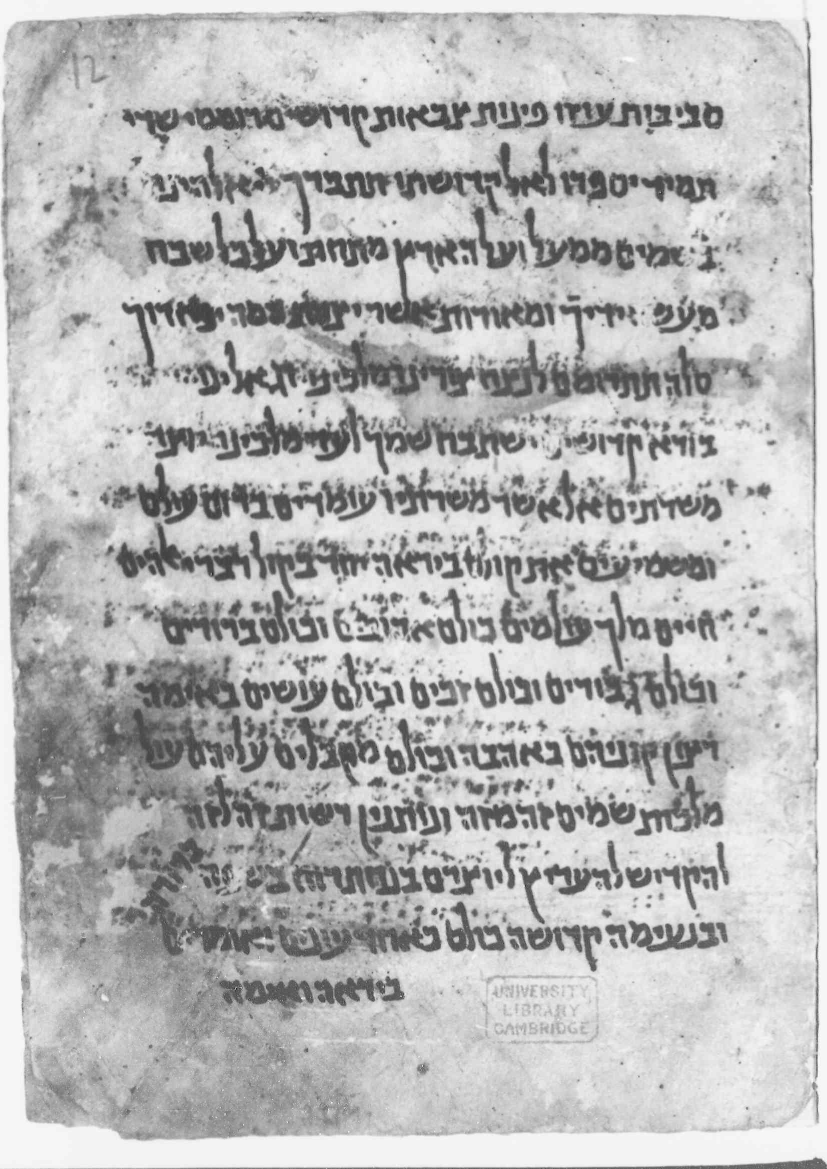

# Step 2 – Threshold the image for each threshold value between 0 and 255

Example for threshold for the value of 156 –

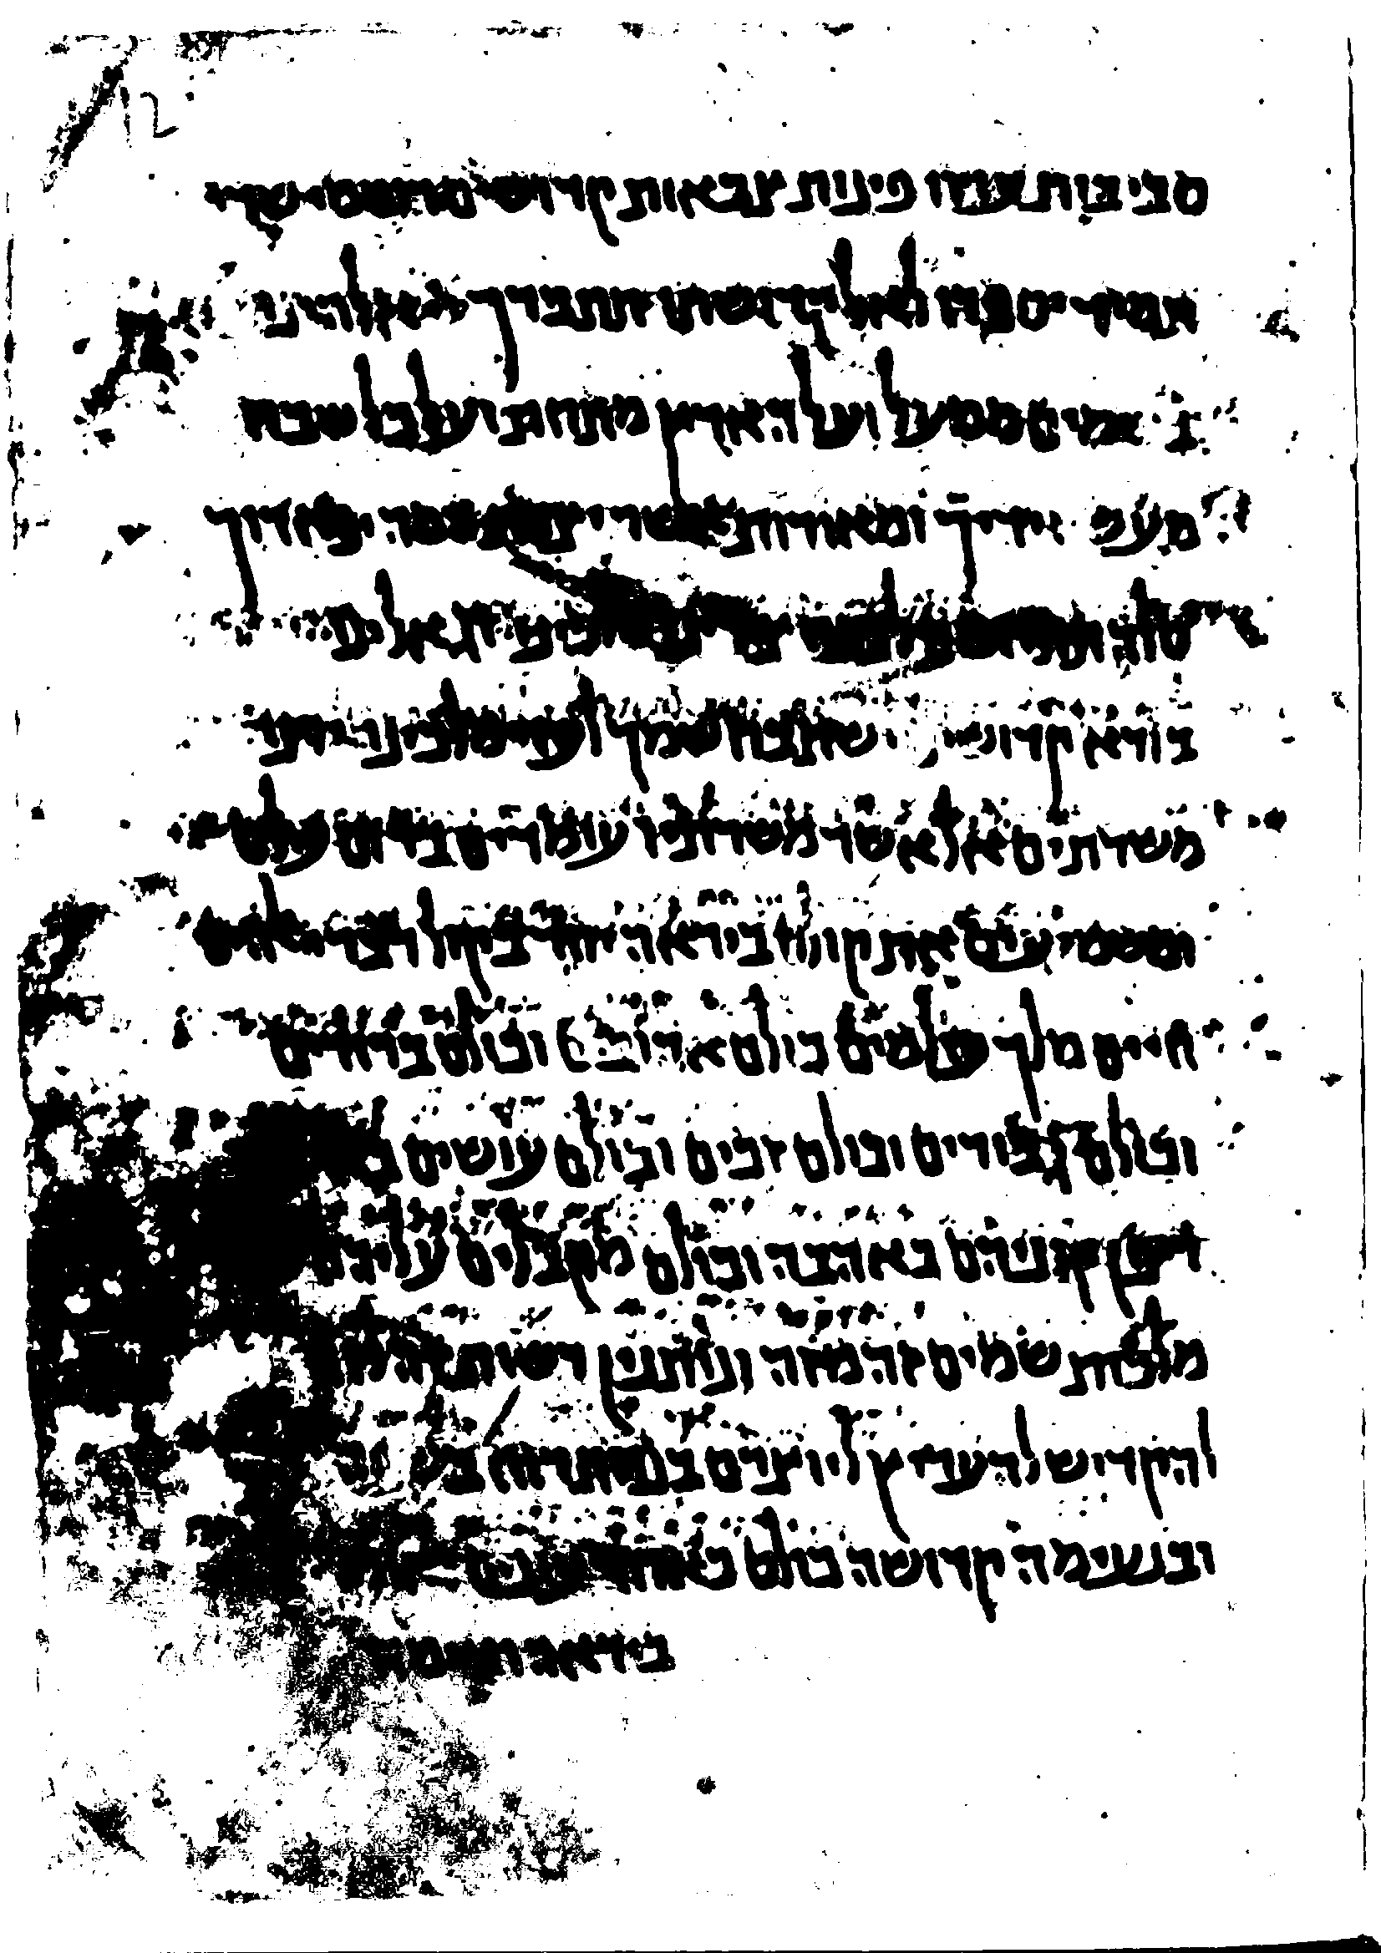

# Step 3 – Find components in the image after threshold

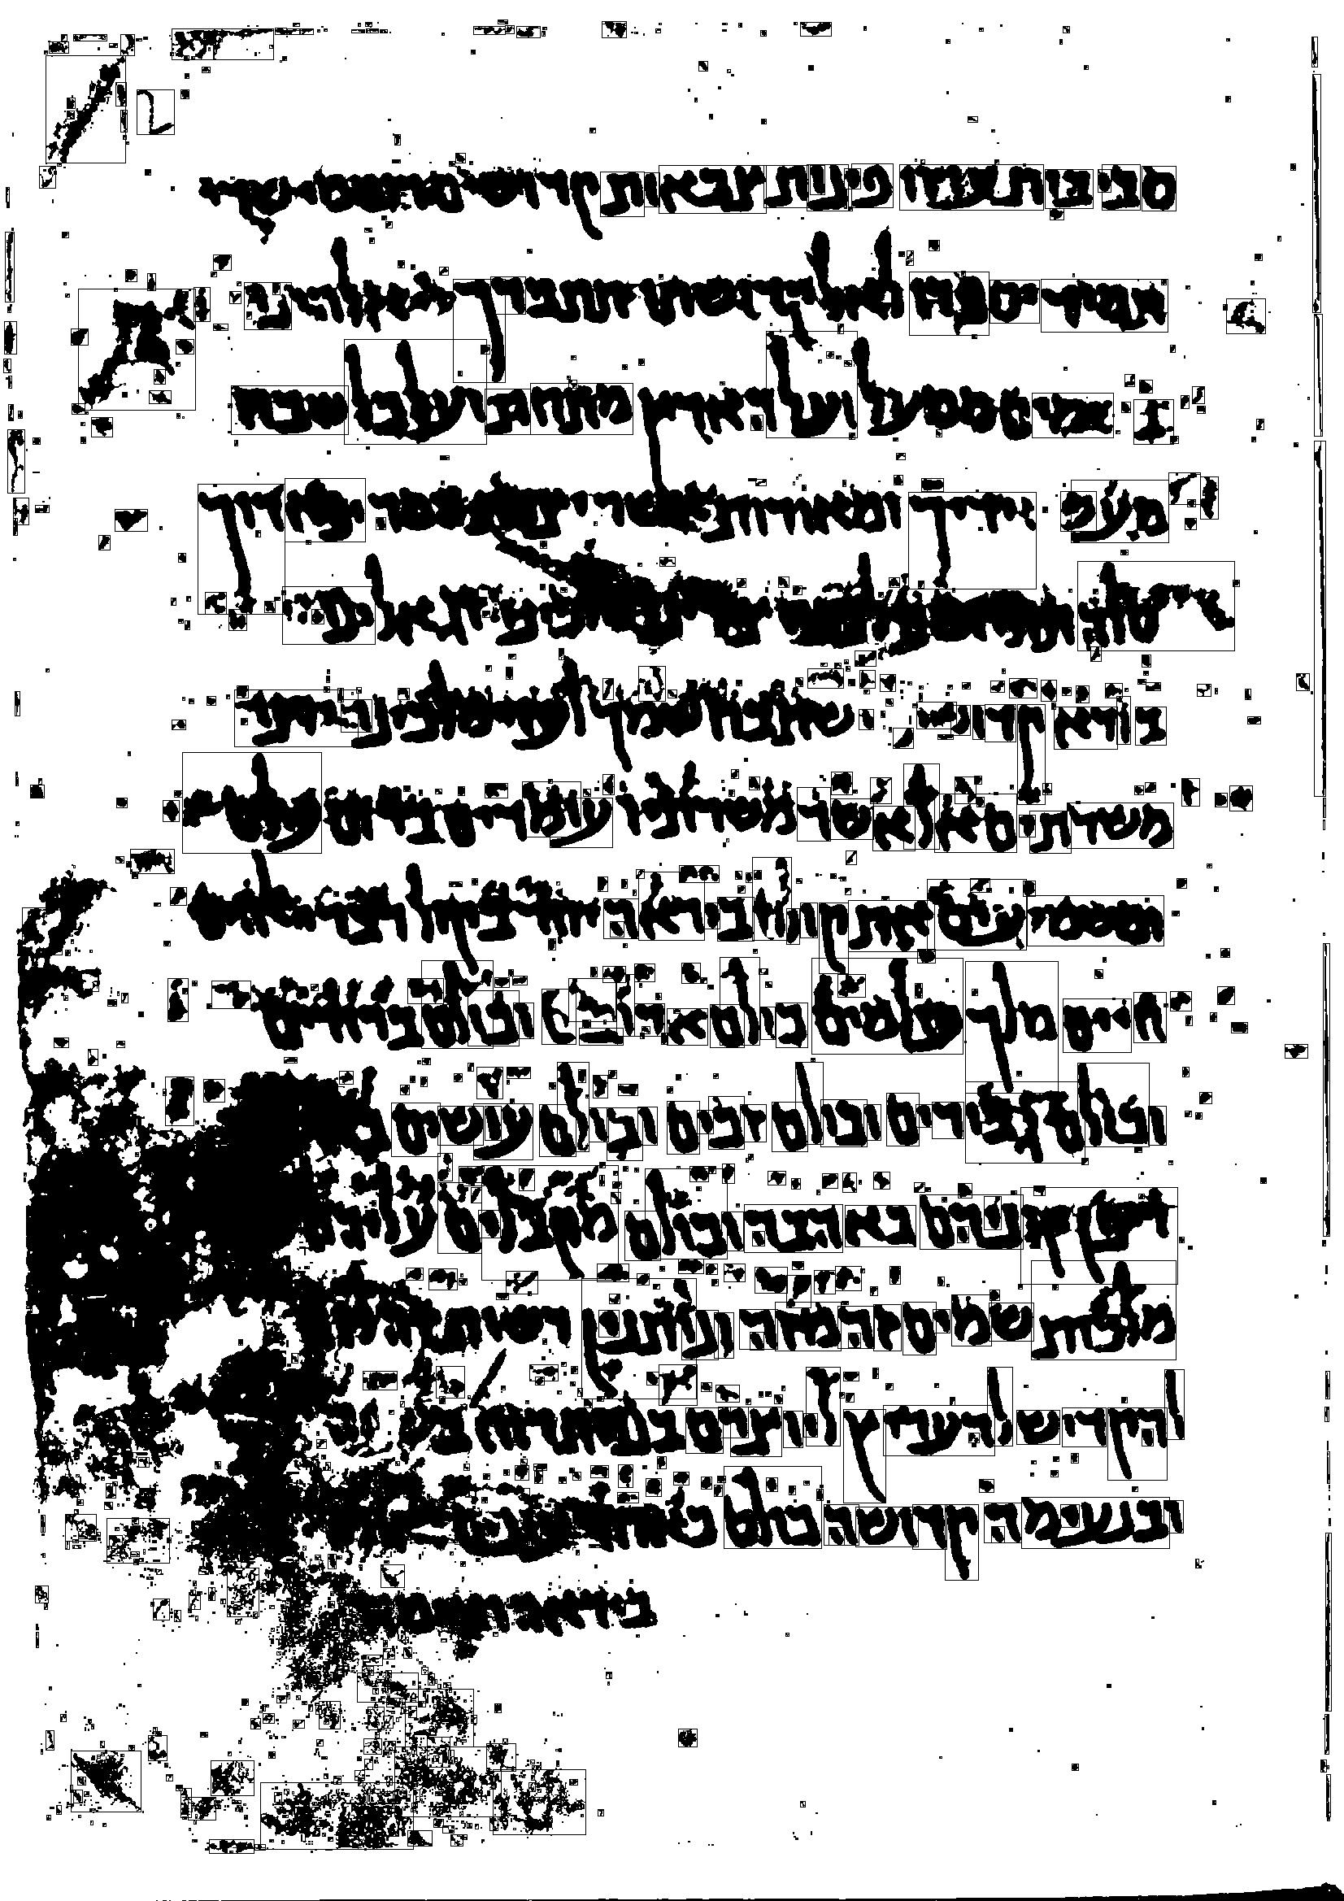

Note – the components are marked in black rectangles – and are relevant for the image with the threshold of 156. It obviously changes between different threshold values.

# Step 4 – Calculate component-count evolution map and relative-total-area-evolution-map

## Component-count EM –

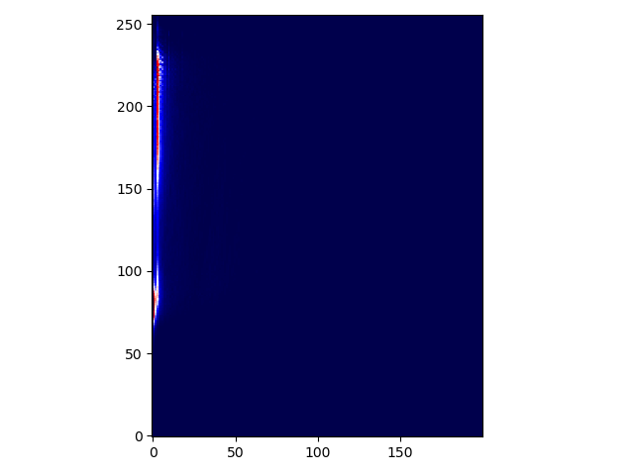

## Relative Total Area EM –

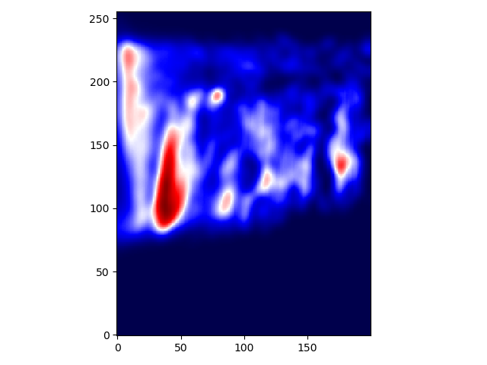

# Step 5 – Find Blobs in EM and Calculate Scores

