LEARN COMPUTER

TODAY

PROFESSOR: MICHAEL, TAN

TITLE: WEB DEVELOPMENT

HTMI - Hypertext Markup Language, consist of elements and tags

CSS- **Cascading Style Sheets**

**JavaScript- take an interactive the website project.**

**The main component of web development, particularly in front-end-development, used by three primary technology JavaScript, CSS and HTML.**

**Web developer – is the one way to looking and find the element of certain project in web project in other side, used by the inspect method.**

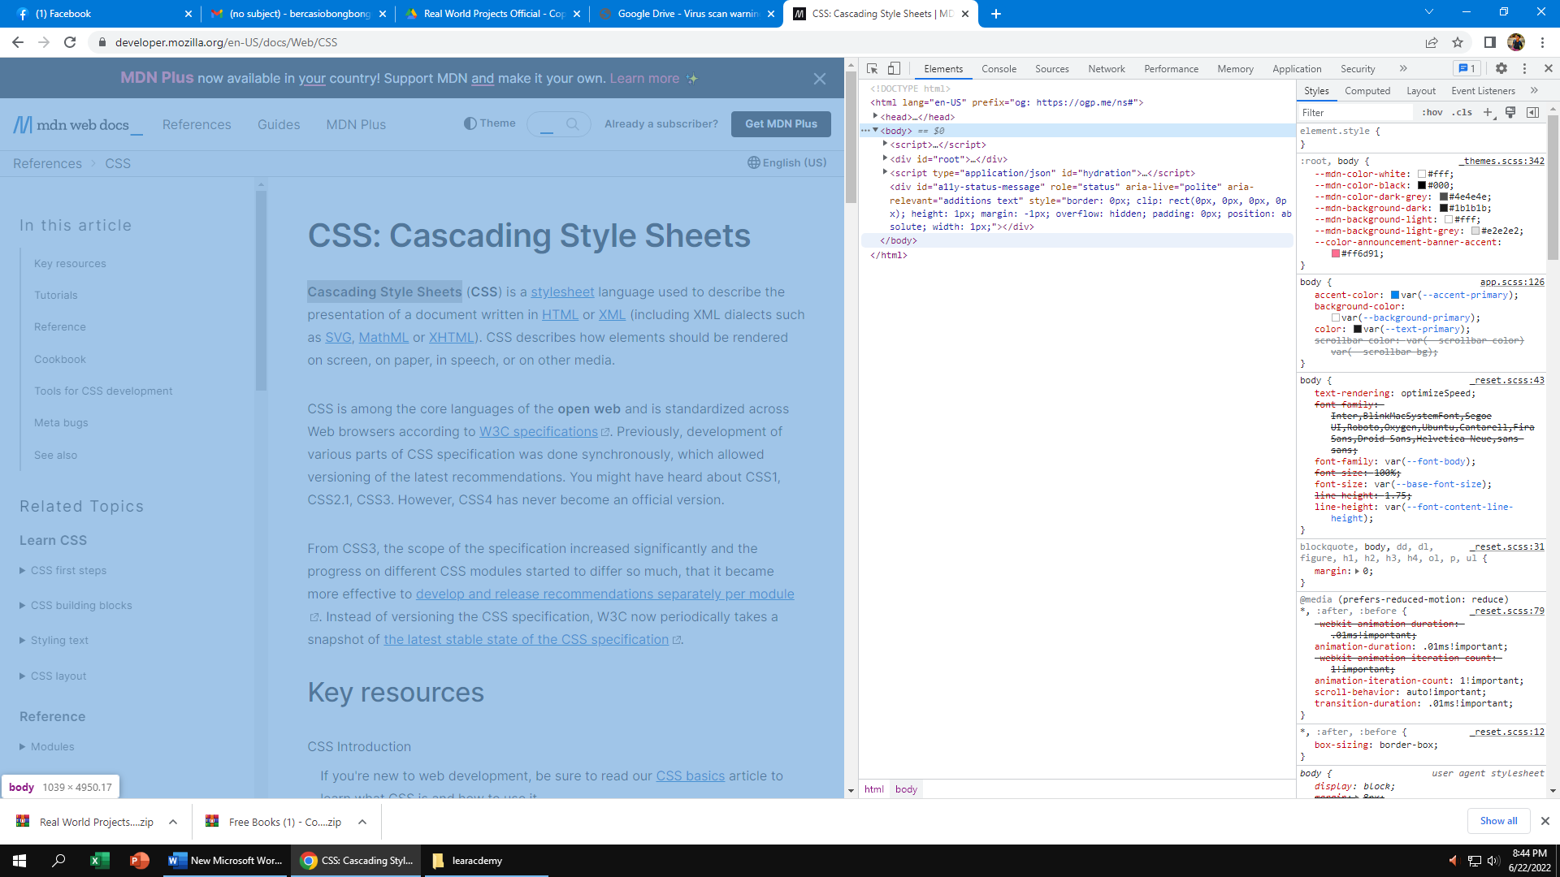

**Browser – is the way, of all the element or tag syntax in short HTML which is the browser read the markup of HTML by reading the document in html they read over right and left**

**Syntax -🡪 Rule**

**<!DOCTYPE html> ---🡪 document type in html**

**<html><html> ------🡪 html document**

**<head><head> -🡪main content/ purpose of the document**

**<title><title> ---- short or main topic of web page**

**<body><body> -🡪 main content**

**<h1><h1> --🡪 main heading / main title**

**<p><p> -🡪 information about the page**

**<footer><footer> ---🡪 additional info**

**Indention---🡪is to arrange or divide in every section of tag element. In that way, it easy to locate the element to declare**

**<ol start=”5”>--🡪 continue the number from the other ol element.**

**<meta charset = “utf-8’> is the character set of the keyboard such as integer or special character, while the it refers universal code will able to translate in various of language like japan or English Is to define to read the content the website.**

**Attribute --🡪 is to define the character set all over the code**

**Value -🡪 comes from the declare of attribute.**

**<br> 🡪 take space on the paragraph.**

**Viewport-🡪 is the responsive method, there are manipulate it’s either laptop, mobile and desktop device**

**Anchor tag -🡪 it to show where the link is located. <a href = “#” <a>**

**Hashtag or # 🡪 is to stay on the main page.**

**Inline 🡪 is the same line of the element.**

**Id-🡪indication in the element or known as the attribute.**

**Debugging -🡪 is to locate the main reason or something conflict.**

**CSS --🡪 it’s arranged the html or know as document style.**

**Example:**

**H1 {----🡪 selector**

**property**

**color:blue;**

**value**

**property**

**font-size:12px;**

**value**

**}**

**Selector * ---🡪 is all element in html.**

**Comment tag --🡪 in every declare in particular you must be adding or put comment as your start your code, in that way it’s easy to locate, and clean and organize properly**

**Fonts --🡪 if you declare the fonts as a developer look the fonts that appropriate the client where the client is will amaze.**

**Position relative --🡪 it’s go in the flow what declaration you put or go along the process or the adopt**

**Position fixed--🡪 whatever we sit in the declaration there are stay on.**

**Indention --- must be arrange the indent the element for easy to recognize and debug in case of modify and updating.**

**Algorithm -🡪 rules to be followed in calculation or other problem solving especially the computer**

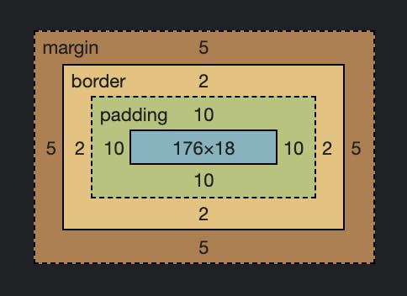 **BOX SIZING**

Responsive --🡪 adjustment the screen size used by the media query method

Practice more to enhancement the skills .

Pexel -🡪 for picking some free image from website try to go the pexel website.

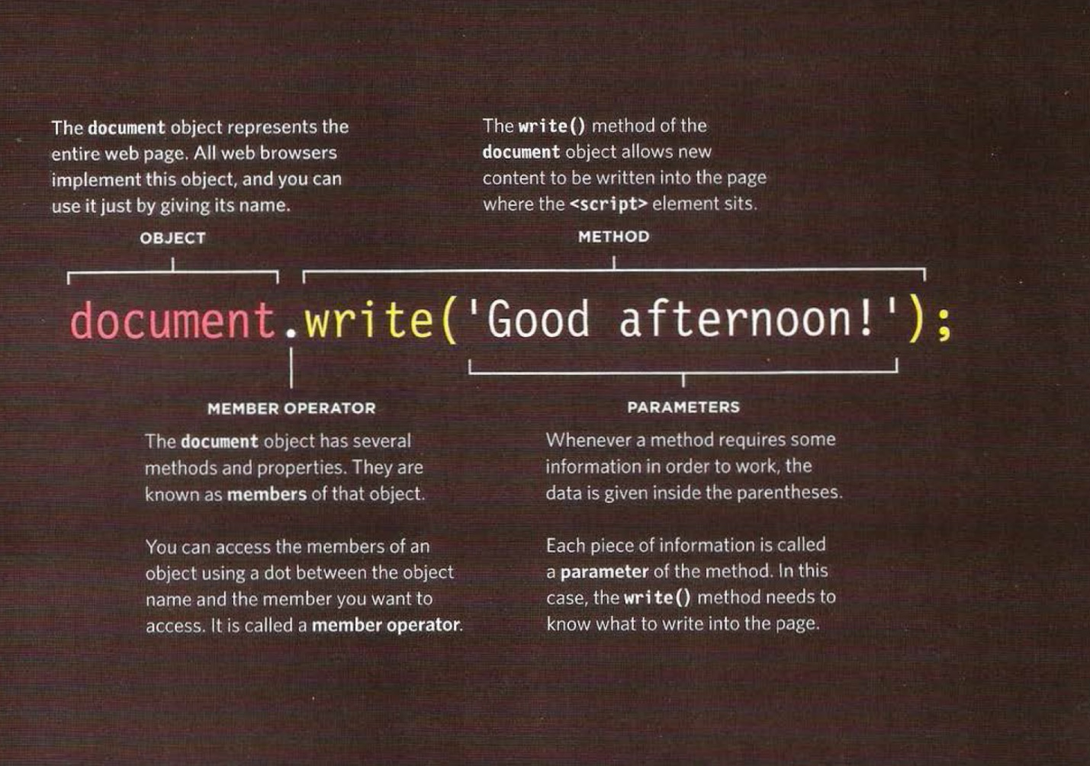

var nam Window.prompt(“plase enter your name”)

outcomes in browser

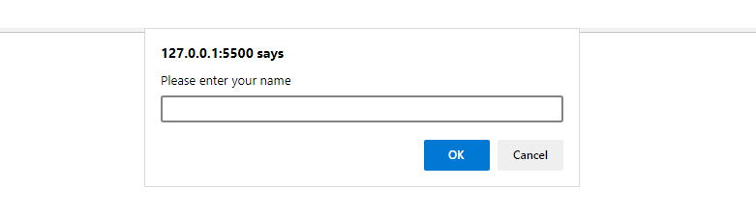

*var* password;

*var* pass1 = "bong";

password = prompt("Please enter your password to view this page!");

*if* (password==pass1) {

        alert("password is correct ! Click ok to enter");

   }*else*{

    window.location = "bong.html";

   }

Outcomes in browser

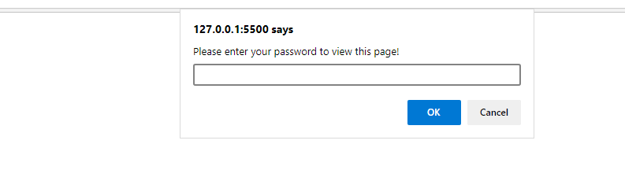

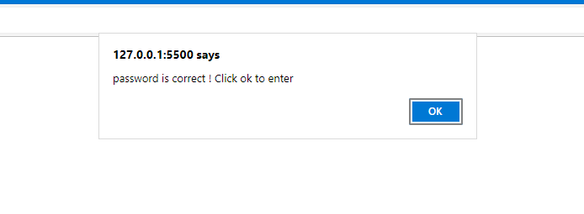

*var* url_link = $("#link-element").attr("href");

    console.log(url_link);

to entering the specific website like google used this kind of method to pursue the website you get. Use the var and the value var your putting for declare and used by the assignment operator or equal, then the standard of the dollar sign as a first to declare instance of element.

Inside of it as called argument put or get the DOM from hmtl of CSS started of either class of id as the modification and identification and add with method along the parameter whether key method or adding the class.

    $("#link-element").attr("href", "https://www.udemy.com");

    url_link = $("#link-element").attr("href");

    console.log(url_link);

As same the above explanation. The different is the the parameter of method it is the link there take.

    $("#toggle-tab").click(*function*() {

        $("#tab-content").toggle(500);

        $("#toggle-tab").toggleClass("bong");

    });

    $("#toggle-tab").click(*function*() {

        $("#tab-content").toggle();

        $("#toggle-tab").toggleClass("bong");

    });

This kind of method which is toogleClass there are preparing an class or id in css whereas the name of class is “bong”.

Outcomes

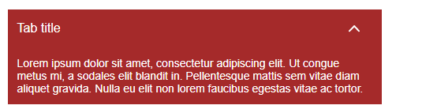

In the jQuery event if you are to figure the some classic of event In document either In internet there had a lot of information you took up particularly the animation event.