Inheritance

**DEADLINE:** 26/05/2020

## FOLDER STRUCTURE

|  |  |
| --- | --- |
| FL13_HW15/*  └─ homework/*  └─ index.html*  └─ .eslintrc.js  └─ js*  └─ task1.js*  └─ task2.js* | *   – required |

## TASK

1. Create your own **assign** method which mimics **Object.assign**.
2. Create **Vehicle, Car, Motorcycle**

Classes accept the following properties during creation;

**Vehicle**: color, engine,

**Car**: model, color, engine;

**Motorcycle**: model, color, engine

All classes by default have **maxSpeed** property. For **Vehicle** **maxSpped** = 70,

**Car**: **maxSpeed** = 80, **Motorcycle**: **maxSpeed** = 90;

***NOTE:*** If you need other properties you can add them

All classes have the following methods:

* **upgradeEngine(newEngine, maxSpeed)** – sets new engine and update maxSpeed; **NOTE:** You can upgrade engine only if car is stopped;
* **getInfo()** – returns information about class { engine, color, maxSpeed, model }.
* **drive()** - The vehicle starts to drive and every 2 seconds speed increase at 20.

If speed is greater than maxSpeed the warning message should be shown

**'speed is too high, SLOW DOWN!'**. But vehicle continues to drive;

When **Motorcycle** class starts to drive the message **‘Let’s drive’ is** shown.

Also for **class Motorcycle** if difference between current speed and maxSpeed is greater than or equal to **30** the message **‘Engine overheating’** is shown and **Motorcycle** begin braking.

N**OTE:** if car already drive you can't call this method again.

* **stop()** - The vehicle decrease it's speed every 1,5 second at 20.

When vehicle is stopped, the following messages should be shown:

* + For **Vehicle** class - **“ Vehicle is stopped. Maximum speed during the drive was *** ”;**
  + For **Car** class **– “Car ** is stopped. Maximum speed during the drive *** ”;**
  + **For Motorcycle – “Motorcycle ** is stopped. Good drive”;**

**\*\* -** model of the vehicle;

**\*\*\*** - max speed from moment the vehicle begin drive until stopped;

**NOTE:** if vehicle begin braking you can't do it again, the message **‘Already slows down’** should be shown, but you can continues to drive;

The **Car** class has **changeColor(newColor)** method – sets the new color for the Car.

**NOTE:** you can’t choose the color in which the car is already painted

***NOTE:*** If you need other methods you can add them

RESTRICTIONS

* Do not use ES6 classes
* Do not use any external libraries

## CODE

**TASK 1**

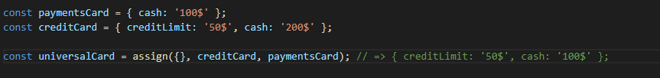

**TASK 2**

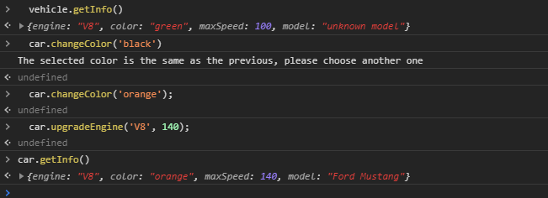

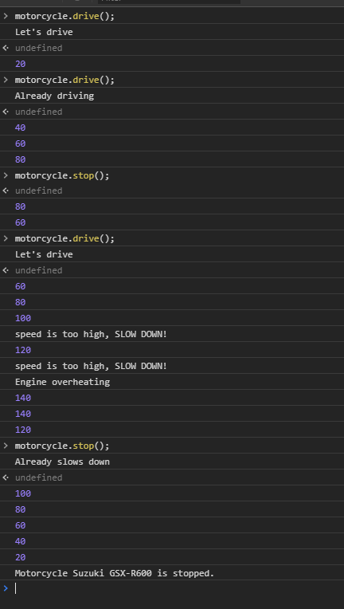

## BEFORE SUBMIT

* Check if invocation examples are working with your code;
* Check file structure;
* Check code structure (remove unnecessary code/comments).
* Validate code via eslint;

In order to use npm you should install nodejs (https://nodejs.org/ );

Install eslint to check your code (npm install -g eslint);

open a terminal (or cmd);

go to js folder;

run eslint ./${file-name}.js;

Code should be without ‘errors’;

**SUBMIT**

* The folder should be uploaded to github repository '**FL-13**' into **master** branch

## USEFUL LINKS

* <http://eloquentjavascript.net/06_object.html>
* <https://developer.mozilla.org/en-US/docs/Web/JavaScript/Inheritance_and_the_prototype_chain>
* [JavaScript inheritance behind the scene __proto__, [[prototype]] and prototype](https://hackernoon.com/understand-nodejs-javascript-object-inheritance-proto-prototype-class-9bd951700b29);
* [Inheritance and the prototype chain](https://developer.mozilla.org/en-US/docs/Web/JavaScript/Inheritance_and_the_prototype_chain);
* [Common Misconceptions About Inheritance in JavaScript](https://medium.com/javascript-scene/common-misconceptions-about-inheritance-in-javascript-d5d9bab29b0a);
* [Object.create](https://developer.mozilla.org/en-US/docs/Web/JavaScript/Reference/Global_Objects/Object/create);
* [Composition over Inheritance](https://www.youtube.com/watch?v=wfMtDGfHWpA);