- Use case diagram
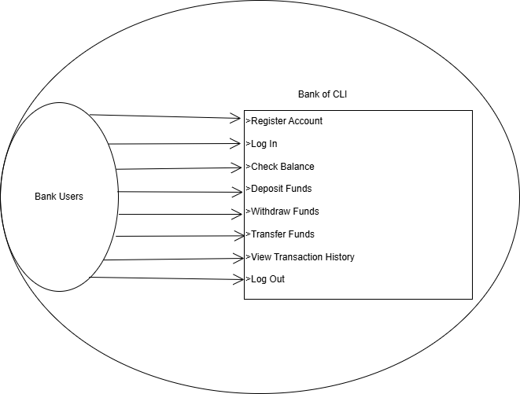
- User stories
As a user I want to register, then I can access Bank of CLI.
As a user I want to login, then I can access the Bank of CLI.
As a user I want to check balance, then I can see the amount of money what I have
As I user I want to deposit money, then I can save money into my account.
As I user I want to withdraw money, then I can buy anything what I want
As a user I want to transfer money, then I can send money to my family.
As a user I want to see transactions history, so I can track my payment history.
As a user I want to log out from my account, then I can keep my account safe.

- Class model diagram
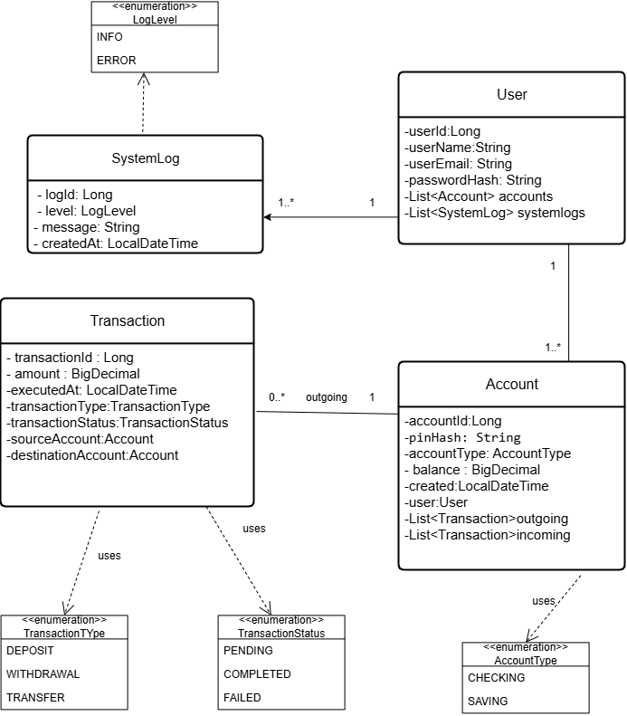

- ERD diagram
