Refinitiv captures and calculates over 500 company-level ESG measures, of which a subset of 186 of the most comparable and material per industry fields power the overall company assessment and scoring process.

The underlying measures are based on considerations around comparability, impact, data availability and industry relevance that varies across each industry groups. They are grouped into 10 categories. A combination of the 10 categories, weighted proportionately to the count of measures within each category, formulates the three pillar scores, ESG Score, ESG Controversy Score and ESG Combined (ESGC) Score which is discounted for significant ESG controversies impacting the corporations in our coverage which reflects the company’s ESG performance, commitment and effectiveness based on publicly reported information.

The comparable data measures for each industry are rolled up into 10 categories and then classified into 3 pillars. ESG Score is derived from the 3 pillar scores and the ESG controversies score is calculated from the controversies available for a company. The ESG Combined Score is derived from the ESG Score and the ESG Controversies Score.

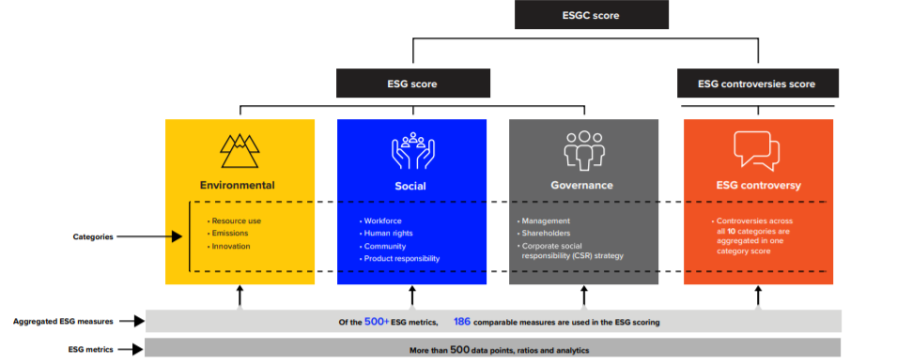

**Category Benchmarks**

• To calculate the Environmental and Social category scores, as well as the Controversies score, TRBC Industry Group is used as the benchmark as these topics are more relevant and similar to companies within the same industries.

• To calculate the Governance categories, Country of Headquarters is used as the benchmark as best governance practices are more consistent within countries.

Company Apple Inc’s TRBC Industry Group is Computers, Phones & Household Electronics and the country of headquarter is United States.

Firstly, we will treat underlying data points – Boolean data and numeric data. Each measure has a polarity indicating whether a higher value is positive or negative. For instance, having an emissions reduction policy is positive, but having environmental controversies is negative (Boolean data). More water recycled is positive, but more emissions is negative (Numeric data).

Boolean questions are typically answered with ‘Yes’, ‘No’ or ‘Null’. For instance, data measure ‘Policy water efficiency’ (Does the company have a water efficiency policy?) is positive data measure. If company published that they have initiatives to reduce water efficiency, we answer Yes, then this Boolean data measure is converted to numeric value ‘1’. If company published that they do not have any initiatives to reduce water, answer No, and will convert No to 0.

Boolean data points are converted to numeric values for the percentile score calculation. Details are available in the table below:

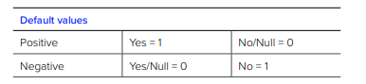

We use Percentile rank scoring methodology to calculate the 10 category scores and the ESG Controversies score. The methodology is based on three factors:

• How many companies are worse than the current one?

• How many companies have the same value?

• How many companies have a value at all?

Below is the formula of Percentile rank scoring methodology:



As mentioned above, TRBC Industry Group is used as the benchmark when calculate Environmental and Social Category Scores

For instance, we calculate Emissions Score of FY2020 for Apple Inc data measures with Trophy icon will be involved in company’s ESG scores calculation.

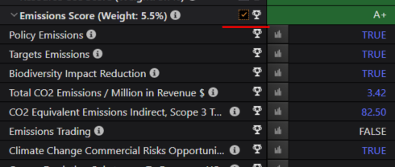

**How to calculate Emissions category score of Apple Inc**

* There are 23 metrics that are considered in calculating emission category scores.
* Values are extracted for all 23 metrics
* Numeric metrics are considered only if reported by the company
* Relevant numeric values are assigned and calculated for Boolean metrics
* Percentile score calculation formulas are applied for each measure

Take ‘Total CO2 Emissions/Million in Revenue’ as an example, use below formula to calculate:

In the same industry:

1.How many companies reported ‘Total CO2 Emissions/Million in Revenue’

2.How many companies have the same value with Apple Inc.

3.How many companies have worse value compared with Apple Inc.



The same steps are applied to all other data points in the category.

After deriving percentile scores at a data point level, percentile scores are summed up at a company level. Percentile scores at company level are sorted from highest to lowest. Then use percentile scores formula to derive the company’s emission category score.

Kindly find the category scoring example in Appendix A (page 16-17) of ESG scoring methodology.

<https://www.refinitiv.com/content/dam/marketing/en_us/documents/methodology/refinitiv-esg-scores-methodology.pdf>

Kindly note that country of headquarter is benchmark for governance category score, formula is the same.

After calculating category scores we can use category weight to calculate the pillar score.

|  |  |
| --- | --- |
| Title | Title |
| Resource Use Score | Environment Pillar Score |
| Emissions Score |
| Innovation Score |
| Workforce Score | Social Pillar Score |
| Human Rights Score |
| Community Score |
| Product Responsibility Score |
| Management Score | Governance Pillar Score |
| Shareholders Score |
| CSR Strategy Score |

**Category weights**

The weight of each pillar is defined by the type of company. Objective and proprietary ESG magnitude (materiality) matrix – the introduction of objective and market dynamic industry-specific ESG themes and category weights

Category weights will be calculated based on data to determine the relative importance of each theme to each industry group. Based on the themes covered in each category, suitable data points are identified which are used as a proxy for industry magnitude. The Themes to data points (KPIs) have a one-one relationship, in other words, there is one data point identified per the theme. For some themes, there are no KPIs that can be used as good proxies of relative importance due to primarily insufficient disclosure. Across categories of more than one theme and respective data points, the scoring methodology takes the average of each data point per industry group to calculate the weight at a category level.

Find more information in the ESG Scoring Methodology.

<https://www.refinitiv.com/content/dam/marketing/en_us/documents/methodology/refinitiv-esg-scores-methodology.pdf>

Appendix C (page 19) is the list of category weights that are used for the score calculation. Weights are applied in the ESG Score calculation at the Category level. Category weights are derived based on the materiality matrix. Appendix B (page 18) in the guide is the Materiality Matrix which identifies the relevancy or materiality of the industries for each category based on the data availability and industry relevancy.

**Materiality matrix**

The Materiality matrix is used to derive the Category weights.



For instance:

ESG Magnitude (materiality) matrix:

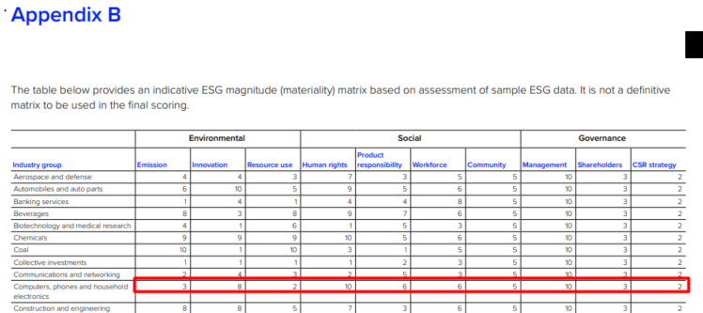

ESG Category Weight matrix:

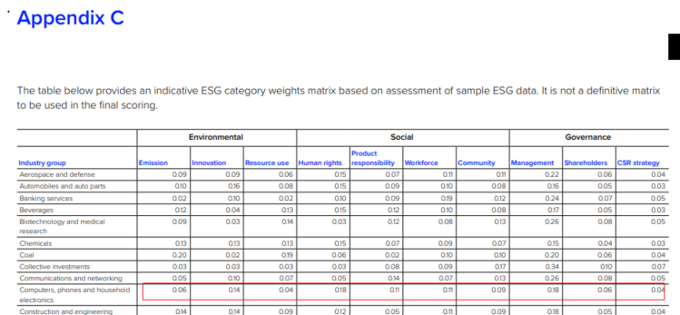

Sum of Magnitude of all categories (refer Appendix B) for Computers, Phones & Household Electronics = 3+8+2+10+6+6+5+10+3+2 = 45

Emission category weight (refer Appendix C) for Telecommunication Services = 3/45 = 0.06 (as mentioned in Appendix C)

Use the same method to calculate Environmental and Social category weights.

For governance category,

As all the data points are equally important to the calculation of magnitude weights for corporate governance in all industry groups, this calculation is based not on themes but rather on underlying data points. The default category weights are assigned at five points, with the points’ distribution ranging from 1 to 10. Since governance comprises three categories, the total points under governance would be 15. To derive the magnitude weight for governance, all data points per category are divided by the total of governance data points (part of scoring) and then multiplied by the total of 15 points. Find more details on page 10-13 of ESG scoring methodology document.

After we get all category scores and category weights, we can follow below steps to calculate the pillar score:

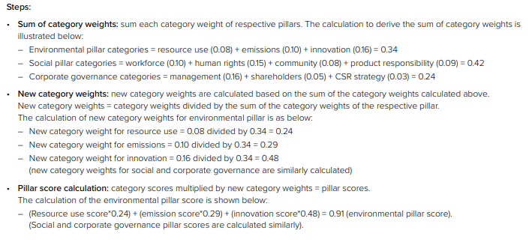

For IAM.CS, the calculations are as followed:

Sum of individual pillar weights= 3.7+5.5+13.8 = 23

New category weights = 3.7/23 = 0.16

5.5/23 = 0.24

13.8/23 = 0.6

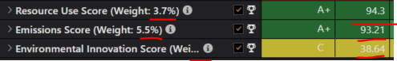

Pillar score calculation = 94.3*0.16 +93.21*0.24 +38.64*0.6 = 60.64 (this fig is rounded off)

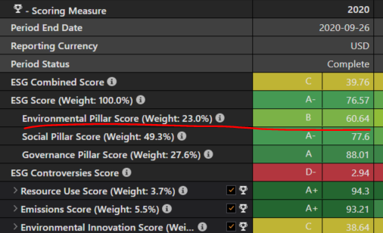

**For Apple Inc’s Environmental Pillar weight** = 3.7+5.5+13.8 = 23% (round off)

Then we can use below formula to calculate company ESG score:

ESG score = Environmental Pillar Score * Environmental Pillar weight + Social Pillar Score *Social Pillar weight + Corporate Governance Pillar Score * Corporate Governance Pillar weight

ESG Controversy Score is calculated based on 23 ESG controversy topics with recent controversies reflected in the latest complete period. The controversy news we add is dynamic i.e. ahead of adding other non-controversy data points. Non-controversy data points are added annually once for the company. Controversies that are marked under the prefix of ‘Recent’ are the controversies that have occurred post the Fiscal Year-End of a particular company. The arrangement of adding ‘Recent’ is for incorporating the latest controversies into the scoring methodology and for having the latest controversies impact the score of the company.

As the ESG controversies have a negative polarity. If the company has a controversy it will materially impact corporations, so when the companies are involved in ESG controversies the ESG Controversies Score will be lesser (below 100) and the ESG Combined Score is calculated as the weighted average of the ESG scores.

Find more detail ESG controversies calculation method on page 14 of ESG scoring methodology.

**ESG Combined Score** – ESG Combined Score is calculated as the weighted average of the ESG scores. When companies are not involved in ESG controversies it will get a score of 100 and as the combined score is the overall score considering ESG performance the ESG Score is considered for ESG combined score when the ESG controversy score when it is larger than the ESG score.

The main objective of this score is to discount the ESG performance score based on negative media stories. It does this by incorporating the impact of significant, material ESG controversies in the overall ESGC score.

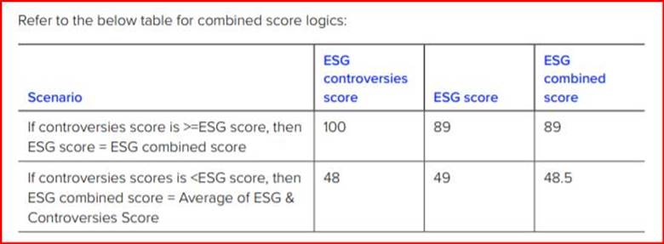

Find more detail information in our Refinitiv ESG scoring methodology document:

<https://www.refinitiv.com/content/dam/marketing/en_us/documents/methodology/refinitiv-esg-scores-methodology.pdf>

Please note, the score calculation is automatically computed using the logic from our methodology and does not have any manual intervention.