The class diagram in figure 1, is still very close to the class diagram made in week 4 with object orientation. There are several changes in the class structure:

**-The board class was added**

**-the entity class has a Board class as a member**

**-The Energizer and ScaredGhost classes were removed**

**-The Fruit class was added**

**-Ghost inherits from eatable**

By adding a board class there was an object that represents the map. This way entities have the ability to access the map they are placed on.

Due to the way the collision detection was implemented there was no need for the energizer to be in a separate class. It just is a regular eatable with a eat-value of zero. The collision detection then knows what actions to take to make the ghosts scared.

Fruit however was put into a separate class as it needs to spawn in a random location on the map. This is functionality specific to fruit.

Instead of having a scared ghost class and a regular ghost class, this was put into a single class. The ghosts now just have two states they can be in, a scared state and a normal state.

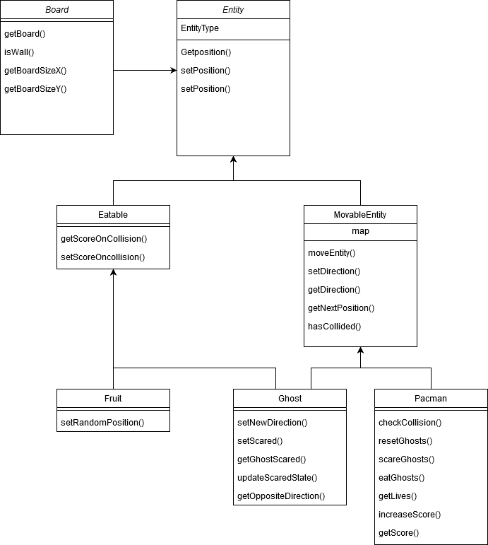

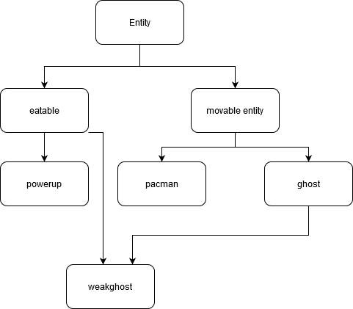

Figure :Old class diagram

Figure 1: new class diagram