CS 2130 PROJECT #4: Relations, Boolean Matrices, Digraphs, and Trees

In this project, you will use the Boolean matrix representation of directed graphs to perform various operations on the digraphs and to examine special properties of the digraphs. A Boolean matrix class file BMat.java will be given to you. This class contains various functions (methods) that operate on Boolean matrices. You will write additional functions and put them into this class file.

Part A

Add the following functions to the BMat class:
1. BM1.outdegree(K) - Returns the out-degree for node K in Boolean matrix BM1. Assume that the nodes are numbered 0,1,2,...,SIZE-1.
2. BM1.meet(M2) - Returns the logical AND of matrices BM1 and BM2.
3. BM1.transpose() - Returns the transpose of matrix BM1.
4. BM1.product(M2) - Returns the Boolean product of matrices BM1 and BM2.
5. BM1.tclosure() - Returns the transitive closure of matrix BM1 (use Warshall's algorithm).
6. BM1.rootnode() - Returns the root node number (0 to SIZE-1) of BM1 if a candidate root node exists. Returns -1 if there is no root node. For a root node to exist, there must be exactly one node with in-degree 0. All other nodes must have in-degree 1.

Part B

Write a test program that uses BMat objects to do specified Boolean matrix calculations. The starting version of your program should be the sample file P4Test.java. Instance BMat objects for the matrices A, B, C, D, E, F, and G that are defined in P4Test . Using BMat methods, have your program calculate the following (X is an integer variable, and W is a work matrix):
a. W = (C' ∧ (A ∨ B)) ∧ B' (M' = complement of M)
(!C and (A or B))and!B
b. W = (B^{T} ʘ B) ∧ (C ∨ C^{T})
c. W = ʘC¹⁸ = C ʘ C ʘ ... ʘ C (18 C's)
d. W = (D ∨ E)^{T} ∧ (D^{T} ∨ E^{T})
e. W = ʘD¹ ∨ ʘD² ∨ ʘD³ ∨ ʘD⁴
f. X = maximum out-degree of all nodes in D
g. W = symmetric closure of D. Is D symmetric?
h. W = transitive closure of E. Is E transitive?
i. Show that matrix F represents a tree (has a candidate root node and has no cycles).
j. Show that matrix G does not represent a tree.

Turn in:
1. Source code for the functions you added to BMat.java.
2. Source code for your test program.
3. Output from the test program.
4. A drawing of the digraph for each of the Boolean matrices A, B, C, F, and G. Try to arrange the nodes so that the arrows cross each other as little as possible.

int A[][] = new int[][]
{{1, 1, 0, 0, 1},
{1, 0, 1, 0, 0},
{0, 0, 0, 0, 0},
{1, 0, 0, 0, 0},
{0, 0, 1, 0, 1}};

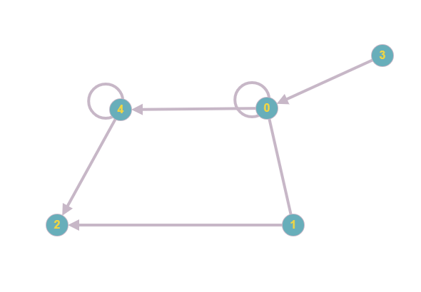

int B[][] = new int[][]
{{0, 1, 0, 0, 1},
{0, 1, 1, 0, 0},
{1, 0, 1, 0, 0},
{1, 0, 0, 0, 0},
{0, 1, 0, 0, 1}};

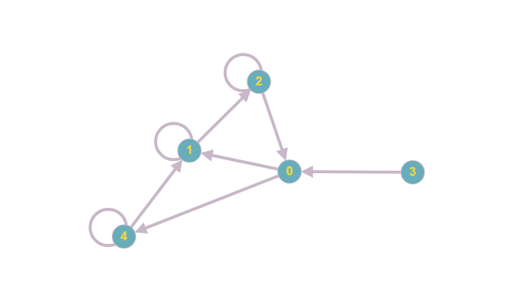

int C[][] = new int[][]
{{0, 1, 0, 0, 0},
{0, 0, 1, 0, 0},
{0, 0, 0, 1, 0},
{1, 0, 0, 0, 1},
{0, 1, 0, 0, 0}};

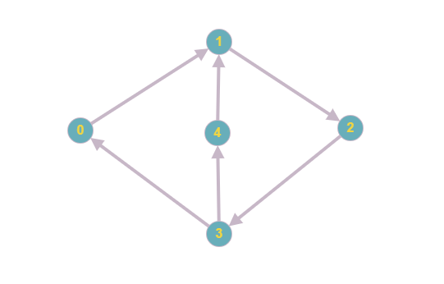
int D[][] = new int[][]
{{1, 1, 0, 0, 0, 0},
{1, 1, 1, 0, 0, 0},
{0, 1, 1, 1, 0, 0},
{0, 0, 1, 1, 0, 0},
{0, 0, 0, 0, 0, 1},
{0, 0, 0, 0, 1, 1}};
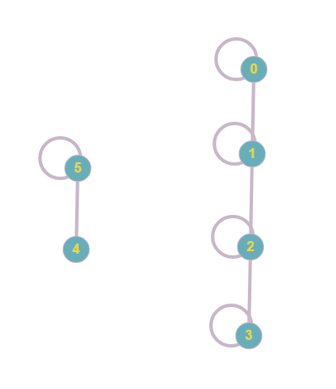

int E[][] = new int[][]
{{0, 1, 1, 0, 0, 1},
{0, 1, 1, 0, 0, 1},
{0, 0, 1, 0, 0, 1},
{0, 0, 0, 0, 1, 1},
{0, 0, 0, 1, 1, 1},
{0, 0, 0, 0, 0, 0}};
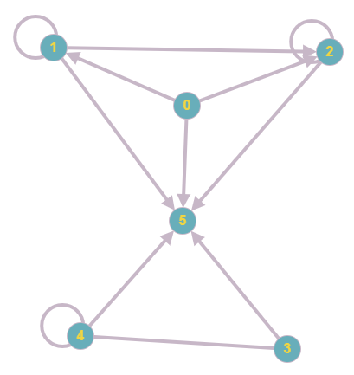

int F[][] = new int[][]
{{0, 0, 0, 0, 1, 0, 1, 0, 0},
{1, 0, 0, 1, 0, 0, 0, 0, 0},
{0, 0, 0, 0, 0, 0, 0, 0, 0},
{0, 0, 1, 0, 0, 0, 0, 1, 1},
{0, 0, 0, 0, 0, 0, 0, 0, 0},
{0, 1, 0, 0, 0, 0, 0, 0, 0},
{0, 0, 0, 0, 0, 0, 0, 0, 0},
{0, 0, 0, 0, 0, 0, 0, 0, 0},
{0, 0, 0, 0, 0, 0, 0, 0, 0}};

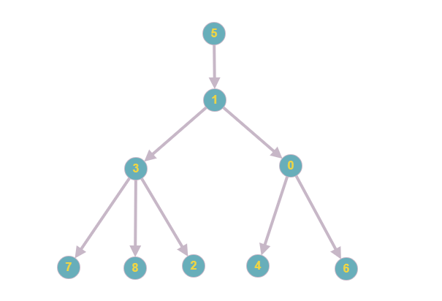

int G[][] = new int[][]
{{0, 0, 0, 1, 0, 0, 0, 0, 0},
{0, 0, 0, 0, 0, 0, 0, 0, 0},
{1, 0, 0, 0, 0, 0, 0, 0, 0},
{0, 0, 1, 0, 0, 1, 0, 0, 0},
{0, 1, 0, 0, 0, 0, 1, 0, 1},
{0, 0, 0, 0, 0, 0, 0, 1, 0},
{0, 0, 0, 0, 0, 0, 0, 0, 0},
{0, 0, 0, 0, 0, 0, 0, 0, 0},
{0, 0, 0, 0, 0, 0, 0, 0, 0}};

