Coordinate Frames in GNSS Positioning
Global Navigation Satellite System (GNSS) receivers internally compute user position, velocity, and timing solutions in the Earth-Centered Earth-Fixed (ECEF) coordinate system. The ECEF frame is a Cartesian reference system whose origin is located at the Earth’s center of mass, with axes fixed to the rotating Earth. This representation is mathematically convenient for satellite orbit modeling, observation equations, and navigation filter implementation, and therefore it is the natural coordinate system used by GNSS-SDR and most GNSS processing engines.
Although ECEF is optimal for computation, it is not well suited for interpreting positioning performance or accuracy from an application or monitoring perspective. The ECEF axes do not correspond to locally meaningful directions, and changes in ECEF coordinates cannot be directly associated with intuitive movements such as eastward drift, northward displacement, or altitude variation. Consequently, error statistics expressed in ECEF lack physical interpretability when assessing receiver performance.

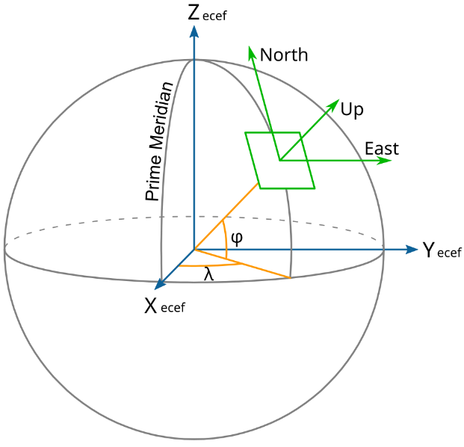
The east north up (ENU) local tangent plane in green arrows

Motivation for the ENU Coordinate System
To enable meaningful interpretation of position and accuracy, GNSS results are commonly transformed into the local East-North-Up (ENU) coordinate system. The ENU frame is defined at the estimated receiver position, with the East axis tangent to the Earth’s surface in the direction of increasing longitude, the North axis tangent in the direction of increasing latitude, and the Up axis normal to the reference ellipsoid. This local tangent plane directly corresponds to the user’s physical environment.
Unlike ECEF, the ENU frame allows horizontal and vertical errors to be interpreted independently. Variations along the East and North axes describe horizontal motion and horizontal uncertainty, while variations along the Up axis describe altitude behavior. For this reason, ENU is the standard coordinate system used for performance evaluation, navigation accuracy reporting, and real-time monitoring.

Covariance Representation in GNSS
GNSS receivers do not only estimate position but also compute the uncertainty associated with that estimate. This uncertainty is represented by a covariance matrix, which statistically describes how position errors are distributed and correlated. In GNSS-SDR, the covariance matrix is provided in ECEF coordinates and is defined as
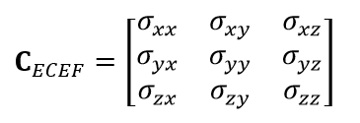
While this matrix is mathematically complete, its elements cannot be directly interpreted in terms of horizontal or vertical accuracy. For example, the variance $σ_{xx}$ does not correspond to either eastward or northward uncertainty, and correlations between axes are not physically meaningful from a local perspective.

Transformation of Covariance from ECEF to ENU
To obtain a physically interpretable uncertainty description, the ECEF covariance matrix is transformed into the ENU frame using a rotation matrix derived from the receiver’s latitude and longitude. The transformation is given by
$C_{ENU}=R C_{ECEF} R^{T}$
where $R$ is the ECEF-to-ENU rotation matrix. This operation preserves all statistical properties of the estimation error while expressing them in a locally meaningful reference frame.
The resulting ENU covariance matrix has the form
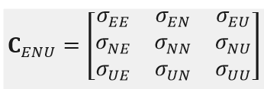
where the diagonal terms represent variances in the East, North, and Up directions, and the off-diagonal terms represent correlations between these components.
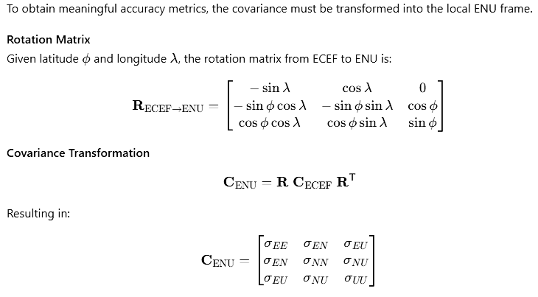

Positional Accuracy in a Radial Sense
In practice, positional accuracy is typically evaluated in a radial sense rather than along individual Cartesian axes. Horizontal position accuracy is defined as the uncertainty in the horizontal plane and is derived from the East and North variances. The one-sigma horizontal position accuracy is computed as
$σ_{H}=\sqrt{σ_{EE}+σ_{NN}}$
This metric represents the expected radial horizontal error in meters and directly corresponds to standard GNSS performance indicators such as Horizontal Dilution of Precision (HDOP). Vertical accuracy is similarly derived from the Up variance as
$σ_{V}=\sqrt{σ_{UU}}$
These quantities provide a clear and intuitive measure of receiver performance and cannot be meaningfully obtained from ECEF covariances alone.

Rationale for GUI Design Choice
In the VisionX GNSS-SDR monitoring GUI, both ECEF and ENU representations are displayed to provide full technical visibility. ECEF position and velocity components are shown for diagnostic and completeness purposes, as they reflect the native output of the GNSS engine. However, all accuracy-related metrics, including horizontal uncertainty, vertical uncertainty, and covariance evolution, are derived and displayed in the ENU frame.

