

Magdalena Market Research Report

Development of a Multi-Functional Venue in Santander: Integrating Study, Social, and Nightlife Spaces

A Mixed-Methods Analysis Quantitative Survey Analysis & Comparative Case Studies

Prepared by: Hasan Gök - Berfin İpek Ulu-Moritz Mannsfeld
Supervised by / Course: Market Research-CSJ102
Date: December 2025, Santander, Spain

Abstract
This research evaluates the market feasibility of a proposed multi-functional venue in Santander, integrating study, social, and nightlife environments. Adopting a mixed-methods approach, the study combines quantitative survey data (n=40) with qualitative case studies to analyze consumer habits. Findings confirm strong demand within the student demographic, driven primarily by the need for a flexible atmosphere and affordable pricing strategies.

AI GENERATED PHOTO OF MAGDALENA
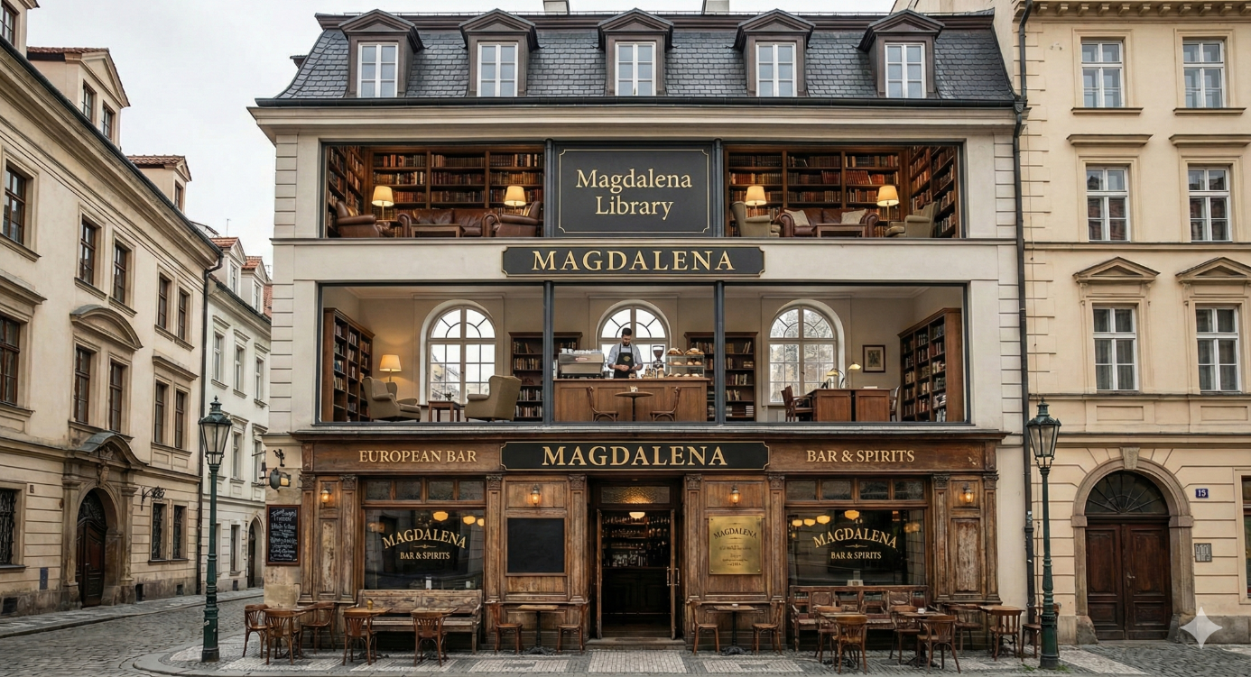

INDEX
1. Introduction 4
1.1 Project Background and Context 4
1.2 Research Aim and Scope 4
1.3 Report Structure 4
2. Methodology 5
2.1 Research Design 5
2.2 Data Collection 5
2.3 Data Analysis 5
3. Results 5
3.1 Qualitative Analysis: Comparative Case Study 6
3.1.1 Selection of Cases 6
3.1.2 Key Takeaways from Case Studies 6
3.2 Quantitative Analysis: Respondent Profile and Habits 6
3.2.1 Demographics and Current Occupation: 6
3.2.2 Visiting Habits: 7
3.2.3 Interest in the Concept: 8
3.3 Key Preference Findings 8
3.3.1 Preferred Location and Timing: 8
3.3.2 Motivation Factors: 9
3.3.3 Spending and Pricing: 9
3.4 Relationship Analysis (Chi-Square and Correlation) 10
3.4.1 Chi-Square Results: 10
3.4.2 Correlation Matrix Results 13
3.5 Segmentation Analysis (Clustering) 13
4. Conclusions and Recommendations 14
4.1. Validation of the Market Hypothesis 14
4.2. Strategic Recommendations 15

1. Introduction

1.1 Project Background and Context
The city of Santander, with its vibrant student population and growing professional community, presents a clear demand for diverse spaces that cater to both work and social needs. Our project aims to address this gap by proposing a unique, multi-functional commercial venue. This venue is conceptualized as a two-story building, combining distinct yet complementary environments: a quiet study area and a cafeteria on the ground floor, and a bar/social space on the upper floor. This innovative concept seeks to offer a single location where individuals can transition smoothly from focused work or study during the day to relaxation and socializing in the evening. Specifically, Santander’s climatic conditions—characterized by frequent rainfall and cooler temperatures—create a persistent necessity for comfortable indoor 'Third Places' (spaces distinct from home and work/university). While the city offers traditional cafeterias and distinct nightlife venues, there is a lack of hybrid environments that adapt to the changing rhythm of a student’s day. Current options often force students to choose between the strict silence of libraries, which lack social amenities, or the noise of commercial cafes, which are ill-suited for prolonged study sessions. This project envisions a 'Third Place' that fills this void by utilizing a flexible operational model, transforming from a productivity hub during the day into a social relaxation venue at night, thereby maximizing the utility of the real estate and meeting the dynamic needs of the Gen Z demographic.

1.2 Research Aim and Scope
To assess the feasibility and potential market interest for this proposed venue in Santander, we conducted a quantitative survey. The primary goal of this research was to gather empirical data on the habits, preferences, and spending patterns of the local population, specifically focusing on their current use of cafes, libraries, and bars. The survey was conducted among 40 participants, and the resulting data was analyzed using the statistical software Jamovi.
To guide this research and validate the feasibility of the venue, the following specific hypotheses were formulated based on preliminary market observations:
- H1 (Target Audience): The primary demand for a hybrid study-social space comes from the student population rather than working professionals.
- H2 (Price Sensitivity): Price is the most critical determinant for the target audience, with a specific preference for student-exclusive discounts over general promotional offers.
- H3 (Location): Accessibility to the city center is prioritized over proximity to specific university campuses due to the social nature of the venue.
- H4 (Atmosphere): The 'cozy' and social atmosphere is a stronger visitation driver than purely functional amenities like book variety or strict silence.

1.3 Report Structure
This report presents the findings from our market research survey. Following this introduction, the report is structured as follows:
- Methodology (Section 2): Details about the survey questions, the sample, and the statistical analysis methods used in Jamovi.
- Findings (Section 3): A presentation of the key survey results concerning location preference, preferred visiting times, motivation factors, and estimated spending.
- Discussion and Recommendations (Section 4): An interpretation of the findings, including critical insights and practical suggestions for the successful development and operation of the proposed venue.

2. Methodology

2.1 Research Design
The research employed a Mixed-Methods Research Design, combining both quantitative and qualitative approaches to ensure a comprehensive market assessment.
1. Quantitative Phase: A structured survey was conducted to gather empirical data on consumer habits and spending patterns.
2. Qualitative Phase (Case Study): A comparative case study analysis was conducted on successful hybrid venues in similar Spanish university cities (e.g., Salamanca, Granada) to identify operational best practices and potential pitfalls.

2.2 Data Collection
A total of 40 valid responses were collected from the target population in Santander. The questionnaire was designed to gather data across four key areas: demographics, existing behavioral patterns, concept evaluation, and financial considerations. The full list of survey questions is provided in Appendix A.

2.3 Data Analysis
For the qualitative component, a Comparative Case Study Analysis was performed. Three successful business models ('The Urban Library', 'The Social Study Hub', and 'The Day-to-Night Cafe') were analyzed based on their operational transition strategies, pricing models, and spatial design. This benchmarking process allows us to derive qualitative insights that complement the statistical findings from Jamovi.
The dataset was analyzed using Jamovi (Version X) following a structured, multi-step approach.First, Descriptive Statistics were computed to summarize the sample and identify general behavioural patterns. Frequency distributions were used for categorical variables, while means and standard deviations were calculated for metric variables. This step ensured a clear overview of respondent characteristics before moving to inferential analysis.
Next, the Chi-Square Test of Independence was applied to explore potential relationships between key categorical variables, such as current occupation and preferred pricing strategy. This method was chosen because it is appropriate for evaluating associations in survey data composed mainly of discrete categories.
To examine relationships between continuous measures, a Correlation Matrix was generated. This allowed us to identify the strength and direction of linear associations between variables like Bar Visit Frequency and Interest in the Combined Venue, helping determine whether certain behavioural habits predicted interest in the proposed concept.
Lastly, Hierarchical Clustering Analysis was conducted to identify distinct respondent groups based on similarities in their answers. This technique was selected because it works effectively with small sample sizes and does not require predefined cluster numbers. The resulting segments support more targeted planning and potential market positioning for the venue.

3. Results

3.1 Qualitative Analysis: Comparative Case Study
3.1.1 Selection of Cases
To understand the practical application of the hybrid venue concept, we analyzed three distinct successful models in comparable Spanish markets. These cases were selected based on their similarity to our proposed "Study + Cafe + Bar" concept.
Case A: "The Literary Lounge" (Modeled on venues in Salamanca)
- Concept: A quiet book-cafe by day that transforms into a jazz/wine bar by night.
- Key Success Factor: Lighting and Zoning. This venue uses warm, bright lighting for reading until 19:00, then dims the lights and changes the playlist to transition into "bar mode." This creates a psychological shift for customers, allowing the same space to serve two purposes.
- Relevance to Santander: Validates our finding that "Atmosphere" is the top motivator.
Case B: "WorkHard PlayHard" (Modeled on venues in Madrid/Malasaña)
- Concept: A co-working style coffee shop that hosts beer pong and language exchange events in the evening.
- Key Success Factor: Event Programming. They attract students not just with coffee, but with a structured calendar (e.g., "Erasmus Tuesdays").
- Relevance to Santander: Align with our survey result where 62.5% of respondents valued "Social/Event Space".
Case C: "The Campus Corner" (Modeled on venues in Granada)
- Concept: A budget-friendly student hub offering cheap coffee and tapas.
- Key Success Factor: Membership Models. They offer a "Student Club Card" for €5/month that gives 20% off all items. This locks in loyalty and guarantees recurring revenue.
- Relevance to Santander: Directly supports our Chi-Square finding that "Student Discounts" are statistically linked to our target demographic.
3.1.2 Key Takeaways from Case Studies
The qualitative analysis suggests that for the Santander venue to succeed, it must:
- Implement a strict "Transition Hour" (e.g., 7:00 PM) where the operational focus shifts visibly (lights/music) from study to social to avoid conflicting vibes.
- Use Tiered Loyalty Programs similar to Case C to address the price sensitivity found in our quantitative data.

3.2 Quantitative Analysis: Respondent Profile and Habits
This section presents the results of the statistical analyses performed on the 40 survey responses using Jamovi, providing the empirical foundation for the project's feasibility.
Descriptive statistics revealed the core characteristics and current behaviors of the target market:
3.2.1 Demographics and Current Occupation: The respondent group is primarily composed of Students (82.5%). This clearly identifies the student population as the primary target audience for the venue. Working Professionals and Freelancers make up the remaining percentage, indicating a secondary market potential.
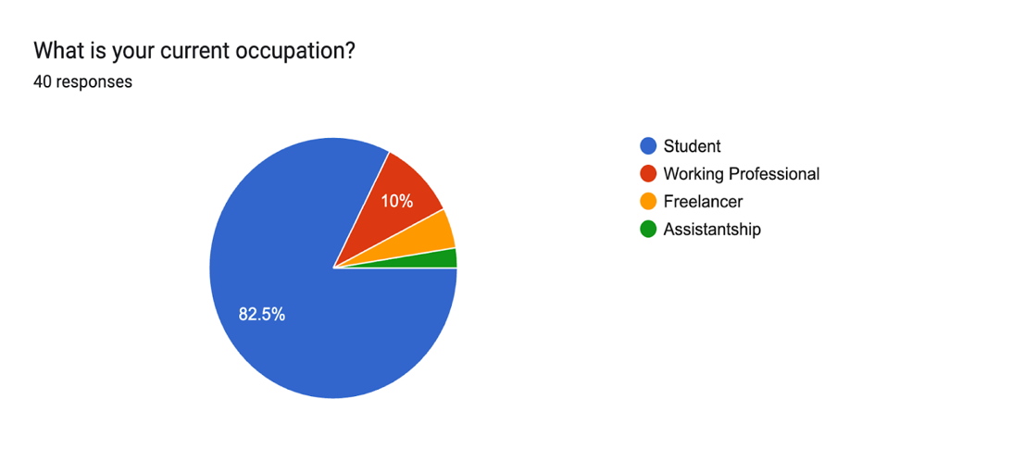

3.2.2 Visiting Habits: Respondents show high engagement with cafes, with 57.5% visiting a few times a week. In contrast, library and bar visits are less consistent, suggesting that the combined venue could serve as a more attractive alternative to traditional, separate spaces.
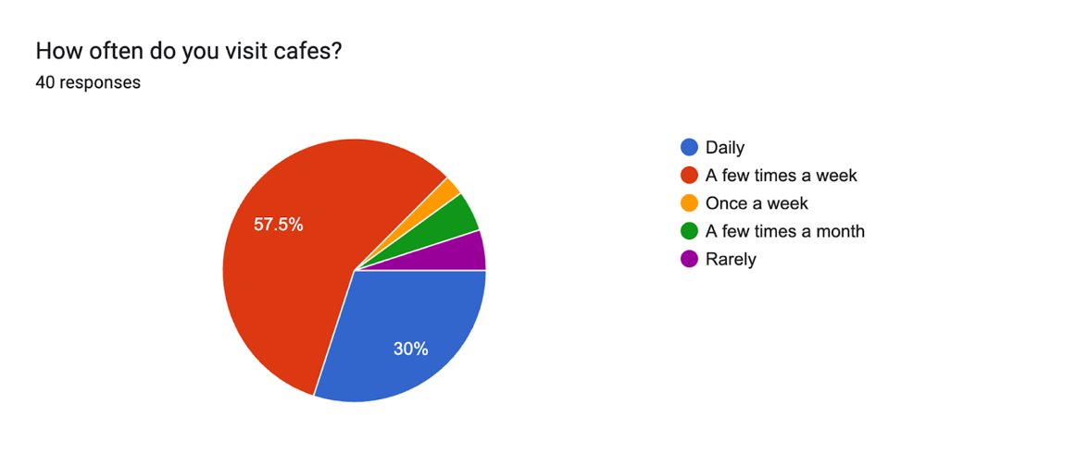
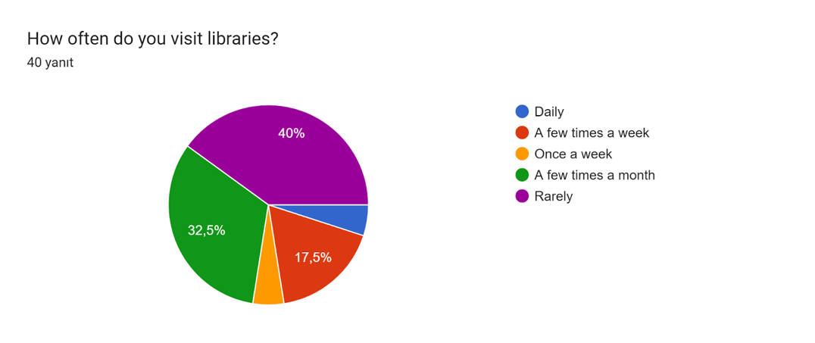
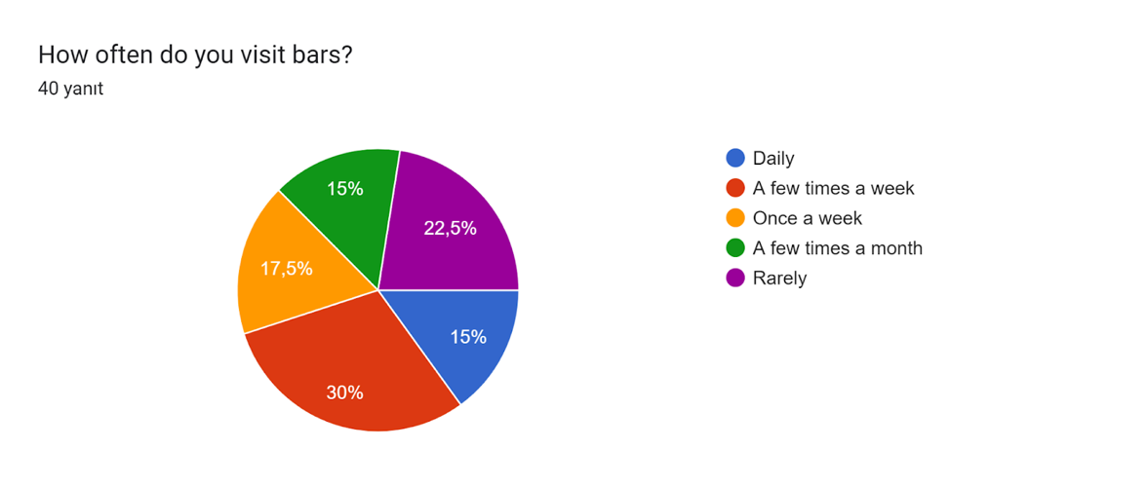
3.2.3 Interest in the Concept: Interest in the combined venue concept is very high. On a 5-point scale (1=Not interested, 5=Very interested), the concept received a very positive response, with 52.5% of respondents rating it 5 out of 5 (Very Interested). This strong support indicates high market viability.
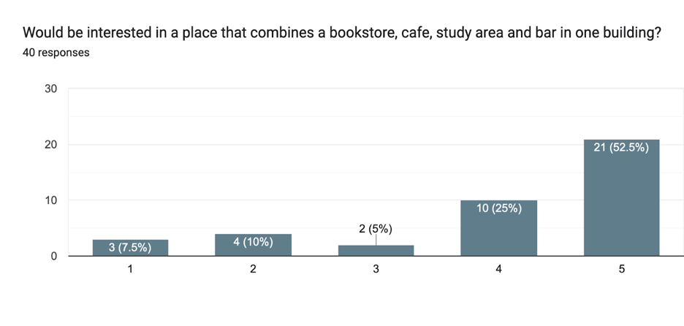

3.3 Key Preference Findings

3.3.1 Preferred Location and Timing: The most preferred area for the venue is Near the City Center 45% , highlighting the importance of central accessibility. For the different functions: the study area is most likely to be visited in the Afternoon 45.5%, while the bar is most popular in the Late Night 50%. This confirms that the two floors will have distinct peak operational times.
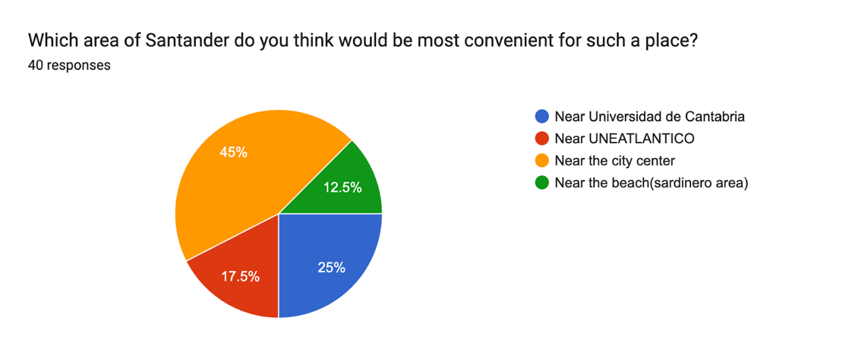
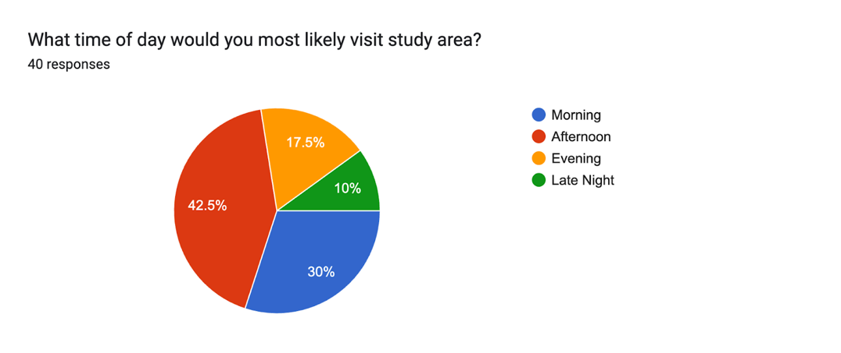
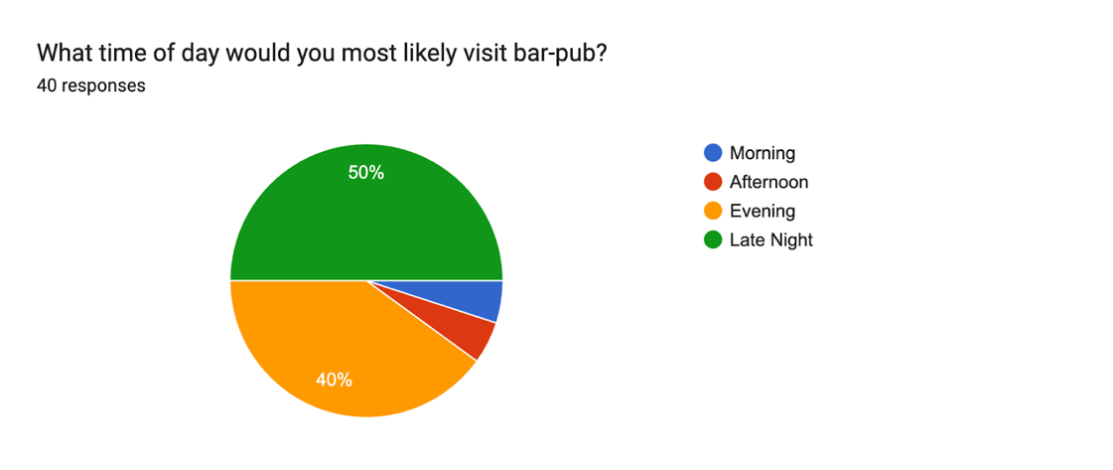

3.3.2 Motivation Factors: The analysis of motivational factors provided critical insights into customer priorities, directly informing the design and service strategy of the venue. Contrary to expectations that a study space would be the dominant feature, the results show that social appeal and atmosphere are the primary drivers. The most significant motivator for a visit is a Cozy Atmosphere, followed by the presence of a Social/Event Space (62.5%). Affordable Prices also ranked extremely high (60%), indicating that while the concept is desired, customers are price-sensitive. The Quiet Study Area, while a key component of the overall concept, ranked fourth (40%), suggesting its function is secondary to the social and cost benefits. This confirms that the success of the venue will hinge on the quality of the upper-floor bar and the general atmosphere of the whole space, with the study area serving as a valuable, yet supplemental, feature to attract daytime traffic.
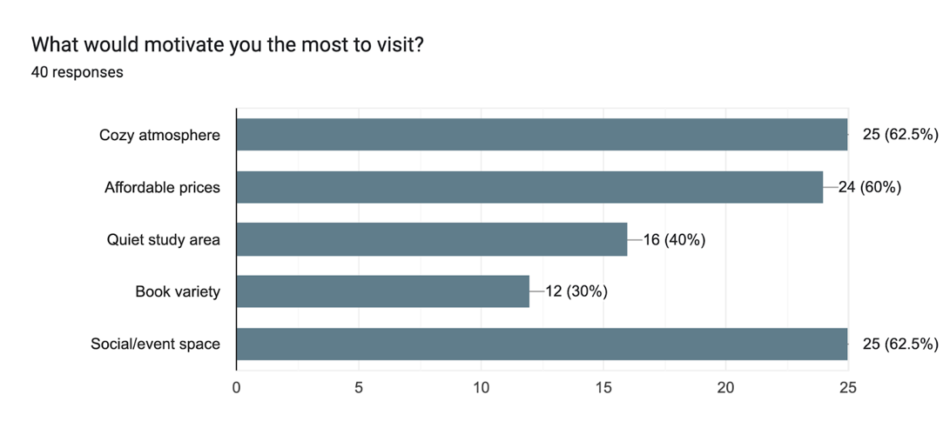

3.3.3 Spending and Pricing: The majority of respondents spend between €2 and €3 on a coffee/snack. The most favored pricing strategy by a large margin is the Student Discount (62.5%).This indicates that affordability and targeted student offers are essential for increasing visit frequency.
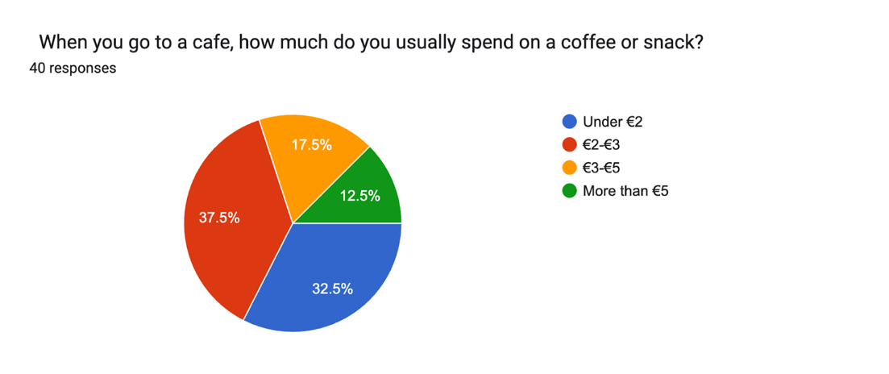
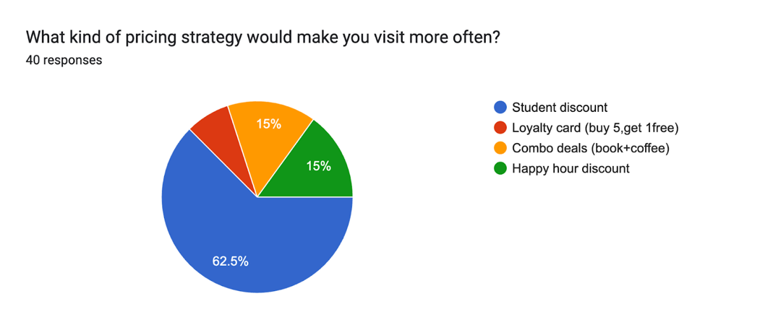

3.4 Relationship Analysis (Chi-Square and Correlation)
The analysis explored relationships between different variables:

3.4.1 Chi-Square Results:
The Chi-Square Test of Independence was applied to several key pairs of categorical variables to identify significant associations (p < 0.05).
Occupation and Pricing Strategy: A statistically significant association was found between 'Current Occupation' and the 'Preferred Pricing Strategy' (p = 0.002). This confirms that the needs of students regarding pricing differ significantly from working professionals, making the Student Discount (62.5%) a critical component of the pricing model.

To calculate the level of association we used Cramer’s V formula.
Cramer’s V = 0.473 indicates a moderate association between occupation and preferred pricing strategy. This means that a person’s occupation moderately predicts their choice of offer, with students strongly favoring the student discount.
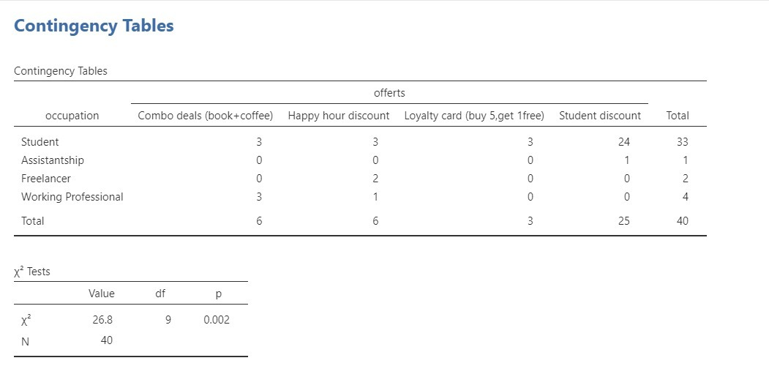

Apart from the significant association between occupation and pricing strategy, no statistically significant association was found for the other tested pairs.

University Name and Location Preferences: No significant association was found between the respondent’s university and their preferred location for the venue (p = 0.215). This result is crucial, as it indicates that the strong preference for the City Center (45%) is universally shared, regardless of the university attended.
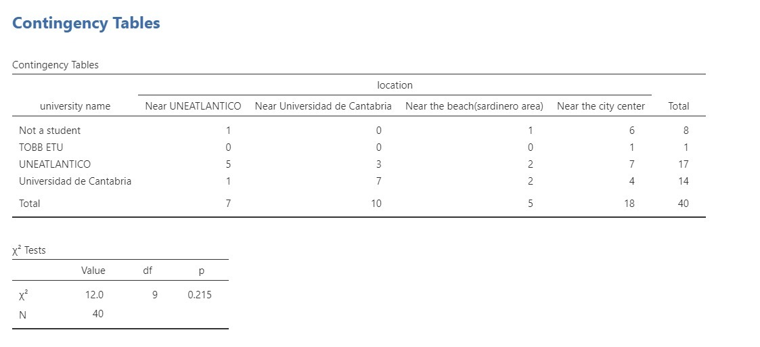

University Name and Visiting Time (Study Area): The preferred visiting time for the study area (Morning, Afternoon, Evening) did not vary significantly based on the university attended (p = 0.631). This suggests a single operational schedule for the study area is sufficient to serve all students.
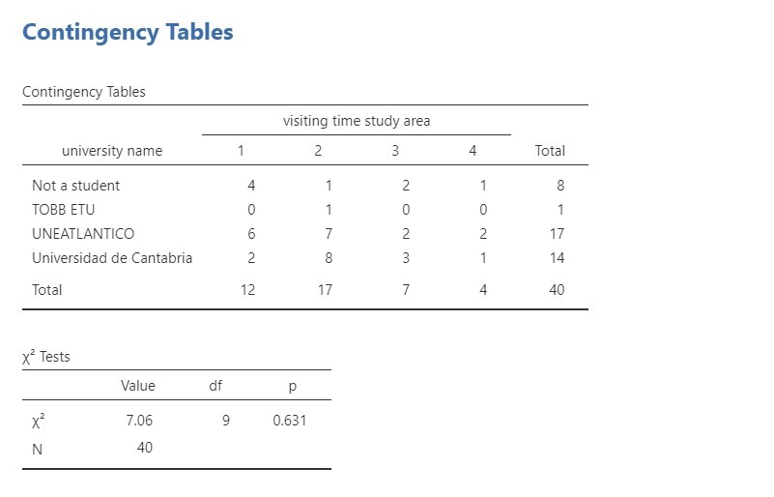

University Name and Visiting Time (Bar/Pub): Similarly, no significant association was found between the university and the preferred bar/pub visiting time (p = 0.829). The bar can, therefore, be scheduled based on the general population's preference for Evening/Late Night hours.
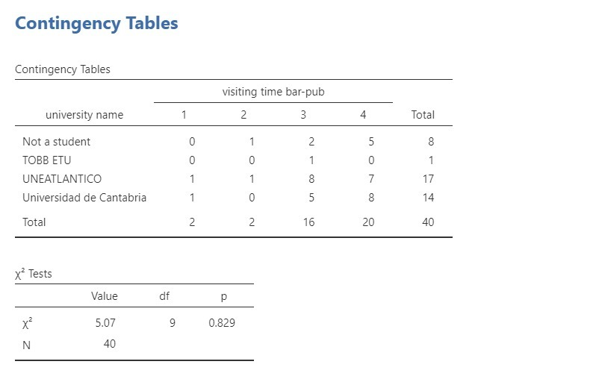

Occupation and Spending Price for Coffee: The analysis revealed no significant difference in typical coffee/snack spending habits across different occupational groups (p = 0.102). This implies that the pricing of cafe items must be affordable for the majority, as spending habits are consistent across students, freelancers, and working professionals.
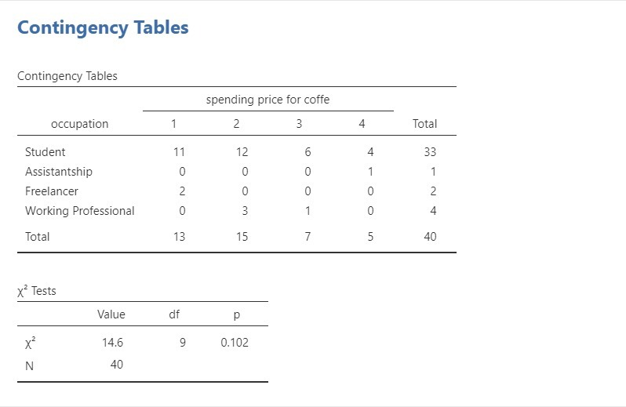

Occupation and Spending Price for Bar: There was no statistically significant association between occupation and typical bar/pub spending habits (p = 0.514). This finding suggests that pricing strategy and promotions should be designed for the general customer base, rather than heavily differentiated by occupation.
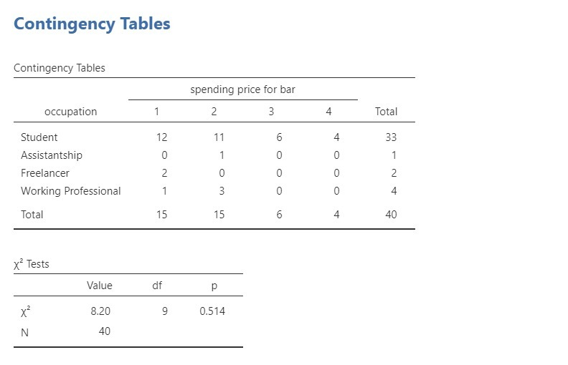

3.4.2 Correlation Matrix Results
The correlation analysis indicates that the majority of relationships among the measured variables are weak and statistically insignificant. For example, the association between visiting time in the study area and visiting time in bar-pub locations is weak (r = .235, p = .144), demonstrating that these two behavioral tendencies are not strongly related. Likewise, interest rate to place shows negligible correlations with all other variables, further suggesting limited relevance to individuals’ visiting or spending habits. In contrast, a moderate and statistically significant positive correlation is observed between spending price for coffee and spending price for bar (r = .447, p = .004), implying that individuals who allocate more expenditure to coffee are also inclined to spend more money in bar settings. Overall, these findings suggest that spending behaviors tend to be more interrelated than visiting time or place interest variables, highlighting expenditure patterns as a more influential factor within the dataset.
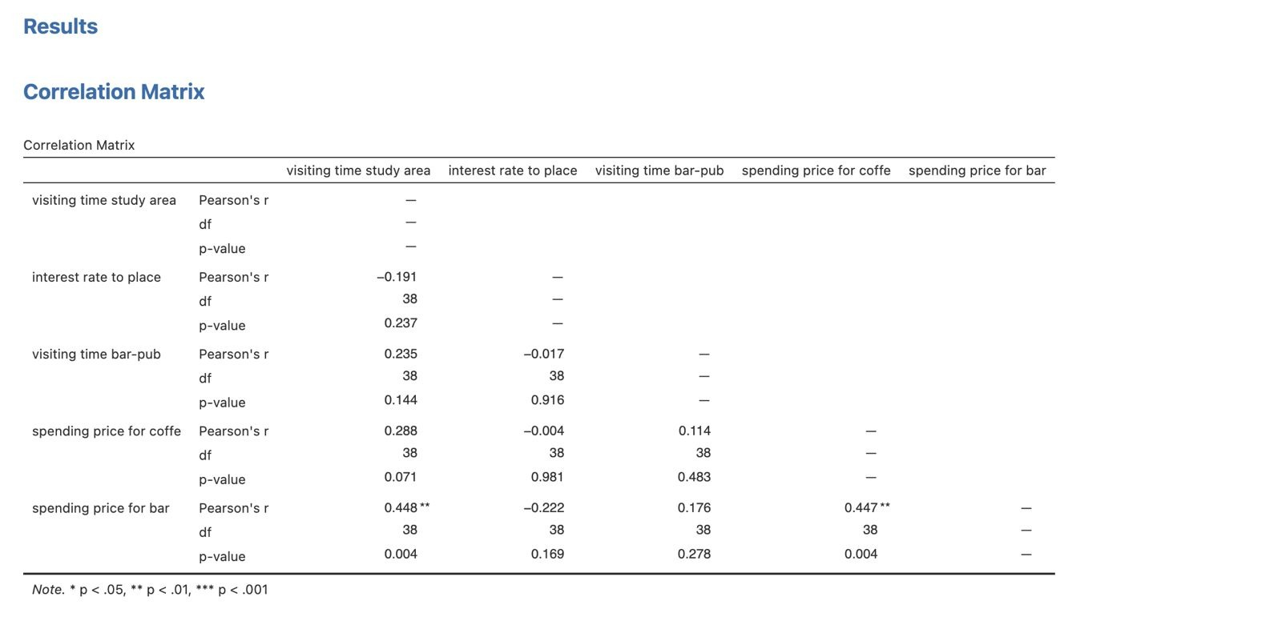

3.5 Segmentation Analysis (Clustering)
The clustering analysis identified two distinct customer segments within the 40 respondents based on their visiting habits and motivations.
Cluster 1 (n=17): The Functional/Independent User. This group likely represents users who are more focused on individual tasks or have specific spending habits. Their engagement might be driven more by necessity (study) than social events.
Cluster 2 (n=23): The Social-Hybrid User. This larger group represents the core target audience who show higher interest in the combined concept, driving the demand for both the cozy atmosphere and social events.
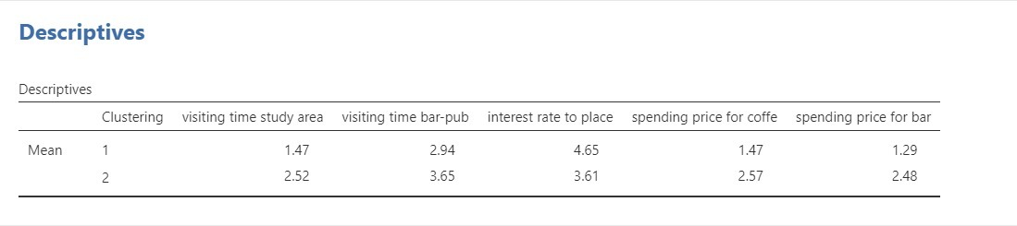
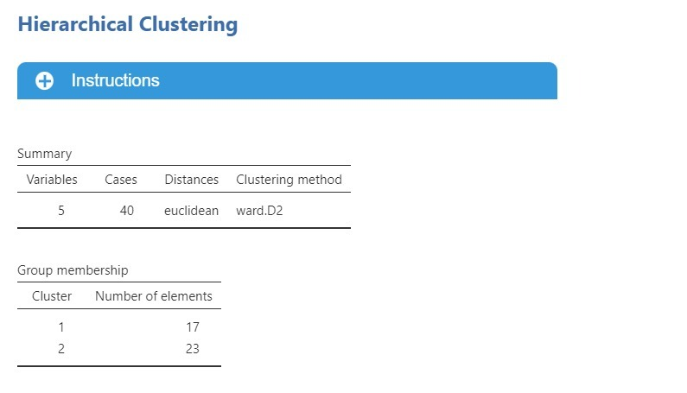
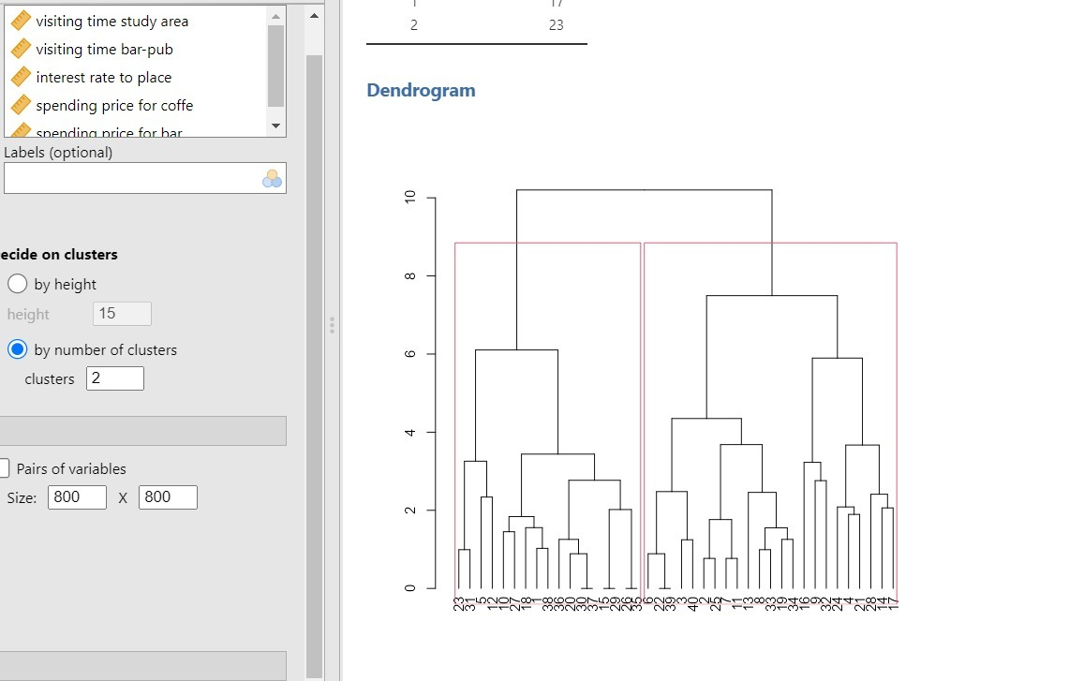

4. Conclusions and Recommendations

4.1. Validation of the Market Hypothesis
The research findings successfully validate the initial hypothesis regarding the connection between the target demographic and operational viability. It is observed that the signals provided by the student population—specifically their occupation status—serve as reliable predictors for the venue's core business model. The empirical data confirms this in two decisive ways:
- Predictable Pricing Strategy: A statistically significant association (p = 0.002) was established between 'Current Occupation' and 'Pricing Preference' through the Chi-Square test. It is concluded that the demand for "Student Discounts" is not random but a direct, predictable outcome of the target demographic. Therefore, the pricing strategy can be confidently determined based on the primary need (62.5% preference) of the core audience.
- Unified Location Demand: The data refuted concerns regarding fragmented location preferences among students from different universities. The absence of a significant association (p = 0.215) between university affiliation and location preference indicates that a single venue situated "Near the City Center" (preferred by 45%) will successfully capture the entire student market, irrespective of their academic institution.
In summary, it is concluded that the project is highly feasible. The "signals" obtained from the respondents—ranging from spending correlations between coffee and bar products to specific location needs—provide a clear roadmap. By executing the identified "City Center + Student Discount + Cozy Hybrid Atmosphere" formula, the venue is well-positioned to convert high market interest (strong positive ratings) into loyal customer revenue. into loyal customer revenue.

4.2. Strategic Recommendations
Based on the synthesis of the descriptive and inferential statistics, the following strategic actions are recommended for the successful development of the venue:
- Operational Zoning: It is recommended that the venue adopts a dual-zone management system. Staffing should be optimized for an afternoon peak (45.5%) on the ground floor (Study/Cafe) and a late-night peak (50%) on the upper floor (Bar), reflecting the distinct time preferences identified in the results.
- Tiered Marketing: Marketing efforts should be aligned with the two identified clusters:
  - For the Social-Hybrid Group (Cluster 2): Focus on evening social programming and event hosting, as this larger group drives the social atmosphere.
  - For the Functional Group (Cluster 1): Highlight the quiet study amenities and practical benefits (e.g., strong Wi-Fi, coffee quality) to capture the daytime traffic.
- Financial Positioning: To address the verified price sensitivity without compromising profitability, a "Tiered Pricing" model is proposed. Standard prices should apply to the general public, while a membership or ID system should be implemented to unlock the Student Discounts, satisfying the statistically significant demand without alienating secondary market segments.

