|  |  |
| --- | --- |
| Name: | Edward Eisenberger |
| ID# | 1066164 |
| Assignment 1 | |
| Due Date | February 11, 2019 |
| Date of Submission | February 9, 2019 |

# Overview

Assignment 1 consists of two (2) problems outlined in the following sections. A single Visual Studio solution containing two (2) C# projects was created to solve both problems.

# Problem 1

## Summary

Problem 1 provided introductory lessons to the C# programming language and image processing. A Visual Studio C# project was constructed from the example project, ImageProcessing_2010.

## Input

The following JPEG was used as input.



Figure - Test Input

## Output

The following images show the results of various Image Processing Operations implemented in the Problem 1 Project.

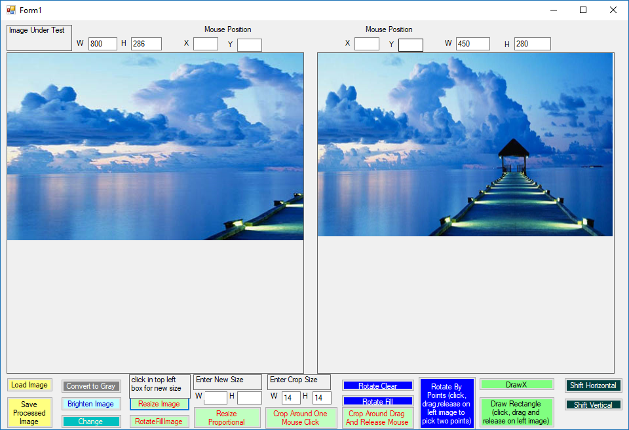

Figure - Resize

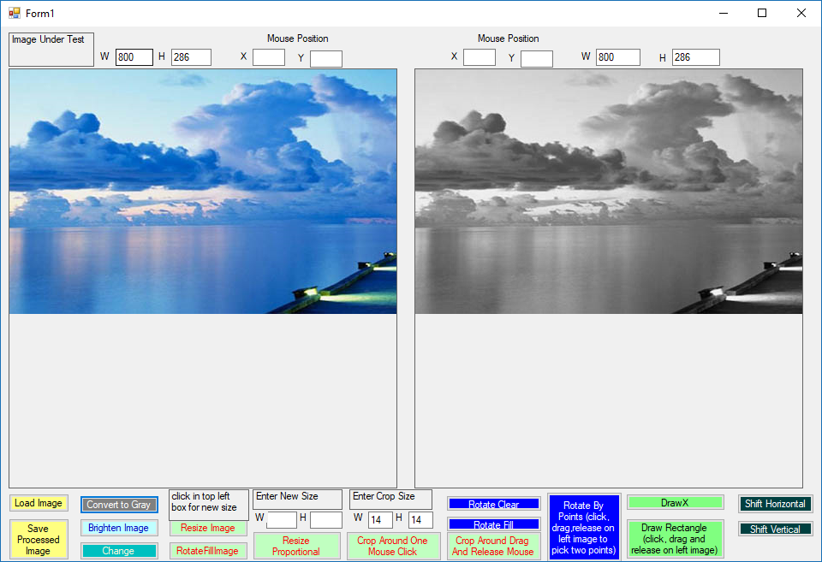

Figure - Grayscale

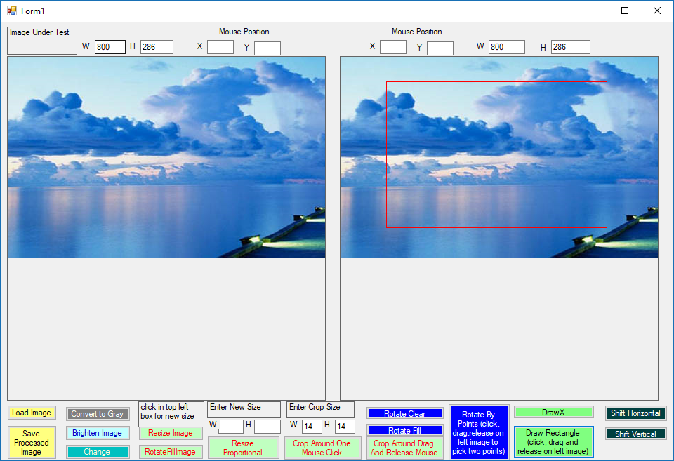

Figure - Draw Rectangle

# Problem 2

## Summary

Problem 2 required implementing the histogram equalization algorithm outlined in Wikipedia (<https://en.wikipedia.org/wiki/Histogram_equalization>) using C#. A Visual Studio C# Windows Forms project was created and consists of a single Windows Form, the entry point (Program.cs), a Histrogram class, and a Histogram Equalizer class. The Form allows the user to browse for a bitmap and perform Histogram Equalization on the selected bitmap.

## Input

Two (2) images available on the Wikipedia site were used for testing.

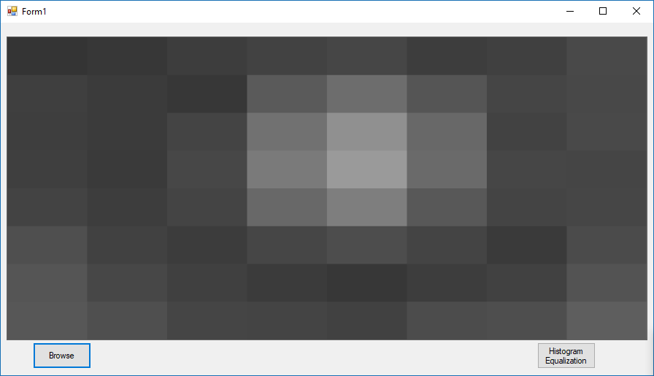

Figure - Example 1 Original

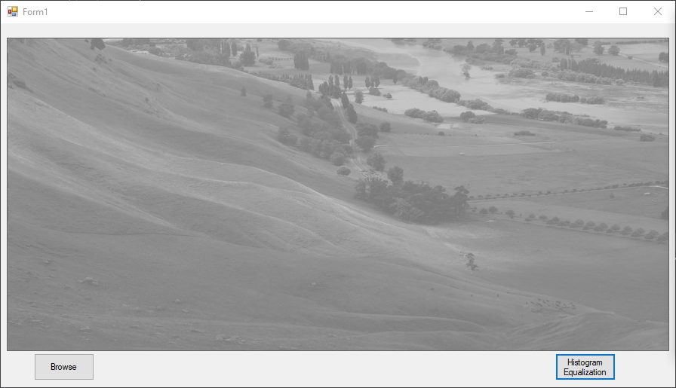

Figure - Example 2 Original

## Output

The results of Histogram Equalization are shown below.

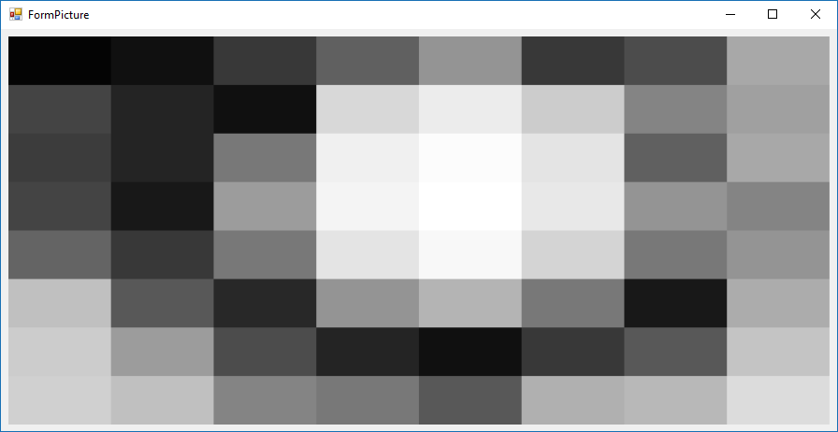

Figure - Example 1 after Histogram Equalization

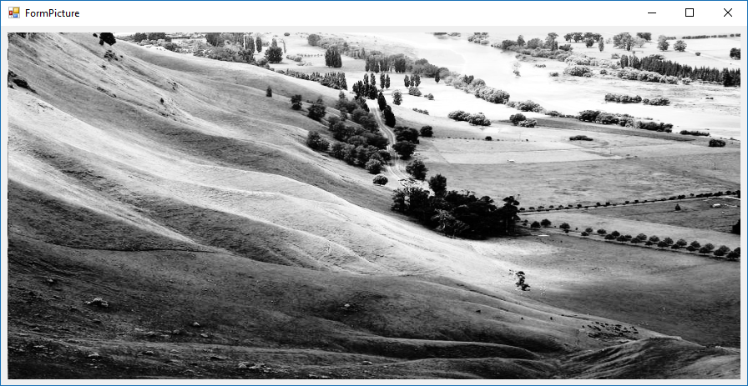

Figure - Example 2 after Histogram Equalization