|  |  |
| --- | --- |
| Name: | Edward Eisenberger |
| ID# | 1066164 |
| Assignment 2 | |
| Due Date | February 18, 2019 |
| Date of Submission | February 17, 2019 |

Contents

Summary 4

Input 4

Convolution Filter Kernel Derivation 5

Identity 5

Kernel Derivation 5

Output 5

Average (Low pass) 5

Kernel Derivation 5

Output 5

High Pass 5

Kernel Derivation 5

Output 6

Sharpening 6

Kernel Derivation 6

Output 6

Gaussian 6

Kernel Derivation 6

Output 6

First Derivative (Gradient) 6

Kernel Derivation 6

Output 6

Second Derivative (Laplacian) 6

Kernel Derivation 6

Output 6

Difference of Gaussians (σ1=0.5, σ2=2.5) 6

Kernel Derivation 6

Output 6

Figure 1 - Input 1: Black and White Husky 4

Figure 2 - Input 2: Landscape 4

# Summary

Assignment 2 consists of deriving kernels for eight (8) convolution filters and implementing the derived kernels in a C# application.

# Input

The following two (2) images were used as inputs to each convolution filter.

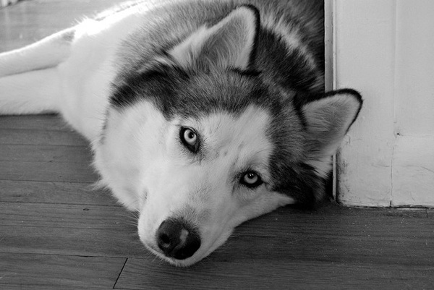

Figure - Input 1: Black and White Husky

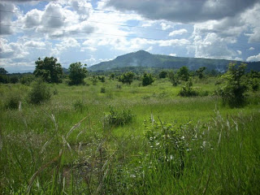

Figure - Input 2: Landscape

# Convolution Filter Kernel Derivation

Kernels column length is equal to row length and the length must be odd, so that a center cell exists.

The sum of all values in a kernel must equal one (1).

Kernels are applied by multiplying each cell by a corresponding pixel cell, summing the results, then storing the resultant summation in location of the center pixel.

Kernels were derived for the following convolution filters.

## Identity

### Kernel Derivation

The Identity Kernel must produce an image identical to the original image, the center cell must be one (1) and all other cells must be zero (0):

$$M_{i}=\left[\begin{matrix}0 & 0 & 0 \\ 0 & 1 & 0 \\ 0 & 0 & 0\end{matrix}\right]$$

### Output

## Average (Low pass)

### Kernel Derivation

The Average (Low pass) kernel uses the neighboring pixels to determine the average pixel value. Therefore, all cells must be 1 divided by the sum of all values.

For a 3x3 kernel:

$$M_{l}=\left[\begin{matrix}1 & 1 & 1 \\ 1 & 1 & 1 \\ 1 & 1 & 1\end{matrix}\right]/9$$

### Output

## High Pass

### Kernel Derivation

The High Pass Kernel is equivalent to an All Pass minus an Low Pass. The Identity Kernel is an All Pass; therefore the High Pass Kernel would equal:

$$M_{h}=\left[\begin{matrix}0 & 0 & 0 \\ 0 & 1 & 0 \\ 0 & 0 & 0\end{matrix}\right]-\frac{\left[\begin{matrix}1 & 1 & 1 \\ 1 & 1 & 1 \\ 1 & 1 & 1\end{matrix}\right]}{9}=\left[\begin{matrix}0 & 0 & 0 \\ 0 & 9 & 0 \\ 0 & 0 & 0\end{matrix}\right]-\left[\begin{matrix}1 & 1 & 1 \\ 1 & 1 & 1 \\ 1 & 1 & 1\end{matrix}\right]=\left[\begin{matrix}-1 & -1 & -1 \\ -1 & 8 & -1 \\ -1 & -1 & -1\end{matrix}\right]$$

$$M_{h}=\left[\begin{matrix}-1 & -1 & -1 \\ -1 & 8 & -1 \\ -1 & -1 & -1\end{matrix}\right]$$

### Output

## Sharpening

### Kernel Derivation

The Sharpening Kernel is equivalent to some percentage of the original image plus some percentage of the high pass filtered image:

$$M_{s}={(1-p)M}_{i}+(p)M_{h}$$

$$M_{s}=\left(1-p\right)\left[\begin{matrix}0 & 0 & 0 \\ 0 & 1 & 0 \\ 0 & 0 & 0\end{matrix}\right]+\left(p\right)(\frac{1}{9})\left[\begin{matrix}-1 & -1 & -1 \\ -1 & 8 & -1 \\ -1 & -1 & -1\end{matrix}\right]=(\frac{1}{9})\left[\begin{matrix}-p & -p & -p \\ -p & \left(9-p\right) & -p \\ -p & -p & -p\end{matrix}\right]$$

### Output

## Gaussian

### Kernel Derivation

The Gaussian Kernel is equivalent to the two-dimensional Gaussian filter, represented by:

$$G\left(x,y\right)=(\frac{1}{2πσ^{2}})e^{\frac{-(x^{2}+y^{2})}{2σ^{2}}}$$

$$M_{g}=\left[\begin{matrix}G(-1,1) & G(0,1) & G(1,1) \\ G(-1,0) & G(0,0) & G(1,0) \\ G(-1,-1) & G(0,-1) & G(1,-1)\end{matrix}\right]$$

The following output uses a $σ$ value of 0.5, which produces the kernel:

$$M_{g}=\left[\begin{matrix}0.0117 & 0.0862 & 0.0117 \\ 0.0862 & 0.6366 & 0.0862 \\ 0.0117 & 0.0862 & 0.0117\end{matrix}\right]$$

### Output

## First Derivative (Gradient)

### Kernel Derivation

The First Derivative (Gradient) Kernel uses Taylor Series to approximate the first derivative:

$$P\left(x±∆x,y±∆y\right)=P\left(x,y\right)+∆x\frac{dP}{dx}+∆y\frac{dP}{dy}, ∆x=1, ∆y=1$$

$$\left[\begin{matrix}(-1,1) & (0,1) & (1,1) \\ (-1,0) & (0,0) & (1,0) \\ (-1,-1) & (0,-1) & (1,-1)\end{matrix}\right]$$

$P\left(x-1,y+1\right)=P\left(x,y\right)-(1)\frac{dP}{dx}+(1)\frac{dP}{dy}$ $P\left(x+1,y+1\right)=P\left(x,y\right)+(1)\frac{dP}{dx}+(1)\frac{dP}{dy}$

$P\left(x-1,y+0\right)=P\left(x,y\right)-\left(1\right)\frac{dP}{dx}+\left(0\right)\frac{dP}{dy}$ $P\left(x+1,y+0\right)=P\left(x,y\right)+(1)\frac{dP}{dx}+(0)\frac{dP}{dy}$

$P\left(x-1,y-1\right)=P\left(x,y\right)-\left(1\right)\frac{dP}{dx}-(1)\frac{dP}{dy}$ $P\left(x+1,y-1\right)=P\left(x,y\right)+\left(1\right)\frac{dP}{dx}-(1)\frac{dP}{dy}$

$Left Column=3P\left(x,y\right)-3\frac{dP}{dx}$ $Right column=3P\left(x,y\right)+3\frac{dP}{dx}$

$$Right Column-Left Column=\frac{3P\left(x,y\right)+3\frac{dP}{dx}-\left(3P\left(x,y\right)-3\frac{dP}{dx}\right)}{6}=\frac{dP}{dx}$$

$P\left(x-1,y+1\right)=P\left(x,y\right)-(1)\frac{dP}{dx}+(1)\frac{dP}{dy}$ $P\left(x-1,y-1\right)=P\left(x,y\right)-\left(1\right)\frac{dP}{dx}-(1)\frac{dP}{dy}$

$P\left(x+0,y+1\right)=P\left(x,y\right)+\left(0\right)\frac{dP}{dx}+\left(1\right)\frac{dP}{dy}$ $P\left(x+0,y-1\right)=P\left(x,y\right)+\left(0\right)\frac{dP}{dx}-(1)\frac{dP}{dy}$

$P\left(x+1,y+1\right)=P\left(x,y\right)+\left(1\right)\frac{dP}{dx}+(1)\frac{dP}{dy}$ $P\left(x+1,y-1\right)=P\left(x,y\right)+\left(1\right)\frac{dP}{dx}-(1)\frac{dP}{dy}$

$Top Row=3P\left(x,y\right)+3\frac{dP}{dy}$ $Bottom Row=3P\left(x,y\right)-3\frac{dP}{dy}$

$$Top Row-Bottom Row=\frac{3P\left(x,y\right)+3\frac{dP}{dy}-\left(3P\left(x,y\right)-3\frac{dP}{dy}\right)}{6}=\frac{dP}{dy}$$

This shows only the Right and Left columns contribute to $\frac{dP}{dx}$ and only the Top and Bottom rows contribute to $\frac{dP}{dy}$.

The Gradient Kernel X Component, therefore, must have a center column of zero and left and right columns that are equal magnitude, but opposite sign.

The Gradient Kernel Y Component, therefore, must have a center row of zero and top and bottom rows that are equal magnitude, but opposite sign.

$M_{Gx}=\left[\begin{matrix}-1 & 0 & 1 \\ -1 & 0 & 1 \\ -1 & 0 & 1\end{matrix}\right]$ $M_{Gy}=\left[\begin{matrix}1 & 1 & 1 \\ 0 & 0 & 0 \\ -1 & -1 & -1\end{matrix}\right]$

### Output

## Second Derivative (Laplacian)

### Kernel Derivation

### Output

## Difference of Gaussians (σ­1=0.5, σ2=2.5)

### Kernel Derivation

### Output