|  |  |
| --- | --- |
| Name: | Edward Eisenberger |
| ID# | 1066164 |
| Assignment 3 | |
| Due Date | March 4, 2019 |
| Date of Submission | March 2, 2019 |

# Overview

Assignment 3 required implementing Canny Edge Detection and Harris Corner Detection using the opencv framework in both Python and C#.

The results of the Canny Edge Detection and Harris Corner Detection are shown in the following sections for both the Python and C# implementations.

# Python Results

## Canny Edge Detection

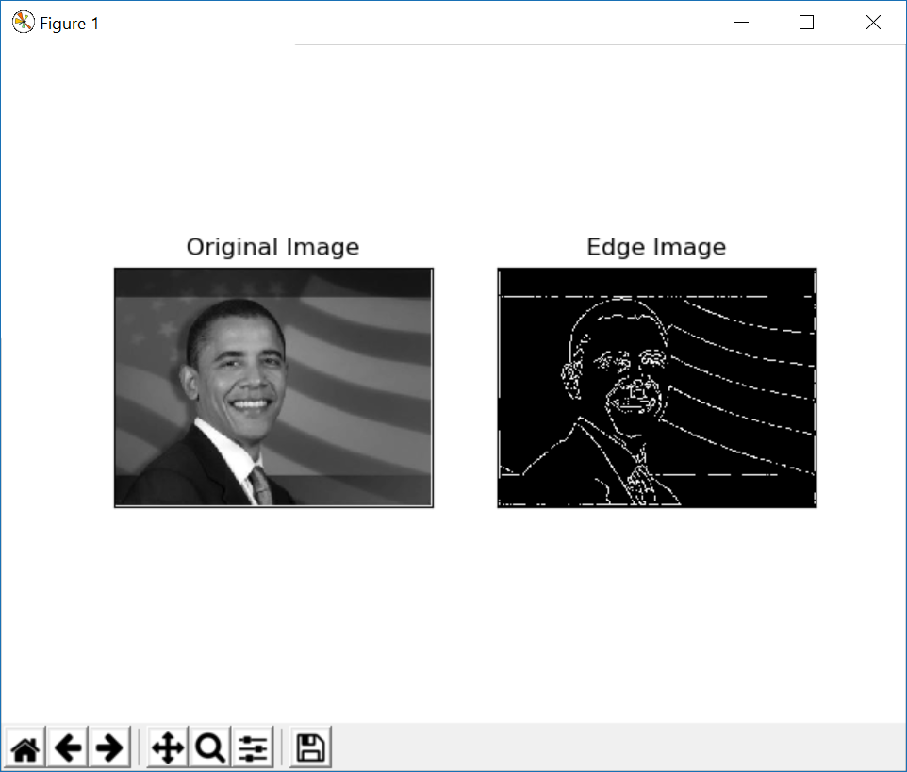

## Harris Corner Detection

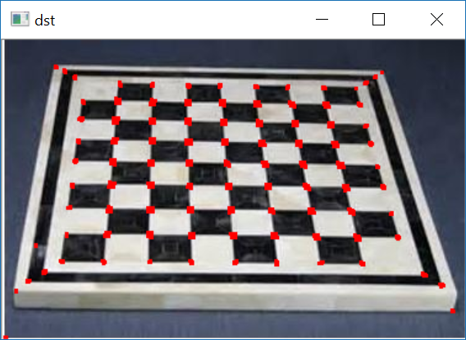

# C# Results

## Canny Edge Detection

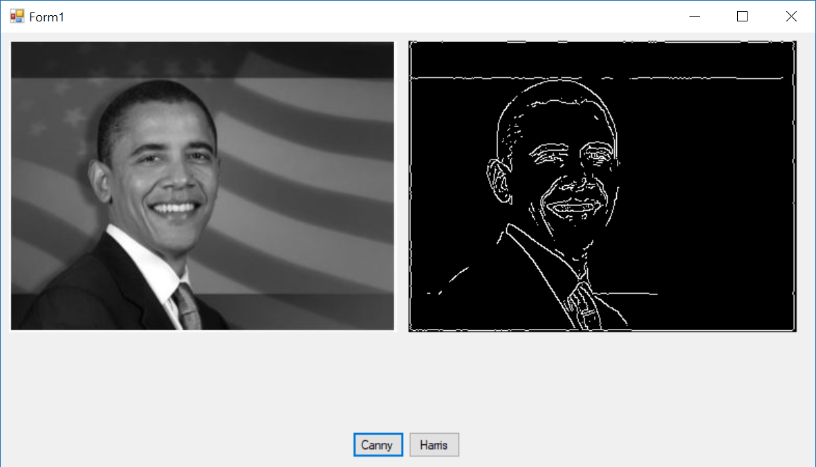

## Harris Corner Detection

