|  |  |
| --- | --- |
| Name: | Edward Eisenberger |
| ID# | 1066164 |
| Assignment 6 | |
| Due Date | March 18, 2019 |
| Date of Submission | March 10, 2019 |

# Part A

## Problem Statement

Suppose you are given a set of points in two shapes. Some of these points are outliers. We can remove these via exhaustive evaluation or via random sampling through a technique called RANSAC. The following partial code shows how you will test for adding and removing outliers. You need to write the code for the outlier removal button handler, so that the two shapes get aligned as shown in the right most part of the screen shot below. The approach will be to remove iteratively one pair of points and see if it reduces the transformation cost.

## Output

The outlier removal button was split into two: Outlier Removal (Iterative) and Outlier Removal (RANSAC). This section displays the output for the Outlier Removal (Iterative) implementation.

The cost of applying the transformation without removing outliers is shown in Figure 1:

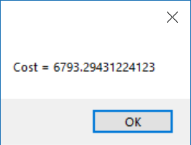

Figure - Cost Without Removing Outliers

Outliers were removed iteratively before applying the transformation, which significantly improved to the cost as shown in Figure 2.

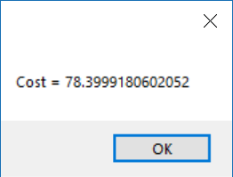

Figure - Cost After Removing Outliers (Iterative)

Figure 3 displays the initial shapes, the transformation without removing outliers, and the transformation after outliers were removed iteratively:

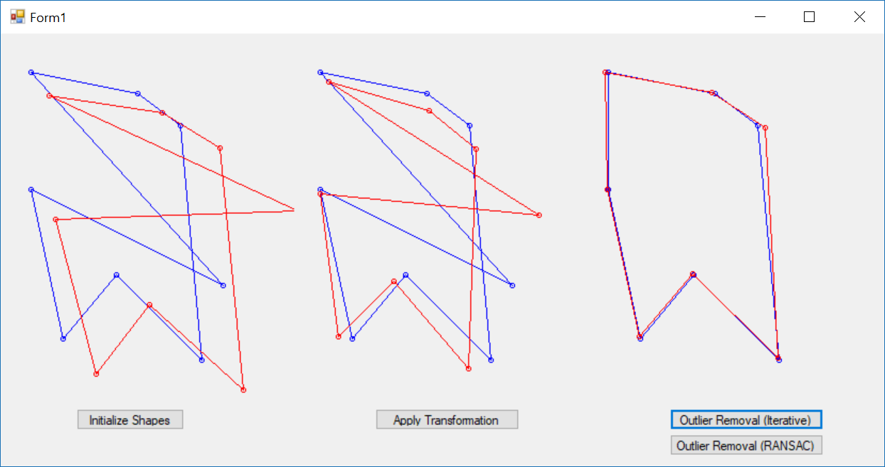

Figure - Final Result (Iterative)

# Part B

## Problem Statement

Repeat part a) using the RANSAC algorithm.

## Output

The outlier removal button was split into two: Outlier Removal (Iterative) and Outlier Removal (RANSAC). This section displays the output for the Outlier Removal (RANSAC) implementation.

Outliers were removed using the RANSAC algorithm before applying the transformation, which significantly improved to the cost as shown in Figure 4:



Figure - Cost After Removing Outliers (RANSAC)

Figure 5 displays the initial shapes, the transformation without removing outliers, and the transformation after outliers were removed iteratively:

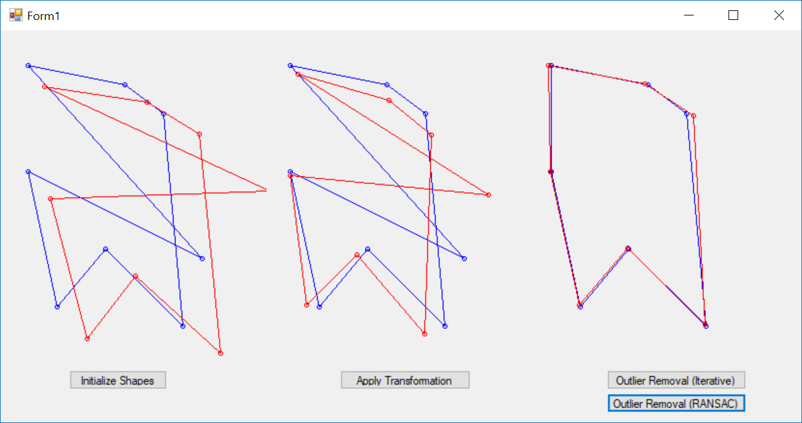

Figure - Final Result (RANSAC)