|  |  |
| --- | --- |
| Name: | Edward Eisenberger |
| ID#: | 1066164 |
| Assignment 1 | |
| Due Date: | Feb. 6, 2019 |
| Date of Submission: | Feb. 5, 2019 |

Contents

Overview 3

Problem 1 3

Summary 3

Input 3

Output 3

Screenshot 4

Problem 2 4

Summary 4

Input 5

Output 5

Problem 3 6

Part a 6

Part b 7

# Overview

Assignment 1 consists of three (3) problems outlined in the following sections. A single Visual Studio solution containing several Python modules was created to solve each problem. The main module, Assignment1.py, contains the main routine which calls

# Problem 1

## Summary

Problem 1 provided introductory lessons to the Python programming language. A python module was created which:

1. Reads students and their corresponding grades from a text file
2. Creates a new student and grades in the list
3. Writes the updated list to a file

The file read into the module is shown in the Input section and the results of the module are shown in the Output section.

## Input

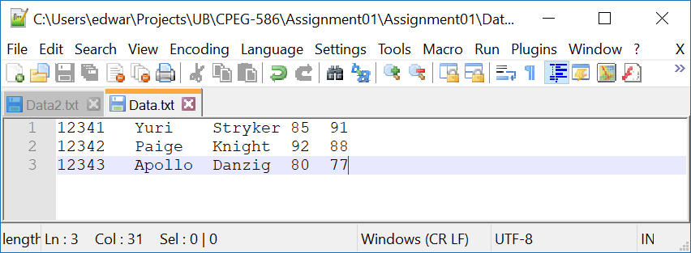

## Output

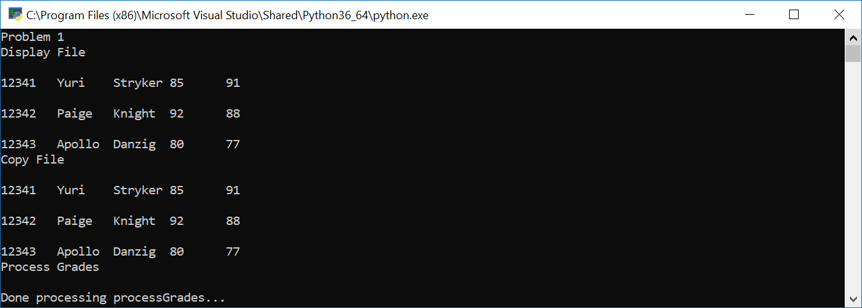

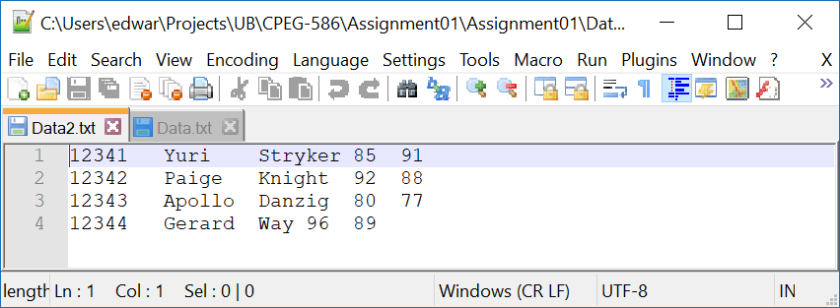

## Screenshot

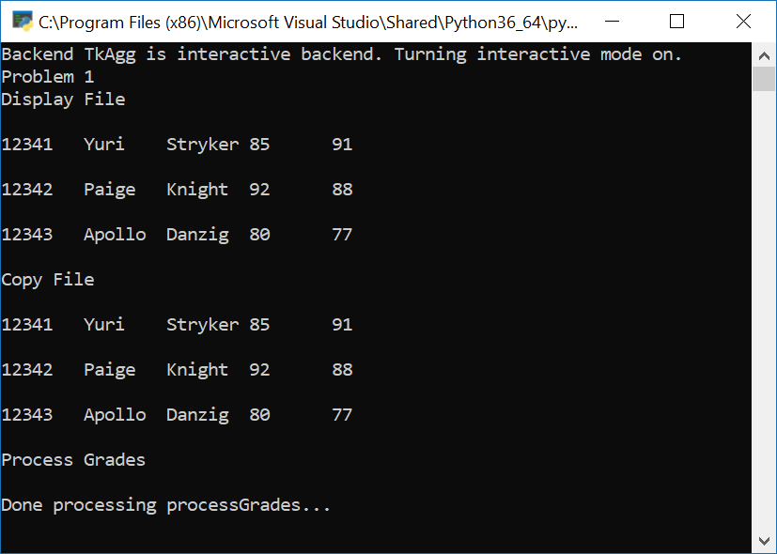

# Problem 2

## Summary

Problem 2 required implementing a Python module which uses Linear Least Squares Optimization to estimate the model parameters of a line to fit the given data. The following Input section details the data used for the Linear Least Squares Optimization python module. The following Output displays the results.

## Input

The following input was hard coded into the Python Module.

|  |  |
| --- | --- |
| X | Y |
| 1 | 3.2 |
| 2 | 6.4 |
| 3 | 10.5 |
| 4 | 17.7 |
| 5 | 28.1 |
| 6 | 38.5 |

## Output

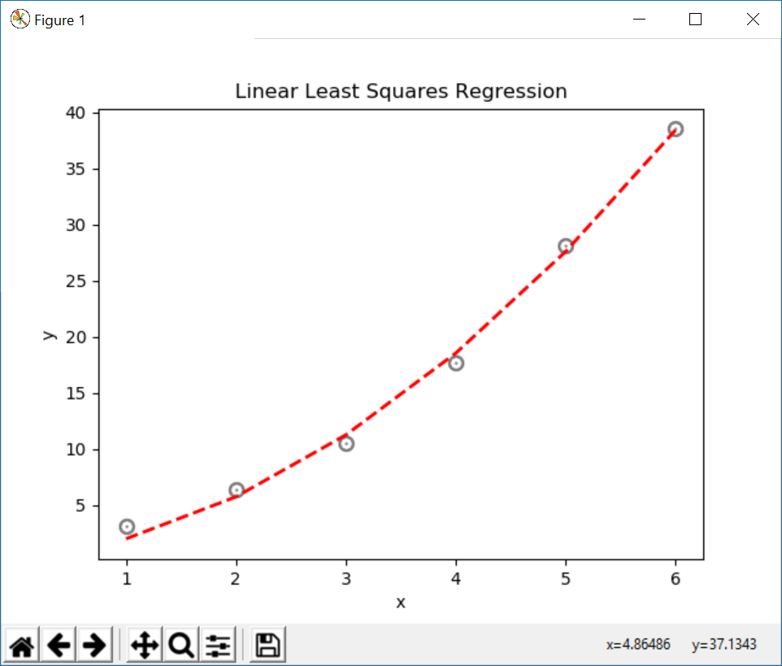

Figure - Linear Least Squares Regression Curve



Figure - Linear Least Squares Regression Coefficients

# Problem 3

## Part a

For the single neuron network described in lecture 1, show derivations for computing gradients w1, w2 and b. Assume the network will be classifying using the decision boundary given by: $y=0.3x+2$ $$S=w_{1}x_{1}+w_{2}x_{2}+b$$ $$a=S=Actual value$$ $$Y=Expected value$$ $$L=\frac{1}{2}{(Y-a)}^{2}$$ $$L=\frac{1}{2}{(Y-(w_{1}x_{1}+w_{2}x_{2}+b))}^{2}$$ $$L=\frac{1}{2}{(Y-w_{1}x_{1}-w_{2}x_{2}-b)}^{2}$$ $$\frac{dS}{dw_{1}}=(-x_{1})(Y-w_{1}x_{1}-w_{2}x_{2}-b)$$ $$\frac{dS}{dw_{2}}=(-x_{2})(Y-w_{1}x_{1}-w_{2}x_{2}-b)$$ $$\frac{dS}{db}=(-1)(Y-w_{1}x_{1}-w_{2}x_{2}-b)$$ $$\frac{da}{dS}=1$$ $$\frac{dL}{da}=1$$ $${Gradient}_{w1}=\frac{dL}{dw_{1}}=\frac{dL}{da}*\frac{da}{dS}*\frac{dS}{dw_{1}}=(-x_{1})(Y-w_{1}x_{1}-w_{2}x_{2}-b)$$ $${Gradient}_{w2}=\frac{dL}{dw_{2}}=\frac{dL}{da}*\frac{da}{dS}*\frac{dS}{dw_{2}}=(-x_{2})(Y-w_{1}x_{1}-w_{2}x_{2}-b)$$ $${Gradient}_{b}=\frac{dL}{db}=\frac{dL}{da}*\frac{da}{dS}*\frac{dS}{db}=(-1)(Y-w_{1}x_{1}-w_{2}x_{2}-b)$$
 ­

## Part b

A python class, Neuron2.py, was implemented to represent a single neuron model which takes two (2) inputs. The gradient equations developed in Part a are used to train the Neuron using the following data for 100000 Epochs.

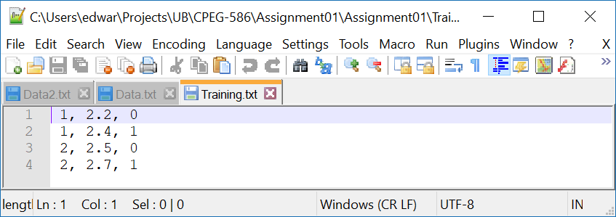

Figure - Training Data

The Neuron is then tested with the following test data:

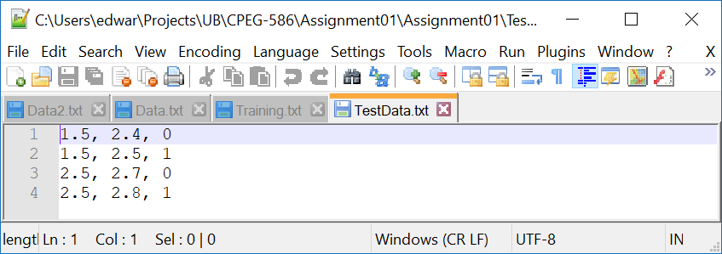

Figure - Test Data

The results of the training and test data are:

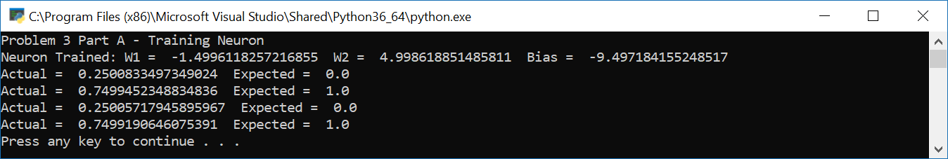

Figure - Neuron Results