|  |  |
| --- | --- |
| Name: | Edward Eisenberger |
| ID#: | 1066164 |
| Assignment 4 | |
| Due Date: | March 18, 2019 |
| Date of Submission: | March 18, 2019 |

Table of Contents

Part A 3

Part B 3

Part C 3

Part D 3

Part E 3

Output 3

# Part A

The Neural Network developed in Assignment 3 was converted to an Object-Oriented form. The application is capable of creating Neural Networks with any number of hidden layers. Each layer contains a configurable number of neurons and the last layer’s activation function can be set to Sigmoid, Tanh, RELU, or SoftMax. All example outputs use Mini Batch with a batch size of 50 and a learning rate of 0.01 for 30 Epochs.

The following figure is an example output of the updated application.

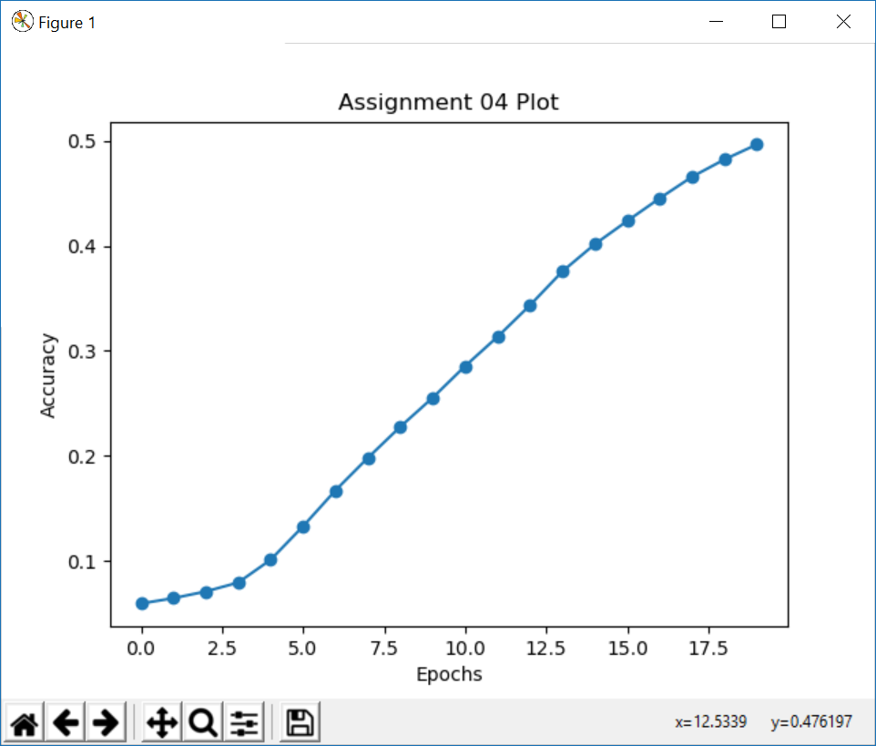

Figure : No Optimizations

# Part B

The Adam optimizer was added to the implementation from part A. The following figure is an example of the Neural Network’s accuracy using the Adam optimizer.

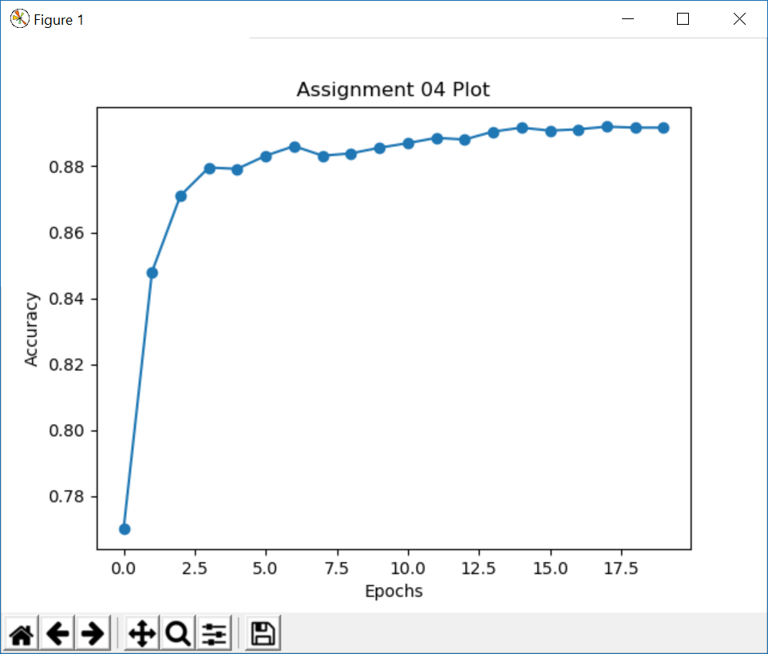

Figure : ADAM Optimization

# Part C

$γ=Scaling Factor$ $β=Offset Factor$

$Mean of Batch=μ_{b}=\frac{1}{N}\sum_{1}^{N}{S_{i}}$ $Variance of Batch=σ_{b}^{2}=\frac{1}{N}\sum_{1}^{N}{{(S_{i}-μ_{b})}^{2}}$

$$Mean Adjusted Batch Sum={\hat{S}}_{l}^{}=\frac{S_{i}-μ_{b}}{\sqrt{σ_{b}^{2}+ϵ}}$$

$$Batch Normalization Output=S_{b}=γ{\hat{S}}_{l}^{}+β$$

$$\frac{∂L}{∂γ}=\frac{∂L}{∂a_{i}}*\frac{∂a_{i}}{∂S_{B}}*\frac{∂S_{b}}{∂γ}=-\left(a_{i}-y_{i}\right)*a_{i}\left(1-a_{i}\right)*{\hat{S}}_{l}^{}=δ*{\hat{S}}_{l}^{}$$

$$\frac{∂L}{∂β}=\frac{∂L}{∂a_{i}}*\frac{∂a_{i}}{∂b}*\frac{∂S_{b}}{∂β}=-\left(a_{i}-y_{i}\right)*a_{i}\left(1-a_{i}\right)=δ$$

$$δ=\frac{∂L_{}}{∂a_{i}}*\frac{∂a_{i}}{∂S_{b}}=-\left(a_{i}-y_{i}\right)*a_{i}\left(1-a_{i}\right)$$

$$δ_{bn}=\frac{∂L}{∂S_{i}}=δγ(\left(\frac{∂{\hat{S}}_{l}^{}}{∂S_{i}^{}}\right)+\left(\frac{∂{\hat{S}}_{l}^{}}{∂μ_{b}^{}}*\frac{∂μ_{b}^{}}{∂S_{i}^{}}\right)+\left(\frac{∂{\hat{S}}_{l}^{}}{∂σ_{b}^{2}}*\frac{∂σ_{b}^{2}}{∂S_{i}^{}}\right))$$

$$\frac{∂{\hat{S}}_{l}^{}}{∂S_{i}^{}}=\frac{1}{\sqrt{σ_{b}^{2}+ϵ}}$$

$$\frac{∂{\hat{S}}_{l}^{}}{∂μ_{b}^{}}*\frac{∂μ_{b}^{}}{∂S_{i}^{}}=\left(\frac{1}{N}\right)\left(\frac{-1}{\sqrt{σ_{b}^{2}+ϵ}}*\sum_{1}^{N}{-2\left(S_{i}-μ_{b}\right)}\right)$$

$$\left(\frac{∂{\hat{S}}_{l}^{}}{∂σ_{b}^{2}}*\frac{∂σ_{b}^{2}}{∂S_{i}^{}}\right)=(\frac{-1}{2}\left(S_{i}-μ_{b}\right)\left(σ_{b}^{2}+ϵ\right)\left(\frac{2}{N}\left(S_{i}-μ_{b}\right)\right)=\frac{-1}{N}{\left(S_{i}-μ_{b}\right)}^{2}\left(σ_{b}^{2}+ϵ\right)$$

$$δ_{bn}=δγ\left(\left(\frac{1}{\sqrt{σ_{b}^{2}+ϵ}}\right)+\left(\left(\frac{1}{N}\right)\left(\frac{1}{\sqrt{σ_{b}^{2}+ϵ}}*\sum_{1}^{N}{-2\left(S_{i}-μ_{b}\right)}\right)\right)+\left(-\frac{1}{N}{\left(S_{i}-μ_{b}\right)}^{2}\left(σ_{b}^{2}+ϵ\right)\right)\right)$$

$$δ_{bn}=\frac{δγ}{N}\left(\left(\frac{N}{\sqrt{σ_{b}^{2}+ϵ}}\right)-\left(\left(\frac{2}{\sqrt{σ_{b}^{2}+ϵ}}*\sum_{1}^{N}{\left(S_{i}-μ_{b}\right)}\right)\right)-\left({\left(S_{i}-μ_{b}\right)}^{2}\left(σ_{b}^{2}+ϵ\right)\right)\right)$$

$$δ_{bn}=\frac{δγ}{N{(σ_{b}^{2}+ε)}^{\frac{1}{2}}}[N-1-{\hat{S}}_{l}^{2}]$$

# Part D

Batch Normalization was implemented in all layers excluding the last layer.

The following figure is an example of Batch Normalization with the Adam Optimizer.

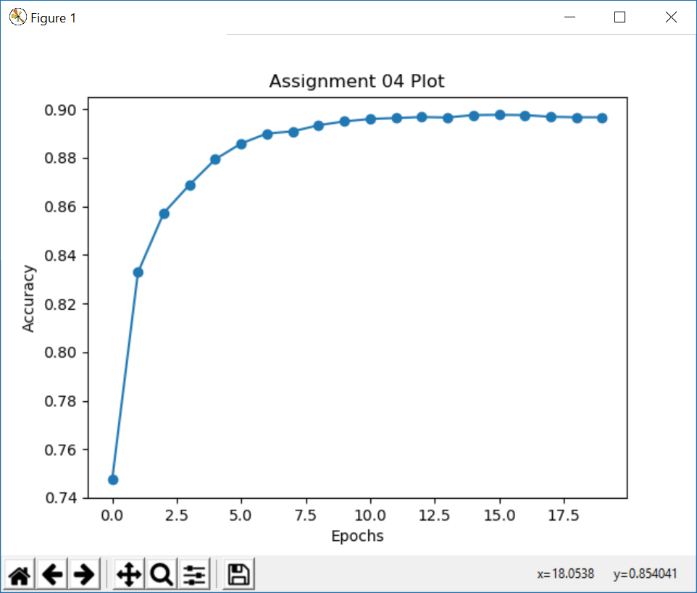

Figure : Batch Normalization with Adam Optimizer