|  |  |
| --- | --- |
| Name: | Edward Eisenberger |
| ID# | 1066164 |
| Assignment 1 | |
| Date of Submission | May 24, 2019 |

# Overview

Assignment 1 consisted of implementing the examples in the Handout on “Multithreading in Csharp” up to page 12, cross threading errors.

# Part A: MultiThreading

## Summary

The MultiThreading project introduced the Data Synchronization Problem. Two threads are executed which access the same data. The lock(object) operation is used to ensure synchronization on class data members.

## Results

The output of the project is shown below:

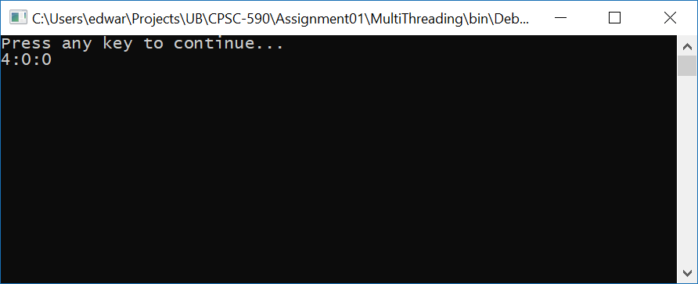

# Part B: Threading2

## Summary

Threading2 introduced the concept of background threads, which are automatically terminated when the program ends, and threads which cannot be stopped partway through execution. It also introduced the concept of joining long running threads.

## Results

The following sections show example output from the application and each operation.

### Application

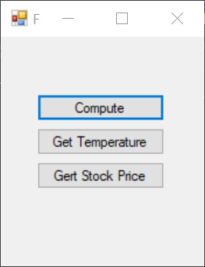

### Compute

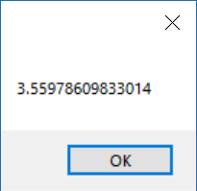

### Get Temperature

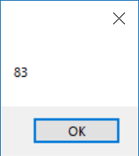

### Get Stock Price

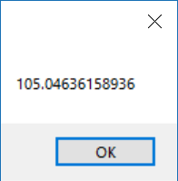

# Part C: CrossThreading

## Summary

The CrossThreading application introduced the concept of sharing data between threads via delegates. A thread is executed which updates a label on the UI thread with the current time every second for 10 iterations.

## Results

The following image is the output of the application:

