|  |  |
| --- | --- |
| Name: | Edward Eisenberger |
| ID# | 1066164 |
| Assignment 3 | |
| Date of Submission | June 7, 2019 |

Table of Contents

Overview 3

Part 1: ReaderWriterLock 3

Summary 3

Results 4

Part 2: TPLTest 5

Summary 5

Results 5

# Overview

Assignment 2 consisted of implementing the examples in the Handout on “Multithreading in Csharp” from page 12 to page 23 (excluding process and thread monitoring).

# Part 1: ReaderWriterLock

## Summary

ReaderWriterLock is a C# class in the System.Threading namespace as part of the .NET Framework. It is used to protect a shared resource by synchronizing access to a resource. The ReaderWriterLock allows either concurrent read access for multiple threads or write access for a single thread. This works best where most accesses are reads and writes are infrequent and short duration. This provides better throughput than a one-at-a-time lock, such as Monitor.

A coding example utilizing ReaderWriterLock can be found in the ReaderWriterLockExample project within the Assignment03 Visual Studio solution.

## Results

The following image is the output of the application.

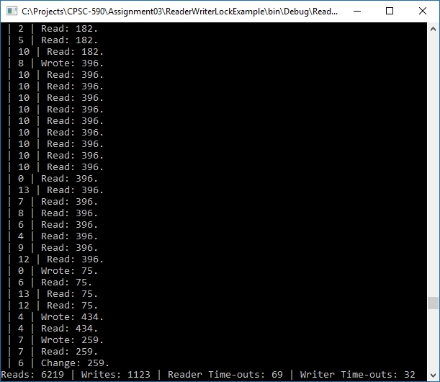

# Part 2: TPLTest

## Summary

Part 2 consisted of implementing the examples in the Task Parallel Library handout.

## Results

The following images are example outputs of the various examples in the Task Parallel Library handout.

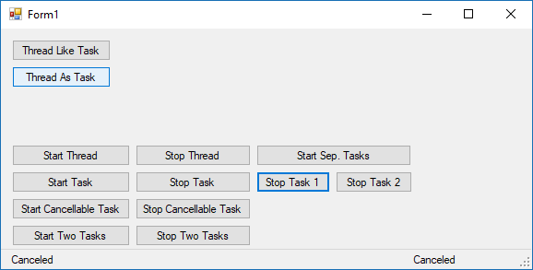

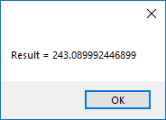

Figure 1 - Thread Like Task



Figure 2 - Thread As Task

