|  |  |
| --- | --- |
| Name: | Edward Eisenberger |
| ID# | 1066164 |
| Assignment 6 | |
| Date of Submission | June 21, 2019 |

Table of Contents

Overview 3

Part 1: WCF Tutorial 3

Summary 3

Results 3

FirstWCFHost, FirstWCFClient, and WCFLib 3

SecondWCF and SecondWCFClient 4

Part 2: WCF Publisher Subscriber and Client Callbacks 6

Summary 6

Results 6

# Overview

Assignment 4 consisted of reading and implementing the examples in the handouts “Distributed Computing – WCF Tutorial” and “Distributed Computing – WCF Publisher Subscriber and Client Callbacks.”

# Part 1: WCF Tutorial

## Summary

The “Distributed Computing – WCF Tutorial” handout introduced the Windows Communication Foundation (WCF) technology. The following projects were implemented: WCFLib, FirstWCFHost, FirstWCFClient, SecondWCF, and SecondWCFClient.

## Results

The results for each of the handout examples are shown below.

### FirstWCFHost, FirstWCFClient, and WCFLib

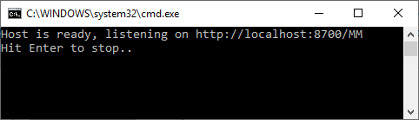

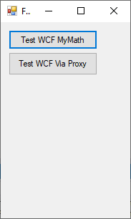

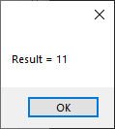 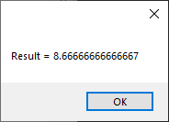

### SecondWCF and SecondWCFClient

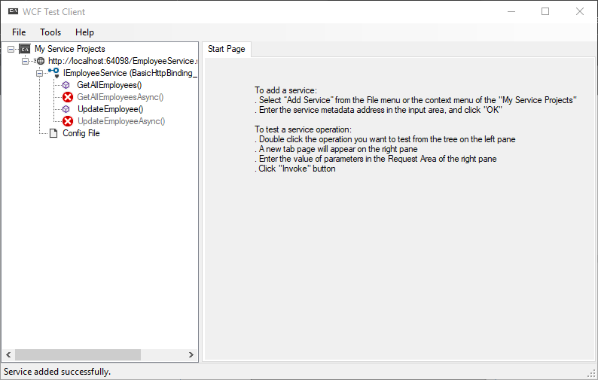

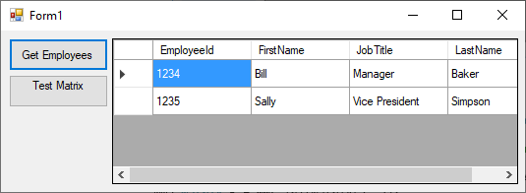

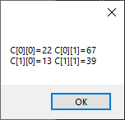

# Part 2: WCF Publisher Subscriber and Client Callbacks

## Summary

The “Distributed Computing – WCF Publisher Subscriber and Client Callbacks” handout expanded on WCF and introduced client callbacks using the Publisher Subscribers pattern. The following projects were implemented: PubSubLib, PubSubHost, and PubSubClient.

## Results

