|  |  |
| --- | --- |
| Name: | Edward Eisenberger |
| ID# | 1066164 |
| Assignment 9 | |
| Date of Submission | August 3, 2019 |

Table of Contents

Overview 3

Summary 3

Results 3

Alea GPU Application 3

Alea GPU.For with Lambda Expression 3

Alea GPU with Kernel 4

Matrix Initialization 4

Matrix Multiplication: Sequential 4

Matrix Multiplication: Alea GPU Kernel 1 4

Matrix Multiplication: Alea GPU Kernel 2 4

Matrix Multiplication: Alea GPU Kernel 3 5

Matrix Multiplication: Alea GPU Kernel 4 (GPU.For) 5

PyCuda: Element-Wise Array Multiplication and Matrix Multiplication 5

# Overview

Assignment 09 consisted implementing the examples in the “GPU Programming Using CUDA and Alea GPU” handout.

# Summary

Assignment 09 was implemented in a single Visual Studio 2017 solution, Assignment09, and contains two projects: GPUAleaTest and PyCudaTest.

GPUAleaTest contains the implementations for the Alea GPU examples.

PyCudaTest contains the implementations for the Python examples and exercise.

# Results

## Alea GPU Application

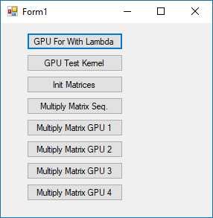

## Alea GPU.For with Lambda Expression

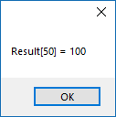

## Alea GPU with Kernel

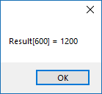

## Matrix Initialization

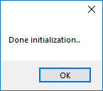

## Matrix Multiplication: Sequential

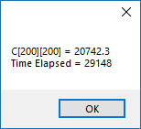

## Matrix Multiplication: Alea GPU Kernel 1

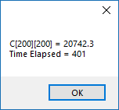 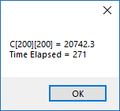

## Matrix Multiplication: Alea GPU Kernel 2

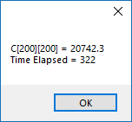 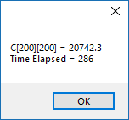

## Matrix Multiplication: Alea GPU Kernel 3

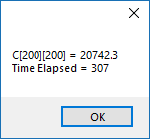 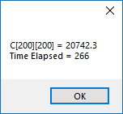

## Matrix Multiplication: Alea GPU Kernel 4 (GPU.For)

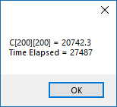 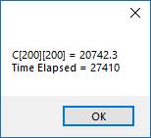

## PyCuda: Element-Wise Array Multiplication and Matrix Multiplication

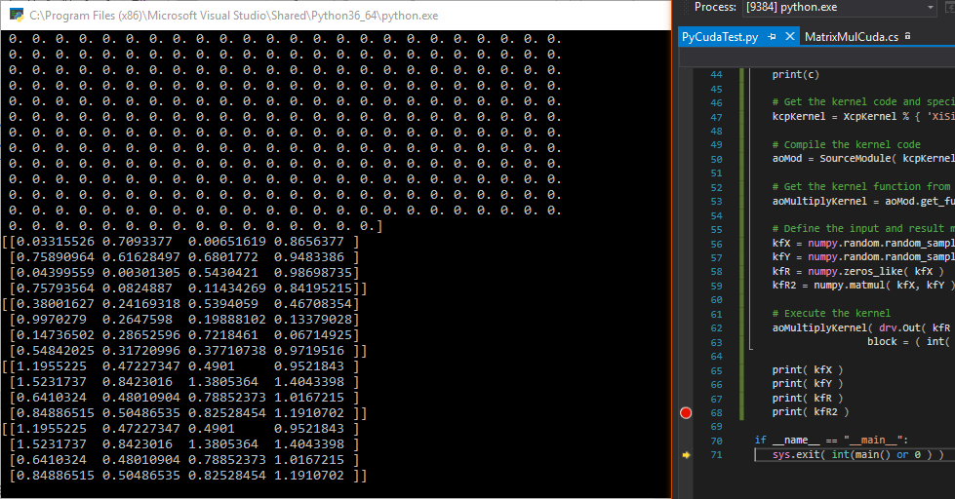

The figure above contains the outputs of the Element-Wise Array Multiplication result array as well as the matrices contained in the Matrix Multiplication:

* The first matrix is input X
* The second matrix is input Y
* The third matrix is the result of the GPU Matrix Multiplication X * Y
* The fourth matrix is the result of the sequential Matrix Multiplication via numpy.matmul