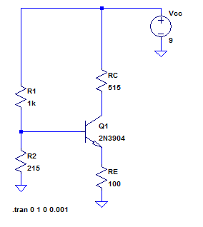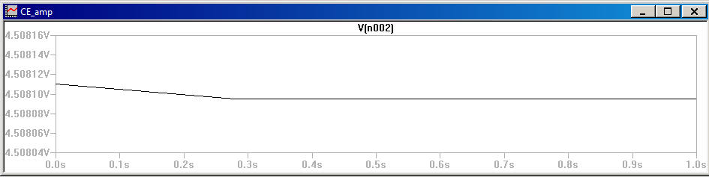

For input peak to peak

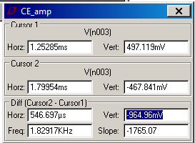

Vc peak to peak

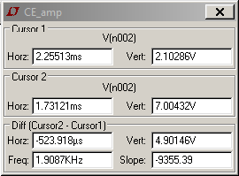

Waveform for gain analysis

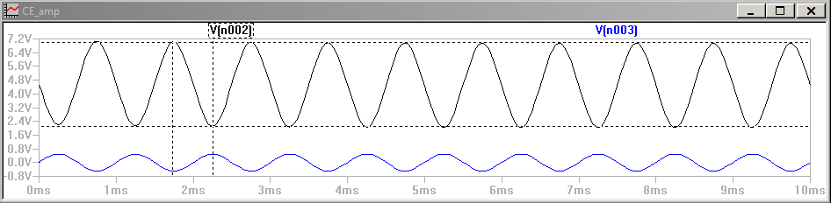

For R1 = 1.2k R2 = 220

Vc

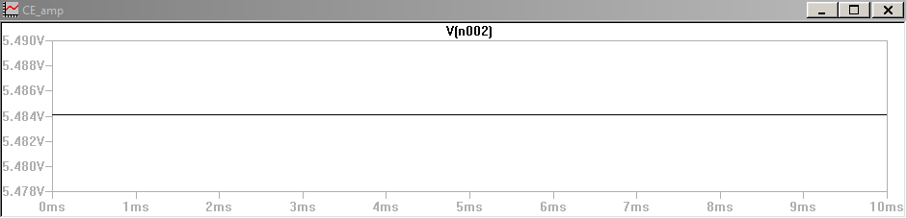

Circuit

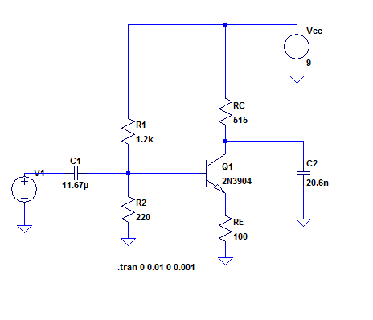

Gain waveform

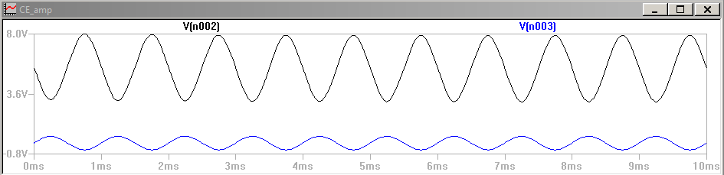

Gain with input amplitude of 0.5

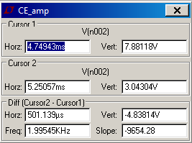

Waveform with clipping (amplitude 0.84 v)

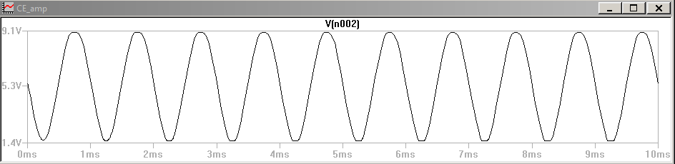

Lower corner frequency

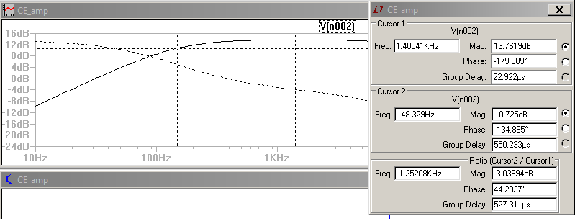

Upper corner frequency

