Lab Number 4 Report

Ben Simpson, Section # 001

Benjamin Bergeson, Section # 001

**Introduction**

The objective of this lab is to design a BJT amplifier that meets the following specifications:

1. Gain of 5±1 Vout/Vin
2. Maximum possible voltage swing
3. Lower corner frequency of 100-200 Hz
4. Upper corner frequency of 10-20 kHz
5. Single voltage supply with amplitude of 9 V

We will be designing a circuit (shown in figure 1) that has a common emitter BJT amplifier and

**Amplifier Design**

The main design requirements to meet are (1) gain of 5 Vout/Vin and (2) maximum voltage amplitude of the output. The equations that we will need to use are show below.

 or 

(2)

(1)

 or 

There are three main variables (RE, RC, and IC) and two equations. We will use 100 Ω for RE because we want RE to be fairly small so we don’t limit the gain too much. With two variables and two equations, we are now able to solve for RC and IC. Our calculations can be seen below in figure 1. After the calculations we get the following values: RC = 514.87 Ω and IC = 8.74 mA.

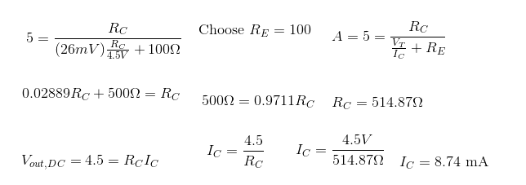

Figure Calculations for IC and RC

Now that we have the IC that we need, we can figure out the R1 and R2 that we need to get the IC. We got that R1 = 1kΩ and R2 = 100 Ω. Our calculations can be seen below in figure 2.

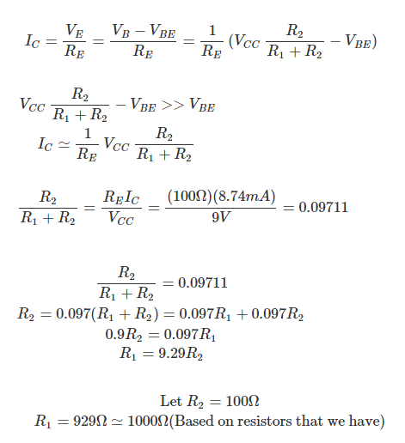

Figure Calculations for R1 and R2

With the values that we calculated we can figure out the input and output resistances. We find that Rin = 90.91 Ω and Rout = 514.87 Ω. Our calculations can be seen below in figure 3.

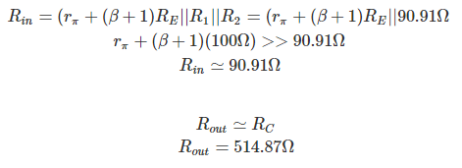

Figure Calculations to find Rin and Rout

We then did the calculations (seen below in figure 4) to figure out C1 and C2 to get the desired corner frequencies. We find that C1 = 11.67 µF and C2 = 20.6 nF.

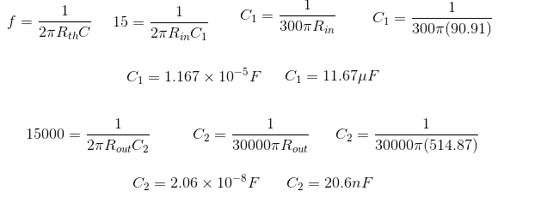

Figure Calculations for C1 and C2

**Circuit Simulation**

Now that we have these values we can proceed with designing the circuit in LTSpice and our simulations. Our schematic in LTSpice can be seen in figure 5. The values in the schematic have been changed to reflect later calculations.

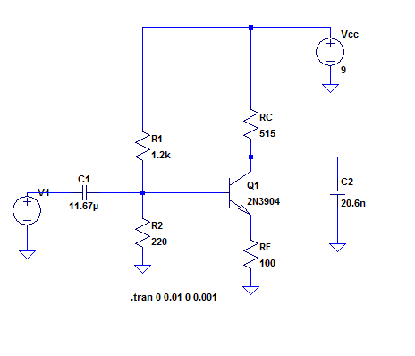

Figure 5 LTSpice schematic

For our DC analysis simulation, we had to try several different values for RC, R1, and R2 before we could get all aspects to meet specs. The values that we arrived at are as follows: R1 = 1.2 kΩ, R2 = 220 Ω, RC = 515 Ω, and RE = 100 Ω.

We simulated the DC portion of the circuit using the values listed above and got the VC to equal roughly 4.5 V. The simulation plot can be seen below in figure 6.

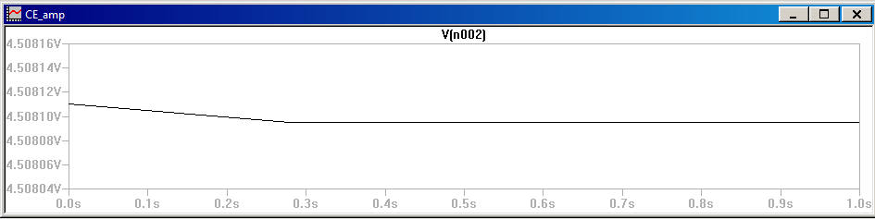

Figure LTSpice simulation plot for VC

We simulated the gain analysis and got the following waveform and values (figure 7). As can be seen below, with an input peak to peak of roughly 1 V, output peak to peak is 4.9 V. That is within the lab specification of having a gain of 5V ± 1.

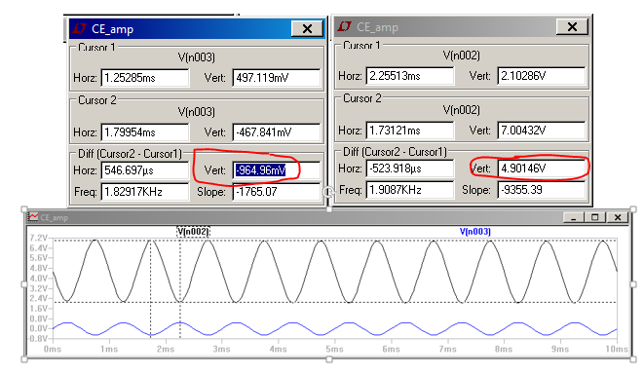

Figure Values and waveforms for gain analysis simulation

In the simulation for maximum swing analysis, we found that the bottom started clipping slightly earlier than the top. The bottom started clipping with and input amplitude of 0.84 V. The top didn’t start clipping until input reached an amplitude of 0.88 V. The wave form for when the bottom starts clipping can be seen below in figure 8.

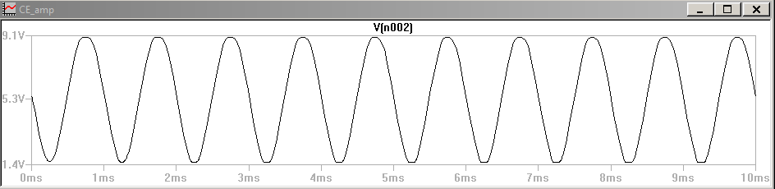

Figure Waveform when bottom starts clipping

With the adjusted values for the resistors, the capacitor values had to be changed as well. Using the same calculation method as seen in figure 3 and 4, we found that C1 = 5.7 µF and C2 = 20.6 nF. Using these capacitor values, we were able to run a simulation to determine the upper (figure 9) and lower (figure 10) corner frequencies. In the simulation we found that the upper corner frequency was around 15.1 kHz and lower corner frequency was around 148 Hz.

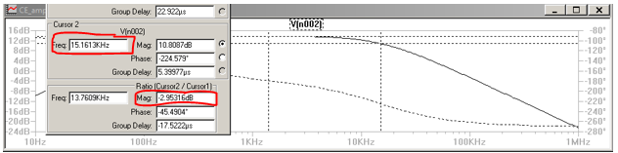

Figure Upper corner frequency

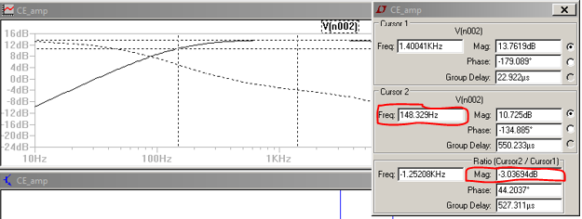

Figure Lower corner frequency

**Circuit Construction**

After completing our simulations, we built the circuit using the values that we simulated with. Some of these values had to be adjusted slightly in order to match our available parts. The final schematic of the circuit that we built reflecting both our simulation results and our available parts is shown in Figure 11. A picture of our completed circuit can be seen in figure 12.

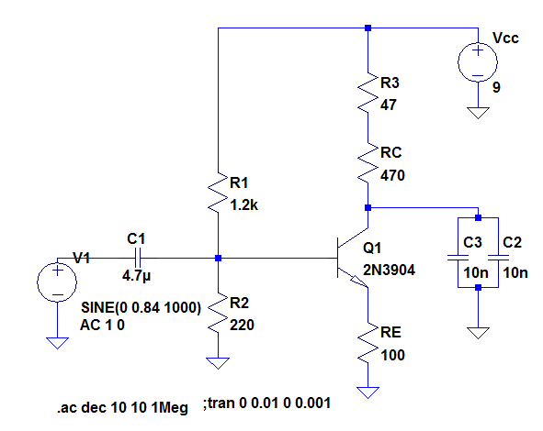

Figure Final Circuit Schematic

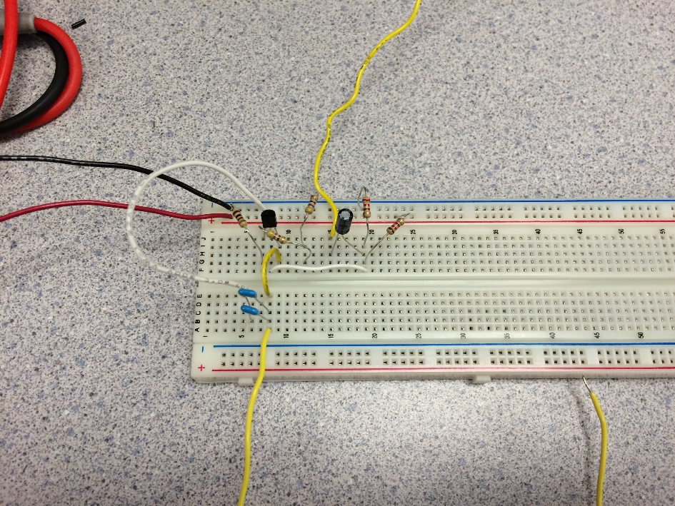

Figure 12 Photo of completed circuit

**Circuit Testing**

The first test that we performed on the circuit was to measure the biasing of the BJT. We connected 9V to our VCC and did not apply any input in order to measure the circuit at the bias point. We measured the bias point collector voltage, VCQ, to be 4.4 V. This matches with our simulation in Figure 6. We also measured the BJT’s collector to emitter voltage, VCE, to be at about 1.3 V. The collector current was measured to be 7 mA. We concluded that the BJT was in active mode since VCE was greater than the minimum value of 0.2 V required for active biasing, and the collector current was not close to 0 A.

Using the oscilloscope we were able to measure the gain of the circuit at an arbitrary 1 kHz. We chose this frequency since it is close to the middle of the amplifier’s specified bandwidth. The waveform can be seen below in figure 12. Waveform 1 is the input and waveform 2 is the output.

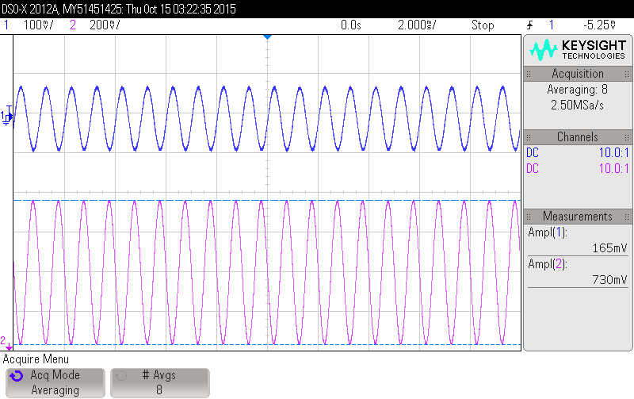

Figure Oscilloscope gain waveform

By division, it can be seen that the amplitude of the gain |Vout/Vin| is equal to 4.42 V/V. After further testing at a few other frequencies, we found the gain to be 4.45 V/V. This is within our spec of a gain of 5±1 V/V.

Next, we tested the maximum voltage swing of the amplifier. Keeping the input signal’s frequency at 1kHz, we increased the amplitude until the output began clipping. The bottom of the output started clipping at an input of 1.696 Vpp, and the top of the output started clipping at 1.982 Vpp. This is close to our simulation that found clipping start at an input of 1.68 Vpp. Taking the difference of the top and bottom clipping points, dividing it by the average of the two clipping points, and multiplying that by 100%, we found out that top and bottom clip within 15% of each other. This is within the allowable 20% in the spec.

The waveform of the signal right below the first clipping point is shown in Figure 13. Since the output of the signal is bounded at the clipping points, it does not grow beyond its value at the point where it clips. Thus, as can be seen in Figure 13, the maximum amplitude of our circuit output is about 7.11 Vpp. As the input increases beyond this, the output starts to look like a square wave with an amplitude equal to that of the maximum amplitude of the circuit.

Finally we tested the frequency response of the circuit. We adjusted the frequency of the input to find the corner frequencies. In order to do this, we found the points where Vout = Vin*Gain*0.707. These points are shown in Figure 14 and Figure 15. Although we kept the function generator at the same input voltage, the measured value of Vin varied slightly with frequency. Thus the values for Vout at the corner frequencies are slightly different for the upper and lower corner frequencies.

The upper corner frequency is 15.5 kHz and the lower corner frequency is 170 Hz. This is within the specified ranges of 10-20 kHz and 100-200 Hz respectively and in concordance with our simulation.

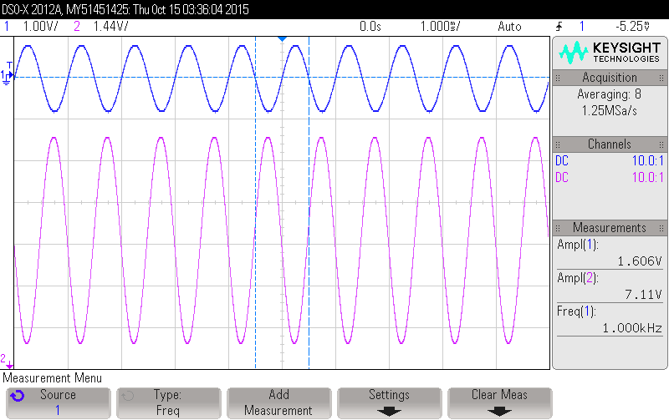

Figure Amplifier at max input before clipping

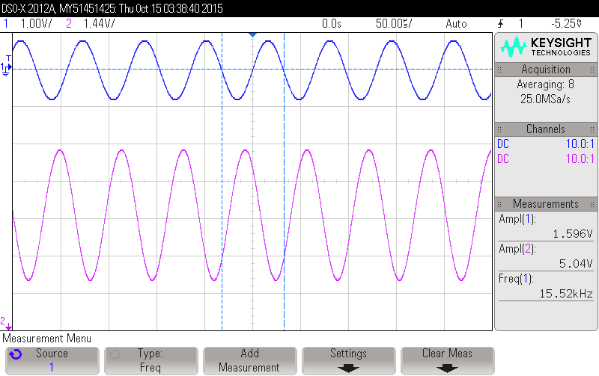

Figure Upper corner frequency

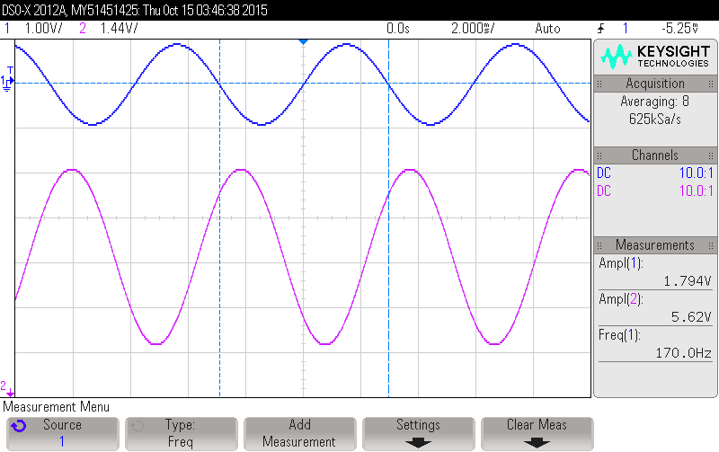

Figure Lower corner frequency

**Conclusion**

The objective of this lab was to build a BJT amplifier that meets the given specifications. Using these specifications and a common emitter BJT topology, we calculated the required resistors and capacitors. What worked so well on paper did not work well in simulation. We tried adjusting values several times to make the results meet the specs. This process was very iterative. When one spec was met, often times, the others will no longer be met. It took several tries to arrive at out final component values that met the given specifications.

In comparison to our previous lab, building the transmitter, in building this circuit, the measured values matched much more closely to the simulated values. Most of the measured values were within 10 % of the simulated values. This was most likely due to the fact that the circuit architecture we used in this lab relied more on resistor values than the internal values of the BJT. This shows that precise measurement of all component values, even the seemingly small ones, can affect the precision of the result.

This lab was gave us good practice for designing BJT amplifiers. It showed us the necessary steps of calculations, simulations, and iterative adjustments to arrive at the desired result. It also showed us how using different circuit architecture can produce more consistent results between simulation and production.