Introduction
Empirically and from documentation, the AAON heat pump has 6 operating modes. Figure 1 identifies the thermostat signals associated with each mode. Note that these signals do not appear to be sufficient to identify periods with condenser reheat. Of the remaining possible combinations, only two occur in the data: all wires low, and another with Y1 and Y2 low, O and Deh high.
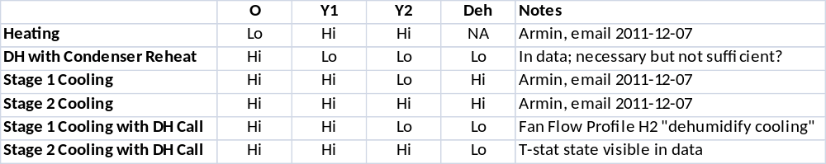
Figure 1: Operating Modes
For RP-1449, we are extending the code to model the Condenser Reheat mode. The model will consist of an adjustment relative to the normally modeled cooling performance. To determine the adjustment factor, we also need to know the empirical EER in service of the AAON in cooling mode.
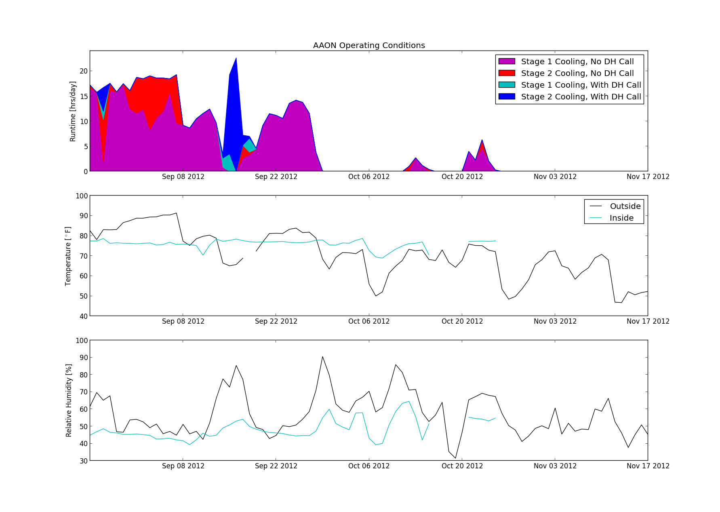
Figure 2: 2012-11-29-runtime-in-out-timeseries.png

The top panel of Figure 2 shows the distribution of the cooling modes over time. The period begins on 2012-08-25, when the digital scroll compressor was replaced with the two stage compressor which we want to model. The most recent data download was on 2012-11-19. The remaining panels plot indoor and outdoor conditions. Outdoor conditions come from a HOBO datalogger on site and weather data from DFW airport, collated by Weather Underground. The HOBO data is preferred when available; the last collection was 2012-11-12, after which all data is from DFW. Indoor conditions are an average of measurements at several locations. There are HOBOs in the master bedroom, the second bedroom, and at the thermostat. The return air temperature is also included, at times when the air handler is running. After 2012-11-12, the return air temperature is the only available indoor data.

Cooling Modes
From the 3-month period shown above, I selected periods of steady state runtime for system characterization. Each point in the graphs below represents a half-hour average. At the beginning of each half-hour interval, the system had been running in the same mode for at least half an hour. There are 154 such intervals for Stage 1 Cooling, and 87 for Stage 2.
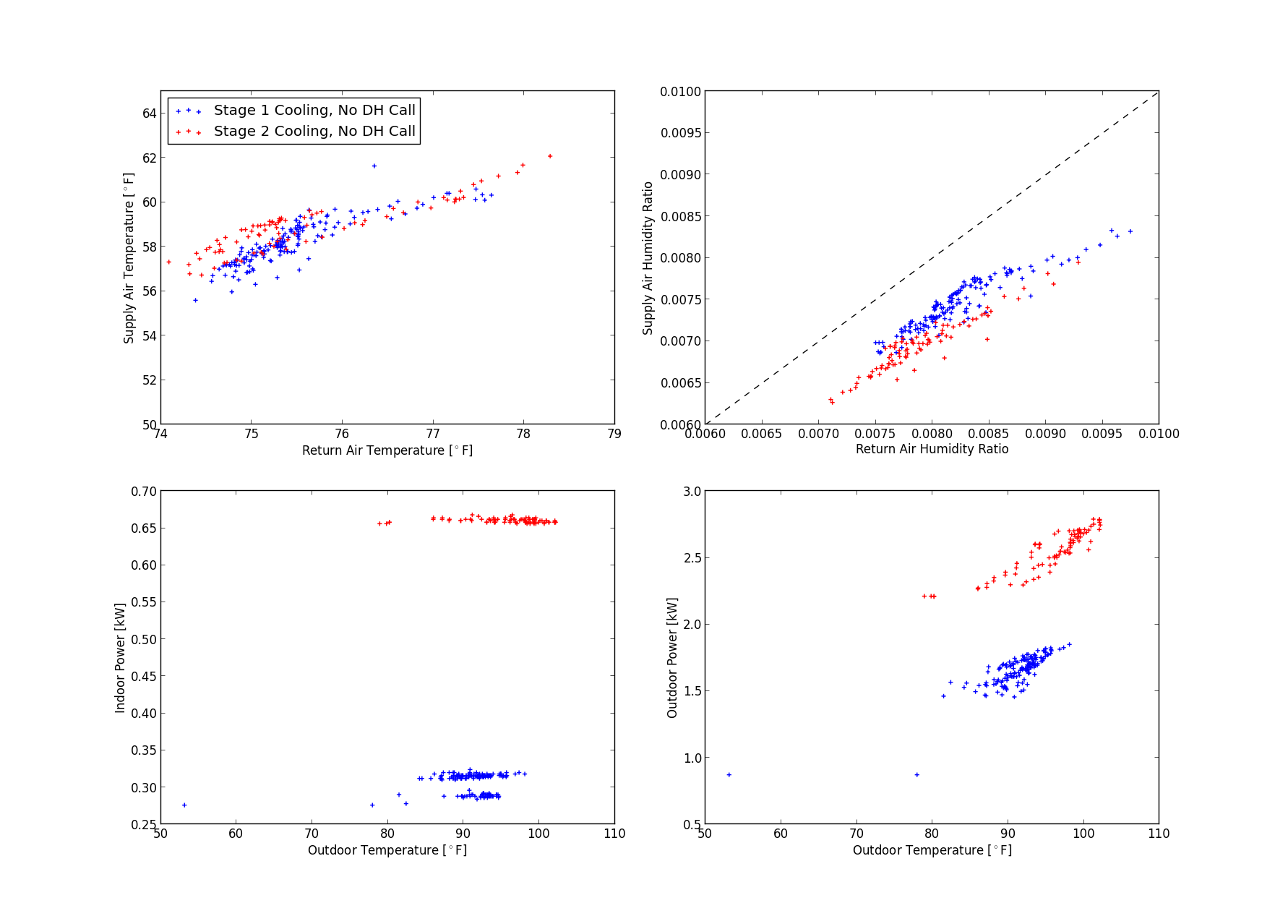
Figure 3: 2012-11-29-c1-c2-subplots.png
Temperature drop is about the same in both modes, indicating that CFM per delivered ton is kept about the same.
The electrical power plots show that the AHU fan speed (indoor power) is higher in stage two, and independent of outdoor temperature, as expected. Compressor power increases with increasing temperature.
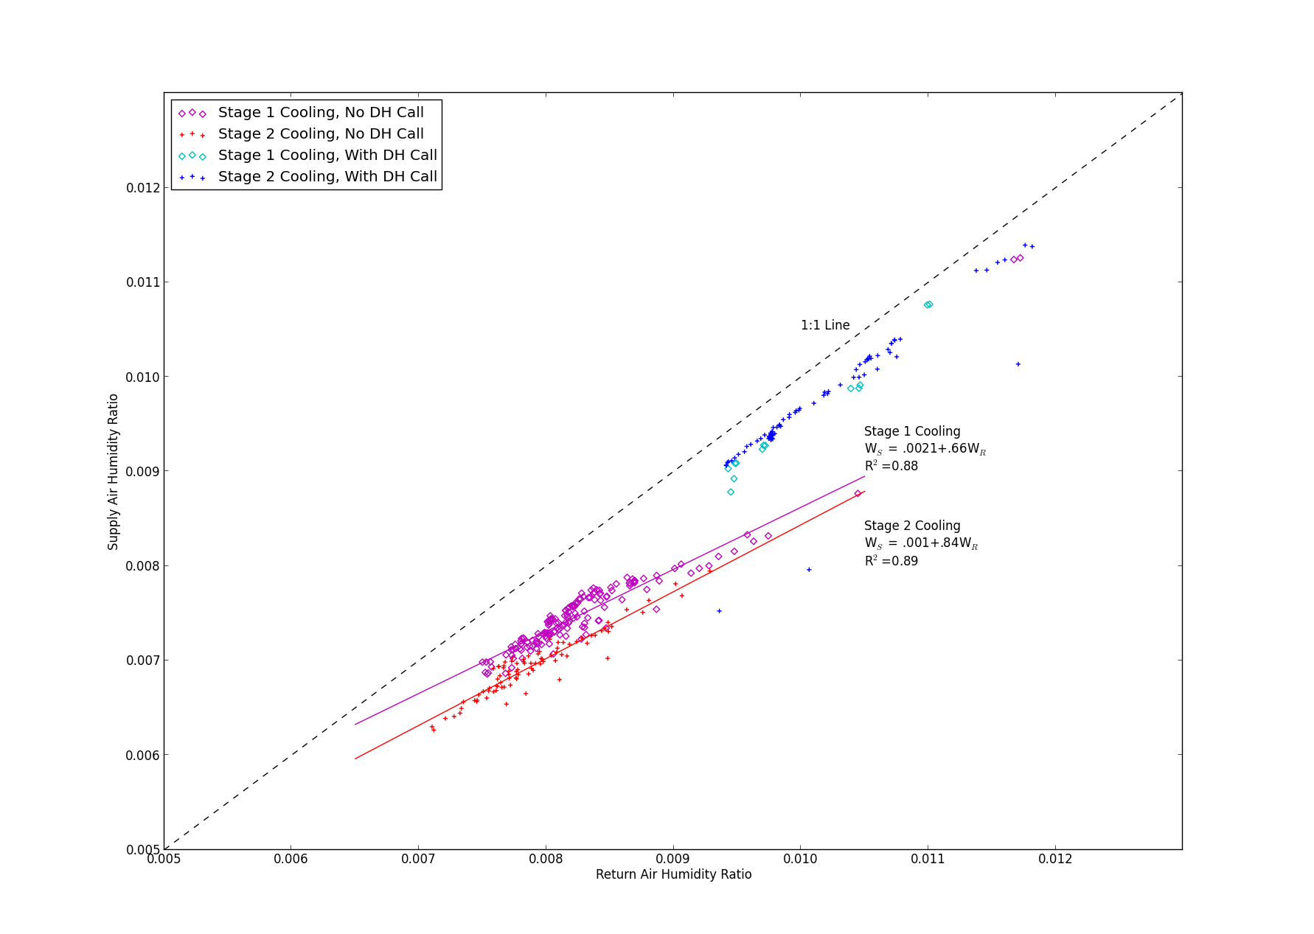
Figure 4: 2012-11-29-Wret-Wsup-mode-fit.png
In Figure 4, supply air humidity ratio is lower for Stage 2 Cooling. The rate of moisture removal in Stage 2 is substantially higher due to the increased airflow. Supply humidity ratio is about 0.24 g/kg lower for Stage 2 at any given return air humidity ratio. The 95% confidence interval is -0.16, -0.31. The difference in slope (Wret dependance) cannot be shown to be statistically significant.

For the purpose of accurate fitting, I omitted two outliers from the Stage 1 Cooling dataset. These points occur at much lower outdoor temperature than the rest of the data. They are obvious on the plot of outdoor electrical power in Figure 3. In Figure 4, they are at the upper right, adjacent data points with dehumdification call.
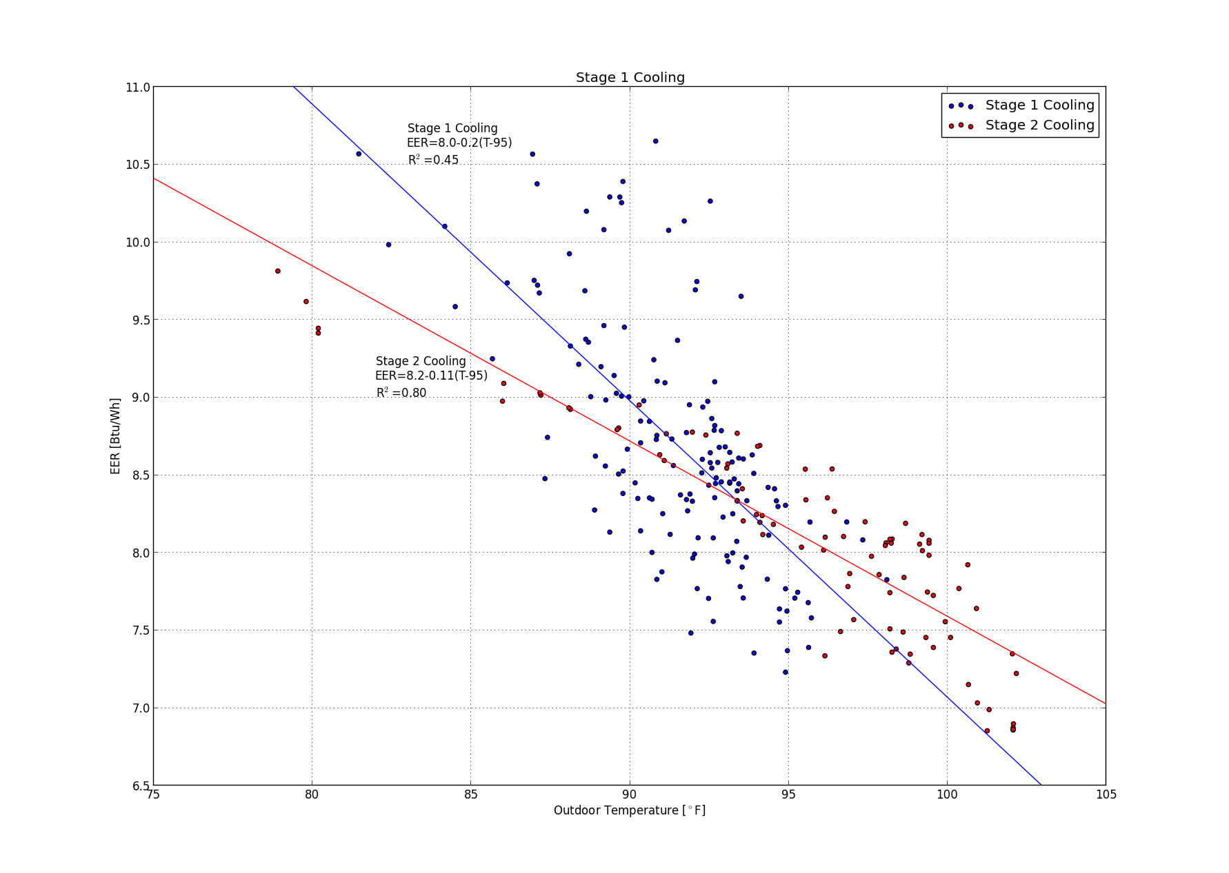
Figure 5: 2012-11-29-To-eer-c1-c2.png

From the data above, and the equation for air enthalpy in ASHRAE Fundamentals, I calculated EER for each half-hour steady-state interval. I excluded the outliers described above. The graph above shows the best fit lines and equations for each cooling mode. Expressing the equations in this way gives the constant term a natural interpretation -- EER at the standard test condition of 95°F.

Condenser Reheat Mode
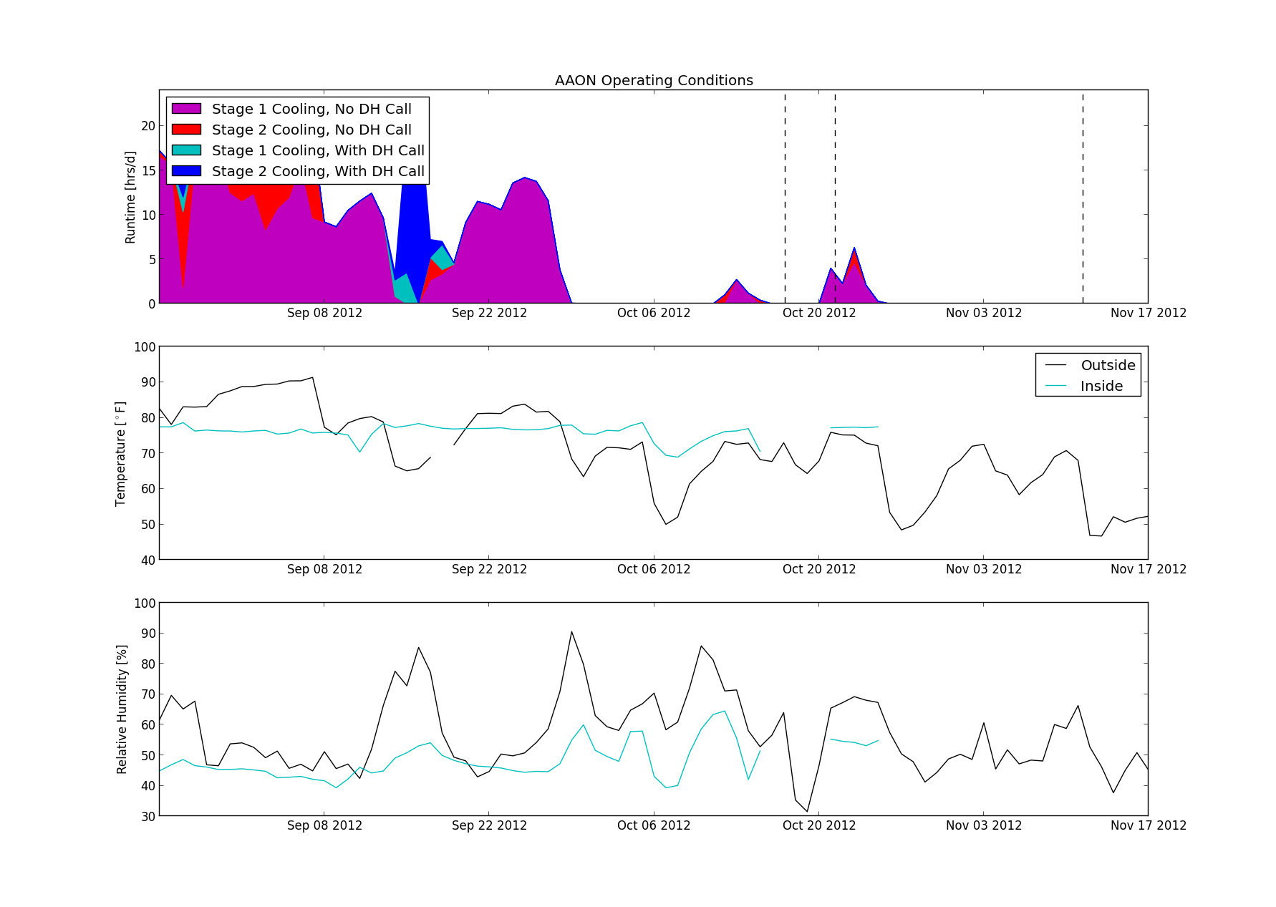
Figure 6: 2012-11-29-runtime-dh-marked.png
There are three short periods when the reheat coil inlet rises above 90°F. The graph above repeats the graph from Figure 2 but adds a vertical line at each of these dehumdification events. The dates are 2012-10-17, 2012-10-21, and 2012-11-11.

The following three graphs show the conditions in the air handler during and immediately before and after each dehumidification period. During the first two events, the system reached a steady state about 10 minutes after the reheat coil came on, and maintained fairly constant operating conditions for about 15 minutes after. The 15 minute average of this period was used for the graphs that follow. The 2012-11-11 event never reached a clear steady state. I nevertheless used the average over the 15-minute interval starting 10 minutes after reheat began.
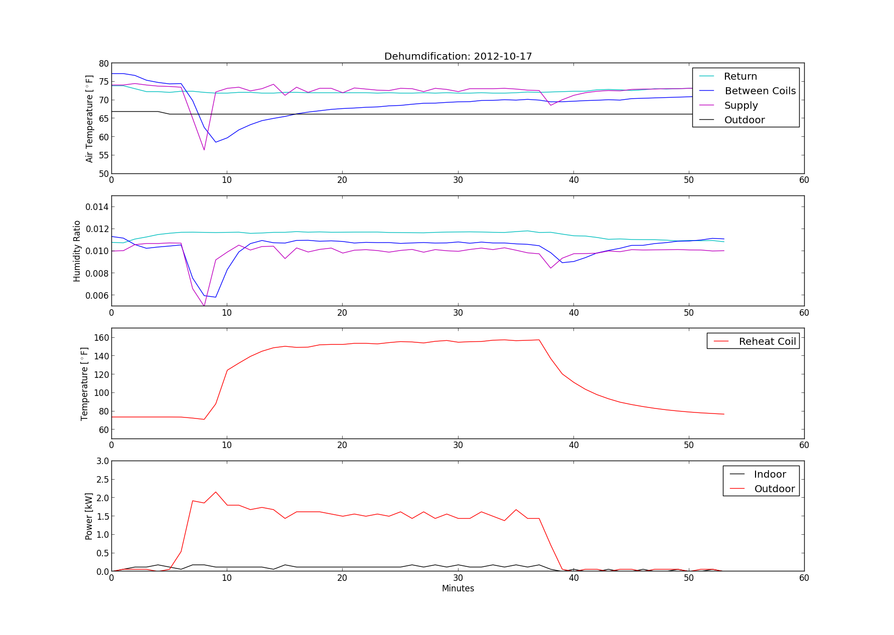
Figure 7: 2012-11-29-dh1-timeseries.png
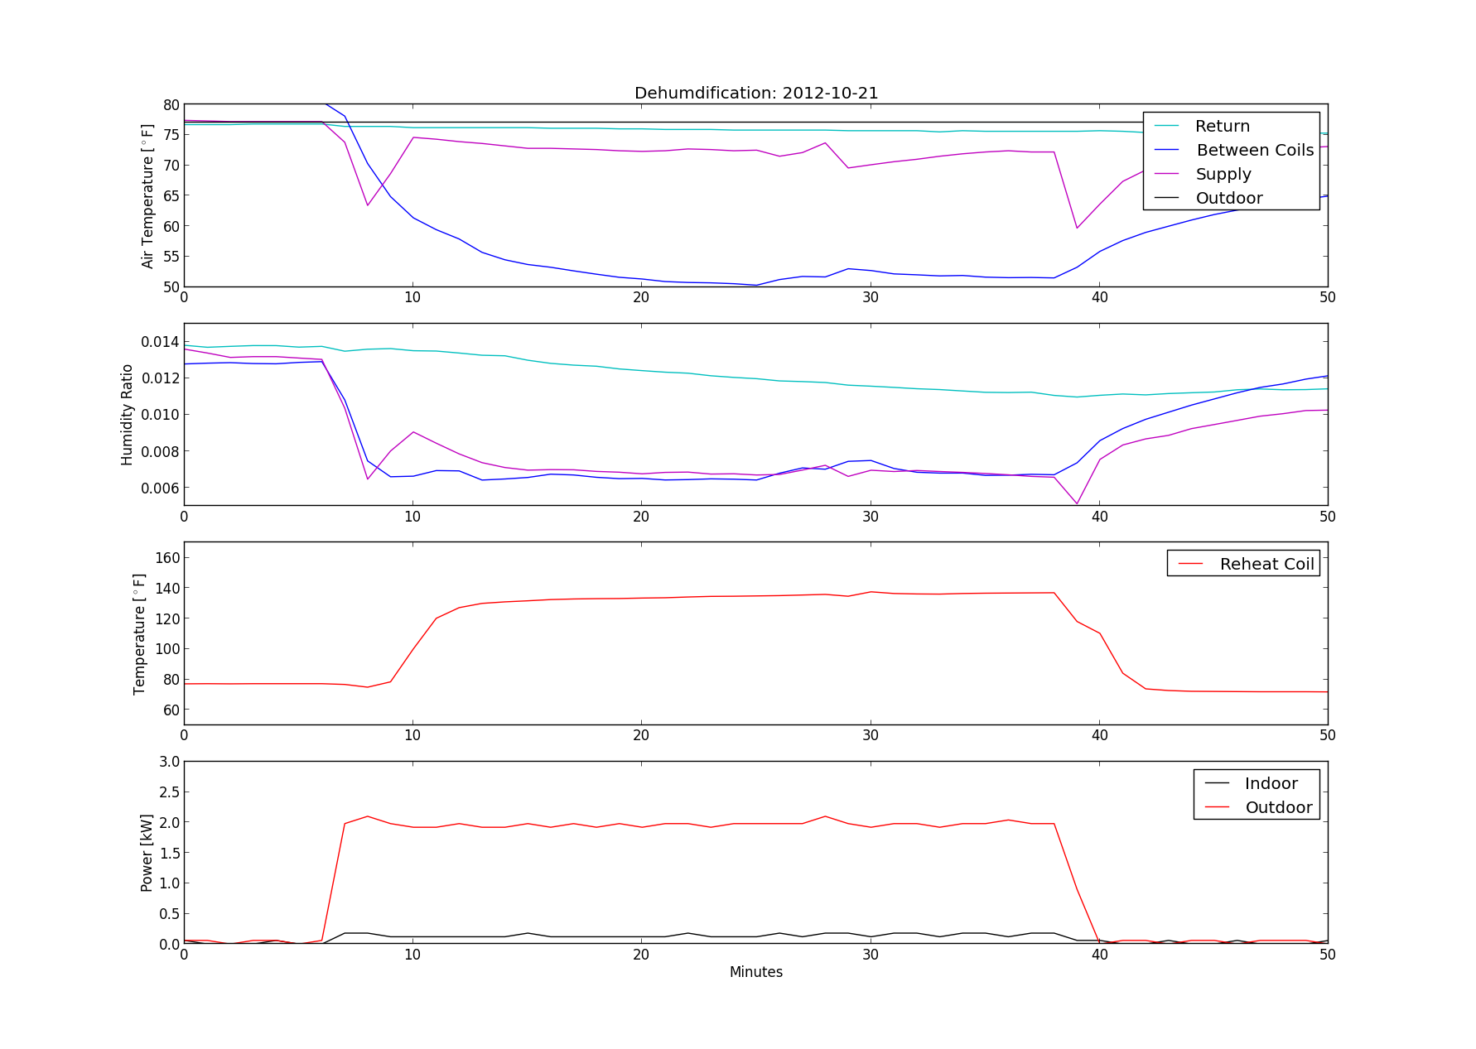
Figure 8: 2012-11-29-dh2-timeseries.png
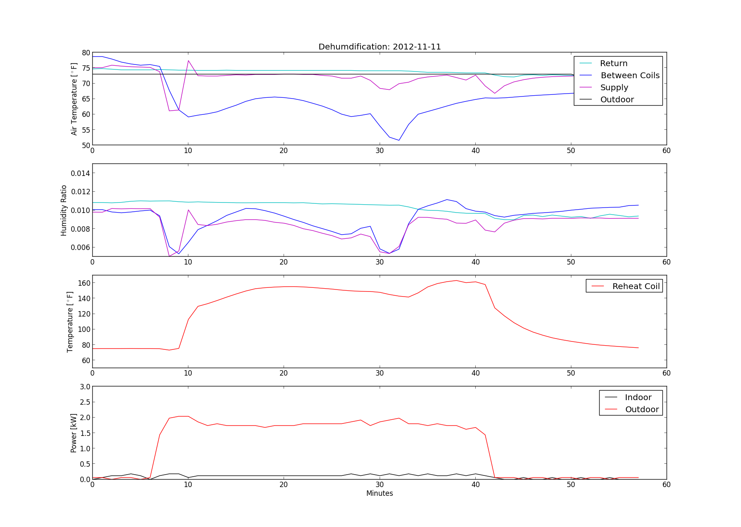
Figure 9: 2012-11-29-dh3-timeseries.png
During each dehumdification call, there is a temperature drop across the cooling coil, and a subsequent rise across the reheat coil. Figures 10 and 11 show the average air conditions at each measurement location during each dehumidification call. The low cooling on 2012-10-17, and resulting low moisture removal, is striking.
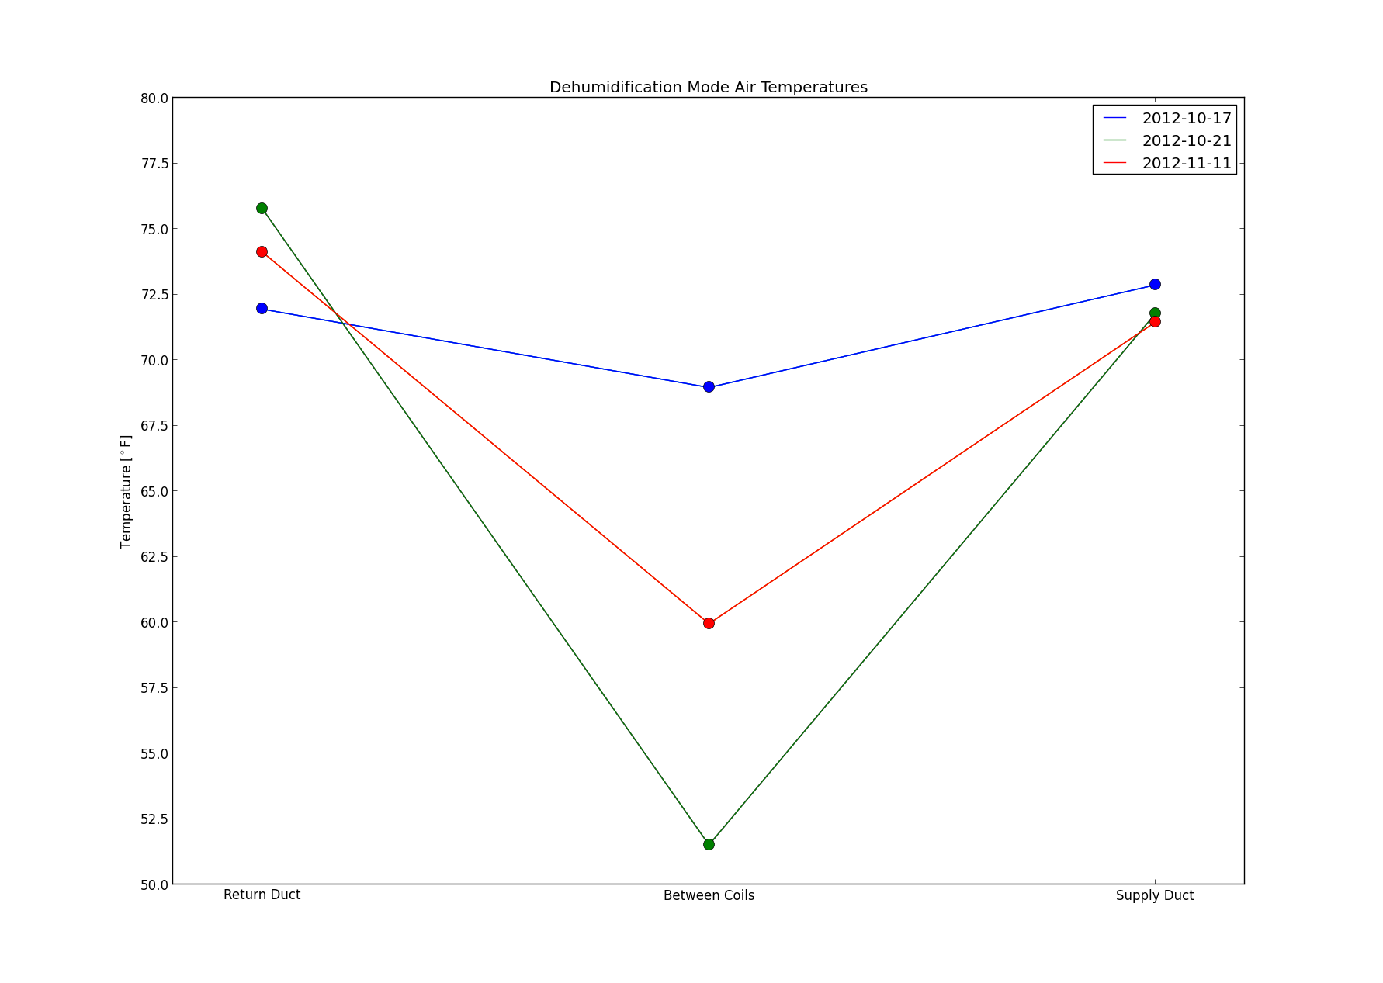  Figure 10: Air Temperature During DH | 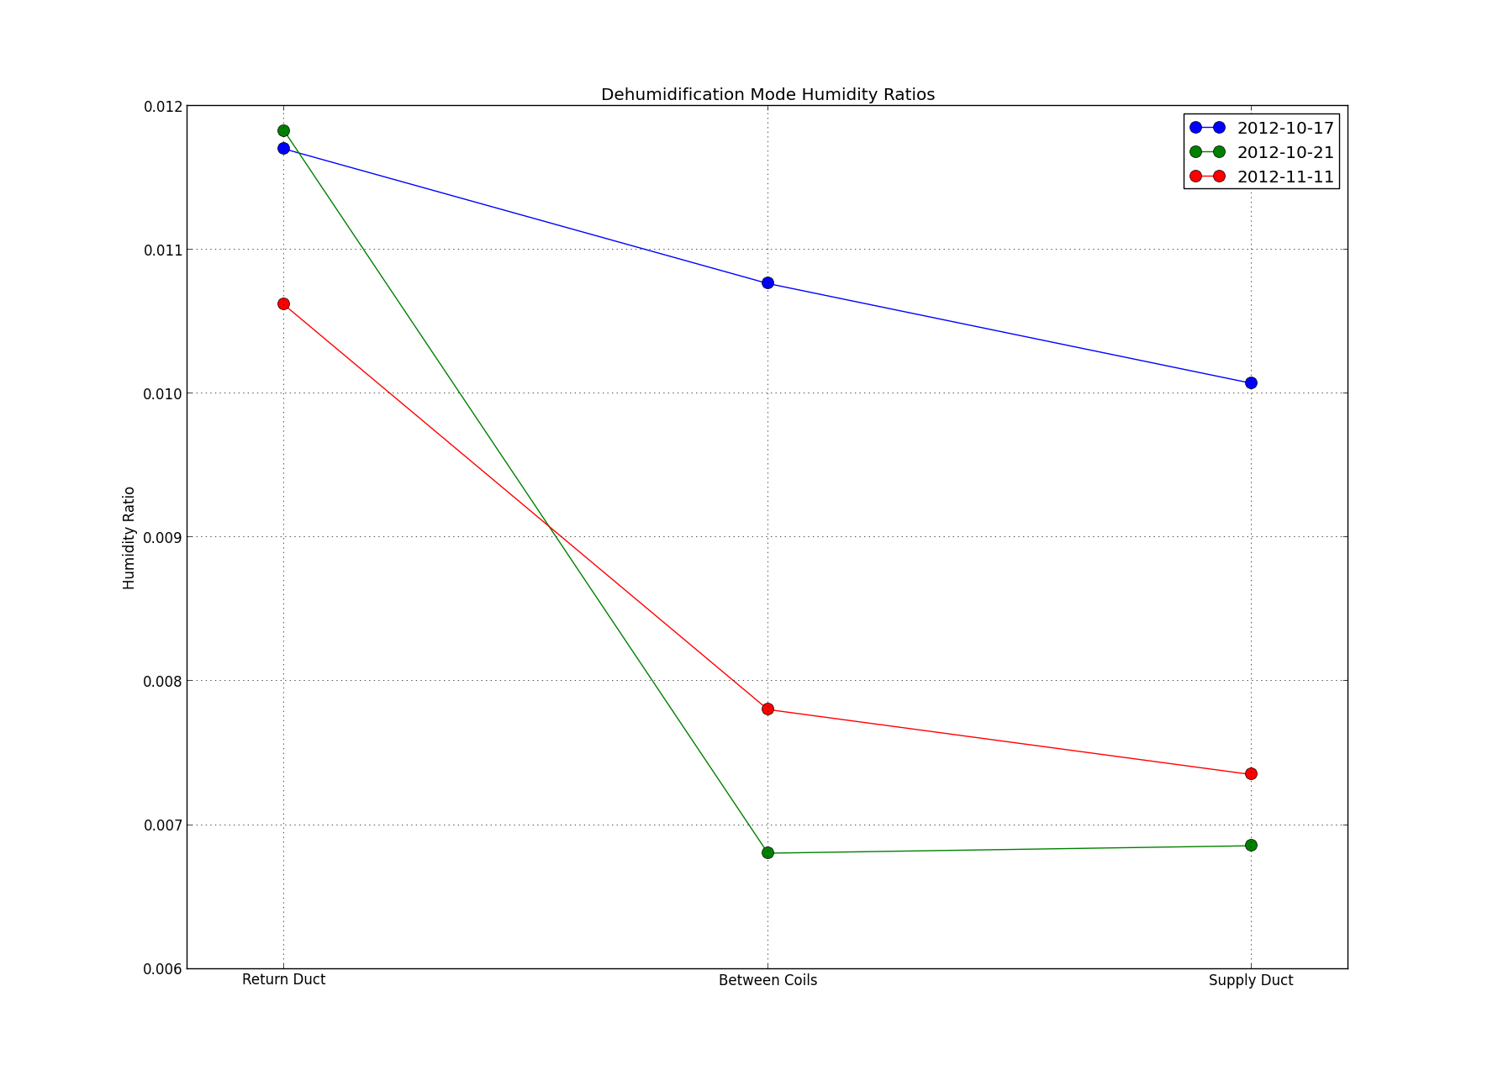  Figure 11: Humidity Ratio During DH

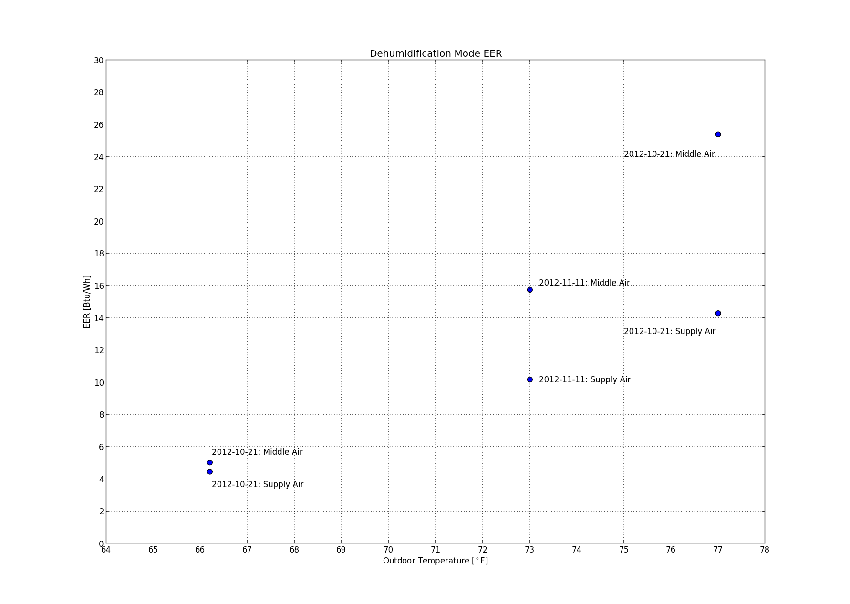
Figure 12: 2012-11-29-To-eer-dh.png
For the purpose of modeling, EER is calculated using the temperature between the coils. This captures the full sensible cooling, and allows reheat to room neutral temperature to be handled separately in the model. In other circumstances, it might be more useful to calculate performance based on the supply air. For instance, the total delivered capacity (sensible+latent). The graph above compares the two ways of calculating EER.

Conclusions
The data for both cooling modes are physically reasonable and sufficient for modeling. I'm uncertain whether the dehumidification data are sufficient to fit a useful model. We have only three usable data points in Lewisville for calculating dehumdification EER. I find the large range of dehumdification EER values, and the increase of EER with temperature, quite surprising.

