Isolating Dehumidification Periods
The state variables representing thermostat wires (Stat_HPheat_AVG, Stat_CoolStg1_AVG, Stat_CoolStg2_AVG, Stat_Dehum_AVG, Stat_DehDisabl_AVG) are not adequate to isolate periods of dehumidification. (Throughout, dehumidification implies the operation mode with dehumidification and minimal sensible heating or cooling.) The variables seem to do a good job of indicating periods of heating and cooling.
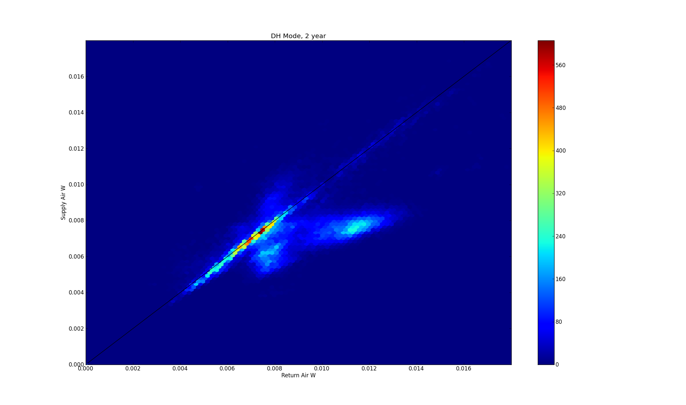
Figure 1: 2012-03-23-dh-W
Relying on state variables alone results in a large number of false positives---times labeled as dehumidification when no moisture is actually being removed. The black line in Figure 1 indicates humidity ratio of the supply air equal to the return air. The majority of the data (red, yellow) has no moisture removal.
The above figure does show some periods of dehumidification, however. These periods can be defined empirically in terms of the temperatures and relative humidities that define dehumidification.
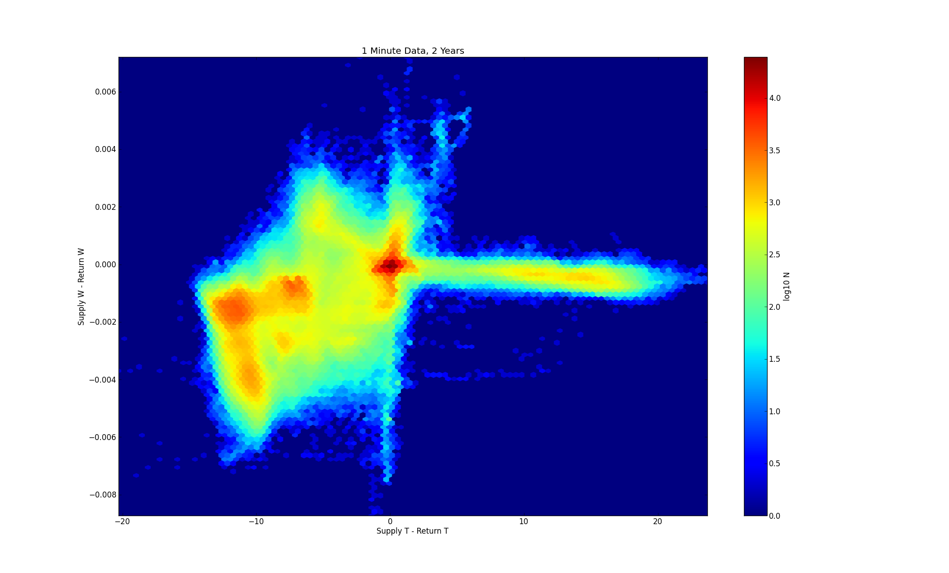
Figure 2: 2012-03-21-dT-dW
Figure 2 is one way of describing the operation of the system, in terms of temperature change and moisture change across the air handler. The heating and cooling periods are well defined, but the dehumidification periods are not clearly separated from the cooling periods.
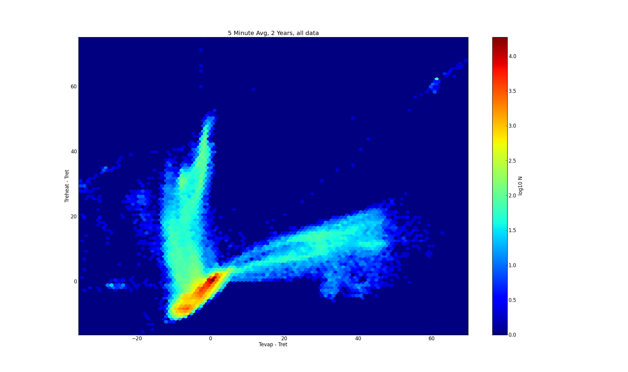
Figure 3: 2012-03-21-5m-dTevap-dTreheat
A better approach is to look at the coil temperatures directly. By normalizing the coil temperatures to the return air temperature (similarly to Figure 2) each operating mode has a unique signature. Figure 3 shows cooling, heating, dehumidification, and also many periods when the heat pump is not operating. Note that the color scale is logorithmic here, to show the heating and dehumidification plumes on the same scale as the off-state peak. When the heat pump is not operating, both coils settle to the same temperature as the return air. During cooling, the primary (evaporator) coil is cold, and the cooled air cools the reheat coil. In heating, the primary coil heats the air, and the air heats the reheat coil. Only in dehumidification is the reheat coil receiving refrigerant, and only in this mode the primary coil is cold while the reheat coil is hot.

Note that the primary coil temperature sensor is substantially warmed by the airflow across it, and so does not accurately reflect the coil temperature. For instance, during cooling, the sensor reports a coil temperature higher than the supply air temperature. Reporting the temperature relative to return air emphasizes that cooling is occurring, rather than the misleading absolute temperature.

It remains only to pick appropriate thresholds defining the dehumidification region of Figure 3. Initially, I looked at primary coil temperatures 1C below return air, and reheat temperatures 1C above return air. This proved overly liberal, including what appear to be two different operating conditions.

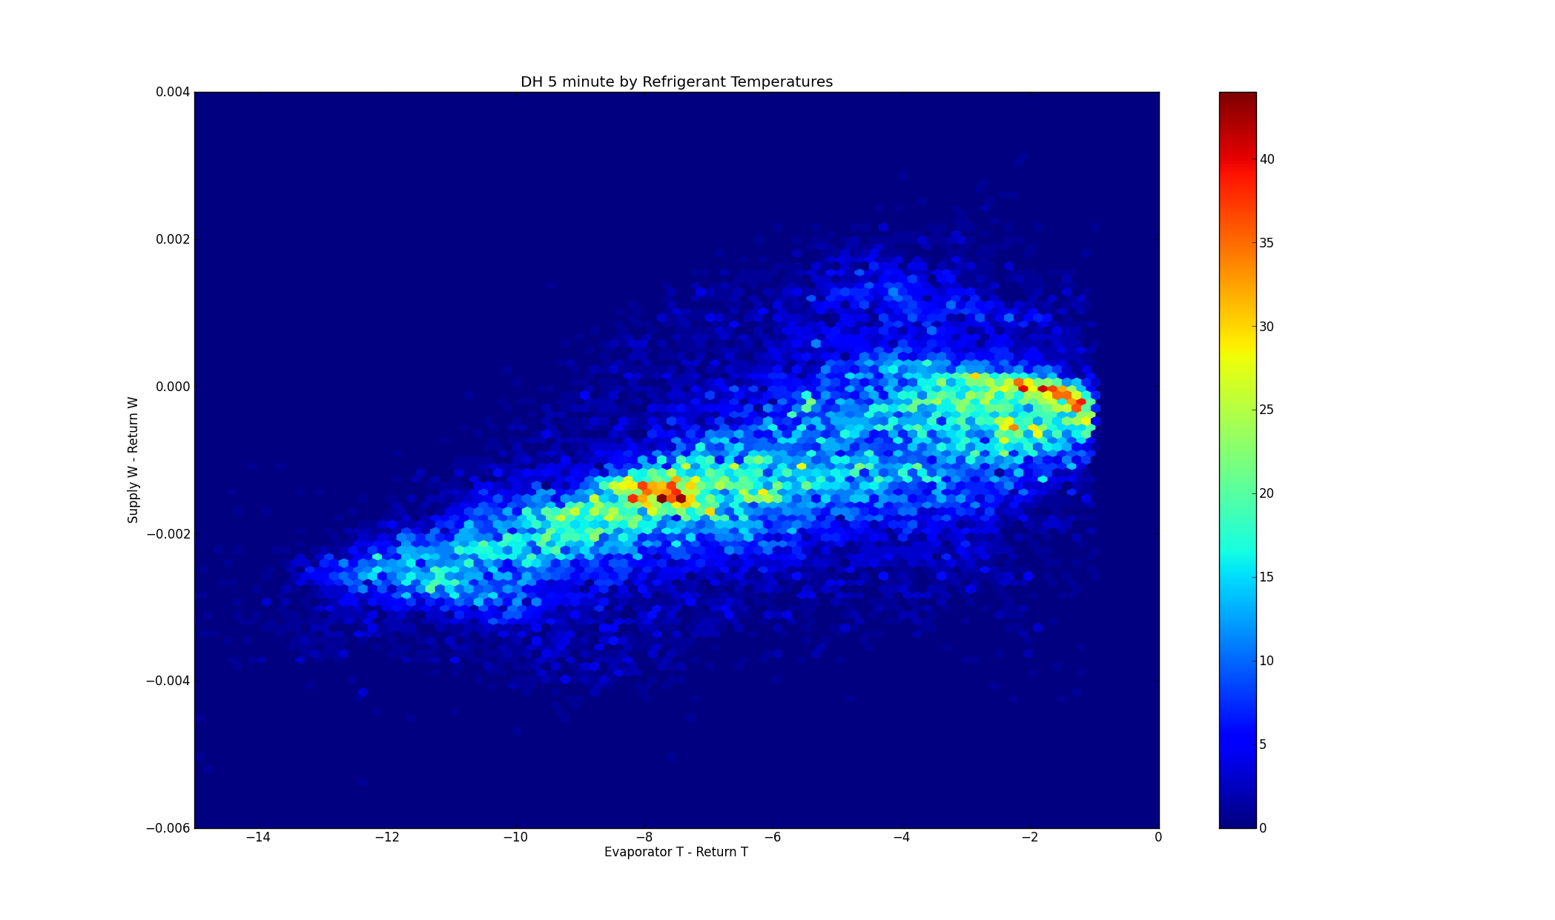
Figure 4: 2012-03-21-dW-dTevap

I believe that the peak in Figure 4 with slight evaporator cooling and reduced dehumidification corresponds to startup periods when the heat pump has not yet reached steady state. This is supported by the time series. Based on the above graph, I have taken evaporator temperature of 4C below return air as sufficient to exclude nearly all of the startup data.

Previously we found that double filtering during the early period of data collection significantly affected at least fan power. There are also significant periods of missing power measurements. I believe that the subset of data with dehumidification defined as above, after the second filter was removed, and with power measurements, will support reasonable regressions. Significant noise remains---the heat pump does not maintain a consistent supply temperature during dehumidification---but I believe it is reasonable to model the average, and ignore the hunting.

