Q 3.1

To compute *p*(*s*1, *s*2|*t*, *y*), the full conditional distribution of the skills *s*1 and *s*2, we start with the Bayesian network from Q2 above, and we apply the results of Gaussian conditional distributions. The variables in the problem are:

*s*1: a Gaussian random variable *s*1 ~N (*μs* , *σ*2 ).

1 *s*1

*s*2: a Gaussian random variable *s*2 ~N (*μs* , *σ*2 ).

2 *s*2

*t*: *t* = *s*1-*s*2 + *ϵ* where *ϵ~*N (0, *σ*2) is Gaussian noise.

*t*

*y* = 1 if Player 1 wins (i.e., *t* > 0),

*y* = −1 if Player 2 wins (i.e., *t* < 0).

The full probabilistic model for the problem is a joint distribution over *s*1, *s*2, *t*, and *y* factorized as:

*p*(*s*1, *s*2, *t*, *y*) = *p*(*s*1)*p*(*s*2)*p*(*t*|*s*1, *s*2)*p*(*y*|*t*)

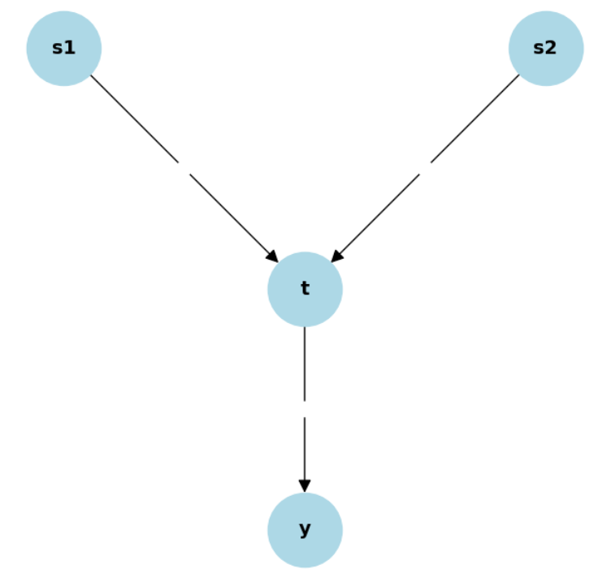

*p*(*s*1) and *p*(*s*2) are the prior distributions for the skills of the two players, which are Gaussian:



*p*(*t*|*s*1, *s*2) is the distribution of the outcome, conditioned on the skills:



This is a Gaussian with mean *s*1-*s*2 and variance *σt*2, representing the uncertainty in the outcome.

*t*

*p*(*y*|*t*) is the probability of the match result *y*, conditioned on *t*:

*p*(*y*|*t*) = I(*y* = sign(*t*))

This is an indicator function that sets *y* to 1 if *t* > 0 (i.e., Player 1 wins), and to -1 if *t* < 0 (Player 2 wins).

From the graph, *y* depends only on *t*, so we can eliminate *y* and compute *p*(*s*1, *s*2|*t*). Since *y* is deterministic given *t*, the distribution of *y* does not affect the continuous variables. This gives us the reduced joint distribution:



This is a Gaussian distribution because the priors and likelihood are Gaussian.

*p*(*s*1, *s*2|*t*) is obtained from the joint multivariate Gaussian distribution of the form:

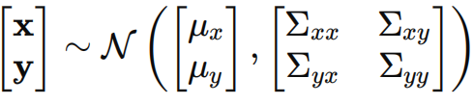

Mean: 

Covariance: 

To compute the conditional distribution *p*(*s*1, *s*2|*t*), we use the following result for the conditional distribution of a multivariate Gaussian:

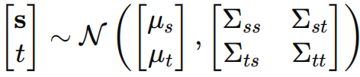

Where:

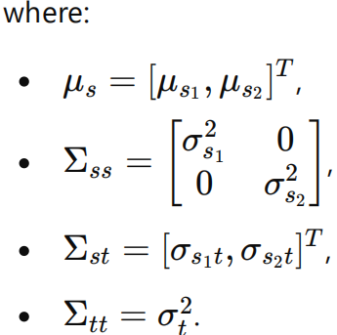

Or

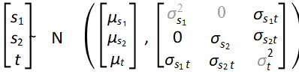

And the mean as well as the covariance are:

 = 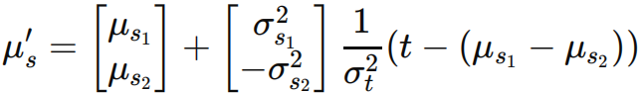

` = 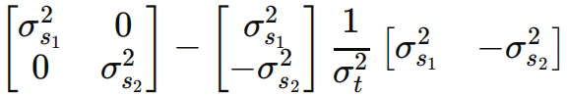

Q 3.2

To solve for p(t|s1,s2,y) (the conditional distribution of the match outcome given the skills s1 , s2, and the result y):

Using Bayes’ theorem, we can write the posterior distribution as:

p(t|s1,s2,y)∝p(y|t)p(t|s1,s2)

* p(t|s1,s2) is the Gaussian distribution for the match outcome t, given the skills s1 and s2.
* p(y|t): This is the probability of observing the game result y given the outcome t.

Since t=s1−s2, the match outcome, t, is normally distributed as:

t∼N(s1−s2,σt2) meaning:

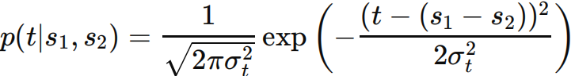

p(y|t) is nonzero only when t has the same sign as y. Specifically:

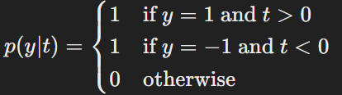

Thus, the posterior distribution p(t|s1,s2,y) is a **Truncated Gaussian** with the following form:

p(t|s1,s2,y=1)∝N(t|s1−s2,σt2) truncated to t>0

p(t|s1,s2,y=−1)∝N(t|s1−s2,σt2) truncated to t<0

This truncated Gaussian has the same mean and variance as the original Gaussian N(s1−s2,σt2, but it is constrained to the region where t>0 or t<0 depending on the game result.

For a truncated Gaussian, the mean and variance are adjusted based on the truncation. For example, if truncating to t>0, the mean of the truncated distribution is **shifted upward** from the original mean of s1−s2. Similarly, if truncating to t<0, the mean is **shifted downward**.

Q3.3

From the definition of p(y=1)=p(t>0), which is the probability that Player 1 wins (i.e., the outcome variable t is greater than 0).

p(t>0)=1−p(t≤0)

Since t is a normally distributed random variable with mean μt and variance σ2t, we can use the CDF of the normal distribution to express p(t≤0)p:

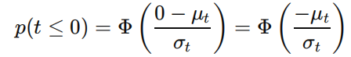

Where Φ is the cumulative distribution function (CDF) of the standard normal distribution, and and are the mean and standard deviation of the outcome variable . Thus, we can express p(t > 0) as:

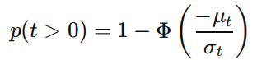

Now, we need to express μt and σt in terms of the skill levels and of Player 1 and Player 2.

The outcome variable is the difference between the skill levels of Player 1 and Player 2, with some added noise:

t = s1 − s2 + ϵ

Where represents the noise in the game outcome.

The mean and variance of t are given by:

μt = μ1 − μ2 and 

Substituting for μt and σt we find

