Sample Course Name

Sample Course Module Name

Author: Asst. Prof. Dr. Uğur CORUH

## Algorithms And Programming I

### Week-1 (Sample Course Module Name)

#### Spring Semester, 2022-2023

Download [DOC](week-1.en.md_doc.pdf), [SLIDE](week-1.en.md_slide.pdf), [PPTX](week-1.en.md_slide.pptx)

### Java

* Sample Outline
* Sample Outline

## **##** Sample Topic**

**

### Sample Topic

* **What is Lorem Ipsum?** Lorem Ipsum is simply dummy text of the printing and typesetting industry. Lorem Ipsum has been the industry’s standard dummy text ever since the 1500s,
  + when an unknown printer took a galley of type and scrambled it to make a type specimen book. It has survived not only five centuries,
    - but also the leap into electronic typesetting, remaining essentially unchanged.
      * It was popularised in the 1960s with the release of Letraset sheets containing Lorem Ipsum passages, and more recently with desktop publishing software like Aldus PageMaker including versions of Lorem Ipsum.

### Sample Images-1

* **What is Lorem Ipsum?** Lorem Ipsum is simply dummy text of the printing and typesetting industry. Lorem Ipsum has been the industry’s standard dummy text ever since the 1500s,

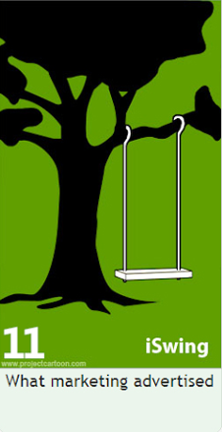

center h:400px

### Sample Images-2

* **What is Lorem Ipsum?** Lorem Ipsum is simply dummy text of the printing and typesetting industry. Lorem Ipsum has been the industry’s standard dummy text ever since the 1500s,



bg right:50% h:400px

### Sample Images-3

* **What is Lorem Ipsum?** Lorem Ipsum is simply dummy text of the printing and typesetting industry. Lorem Ipsum has been the industry’s standard dummy text ever since the 1500s,



bg left:50% h:400px

### Sample Images-4

* **What is Lorem Ipsum?** Lorem Ipsum is simply dummy text of the printing and typesetting industry. Lorem Ipsum has been the industry’s standard dummy text ever since the 1500s,



bg h:400px

### Sample Images-5

* **What is Lorem Ipsum?** Lorem Ipsum is simply dummy text of the printing and typesetting industry. Lorem Ipsum has been the industry’s standard dummy text ever since the 1500s,

 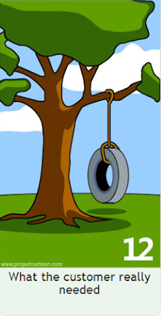

## References

* https://avesis.erdogan.edu.tr/ugur.coruh
* https://www.linkedin.com/in/ugurcoruh/
* https://www.hindawi.com/journals/scn/2018/6563089/
* https://dl.acm.org/doi/abs/10.1145/3410352.3410836
* https://www.sciencedirect.com/science/article/abs/pii/S2214212621002623

$End−Of−Week−1−Module$